1. **Outdoor Deployment**

The *Arduino Version* of the *Sensor Node* is assembled on a vulnerable solderless breadboard. Outdoor applications require the breadboard to be safe and weatherproof.

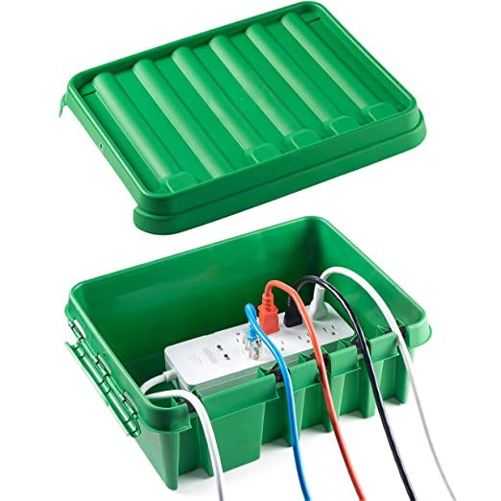

Figure 11. Waterproof Case.

Figure 12. Waterproof Case.

A Nanuk 903 Waterproof Case and a Green Case were used to house the Node. Both cases are contain ports to allow power cords to run in/out of the case.

Figure 13. Voltaic Battery

Figure 14. Voltaic Solar Panel

Figure 15. CO2 Sensor Housing Unit.

Figure 16. Housing Unit attached to the Anemometer.

Figure 17. Sensor Node Deployed in an Outdoor Setting.

It is preferable that the *Sensor Node* is powered by a continuous power supply, such as an on-grid outlet. However, if deployed in remote areas, the Node must be powered via solar energy. A company called *Voltaic*

* Waterproof Case
* Solar Battery
* Solar Panel
* Housing Unit
* Calculations