Animal Behavior Observation Lab (Webcam Ethogram + Chi-Square)
Dr. Alicia M. Rich

0.1 Learning goals
By the end of this lab you should be able to:
- Use an ethogram to record animal behavior with operational definitions.
- Collect data using scan sampling.
- Write a clear null and alternative hypothesis about behavior.
- Use a chi-square test to evaluate your hypothesis.

1 Part 1 (in lab): Mystery box
(Complete the mystery box activity as instructed.)

2 Part 2: Observing animal behavior (webcam)

2.1 Materials
- Live animal webcam/video
- This handout
- Timer (phone timer is fine)
- Data table (below)

2.1.1 Video Feed Choices
San Diego Zoo
https://zoo.sandiegozoo.org/live-cameras
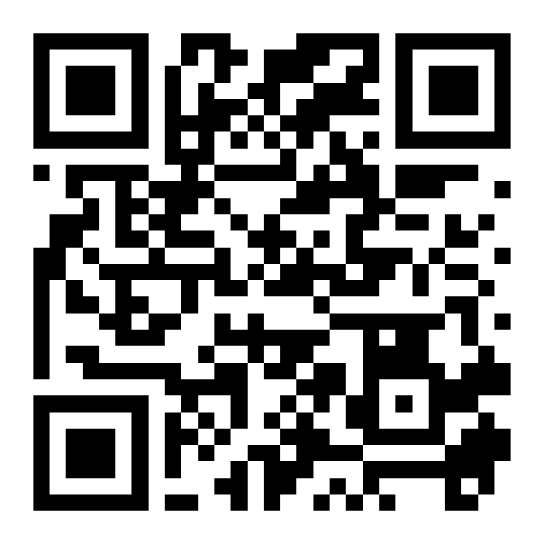
Lincoln Park Zoo
https://www.lpzoo.org/live-cams/

Smithsonian National Zoo
https://nationalzoo.si.edu/webcams

Explore.org Live Feeds
https://explore.org/livecams/currently-live
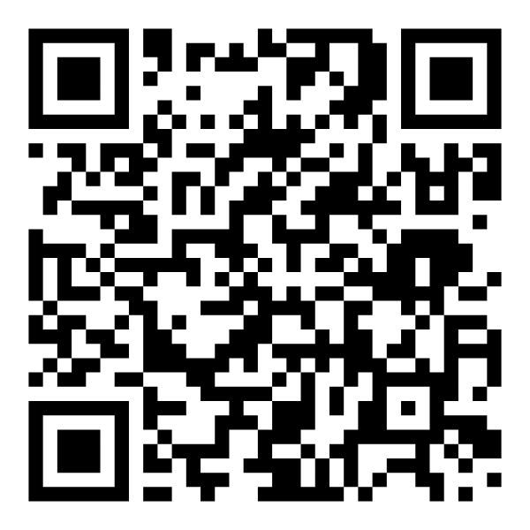

2.2 Important observation rules
- Score only what you can see, not what you think the animal “means.”
- If the animal is partly hidden and you cannot determine the behavior, use:
  - Behavior Obscured (you know where it is, behavior unclear)
  - Animal Not Visible (you can’t see it at all)

3 Step A — Choose a focal animal and a “comparison”
You will test a question using two conditions. Choose ONE comparison:
Option 1 (recommended): Time comparison
- Condition A: first 10 minutes of observation
- Condition B: second 10 minutes of observation
Option 2: Two animals
- Animal A vs Animal B (only if both are visible reliably)
Option 3: Two exhibit zones
- Zone A vs Zone B (only if the exhibit is clearly divided and you can tell zones)

3.1 Write your choice here:
Comparison type:

Condition A:

Condition B:

4 Step B — Pick 5 behavior categories (simplify the ethogram)
The full ethogram is extensive. For this lab, you will collapse behaviors into 5 simple categories so your chi-square test stays clean.
Use these categories (circle the exact codes you will use):
- Inactive (Inactive / Standing / Sitting / Lying / Floating / Vertical clinging / Hanging)
- Feeding/Foraging/Drinking (Feeding/Foraging/Drinking + all foraging subtypes + Feeding/Drinking/Ruminating/Nursing)
- Locomotion (Walking/Running/Climbing/Leaping/Swimming/Flying/etc.)
- Other (Solitary) (Exploration, self-maintenance, scent marking, solitary play, elimination, vocalization, etc.)
- Social (Affiliative + Reproductive + Agonistic)
- Undesirable (Pacing, stereotypies, self-injury, etc.) — include only if you see it
- Not Visible (Behavior Obscured + Animal Not Visible)
Your required categories: choose exactly 5, and one MUST be Not Visible. Write your 5 categories here:

Tip: If you never see “Undesirable” or “Social,” don’t include them—pick categories you expect to observe at least sometimes.

5 Step C — Collect data using scan sampling
You will do 20 scans total (10 scans per condition).
- Set a timer for 1-minute intervals
- At each minute mark, record the single best behavior category that describes what the animal is doing at that instant
- If more than one behavior occurs, score the behavior that is most dominant at the instant of the scan
- If you cannot determine behavior, score Not Visible (Obscured or Not Visible)

5.1 Scan sheet
Fill in one row per scan.
Scan # | Condition (A or B) | Behavior category (one of your 5) | Notes (optional)
1 | A
2 | A
3 | A
4 | A
5 | A
6 | A
7 | A
8 | A
9 | A
10 | A
11 | B
12 | B
13 | B
14 | B
15 | B
16 | B
17 | B
18 | B
19 | B
20 | B

6 Step D — Convert your scans into a summary count table
Count how many times each category occurred in each condition.

6.1 Observed counts (O)
Behavior category (your 5) | Condition A (count) | Condition B (count) | Row total
Category 1
Category 2
Category 3
Category 4
Category 5
Column totals | 10 | 10 | 20
(If your totals aren’t 10 and 10, you missed scans—fix before continuing.)

7 Part 3: Hypotheses (chi-square test of independence)

7.1 Your research question (one sentence)
Example formats:
- “Does the distribution of behaviors differ between Condition A and Condition B?”
- “Does Animal A show a different behavior profile than Animal B?”
Question:

7.2 Null hypothesis (H0)
For a chi-square test of independence:
H0: The proportion of scans in each behavior category is the same in Condition A and Condition B.
Write it in your own words:

7.3 Alternative hypothesis (HA)
HA: The distribution of behaviors is different between Condition A and Condition B.
Write it in your own words:

8 Step E — Calculate expected counts (E)
For each cell:
$$E=\frac{\left(\text{row total}\right)\left(\text{column total}\right)}{\text{grand total}}$$
Because each column total is 10 and grand total is 20:
$$E=\frac{\left(\text{row total}\right)\left(10\right)}{20}=\frac{\text{row total}}{2}$$
So for each behavior category, the expected count in Condition A equals half of the row total, and same for Condition B.

8.1 Expected counts (E)
Behavior category | Row total | Expected in A (E) | Expected in B (E)
Category 1
Category 2
Category 3
Category 4
Category 5

9 Step F — Compute chi-square
For each cell:
$$χ^{2}=∑\frac{{\left(O−E\right)}^{2}}{E}$$

9.1 Chi-square work table
Fill in all 10 cells (5 categories × 2 conditions).
Behavior category | O (A) | E (A) | (O−E) | (O−E)²/E | O (B) | E (B) | (O−E) | (O−E)²/E
Category 1
Category 2
Category 3
Category 4
Category 5
Totals |  |  |  | chi² =

10 Step G — Degrees of freedom and decision
Degrees of freedom for chi-square test of independence:
$$df=\left(r−1\right)\left(c−1\right)$$
Here, (r=5) behavior categories and (c=2) conditions, so:
$$df=\left(5−1\right)\left(2−1\right)=4$$
- Use your course method (table or calculator/software) to find the p-value for your χ² with df = 4.
- Use (= 0.05) unless your instructor tells you otherwise.
chi-square value:

df:
4
p-value:

Decision:
- [] Reject H0
- [] Fail to reject H0

10.1 Interpretation (2–4 sentences)
- What does your result mean in plain language?
- Which behaviors contributed most to χ² (largest (O−E)²/E values)?

11 Data quality checks (answer briefly)
- Did you have any categories with expected counts less than 5?
- [] No
- [] Yes
  - If yes, combine two similar categories and re-run the test.
- Were there many Not Visible scans?
- [] No
- [] Yes
  - Briefly explain why (camera angle, animal location, exhibit complexity, etc.).
- One limitation of your observational design:

12 Submission checklist
Turn in:
- Completed scan sheet
- Observed count table (O)
- Expected count table (E)
- Chi-square work table with χ², df, p-value
- Short interpretation + data quality checks

