AZA Regional Studbook

Bowmouth Guitarfish (Rhina ancylostoma)

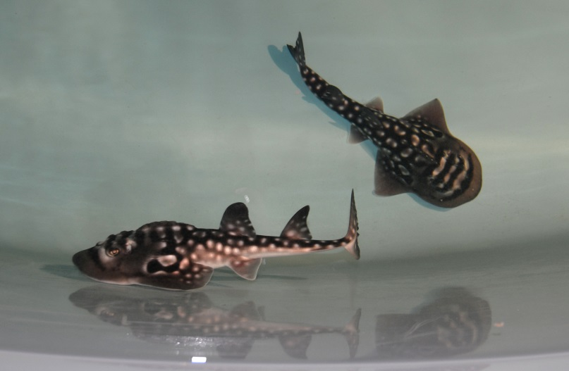
Photo credit: Justin Cain, Newport Aquarium

AZA Regional Studbook Keeper &
Program Coordinator
Jen Hazeres, Newport Aquarium
jhazeres@newportaquarium.com

Studbook data current as of July 2022
Distribution date: September 2022
Second Edition
Table of Contents
AZA Studbook Disclaimer………………3
Data Field Descriptions…………………4
Taxonomy…………………….……….….5
Natural History…………….…….…….….5
Geographic Distribution…….……..…….6
Habitat and Ecology………………….….6
Status in Wild…………………………….7
Shark Rays in Captivity…………………7
Photographs……………………….…….8
Living Population……………………......9
Historic Population…………..………....10
Current Institutions……………………..15
Institutional Representatives…………..15
Historic Institutions……………………..16
References………………………………17
AZA Regional Studbook Disclaimer

Copyright September 30,2022 by Newport Aquarium, Newport, KY. All rights reserved. No part of this publication may be reproduced in hard copy, machine-readable or other forms without advance written permission from Newport Aquarium. Members of the Association of Zoos and Aquariums (AZA) may copy this information for their own use as needed.

The information contained in this studbook has been obtained from numerous sources believed to be reliable. AZA and Newport Aquarium make a diligent effort to provide a complete and accurate representation of the data in its reports, publications, and services. However, AZA and Newport Aquarium do not guarantee the accuracy, adequacy, or completeness of any information. AZA and Newport Aquarium make no warranties or representations of any kind, express or implied, including but not limited to warranties of merchantability of fitness for particular purpose. AZA and Newport Aquarium disclaim all liability for errors or omissions that may exist and shall not be liable for any incidental, consequential, or other damages (whether resulting from negligence or otherwise) including, without limitation, exemplary damages or lost profits arising out of or in connection with the use of this publication.

Because the technical information provided in the studbook can easily be misread or misinterpreted unless properly analyzed, AZA and Newport Aquarium strongly recommend that users of this information consult with the Studbook Keeper in all matters related to data analysis and interpretation.

Data Field Descriptions

Studbook ID – unique number assigned to each individual in the studbook. The studbook number is a permanent number.

Birth Date – indicates the date of the animal’s birth. There is a birth date for every individual. Please check the next column, “Birth Date Est.” to judge the accuracy of that date.

Birth Date Est. – indicated if the Birth Date field is an estimate
None – no estimation
Day – the day is estimated
Month – the month is estimated
Year – the actual birth date is within the year of the Birth Date field

Sire/Dam – numbers indicate the Studbook ID of the parents of the zoo/aquarium born animals
Wild – indicates that an animal was wild caught and its parents are unknown wild individuals
Unk – indicates that an animal was zoo/aquarium born but identification of the parent is not known
Mult – indicates that there are several possible parents at the zoo/aquarium, but the specific one could not be determined. A parental assumption note in the Specimen Note field is included with this parental designation to indicate which animal could be the potential parent.

Sex – male, female, unknown

Event – documents the movements of individual animals from the first location to the current or last known location. This includes Wild Capture, Birth/Hatch, Transfer, Death, Go LTF (Lost to Follow up), Return from LTF, and Release. UNKNOWN indicated that the animal exists or existed, but its location cannot be reliably confirmed.

Location – indicates where the event took place

Local ID – the number assigned by the institution in which the event took place. UNK – indicates that either an ID was not assigned or no information exists to indicate that an ID was assigned.

Date – documents the date that events occurred. Each event has a date associated with it. Also, check the adjacent column (Date Est.) to determine the accuracy of this date.

Date Est. – indicates if the adjacent date is an estimate
None – no estimation
Day – the day is estimated
Month – the month is estimated
Year – the actual date is within the year of the Event Date field

House Name – this field indicated the name given to the animal at a specific location. Individuals may be given a different house name each time they move to a different location.

Taxonomy

Kingdom – Animalia
Phylum – Chordata
Class – Chondrichthyes
Order – Rajiformes (Rhinopristiformes)
Family – Rhinobatidae (Rhinidae)
Genus – Rhina
Species – ancylostoma
(Bloch and Schneider 1801)

Natural History

R. ancylostoma (some common names include shark ray and bowmouth guitarfish) are the sole member of the Subfamily Rhininae (Family Rhinobatidae) (Eschmeyer 2015). This robust marine species most often is found swimming around coral reefs or over open areas of mud or sand of Indo-West Pacific regions ranging from the Red Sea, Arabian Gulf and East Africa to Papua New Guinea, southwards to New South Wales, Australia and northwards to Japan (Gordan 1992, Compagno et al. 1989). Shark rays are a coastal species found in water depths of 3 to 90 meters (Sommer and Poutiers 1996).

The rounded snout and unique jaw structure lend themselves to the descriptive and prehistoric look of the fish that is most intriguing and easily distinguishes it from other elasmobranchs. Most conspicuously, the dorsal surface of its cephalic region has nine distinct linear ridges of conical thorns that vary in length and prominence: the longest and most conspicuous nape ridge that runs medial and anterior to the first dorsal fin; a symmetrical pair of average length supraorbital ridges; a symmetrically located pair of ridges of decreasing length and prominence on either side of the nape ridge; and finally, a small symmetrically located pair of ridges that lay anterior and slightly medial to the supraorbital ridges. There has been speculation that these ridges are used for defense (SAAMBR 2013; Dvornak et al. 2017). Individual conical thorns on the ridges loosen and fall out periodically. These are slowly replaced by a new thorn that does not appear as sharp (authors’ personal observations). Shark rays exhibit countershading that consists of a brownish gray dorsal surface and a white ventral surface. The dorsal surface may be mottled with white spots. The presence and intensity of these white spots differ between individuals and age with younger individuals displaying more intense patterns. Young shark rays also have noticeable black bands between their eyes that fade with age (Last and Stevens 2009). Adults may reach lengths up to 270 cm (Randall 1995).

The diet of shark rays consists mainly of crustaceans and mollusks (Compagno et al. 1999), and fishes (Gordan, 1992).

Geographic Distribution

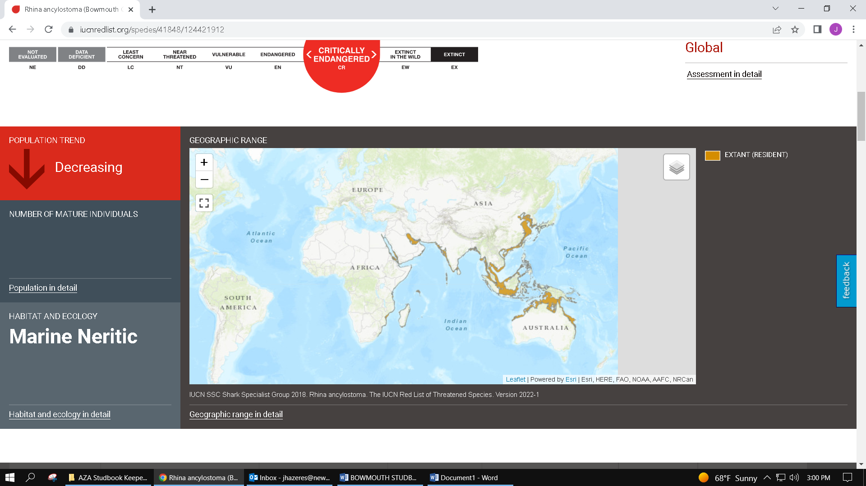

IUCN SSC Shark Specialist Group 2018. Rhina ancylostoma. The IUCN Red List of Threatened Species. Version 2022-1

Habitat and Ecology

According to the International Union for Conservation of Nature (IUCN) Red List, the shark ray has a coastal distribution throughout its range, generally occurring close inshore and around coral reefs. (Anonymous 2003, Fricke et al. 2011). They live on or close to the seabed, mainly over sandy or muddy substrates. Very little is known about the life history characteristics of this species, however, it is lecithotrophic viviparous (Compagno and Last 1999). Males mature between 150 and 175 cm TL, and one pregnant female was recorded with 9 mid-term embryos ranging between 27-31 cm TL (Last and Stevens 2009). Newborn tail length measurements from 2 different litters (litter 1- 7 pups; litter 2- 9 pups) averaged 49 cm along with an average weight of 1.01 kg. (author’s personal observations). Further research on the biology, life history, and exploitation of this species is needed.

Status in Wild

The IUCN Red List has listed shark rays as Critically Endangered as of December 2018, and it is inferred that the bowmouth guitarfish has undergone a >80% population reduction over the last three generations (45 years). Very little is known about the biology or population status of this species as it does not appear to be commonly found anywhere. Estimated generation length of 15 years is moderate but this is based on proxy data and needs to be further verified (White et al., 2014).

The shark ray is a widely distributed inshore species of the Indo-West Pacific. This species is taken by multiple artisanal and commercial fisheries throughout its range, both as a target species and as bycatch. Flesh is sold for human consumption in Asia and the fins from large animals fetch exceptionally high prices thus creating a significant incentive for bycatch to be retained.

Local population depletion can be inferred from Indonesia where target gillnet fisheries for rhinids and rhynchobatids has declined significantly, reportedly due to declining catch rates. It is probable that the population will continue to decline, at least, until target fisheries become uneconomical. Habitat destruction is also thought to pose a significant threat to the shark ray throughout much of its range.
There are no target fisheries for the shark ray in Australia but it is a known bycatch species in demersal trawl fisheries. The introduction of turtle exclusion devices in Australia has reduced catches of large rays by 94% (Brewer et al. 2006). While some parts of Australasia provide refuge from intense fishing effort, this proportion of the species’ range is not considered to be large enough relative to the global range to lower the assessment (IUCN 2019). The situation should be monitored due to both the suspected vulnerability of this species and the high value of its fins.

Shark Rays in Captivity

AZA institutions within the North American region began to exhibit R. ancylostoma in 2005. The rarity of this species and their unique physical appearance make them a remarkable animal to display. This studbook represents seventeen individuals currently maintained at nine facilities.

Photographs

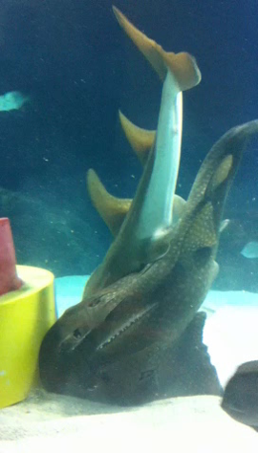
Active copulation observed at Newport Aquarium

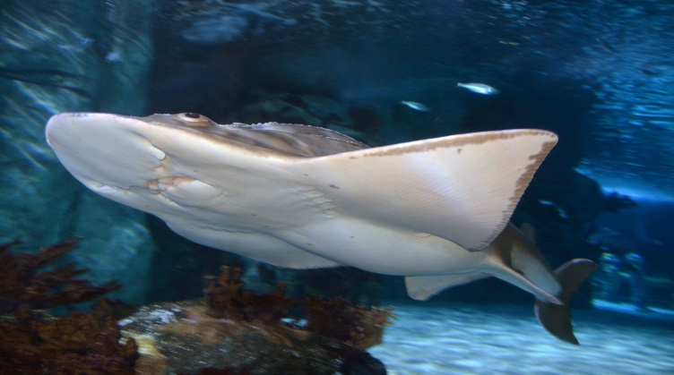
Gravid shark ray at Newport Aquarium

Living Population

Studbook ID | Current Location | Current Local ID | Sex Type | Hatch Date | Current Status | Sire | Dam | Age
32 | ABERDE HK | AQ890 | Male | Oct 10, 2016 | Alive | UND | UND | 5Y,10M,21D
33 | ABERDE HK | AQ891 | Female | Oct 10, 2016 | Alive | UND | UND | 5Y,10M,21D
51 | ATLPALMAQ | Undetermined | Male | Feb 01, 2011 to Aug 01, 2011 | Alive | WILD | WILD | 11Y,3M,29D
52 | ATLPALMAQ | Undetermined | Female | Jan 01, 2019 to Mar 01, 2019 | Alive | WILD | WILD | 3Y,7M,1D
12 | EPCOT | S00307 | Female | Jan 01, 2014 +/- 3 year | Alive | WILD | WILD | 8Y,7M,30D
31 | EPCOT | S00465 | Male | Sep 01, 2018 | Alive | UND 1 | UND 2 | 3Y,11M,30D
9 | GA AQUAR | E09002 | Male | Jan 01, 2007 +/- 6 month | Alive | WILD | WILD | 15Y,7M,30D
10 | GA AQUAR | E09043 | Female | Jan 01, 2007 +/- 6 month | Alive | WILD | WILD | 15Y,7M,30D
11 | GA AQUAR | E15027 | Female | Jan 01, 2014 +/- 1 year | Alive | WILD | WILD | 8Y,7M,30D
1 | NEWPORTKY | 6699 | Female | Apr 01, 2004 +/- 4 month | Alive | WILD | WILD | 18Y,4M,30D
2 | NEWPORTKY | 6700 | Male | Jun 01, 2005 +/- 1 month | Alive | WILD | WILD | 17Y,2M,30D
3 | NEWPORTKY | 6701 | Female | Jun 01, 2008 +/- 3 month | Alive | WILD | WILD | 14Y,2M,30D
34 | OCEAN VAL | 000322 | Male | ~< Feb 01, 2019 | Alive | UND | UND | 3Y,6M,30D
35 | OCEAN VAL | 000321 | Male | ~< Dec 01, 2018 | Alive | UND | UND | 3Y,8M,30D
50 | SEALIFEMN | 10231 | Female | Jan 01, 2010 to Mar 11, 2010 | Alive | WILD | WILD | 12Y,6M,27D
13 | SEALIFETX | Rhina.02.2013 | Female | Jan 01, 2011 +/- 1 year | Alive | WILD | WILD | 11Y,7M,30D
4 | SHARKREEF | 671 | Female | Jan 23, 2008 +/- 3 month | Alive | WILD | WILD | 14Y,7M,8D

Historic Population

Studbook ID | Current Location | Current Local ID | Sex Type | Hatch Date | Current Status | Sire | Dam | Age | Birth Type | Event Type
1 | NEWPORTKY | 6699 | Female | Apr 01, 2004 +/- 4 month | Alive | WILD | WILD | 18Y,4M,30D | Wild Birth/Hatch | Birth/Hatch
 |  |  |  |  |  |  |  |  |  | Wild Capture
 |  |  |  |  |  |  |  |  |  | Transfer
2 | NEWPORTKY | 6700 | Male | Jun 01, 2005 +/- 1 month | Alive | WILD | WILD | 17Y,2M,30D | Wild Birth/Hatch | Birth/Hatch
 |  |  |  |  |  |  |  |  |  | Wild Capture
 |  |  |  |  |  |  |  |  |  | Transfer
 |  |  |  |  |  |  |  |  |  | Transfer
3 | NEWPORTKY | 6701 | Female | Jun 01, 2008 +/- 3 month | Alive | WILD | WILD | 14Y,2M,30D | Wild Birth/Hatch | Birth/Hatch
 |  |  |  |  |  |  |  |  |  | Wild Capture
 |  |  |  |  |  |  |  |  |  | Transfer
4 | SHARKREEF | 671 | Female | Jan 23, 2008 +/- 3 month | Alive | WILD | WILD | 14Y,7M,8D | Wild Birth/Hatch | Birth/Hatch
 |  |  |  |  |  |  |  |  |  | Wild Capture
 |  |  |  |  |  |  |  |  |  | Transfer
 |  |  |  |  |  |  |  |  |  | Transfer
5 | ADVENTURE | 3011 | Male | Apr 20, 2006 +/- 1 year | Dead | WILD | WILD | 14Y,3M,9D | Wild Birth/Hatch | Birth/Hatch
 |  |  |  |  |  |  |  |  |  | Wild Capture
 |  |  |  |  |  |  |  |  |  | Transfer
 |  |  |  |  |  |  |  |  |  | Transfer
 |  |  |  |  |  |  |  |  |  | Transfer
 |  |  |  |  |  |  |  |  |  | Death
6 | ADVENTURE | 2972 | Female | Mar 12, 2006 +/- 1 year | Dead | WILD | WILD | 7Y,5M,18D | Wild Birth/Hatch | Birth/Hatch
 |  |  |  |  |  |  |  |  |  | Wild Capture
 |  |  |  |  |  |  |  |  |  | Transfer
 |  |  |  |  |  |  |  |  |  | Death
7 | NEWPORTKY | - | Female | Mar 12, 2006 +/- 3 year | Dead | WILD | WILD | 7Y,4M,11D | Wild Birth/Hatch | Birth/Hatch
 |  |  |  |  |  |  |  |  |  | Wild Capture
 |  |  |  |  |  |  |  |  |  | Transfer
 |  |  |  |  |  |  |  |  |  | Transfer
 |  |  |  |  |  |  |  |  |  | Death
8 | SEALIFEMO | Rhina | Female | Jun 11, 2012 +/- 6 month | Dead | WILD | WILD | 7Y,3M,19D | Wild Birth/Hatch | Birth/Hatch
 |  |  |  |  |  |  |  |  |  | Wild Capture
 |  |  |  |  |  |  |  |  |  | Transfer
 |  |  |  |  |  |  |  |  |  | Death
9 | GA AQUAR | E09002 | Male | Jan 01, 2007 +/- 6 month | Alive | WILD | WILD | 15Y,7M,30D | Wild Birth/Hatch | Birth/Hatch
 |  |  |  |  |  |  |  |  |  | Wild Capture
 |  |  |  |  |  |  |  |  |  | Transfer
10 | GA AQUAR | E09043 | Female | Jan 01, 2007 +/- 6 month | Alive | WILD | WILD | 15Y,7M,30D | Wild Birth/Hatch | Birth/Hatch
 |  |  |  |  |  |  |  |  |  | Wild Capture
 |  |  |  |  |  |  |  |  |  | Transfer
11 | GA AQUAR | E15027 | Female | Jan 01, 2014 +/- 1 year | Alive | WILD | WILD | 8Y,7M,30D | Wild Birth/Hatch | Birth/Hatch
 |  |  |  |  |  |  |  |  |  | Wild Capture
 |  |  |  |  |  |  |  |  |  | Transfer
12 | EPCOT | S00307 | Female | Jan 01, 2014 +/- 3 year | Alive | WILD | WILD | 8Y,7M,30D | Wild Birth/Hatch | Birth/Hatch
 |  |  |  |  |  |  |  |  |  | Wild Capture
 |  |  |  |  |  |  |  |  |  | Transfer
13 | SEALIFETX | Rhina. 02.2013 | Female | Jan 01, 2011 +/- 1 year | Alive | WILD | WILD | 11Y,7M,30D | Wild Birth/Hatch | Birth/Hatch
 |  |  |  |  |  |  |  |  |  | Wild Capture
 |  |  |  |  |  |  |  |  |  | Transfer
14 | NEWPORTKY | PUP1.1 | Female | Jan 24, 2014 | Dead | 2 | 1 | 0Y,0M,12D | Captive Birth/Hatch | Birth/Hatch
 |  |  |  |  |  |  |  |  |  | Death
15 | NEWPORTKY | PUP1.2 | Male | Jan 24, 2014 | Dead | 2 | 1 | 0Y,0M,8D | Captive Birth/Hatch | Birth/Hatch
 |  |  |  |  |  |  |  |  |  | Death
16 | NEWPORTKY | PUP1.3 | Male | Jan 24, 2014 | Dead | 2 | 1 | 0Y,1M,0D | Captive Birth/Hatch | Birth/Hatch
 |  |  |  |  |  |  |  |  |  | Death
17 | NEWPORTKY | PUP1.4 | Male | Jan 24, 2014 | Dead | 2 | 1 | 0Y,0M,27D | Captive Birth/Hatch | Birth/Hatch
 |  |  |  |  |  |  |  |  |  | Death
18 | NEWPORTKY | PUP1.5 | Female | Jan 24, 2014 | Dead | 2 | 1 | 0Y,0M,13D | Captive Birth/Hatch | Birth/Hatch
 |  |  |  |  |  |  |  |  |  | Death
19 | NEWPORTKY | PUP1.6 | Female | Jan 24, 2014 | Dead | 2 | 1 | 0Y,0M,12D | Captive Birth/Hatch | Birth/Hatch
 |  |  |  |  |  |  |  |  |  | Death
20 | NEWPORTKY | PUP1.7 | Female | Jan 24, 2014 | Dead | 2 | 1 | 0Y,0M,0D | Captive Birth/Hatch | Birth/Hatch
 |  |  |  |  |  |  |  |  |  | Death
21 | NEWPORTKY | ONE | Male | Jan 05, 2016 | Dead | 2 | 1 | 0Y,5M,16D | Captive Birth/Hatch | Birth/Hatch
 |  |  |  |  |  |  |  |  |  | Death
22 | NEWPORTKY | TWO | Female | Jan 05, 2016 | Dead | 2 | 1 | 0Y,0M,4D | Captive Birth/Hatch | Birth/Hatch
 |  |  |  |  |  |  |  |  |  | Death
23 | ADVENTURE | THREE | Female | Jan 05, 2016 | Dead | 2 | 1 | 1Y,7M,22D | Captive Birth/Hatch | Birth/Hatch
 |  |  |  |  |  |  |  |  |  | Transfer
 |  |  |  |  |  |  |  |  |  | Death
24 | NEWPORTKY | FOUR | Female | Jan 05, 2016 | Dead | 2 | 1 | 0Y,2M,19D | Captive Birth/Hatch | Birth/Hatch
 |  |  |  |  |  |  |  |  |  | Death
25 | NEWPORTKY | FIVE | Male | Jan 05, 2016 | Dead | 2 | 1 | 0Y,5M,21D | Captive Birth/Hatch | Birth/Hatch
 |  |  |  |  |  |  |  |  |  | Death
26 | NEWPORTKY | SIX | Female | Jan 05, 2016 | Dead | 2 | 1 | 0Y,7M,3D | Captive Birth/Hatch | Birth/Hatch
 |  |  |  |  |  |  |  |  |  | Death
27 | NEWPORTKY | SEVEN | Male | Jan 05, 2016 | Dead | 2 | 1 | 0Y,2M,25D | Captive Birth/Hatch | Birth/Hatch
 |  |  |  |  |  |  |  |  |  | Death
28 | NEWPORTKY | EIGHT | Female | Jan 05, 2016 | Dead | 2 | 1 | 0Y,2M,21D | Captive Birth/Hatch | Birth/Hatch
 |  |  |  |  |  |  |  |  |  | Death
29 | ADVENTURE | NINE | Female | Jan 05, 2016 | Dead | 2 | 1 | 1Y,7M,6D | Captive Birth/Hatch | Birth/Hatch
 |  |  |  |  |  |  |  |  |  | Transfer
 |  |  |  |  |  |  |  |  |  | Death
30 | EPCOT | S00464 | Male | Sep 01, 2018 | Dead | UND 1 | UND 2 | 3Y,8M,16D | Captive Birth/Hatch | Birth/Hatch
 |  |  |  |  |  |  |  |  |  | Transfer
 |  |  |  |  |  |  |  |  |  | Transfer
 |  |  |  |  |  |  |  |  |  | Death
31 | EPCOT | S00465 | Male | Sep 01, 2018 | Alive | UND 1 | UND 2 | 3Y,11M,30D | Captive Birth/Hatch | Birth/Hatch
 |  |  |  |  |  |  |  |  |  | Transfer
 |  |  |  |  |  |  |  |  |  | Transfer
32 | ABERDE HK | AQ890 | Male | Oct 10, 2016 | Alive | UND | UND | 5Y,10M,21D | Captive Birth/Hatch | Birth/Hatch
 |  |  |  |  |  |  |  |  |  | Transfer
33 | ABERDE HK | AQ891 | Female | Oct 10, 2016 | Alive | UND | UND | 5Y,10M,21D | Captive Birth/Hatch | Birth/Hatch
 |  |  |  |  |  |  |  |  |  | Transfer
34 | OCEAN VAL | 000322 | Male | ~<Feb 01, 2019 | Alive | UND | UND | 3Y,6M,30D | Undetermined | Birth/Hatch
 |  |  |  |  |  |  |  |  |  | Transfer
35 | OCEAN VAL | 000321 | Male | ~<Dec 01, 2018 | Alive | UND | UND | 3Y,8M,30D | Undetermined | Birth/Hatch
 |  |  |  |  |  |  |  |  |  | Transfer
36 | EPCOT | S00312 | Female | ~<Jan 01, 2017 | Dead | WILD | WILD | 0Y,4M,9D | Wild Birth/Hatch | Birth/Hatch
 |  |  |  |  |  |  |  |  |  | Wild Capture
 |  |  |  |  |  |  |  |  |  | Transfer
 |  |  |  |  |  |  |  |  |  | Death
37 | OMAHA | 20999 | Male | Sep 29, 2011 | Dead | UND | UND | 1Y,7M,21D | Undetermined | Birth/Hatch
 |  |  |  |  |  |  |  |  |  | Transfer
 |  |  |  |  |  |  |  |  |  | Death
38 | SHEDD AQ | 301598 | Female | ~ from Oct 24, 2009 to Jan 01, 2010 | Dead | WILD | WILD | 1Y,5M,12D | Wild Birth/Hatch | Birth/Hatch
 |  |  |  |  |  |  |  |  |  | Wild Capture
 |  |  |  |  |  |  |  |  |  | Transfer
 |  |  |  |  |  |  |  |  |  | Death
39 | SHEDD AQ | 301597 | Male | ~ from Oct 24, 2009 to Dec 31, 2009 | Dead | WILD | WILD | 0Y,9M,8D | Wild Birth/Hatch | Birth/Hatch
 |  |  |  |  |  |  |  |  |  | Wild Capture
 |  |  |  |  |  |  |  |  |  | Transfer
 |  |  |  |  |  |  |  |  |  | Death
40 | SHEDD AQ | 2998 | Female | ~<Jul 24, 2006 | Dead | WILD | WILD | 0Y,0M,30D | Wild Birth/Hatch | Birth/Hatch
 |  |  |  |  |  |  |  |  |  | Wild Capture
 |  |  |  |  |  |  |  |  |  | Transfer
 |  |  |  |  |  |  |  |  |  | Death
41 | ABERDE HK | AQ62 | Female | ~ from Apr 01, 2005 to Oct 01, 2005 | Dead | WILD | WILD | 3Y,0M,12D | Wild Birth/Hatch | Birth/Hatch
 |  |  |  |  |  |  |  |  |  | Wild Capture
 |  |  |  |  |  |  |  |  |  | Transfer
 |  |  |  |  |  |  |  |  |  | Death
42 | LONG B AQ | LBRAS081 | Female | May 08, 2004 | Dead | UND | UND | 5Y,6M,10D | Undetermined | Birth/Hatch
 |  |  |  |  |  |  |  |  |  | Transfer
 |  |  |  |  |  |  |  |  |  | Death
44 | ABERDE HK | AQ40 | Undetermined | ~ from Jul 01, 1995 to Jul 01, 2004 | Dead | UND | UND | 11Y,10M,27D | Undetermined | Birth/Hatch
 |  |  |  |  |  |  |  |  |  | Transfer
 |  |  |  |  |  |  |  |  |  | Death
45 | SHARKREEF | Undetermined | Male | ~ from Jul 01, 2006 to Jul 01, 2007 | Dead | WILD | WILD | 4Y,8M,23D | Wild Birth/Hatch | Birth/Hatch
 |  |  |  |  |  |  |  |  |  | Wild Capture
 |  |  |  |  |  |  |  |  |  | Transfer
 |  |  |  |  |  |  |  |  |  | Transfer
 |  |  |  |  |  |  |  |  |  | Death
46 | GA AQUAR | E210004 | Female | Apr 29, 2021 | Dead | 9 | 10 | 0Y,0M,2D | Captive Birth/Hatch | Birth/Hatch
 |  |  |  |  |  |  |  |  |  | Death
47 | GA AQUAR | E21005 | Male | Apr 29, 2021 | Dead | 9 | 10 | 0Y,0M,3D | Captive Birth/Hatch | Birth/Hatch
 |  |  |  |  |  |  |  |  |  | Death
48 | GA AQUAR | E21006 | Female | Apr 29, 2021 | Dead | 9 | 10 | 0Y,1M,0D | Captive Birth/Hatch | Birth/Hatch
 |  |  |  |  |  |  |  |  |  | Death
49 | GA AQUAR | E21007 | Male | Apr 29, 2021 | Dead | 9 | 10 | 0Y,0M,12D | Captive Birth/Hatch | Birth/Hatch
 |  |  |  |  |  |  |  |  |  | Death
50 | SEALIFEMN | 10231 | Female | ~ from Jan 01, 2010 to Mar 11, 2010 | Alive | WILD | WILD | 12Y,6M,27D | Wild Birth/Hatch | Birth/Hatch
 |  |  |  |  |  |  |  |  |  | Wild Capture
 |  |  |  |  |  |  |  |  |  | Transfer
51 | ATLPALMAQ | Undetermined | Male | ~ from Feb 01, 2011 to Aug 01, 2011 | Alive | WILD | WILD | 11Y,3M,29D | Wild Birth/Hatch | Birth/Hatch
 |  |  |  |  |  |  |  |  |  | Wild Capture
 |  |  |  |  |  |  |  |  |  | Transfer
52 | ATLPALMAQ | Undetermined | Female | ~ from Jan 01, 2019 to Mar 01, 2019 | Alive | WILD | WILD | 3Y,7M,1D | Wild Birth/Hatch | Birth/Hatch
 |  |  |  |  |  |  |  |  |  | Wild Capture
 |  |  |  |  |  |  |  |  |  | Transfer

Current Institutions
Mnemonic | Institution Name | Country | Association | ZIMS Institution | Current Holdings | Historic Holdings
ABERDE HK | Ocean Park Corporation | Hong Kong | SEAZA, WAZA, AZA, AMMPA | YES | 2 (1.1.0) | 4 (1.2.1)
ATLPALMAQ | Atlantis, The Palm Aquarium | United Arab Emirates | WAZA, AZA | NO | 2 (1.1.0) | 2 (1.1.0)
EPCOT | Living Seas | United States | AZA, FAZA, AMMPA | YES | 2 (1.1.0) | 4 (2.2.0)
GA AQUAR | Georgia Aquarium | United States | WAZA, SEZARC, AMMPA, AZA | NO | 3 (1.2.0) | 7 (3.4.0)
NEWPORTKY | Newport Aquarium | United States | AZA | NO | 3 (1.2.0) | 21 (8.13.0)
OCEAN VAL | Oceanografic Valencia | Spain | AIZA, AZA, EAZA | YES | 2 (2.0.0) | 2 (2.0.0)
SEALIFEMN | SEA LIFE Minnesota Aquarium | United States |  | NO | 1 (0.1.0) | 1 (0.1.0)
SEALIFETX | SEA LIFE Grapevine Aquarium | United States | AZA | NO | 1 (0.1.0) | 1 (0.1.0)
SHARKREEF | Shark Reef at Mandalay Bay | United States | AZA | NO | 1 (0.1.0) | 2 (1.1.0)

Institutional Representatives

Organization | First Name | Last Name | Email | Phone
Atlantis, The Palm Dubai | Robert | Bennett | robert.bennett@atlantisdubai.com | +971 552004433
Georgia Aquarium | Christopher | Coco | ccoco@georgiaaquarium.org | (404) 581-4350
Oceanografic Valencia | Beatriz | Dominguez | bdominguez@oceanografic.org | +34 667408305
Newport Aquarium | Jen | Hazeres | jhazeres@newportaquarium.com | (859) 620-7832
Living Seas, Epcot | Teryl | Hesse | Teryl.N.Hesse@disney.com | (407) 666-6394
SEA LIFE Grapevine Aquarium | Krista | Huebner | Krista.Huebner@merlinentertainments.biz | (817) 781-8211
SEA LIFE Minnesota Aquarium | Christian | Dietert | Christian.Dietert@merlinentertainments.biz | (952) 883-0202
Shark Reef Aquarium at Mandalay Bay | Jack | Jewell | jjewell@mandalaybay.com | (702 )632-4560
Ocean Park Corporation | Walter | Tang | walter.tang@oceanpark.com.hk | (852) 3923 2624

Historic Institutions
Mnemonic | Institution Name | Country | Association | ZIMS Institution | Current Holdings | Historic Holdings
ADVENTURE | Adventure Aquarium | United States | AZA | NO | 0 (0.0.0) | 5 (1.4.0)
CAIRNSMAR | Cairns Marine | Australia |  | NO | 0 (0.0.0) | 1 (0.1.0)
CONSISTNT | Consistent Sea Inc. | United States |  | NO | 0 (0.0.0) | 1 (0.1.0)
FRED FAN | Fred Fan Aquatics | Taiwan |  | NO | 0 (0.0.0) | 15 (6.9.0)
LONG B AQ | Aquarium of the Pacific, Long Beach | United States | AZA | NO | 0 (0.0.0) | 1 (0.1.0)
OMAHA | Omaha's Henry Doorly Zoo | United States | C2S2, WAZA, AZA | YES | 0 (0.0.0) | 1 (1.0.0)
SEALIFEMO | SEA LIFE Kansas City Aquarium | United States | AZA | NO | 0 (0.0.0) | 1 (0.1.0)
SENTOSA | Resorts World Sentosa / Marine Life Park | Singapore |  | NO | 0 (0.0.0) | 2 (1.1.0)
SHEDD AQ | John G. Shedd Aquarium | United States | AZA, WAZA | NO | 0 (0.0.0) | 3 (1.2.0)
STEINHART | Steinhart Aquarium (CA Acad of Science) | United States | AZA | YES | 0 (0.0.0) | 2 (1.1.0)
WILD | Wild Population |  |  | NO | 0 (0.0.0) | 1 (0.1.0)

References

Bloch, M.E. and Schneider, J.G., 1801. Systema Ichthyologiae. Icouibus e Illustratum.
Berlin. 584 p.

Brewer, D.T., Rawlinson, N., Eayrs, S. and Burrige, C. 1998. An assessment of bycatch reduction devices in a tropical Australian prawn trawl fishery. Fish Research 36: 195-215

Compagno, L.J.V., Ebert, D.A., and Smale, M.J. 1989. Guide to the Sharks and Rays of
Southern Africa. London: New Holland Publishing Ltd., 158 p.

Compagno, L.J.V. and Last, P.R. 1999. Rhinidae (=Rhynchobatidae): Wedgefishes.
Pages 1418-1422. In: FAO identification guide for fishery purposes: The Living Marine Resources of the Western Central Pacific. (Eds Carpenter K.E. and Niem V.) Rome: FAO. 2067 p.

Dvornak, M., Hanna, J., Hazeres, J., Brehob, S. 2017. Husbandry of Bowmouth Guitarfish,
Rhina ancylostoma. The Elasmobranch Husbandry Manual II: Recent Advances in the Care of Sharks, Rays, and their Relatives, Smith, M., Warmolts, D., Thoney, D., Hueter, R., Murray, M., and Ezcurra, J. (Editors). A Special Publication of the Ohio Biological Survey. 67-74 p.

Eschmeyer, W.N. 2015. Catalog of Fishes: Genera, Species, References.
(http://researcharchive.calacademy.org/research/ichthyology/catalog/fishcatmain.asp). Electronic version accessed 4 Dec 2019.

Fricke, R., Kulbicki, M. and Wantiez, L. 2011. Checklist of the fishes of New Caledonia,
and their distribution in the Southwest Pacific Ocean (Pisces). Stuttgarter Beiträge zur Naturkunde A, Neue Serie 4: 341-463.

Gordan, I. 1992. A new record extending the southerly distribution of the shark ray (Rhina
ancylostomus), and notes on the behavior of the specimen in captivity. Australian Journal of Marine and Freshwater Research, 43, 319-323.

Kyne, P.M., Rigby, C.L., Dharmadi & Jabado, R.W. 2019. Rhina ancylostoma. The IUCN
Red List of Threatened Species 2019: e.T41848A124421912.http://dx.doi.org/ 10.230 5/IUCN. UK.20192.RLTS.T41848A124421912.en. Downloaded on 22 August 2022.

Last, P.R. and Stevens, J.D. 2009. Sharks and Rays of Australia, 2nd Edition, Cambridge:
Harvard University Press, 656 p.

Last, P.R., White, W.T., Caira, J.N., Dharmadi, Fahmi, Jensen, K., Lim, A.P.K., Manjaji-
Matsumoto, B.M., Naylor, G.J.P., Pogonoski, J.J., Stevens, J.D. and Yearsley, G.K. 2010. Sharks and rays of Borneo. CSIRO Publishing, Collingwoood, 298 p.

Randall, J.E. 1995. Coastal Fishes of Oman, Honolulu: University of Hawaii Press, 439 p.

Sommer, C. Schneider, W. and Poutiers, J.M. 1996. FAO Species Identification Field
Guide for Fishery Purposes. The Living Marine Resources of Somalia. Rome: FAO, 376 p.

South African Association for Marine Biological Research. 2013.

White, J., Simpfendorfer, C.A., Tobin, A.J. and Heupel, M.R. (2014). Age and growth parameters of shark-like batoids. Journal of Fish Biology 84: 1340–1353.

