Develop an embedded system (hardware and software) to control a level crossing (train gate). The system must always keep the gate closed and when a car approaches it must open automatically. If there is a car and a train is passing by, the gate cannot open. If it is open, you must wait a while for the car to pass and then close due to the train that is arriving. (use interruption for the train signal).

SA:Car presence sensor

ST:Train presence sensor

SCF: Closed gate sensor

SCA: Gate open sensor

MCA: Gate motor opening

MCF: Motot da gate closing

Opening: Light indicating system open

Closing: Light indicating system closing

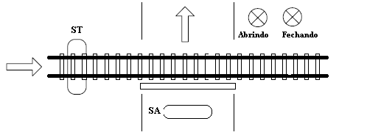

Figure 1: Level crossing system

The system has two sensors attached to the gate, one that indicates that the gate is open and another that indicates that the gate is closed. The car and the train only travel in one direction, as indicated by the arrows in figure 1. The system should work like this:

1. Starts with gate closed, lamps off
2. When a car activates the car presence sensor (SA), the gate should open, triggering the light to open.
3. When the gate closed (SCA) sensor activates, it turns off the engine by opening the gate.
4. Count 20 seconds for the car to pass.
5. Activates the engine, closes the gate until the gate closed sensor (SCF) activates.
6. If the train sensor indicates its arrival, an interruption must occur and keep the gate closed. If a car is passing, 20 seconds must be counted and then the gate closed. Also activate a siren when the train sensor is activated.