Big Data Essentials Course Project
Real-Time Sales Forecasting for a Multi-Store Retail Chain
Integrating HDFS, Kafka, PySpark, MLlib, MySQL, and Django
Case Study: Sales Forecasting
Prepared for: Big Data Essentials Course Project (Dr. Kundan Kumar)
Environment: Windows 11
Date: September 2026

Table of Contents

1. Project Overview
This project implements an end-to-end Big Data pipeline for real-time sales forecasting, developed to satisfy the Big Data Essentials course project requirements. The system integrates distributed storage, real-time message streaming, distributed data processing, machine learning, relational storage, and web-based visualization into a single working pipeline, running entirely on a Windows 11 workstation.
The chosen case study is Sales Forecasting for a simulated multi-store, multi-region retail chain. The objective is to predict daily total revenue using historical transaction patterns, seasonal effects, and real-time incoming transaction data.

1.1 Objectives
- Stream simulated real-time retail transactions using Apache Kafka, sourced from a dataset stored in HDFS.
- Process the streaming data in real time using PySpark Structured Streaming, producing both raw record views and live aggregated totals.
- Engineer time-series features from historical transaction data and train a machine learning model using Spark MLlib to forecast daily revenue.
- Persist both batch predictions and live streaming aggregates into a MySQL relational database.
- Build a Django web dashboard to visualize historical predictions, model performance, and the live data stream.

1.2 Case Study Description
The dataset simulates five years (2022–2026) of retail transactions across 25 stores in 5 regions, covering 200 products across 8 categories. Each transaction record includes the date, store, region, product, category, units sold, unit price, promotion flag, discount percentage, and resulting sales amount. Realistic patterns are embedded in the data generation process, including weekday/weekend demand variation, a November–December holiday sales spike, and promotional discount effects.

2. System Architecture
The system is composed of two parallel data paths that converge at the dashboard layer: a batch training path (historical data → trained model → stored predictions) and a real-time streaming path (live transactions → streaming aggregation → live dashboard updates). Figure 1 illustrates the full architecture.
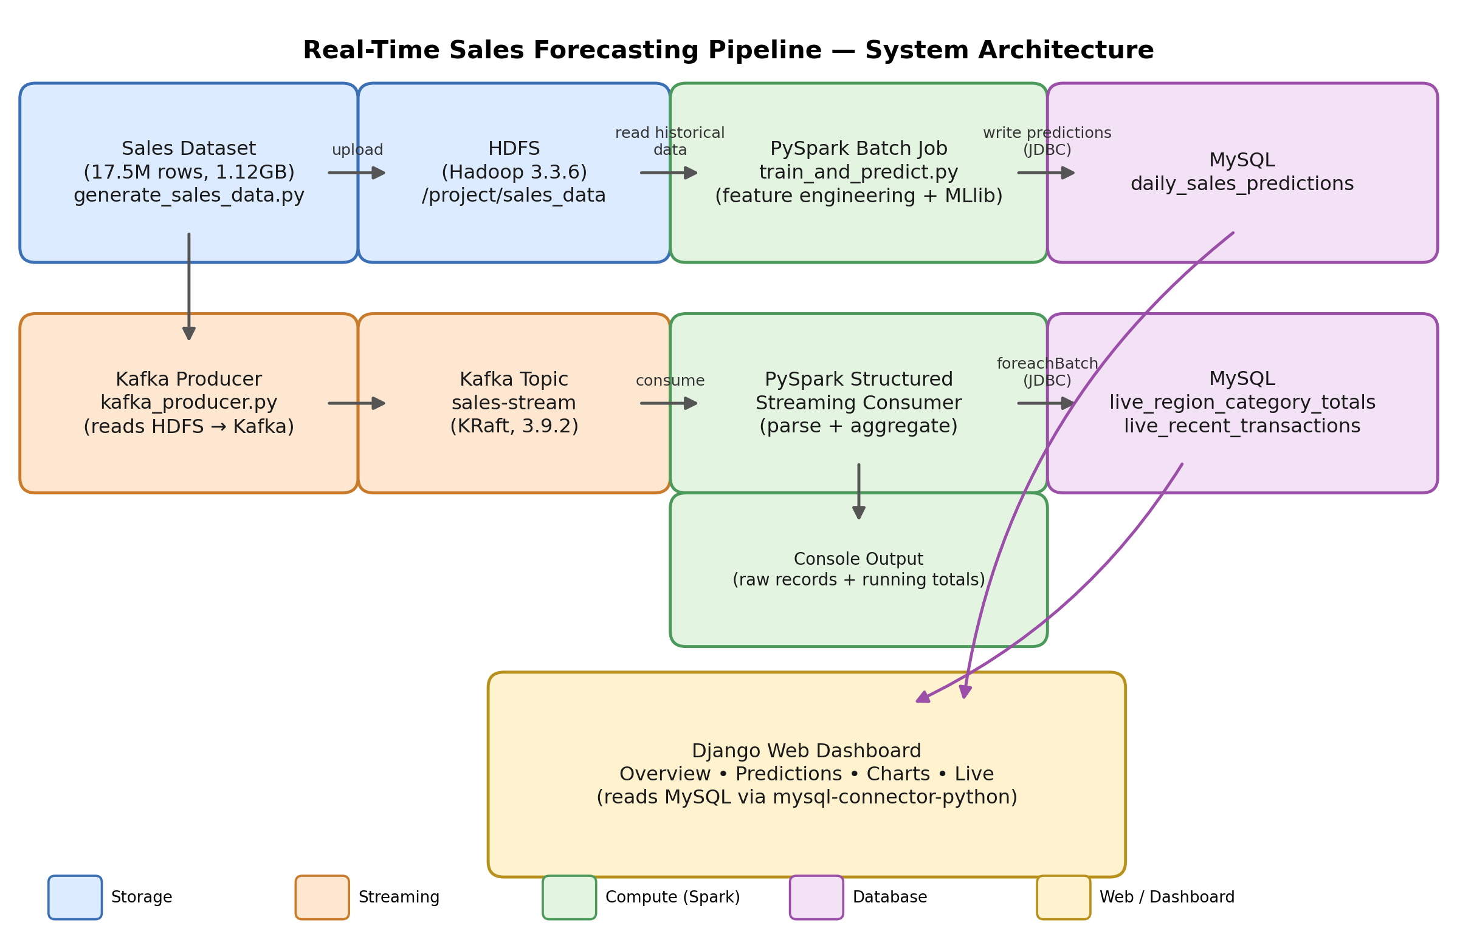
Figure 1: End-to-end system architecture

2.1 Batch Training Path
The full transaction dataset (17.5 million records, 1.12 GB) is generated locally and uploaded to HDFS. A PySpark batch job reads this dataset from HDFS, aggregates it to daily granularity, engineers time-series features, trains a Random Forest Regressor via Spark MLlib, evaluates it on a held-out time window, and writes the resulting predictions to a MySQL table via JDBC.

2.2 Real-Time Streaming Path
A Kafka producer reads the same dataset from HDFS and publishes transaction records one at a time into a Kafka topic, simulating a live point-of-sale feed at a configurable rate. A PySpark Structured Streaming job subscribes to this topic, parses each JSON message, and maintains two continuously updated views: a raw record feed and a running total of revenue and units sold grouped by region and category. Both views are printed to the console and written to MySQL via a foreachBatch sink, making the live data available to the web dashboard.

2.3 Presentation Layer
A Django application serves four pages, all reading exclusively from MySQL: an Overview page with summary KPIs and model accuracy metrics; a paginated Predictions table; a Charts page with four visualizations of model performance; and a Live page that polls a JSON endpoint every 2.5 seconds to reflect the real-time streaming data, including a live/idle status indicator and flash notifications when new data arrives.

3. Technologies Used
The following table lists every core technology used in the project along with the exact version installed and verified during development.
Technology | Version | Role
Java (Eclipse Temurin) | 11.0.32.101 | JVM runtime for Hadoop, Kafka, and Spark
Hadoop (HDFS) | 3.3.6 | Distributed storage for the source dataset
Apache Kafka | 3.9.2 (KRaft mode) | Real-time message streaming
Apache Spark | 3.5.9 (cluster) / PySpark 3.5.1 | Distributed batch and stream processing, MLlib
MySQL Server | 8.0 (custom port 3307) | Relational storage for predictions and live data
MySQL Connector/J | 26.7.0 | JDBC driver used by Spark to write to MySQL
Django | 6.1 | Web dashboard framework
Python | 3.14.7 | Primary scripting language
Chart.js | 4.4.1 (via CDN) | Client-side charting in the dashboard

4. Dependencies

4.1 Python Packages (installed in the project virtual environment)
Package | Version
pyspark | 3.5.1
py4j | 0.10.9.7
kafka-python | 3.0.11
django | 6.1
mysql-connector-python | 26.7.0
pandas | 3.0.5
numpy | 2.5.2
scikit-learn | 1.9.0
scipy | 1.18.1
matplotlib | 3.11.1
setuptools | latest (distutils compatibility shim for Python 3.12+)

4.2 Java Libraries / JAR Dependencies
- winutils.exe and hadoop.dll (Hadoop 3.3.6 Windows native binaries, from the community cdarlint/winutils repository)
- mysql-connector-j-26.7.0.jar — added to Spark's classpath for JDBC writes to MySQL
- spark-sql-kafka-0-10_2.12:3.5.1 and its transitive dependencies (kafka-clients, spark-token-provider-kafka-0-10, hadoop-client-runtime, etc.) — resolved automatically via Maven through spark.jars.packages

4.3 Scala Version
Spark 3.5.9 (standard build) and the Kafka connector artifacts used Scala 2.12.

5. Step-by-Step Workflow

Step 1: Data Collection and Setup
A Python script (generate_sales_data.py) generated a synthetic retail transaction dataset of 17.5 million rows (1.12 GB), covering 25 stores, 5 regions, 200 products, and 8 categories across five years, with built-in weekday, seasonal, and promotional effects. The dataset was uploaded to HDFS at /project/sales_data/sales_data.csv.

Step 2: Real-Time Data Streaming with Kafka
A Kafka producer script (kafka_producer.py) read the dataset from HDFS using PySpark and published each row as a JSON message to a Kafka topic (sales-stream) at a configurable rate, simulating live point-of-sale transactions.

Step 3: Data Processing with PySpark
A PySpark Structured Streaming consumer (spark_streaming_consumer.py) subscribed to the Kafka topic, parsed incoming JSON messages against a defined schema, and computed two live views: raw incoming records and running totals of revenue and units sold grouped by region and category.

Step 4: Prediction Modeling with MLlib
A separate batch script (train_and_predict.py) read the full historical dataset from HDFS, aggregated it to daily revenue totals, engineered ten features (day of week, month, weekend flag, holiday-season flag, promotion rate, average discount, transaction count, units sold, previous-day revenue, and a 7-day rolling average revenue), and trained a Random Forest Regressor using a time-based 1,645/180-day train/test split.

Step 5: Store Data and Predictions in MySQL
Model predictions on the held-out test period were written to a MySQL table (daily_sales_predictions) via Spark's JDBC writer. The streaming consumer separately wrote live aggregates (live_region_category_totals) and a rolling transaction feed (live_recent_transactions) to MySQL using a foreachBatch sink.

Step 6: Build a Django Web Dashboard
A Django application was built with four pages — Overview, Predictions, Charts, and Live — all reading from the MySQL database using the mysql-connector-python Django backend. The Live page polls a JSON API endpoint every 2.5 seconds to reflect new streaming data without a page reload.

Step 7: Testing and Deployment
Each pipeline component was verified independently (HDFS file listing, Kafka topic creation and message delivery, Spark shell startup, MySQL connectivity) before being connected end to end. The full pipeline was run together and verified via a live demonstration: starting HDFS, Kafka, and MySQL, running the streaming consumer and producer concurrently, and confirming that the Django dashboard reflected new data within seconds.

6. Findings

6.1 Model Performance
The Random Forest Regressor (100 trees, maximum depth 8) was evaluated on a held-out set of the most recent 180 days of daily revenue, following a time-based (not random) train/test split appropriate for forecasting tasks.
Metric | Value | Interpretation
RMSE | 233,398.14 | Average magnitude of prediction error, in revenue currency units
MAE | 177,179.90 | Average absolute prediction error
R² | 0.9969 | The model explains 99.69% of the variance in daily revenue

6.2 Feature Importance
The trained model's feature importances reveal which factors most strongly drive daily revenue predictions:
Feature | Importance
daily_units_sold | 0.5067
month_num | 0.1168
is_weekend | 0.1168
is_holiday_season | 0.1044
day_of_week_num | 0.0803
prev_day_revenue | 0.0488
rolling_7day_avg_revenue | 0.0224
transaction_count | 0.0022
avg_discount_pct | 0.0010
promo_rate | 0.0008

6.3 Discussion
- Units sold is by far the dominant predictor (50.7% importance), which is expected since revenue is mechanically driven by volume — this confirms the model has correctly learned the core relationship in the data.
- Calendar-based seasonality (month, weekend, and holiday-season flags) collectively account for roughly a third of the model's predictive power, validating the deliberate weekday and holiday-season effects built into the synthetic dataset.
- The lag-based features (previous-day revenue and the 7-day rolling average) contribute modestly but meaningfully, indicating short-term revenue momentum carries some forecasting value beyond same-day attributes alone.
- Promotion-related fields (promo_rate, avg_discount_pct) show minimal standalone importance, likely because their effect is already captured indirectly through daily_units_sold, since promotions in the dataset primarily act by boosting the units-sold figure.
- The very high R² (0.9969) reflects both a genuinely learnable underlying pattern and the fact that the daily aggregation smooths out much of the transaction-level noise present in the raw 17.5-million-row dataset.

6.4 Scale Summary
Item | Value
Raw transaction records | 17,500,000 rows
Raw dataset size in HDFS | 1.12 GB
Aggregated daily records | 1,825 days (2022–2026)
Training set | 1,645 days
Test set (held out) | 180 days (most recent)
Kafka topic partitions | 1 (single-node development setup)

7. Conclusion
This project successfully demonstrates a complete, working Big Data pipeline that spans distributed storage, real-time streaming, distributed processing, machine learning, relational persistence, and web-based visualization. Every component — HDFS, Kafka, PySpark (both batch and Structured Streaming), Spark MLlib, MySQL, and Django — was integrated and verified end to end on a Windows development environment, including a live-updating dashboard that reflects the real-time streaming pipeline within seconds. The trained Random Forest model achieved strong predictive accuracy (R² = 0.9969) on held-out data, and its feature importances offer genuine, interpretable insight into the drivers of daily retail revenue.

8. Appendix: Project Files
File | Purpose
generate_sales_data.py | Synthetic dataset generator
kafka_producer.py | Reads HDFS data and streams it into Kafka
spark_streaming_consumer.py | PySpark Structured Streaming consumer; writes live data to MySQL
train_and_predict.py | Batch feature engineering, MLlib model training, and prediction storage
sales_dashboard/ (Django project) | Web dashboard: Overview, Predictions, Charts, Live pages

