Association Rule Learning on the Groceries Dataset
Unsupervised Learning Methods — Assignment Report
Software used: R (arules, arulesViz packages)
Date: September 13, 2026

Question 1: Understand the Data
a. Number of transactions: 9,835 shopping baskets.
b. Number of distinct items: 169 unique grocery products.
c. The 10 most frequently purchased items, with their raw counts and support (proportion of transactions containing the item):
Item | Count | Support
whole milk | 2513 | 0.2555
other vegetables | 1903 | 0.1935
rolls/buns | 1809 | 0.1839
soda | 1715 | 0.1744
yogurt | 1372 | 0.1395
bottled water | 1087 | 0.1105
root vegetables | 1072 | 0.1090
tropical fruit | 1032 | 0.1049
shopping bags | 969 | 0.0985
sausage | 924 | 0.0940

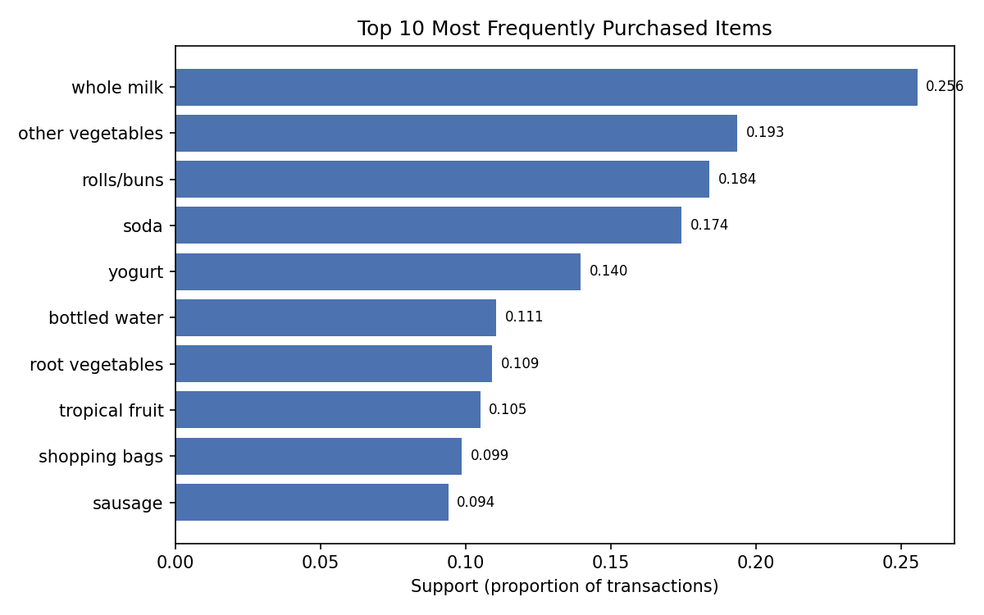
Whole milk, other vegetables, and rolls/buns are the clear leaders, appearing in roughly 18-26% of all transactions — consistent with these being everyday staple items.

Question 2: Frequent Itemsets
Using a minimum support threshold of 1% (support = 0.01) and a minimum itemset length of 2, the apriori algorithm found 213 frequent 2-item itemsets and 32 frequent 3-item itemsets. The 10 (of many) itemsets with two or more products and the highest support are:
Itemset | Support
{other vegetables, whole milk} | 0.0748
{rolls/buns, whole milk} | 0.0566
{yogurt, whole milk} | 0.0560
{root vegetables, whole milk} | 0.0489
{other vegetables, root vegetables} | 0.0474
{yogurt, other vegetables} | 0.0434
{rolls/buns, other vegetables} | 0.0426
{tropical fruit, whole milk} | 0.0423
{soda, whole milk} | 0.0401
{rolls/buns, soda} | 0.0383

c. Highest-support itemset: {other vegetables, whole milk}, with support = 0.0748 (7.48% of all transactions contain both items).
d. What the support value tells us: support measures how common a combination of products is across the entire set of transactions. A support of 0.0748 for {other vegetables, whole milk} means that nearly 1 in 13 shopping trips include both items together — these are two of the most habitually co-purchased staples in the store. Itemsets with very low support (e.g., under 1%) represent combinations that are rare and generally not worth building marketing or shelf-placement decisions around, while high-support itemsets point to strong, everyday purchasing patterns worth acting on.

Question 3: Association Rules
Using minimum support = 0.01 and minimum confidence = 0.3 (with minlen = 2), the apriori algorithm generated 125 association rules. The top 10 rules, ranked by lift, are:
Antecedent | Consequent | Support | Confidence | Lift
{citrus fruit, other vegetables} | {root vegetables} | 0.0104 | 0.3592 | 3.2950
{other vegetables, tropical fruit} | {root vegetables} | 0.0123 | 0.3428 | 3.1448
{beef} | {root vegetables} | 0.0174 | 0.3314 | 3.0404
{citrus fruit, root vegetables} | {other vegetables} | 0.0104 | 0.5862 | 3.0296
{root vegetables, tropical fruit} | {other vegetables} | 0.0123 | 0.5845 | 3.0210
{other vegetables, whole milk} | {root vegetables} | 0.0232 | 0.3098 | 2.8421
{curd, whole milk} | {yogurt} | 0.0101 | 0.3852 | 2.7614
{rolls/buns, root vegetables} | {other vegetables} | 0.0122 | 0.5021 | 2.5949
{root vegetables, yogurt} | {other vegetables} | 0.0129 | 0.5000 | 2.5841
{tropical fruit, whole milk} | {yogurt} | 0.0151 | 0.3582 | 2.5675

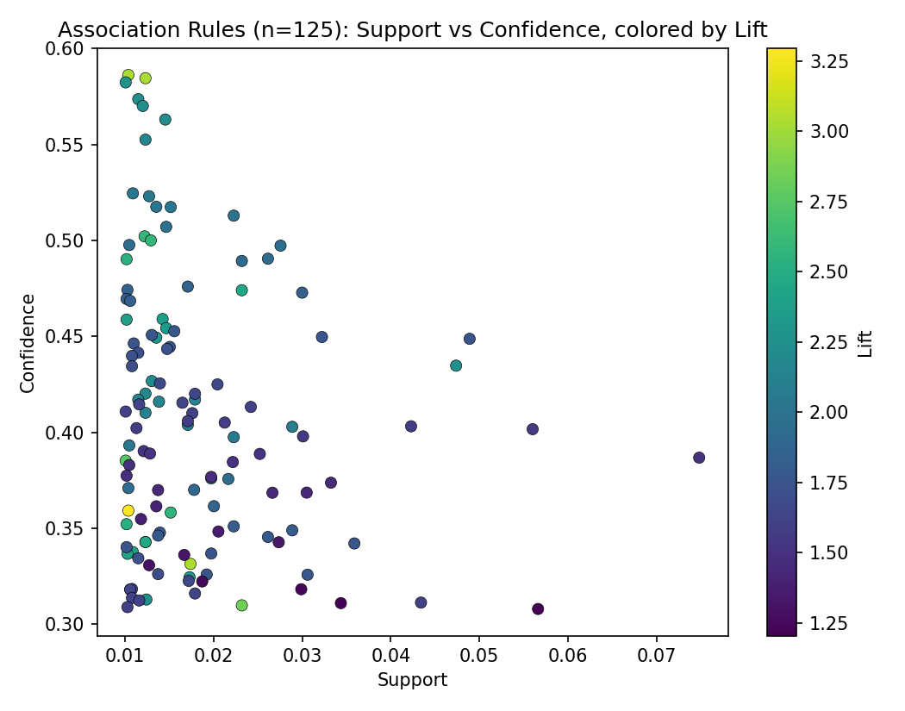
The scatter plot shows all 125 rules by support and confidence, shaded by lift — the rules in the upper-left with the darkest shading are the strongest, most interesting rules (high confidence and high lift, though comparatively rarer / lower support).

Question 4: Understanding the Measures
Three example rules are used to illustrate the three measures:
- Rule 1: {citrus fruit, root vegetables} → {other vegetables} (support = 0.0104, confidence = 0.5862, lift = 3.0296)
- Rule 2: {root vegetables, tropical fruit} → {other vegetables} (support = 0.0123, confidence = 0.5845, lift = 3.0210)
- Rule 3: {other vegetables} → {whole milk} (support = 0.0748, confidence = 0.3868, lift = 1.5136)
a. Support — the proportion of all transactions that contain every item in the rule. For Rule 1, support = 0.0104 means citrus fruit, root vegetables, and other vegetables all appear together in 1.04% of the 9,835 transactions.
b. Confidence — of the transactions that contain the antecedent, the proportion that also contain the consequent. For Rule 2, confidence = 0.5845 means that when a customer buys root vegetables and tropical fruit, they also buy other vegetables 58.45% of the time.
c. Lift — how much more likely the consequent is to be purchased given the antecedent, compared to its baseline purchase rate. For Rule 3, lift = 1.5136 means customers who buy other vegetables are about 51% more likely to also buy whole milk than a random customer — a lift above 1 indicates a positive association, not just coincidence.

Question 5: Find Interesting Rules
a. Highest confidence: {citrus fruit, root vegetables} → {other vegetables}, confidence = 0.5862 (58.62%).
b. Highest lift: {citrus fruit, other vegetables} → {root vegetables}, lift = 3.2950.
c. Highest support: {other vegetables} → {whole milk}, support = 0.0748 (7.48%).
d. These are three different rules. This happens because the three measures capture different things: support favors rules built from very common individual items (whole milk and other vegetables are simply purchased often, so any rule connecting them has high support), while confidence and lift favor rules involving less common but tightly associated items (like citrus fruit and root vegetables), which occur together far more often than chance would predict but not in a large absolute number of transactions. A rule can be common but only weakly associated (high support, low lift), or rare but very strongly associated (low support, high lift/confidence) — this is exactly what we see here.

Question 6: Interpret a Rule
Selected rule: {root vegetables, tropical fruit} → {other vegetables} (support = 0.0123, confidence = 0.5845, lift = 3.0210)
In simple language: customers who purchase root vegetables and tropical fruit together also tend to purchase other vegetables — this combination shows up in 1.23% of all shopping trips, and when a customer buys root vegetables and tropical fruit, 58.45% of the time they also pick up other vegetables.
This is a strong association. The confidence of 58.45% is well above the overall purchase rate of other vegetables (19.35%), and the lift of 3.02 means the combination is more than three times more likely to include other vegetables than would be expected by chance. Together, high confidence and a lift well above 1 indicate a genuine, non-coincidental purchasing pattern rather than a weak or spurious link.

Question 7: Business Application
a. Two products to place close together: root vegetables and other vegetables. They co-occur very frequently (support = 0.0474) and have a strong association (lift = 2.25), so positioning them in adjacent produce sections would match natural shopping behavior and likely encourage additional add-on purchases.
b. A possible product bundle: a "fresh basics" bundle of root vegetables + tropical fruit + other vegetables, since customers who buy the first two very reliably (58.45% of the time) also want the third — a discounted bundle would reward behavior that is already happening naturally and could nudge the remaining ~42% to add it too.
c. Example recommendation use: an online grocery site or self-checkout kiosk could use the rule {other vegetables, whole milk} → root vegetables (or similar high-lift rules) to power a "customers who bought this also bought…" recommendation panel, automatically suggesting root vegetables to any shopper who has other vegetables and whole milk in their cart, increasing basket size.

Question 8: Understanding Association
a. No — an association rule does not prove causation. It only shows that two (or more) items tend to be purchased in the same transaction more often than would be expected by chance. There could be a common underlying cause (e.g., both items are ingredients in a popular recipe, or both are on promotion the same week) rather than one purchase causing the other. Establishing causation would require controlled experiments (e.g., A/B testing shelf placement), not just observational transaction data.
b. A rule can have high confidence but low lift when the consequent item is already very popular on its own. For example, a rule ending in {whole milk} can easily have high confidence simply because most shoppers buy whole milk regardless of what else is in their cart — the antecedent isn't really driving the purchase, it's just riding along with an item everyone buys anyway. Lift corrects for this by comparing confidence to the consequent's baseline popularity.
c. A lift value greater than 1 indicates a positive association: the two items are purchased together more often than would be expected if they were purchased independently. The higher above 1 the lift is, the stronger the association. A lift of exactly 1 means no association (statistical independence), and a lift below 1 means the items are negatively associated — buying one makes the other less likely.

Methodology Note
Analysis was performed in R using the arules package's apriori() function on the Groceries transaction data (9,835 transactions, 169 items), with minimum support = 0.01 and minimum confidence = 0.3 for rule generation (minlen = 2 to exclude single-item rules). The full R script and the complete exported rule table are included with this submission.

