The Site
The Hypogeum
The Basilica
The Medieval Chapel
The Mosque
Excavations and Survey 1997
Building the Alacami
Syria/Cilicia Comparison
Image Split Page
The Mosaics
Tabula Ansata
Mosaics in situ
1960’s excavation
Experience the Alacami
Acknowledgements
Bibliography

The Site
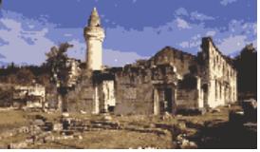
The Alacami is the last surviving free-standing monument of antique Flaviopolis/Flavias, now the modern town of Kadirli on the fringes of the Cilician Plain. Its remains display over a millennium and a half of local history in several transitional building phases. A barrel-vaulted hypogeum [link] was cut into a hillside overlooking the city in the Roman period, in a district which retained its function as a cemetery until recently. In the late 5th/early 6th century the site was artificially terraced for the construction of a large church [link], built in at least two stages from a variety of reused architectural elements and incorporating the hypogeum as a crypt. This was modified in the medieval period with the addition of a small chapel to the apse [Link] and the building finally converted into a mosque in the late 15th century [Link].

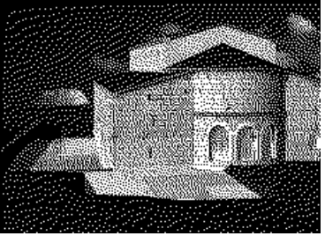
Professor Dr. Halet Çambel has taken an active role in the affairs of the Alacami since her work began at nearby Karatepe in the 1940s. In 1960 her team cleared the interior and conducted excavations in and around the basilica. She urged for the removal of temporary housing, which had begun to clutter the site and also for the re-routing of the adjacent road. In 1961 she organised the construction of a compound wall, which served as a gathering point for architectural and epigraphical fragments from all over the town. The Alacami was registered as an historic monument in 1977. Nevertheless there has been great controversy in recent years over plans to renovate and reopen the building as a mosque. Perhaps the most significant outcome of the renewed archaeological interest at the site is that its public profile has been significantly raised and people's interest aroused. Within this scenario we have discovered the value and efficacy of computer reconstruction, visualisations and interactive demonstrations in communicating the importance of cultural heritage to non-archaeologists.

The Hypogeum
From the opening in the west wall a set of steps lead down into the burial chamber. Low benches flank the north and south walls and four earthenware pipes open into the centre of the vaulted roof, above a deep basin in the plaster floor between the benches. The pipes would seem to have been incorporated to allow ritual libation from above ground, provisions for which were very common in Roman funerary practice. At the east end of the chamber a separate basin is formed by the construction of a low partitioning wall between the flanking benches.

{PICTURE OF INTERIOR}

The Basilica
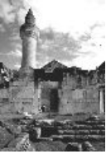

The site of the tomb formed the focus for the second discernible phase of activity on the site, the construction of a three-aisled basilica, with galleries, a clerestory and a slightly projecting apse [link to plan]. To the west end a narthex, porch and staircase were added at a slightly later date. Access to the hypogeum after the construction of the church was afforded by means of a passageway leading from the west steps.

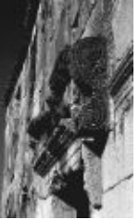

The exterior walls of the basilica are decorated with a base-moulding, a hood-moulding and a cornice, in a style typical for the Antioch region.

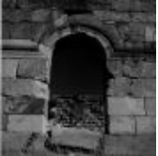
The west porch extended along the north side of the basilica and to the south lay a large irregular courtyard, the main entrance for which was from the west, adjacent to the staircase. Everywhere excavation has been made on this site mosaics have been found, both inside and outside the building {LINK}.

The Medieval Chapel
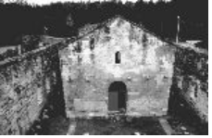
The medieval archaeology of the Alacami bears at least some reflection to the historical developments of devastation and revival, experienced in eastern Cilicia between the 7th and 13th centuries. Between the 12th and the mid 13th centuries, after the collapse or removal of the clerestory and aisle divides of the basilica nave, a very fine single-naved chapel was built which reused the surviving apse of the earlier basilica. The organisation of the site was entirely transformed, as the great basilica walls subsequently formed a compound for the chapel.

The Mosque
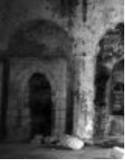
In 1489 Alâüddevle Bozkurt Bey commissioned the conversion of the medieval chapel and its ancient courtyard into a mosque, which took the name Alâüddevle Mescidi. The new owners reused stone from the basilica to construct a small minaret on top of the remains of the west wall of the narthex and a mihrab in the south wall of the chapel. From 1865 it functioned also a medresse and took the name Alacami. The year 1924 saw the construction of a new mosque in the town and the abandonment of the Alacami. So when Halet Çambel first visited the site in the 1940s she found it in opportunistic reuse as a stable!

Excavations and Survey 1997
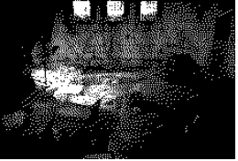
In 1993 I discovered an unpublished plan of the Alacami in the archive of Michael and Mary Gough, now under the charge of Dr Stephen Hill at Warwick University {e-mail}. Mary Gough had produced a more thorough survey of the standing remains when working with Professor Çambel in 1949 and this was finally published by Stephen Hill in 1996. In November 1997, we set out to complete the survey of this complex site and to produce a detailed and contextual plan, supplemented by limited excavation in key areas.

Since the abandonment of the mosque in 1924 a significant proportion of the paving in the chapel has been ripped up in several campaigns by treasure-hunters and on one occasion a building contractor. These trenches were re-excavated in 1997, to assess the archaeology which had survived the intrusions and to make some sense out of what remained. Fortunately some substantial early Byzantine features remained relatively unharmed. These comprised a deep north-south foundation along the chord of the apse, associated with the initial coursing for the basilica construction and with a platform extending some 3.5 metres to the west, apparently the remains of the original chancel. We also re-opened an earlier trench to the west of the church, to examine and survey the west staircase and opening to the crypt passageway.

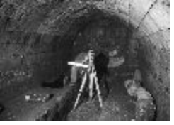

{Reduce these real small - to link page and then larger page}
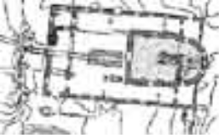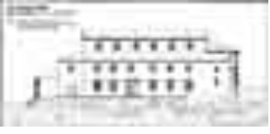

Building the Alacami

The three dimensional modelling strategy has two principal stages. This page features the results of stage 1; to produce a detailed reconstruction of the first phase basilica. The data sources were as follows:

photogrammetric recording of exterior walls (completed in 1996 by Halet Çambel) (LINK)
a structural and topographical Total Station Survey of the site (completed in 1997). (LINK)
excavations of the west steps, subterranean chamber and the chancel area (completed in 1997).
1:1000 digitised map data of the local environment. (LINK)
on-site photography for textures and bump surfaces. (LINK-add textures from K:\alacami textures)
1960s paintings of the excavated mosaics. (LINK)
comparative research into the contemporary regional architecture. (LINK)

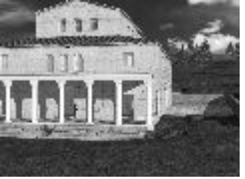
The fine preservation and clear structural definition of the Alacami phases made a reconstruction of the site an achievable goal. Furthermore, the distinctive form and external decoration of the basilica, which is characteristic of an Eastern Cilician building tradition prevalent in the late 5th and 6th centuries, allowed the reconstructed elements to be informed through well-established and local comparisons in Cilicia and northern Syria. {Link to page with comparative images}
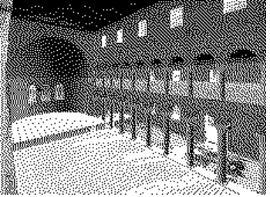
The simulated removal of the later phases, together with the insertion of the colonnades and clerestory dramatically transforms the "feel" of the building in the modelled space. The basilica suddenly has a heightened sense of verticality and the vistas have a clarity which was hard to envisage on the site because the later modifications had imposed such great shifts of visual focus and emphasis.

The task of producing the model stimulated questioning of several archaeological and architectural. How were the galleries accessed? (Link) What was the composition of the overall roofing system? (Link to animated GIF) How did the terracing of the site relate to the internal architectural composition? (Section) Hence the modelling generated questions that it was later possible to investigate on site.

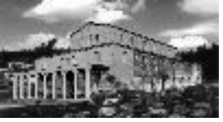
{LINK TO IMAGE SPLIT PAGE}
It was important however not to present the model as a "true" image of the original basilica. A virtual/real-world composition is one way of demonstrating this graphically. To further emphasise the reconstructed elements the photogrammetric elevations {LINK} were mapped onto the modelled walls.

In stage 2 the Alacami model will employed as the template for ongoing research into virtual worlds, being carried out by Glyn Goodrick at the University of Newcastle upon Tyne. The long term research aim is to produce a dynamic, inhabited and interactive architectural entity where many of the environmental variables can be defined by the observer as an avatar within the space. (Link to VTV)

In its initial stages the Alacami project is not seeking to develop new approaches to the computer aided reconstruction of ancient buildings. There is nothing new about either the modelling strategy, the type of data sources, or the final product. Yet this is an example of well established techniques employed as a tool for the display and interpretation of field results and research conclusions from an ongoing project.

We are also employing these techniques to explore the results of terrestrial and GPS survey on the Anastasian Long Walls in Thrace, a project under the direction of James Crow (University of Newcastle upon Tyne) and Alessandra Ricci (Bilkent University, Ankara). [Link to page with images].

{Link -reconstruction history}

Syria/Cilicia Comparison
In terms of construction and external decoration this group is demonstrably akin to the remarkable Syrian archetypes of the late fifth century, typified by the churches at Qal‘at Sim'ān and Qalblauze. Given the probable mid 5th/ early 6th century date for the mosaics (including the tabula ansata) and the stylistic comparison with dated churches in the region, I would support the date range proposed by Hild and Hellenkemper of the late 5th/ early 6th century for the construction of this church.
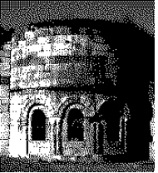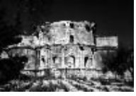

Image Split Page
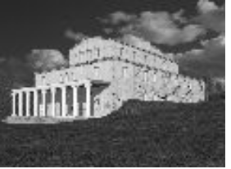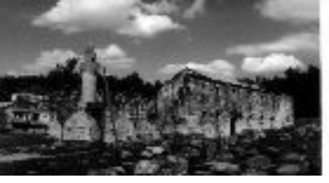

The Mosaics
The basilica was richly adorned with mosaics, both inside and out, some of which remain well preserved. Many were exposed and recorded by Professor Çambel in 1960 {Link to 1960’s excavation} and their continued preservation will be the concern of a future project. The mosaics in the courtyard, to the east of the apse and in the narthex all bear geometric designs, while Professor Çambel observed that the scant remains of the nave pavement indicated the presence of opus sectile and opus alexandrinum. Only fragments remain of the mosaic in the north aisle, yet the well preserved south aisle and side chamber mosaics are beautifully executed and feature faunal scenes.

Tabula Ansata
A monastic connection is alluded to in the tabula ansata, which describes one of the founders of the church Polychronius, as presbyter and abbot.

1960’s excavation
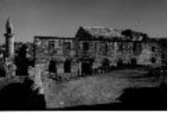Halet Çambel’s excavations at the Alacami in 1960 (Photo courtesy of Halet Çambel).

Mosaics in situ

IMG - PLAN of mosaics as image map [with individual links]

A) Inside the tripartite narthex

B) The south side-chamber mosaic, with the apse on the left.

C) South aisle mosaic showing tabula ansata

The significance of a mosaic is traditionally judged on its art historical or aesthetic qualities and the importance of context often becomes marginalised. Displaying the mosaics within the modelled architectural space underlines the importance of positioning and spatial significance in the decoration of interior space. This is particularly the case for a church where different architectural zones are charged with meaning by the liturgy and processional movement that takes place within them.

Experience the Alacami

With the increasing trend towards spatial theory over “connoisseurship” in discussing the ancient built environment, the two dimensional, black & white site plan is proving inadequate as the interpretative medium. The body-centric experience of architectural space requires the mental reconstruction of buildings, landscapes and vistas, much of which it is now possible to model and adapt to a variety of environmental scenarios. This frees the archaeologist's mind to explore the relationship of the human experience to the articulated space with more clarity.

Acknowledgements

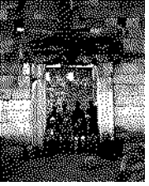

Harun Kâya (Bilkent University) skilfully oversaw much of the on-site organisation and I am deeply indebted to his contribution. Ayşe Salman (İstanbul University) was responsible for some gruelling subterranean elevation drawings and was cheerfully assisted by Çiğdem Girgin )İstanbul Archaeology Museum) who joined us on behalf of the Turkish Ministry of Culture. Our local workforce comprised Cumali Zaralı, Ahmet Gamalak and Ali Güven. This work was undertaken as part of the Karatepe excavations. Our thanks goes especially to Professor Çambel and all our friends at Karatepe who so kindly accommodated us, fed us, and freely imparted their advice and assistance at every opportunity. We were generously supported in 1997 by the British Institute of Archaeology at Ankara and the University of Newcastle upon Tyne. I am indebted to the support I was receiving at the time from the British Academy in the form of a Doctoral Research Award.

The survey was carried out using a Sokkisha Set5 borrowed from the British Institute of Archaeology at Ankara. The data was processed using LSS (Land Survey System), produced by MACarthy Taylor Partnership who continue their generous support and enthusiasm for our work and our specific requirements. The Alacami was modelled in AutoCAD Release 10, with textures and renderings produced using Accurender 2.

For further Information:

Bayliss, R (1997) The Alacami in Kadirli: Transformations of a sacred monument. Anatolian
Studies XLVII: 57-87.

Çambel, H (1997) Alacami. Türkiyemiz 81, May 1997, 42-53 [magazine on Turkish culture
published by Akbank].

Contact r.a.bayliss@ncl.ac.uk {LINK}

Further Bibliography [LINK]
LINK to Bell archive

Artwork and printing by Arlene Rankin of Ravensworth Design, Newcastle upon Tyne.

Bibliography

Bayliss, R. “The Alacami in Kadirli: Transformations of a sacred monument.” Anatolian Studies XLVII (1997), 57-87.
Bell, G. L. “Notes on a journey through Lycaonia and Cilicia I”, RArch (1906) 4th series 7, 1-29 (p. 9-11)
Bent, J. Th. “Recent discoveries in eastern Cilicia”, JHS XI (1890), 231-235.
Bossert, H. Th., Alkım, U.B. Karatepe, Kadirli ve Dolayları İkınci Ön-rapor. İstanbul Üniversitesi Edebiyat Fakültesi (Eski Önasya Kültürlerini Araştırma Enstıtüsü Yayınları 3, 1947).
Çambel, H. “Karatepe-Aslantaş, Aslantaş Barajı Gölü Alanı ve 1982 Dönemi Çalışmaları”, KST V (1983), p. 159.
Çambel, H “Alacami” Tükiyemiz 81, May 1997, 42-53 [magazine on Turkish culture published by Akbank].
Davis, E. J. Life in Asiatic Turkey. A Journal of Travel in Cilicia Pedias and Trachaea, Isauria, and parts of Lycaonia and Cappadocia, London, 1879.
Edwards, R.W. “Two new Byzantine churches in Cilicia”, AnSt XXXII (1982), 23-33.
Heberdy, R., Wilhelm A. Reisen in Kilikien. Ausgeführt 1891 und 1892 im Auftrage der kaiserlichen Akademie der Wissenschaften. Wien, 1896 (Denkschriften der Kaiserlich Akademie der Wissenschaften, Phil.-Hist. Kl. 44).
Hellenkemper, H. “Early church architecture in southern Asia Minor”, in K. Painter (ed.), Churches Built in Ancient Times, 213-238, London, 1994.
Hild, F., Hellenkemper, H., Hellenkemper-Salies, G. “Kommagene - Kilikien - Isaurien”, Reallexikon zur byzantinischen Kunst 4 (1984) 182-356.
Hild, F., Hellenkemper, H.
Kilikien und Isaurien. Tabula Imperii Byzantini 5, Wien, 1990 (Denkschriften der Österreichische Akademie der Wissenschaften, Phil-Hist. Kl. 215).
Hill, G.F. A Catalogue of Greek Coins in Lycaonia, Isauria, and Cilicia, London, 1900.
Hill, S.J. The Early Byzantine Churches of Cilicia and Isauria. Birmingham Byzantine and Ottoman Monographs, Vol.1, Aldershot, 1996.
Mietke, G. “Survey der Römischfrühbyzantinischen siedlung bei Akören in Kilikien 1994”, AST XIII (1995), 35-48.

See Bayliss 1997, 86-7 and Hild & Hellenkemper 1990, 379, for additional sources on the Alacami.

