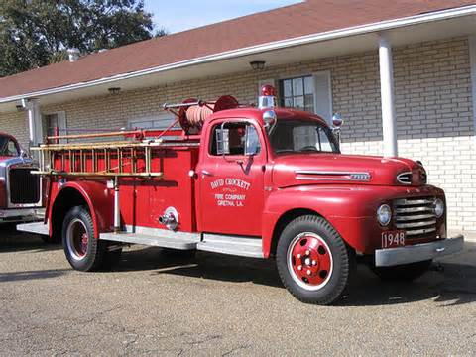CSULB Programming Team Practice

Sept 10, 2014 – Problem #1

Fire truck

Your city's fire department collaborates with the transportation department to maintain maps of the city which reflects the current status (on that day) of the city streets. On any given day, some streets are closed for repairs or construction. The fire engine navigator needs to be able to select routes, from the fire station to the fire, that do not use closed streets. You must write a program that the central dispatcher can use to generate routes from the fire station to a fire.

Street intersections are identified by positive integers not more than 20, with the fire station always at intersection 1.

**Input**

The input file contains several dataset. The first line of each dataset consists of a single integer which is the number of the street intersection closest to the fire. The following lines each consist of a pair of positive integers separated by a space and terminated by a new-line. They represent the adjacent street intersections of an open street. For example, if 4 7 appears on a line, then the street between intersections 4 and 7 is open and there are no other intersections between 4 and 7 on that section of street. The final line of each dataset consists of a pair of 0's.

**Output**

For each dataset, your output must consist of a line for each valid route from the fire station to the intersection closest to the fire, written with the intersections in the order in which they appear on the route. The intersections must appear separated by a space, terminated by a new-line. Include only routes which do not pass through any street intersection more than once. The lines of output must be in lexicographical order. Print a blank line between consecutive datasets.

**Sample Output**

1 2 3 4 6

1 2 3 5 6

1 2 4 3 5 6

1 2 4 6

1 3 2 4 6

1 3 4 6

1 3 5 6

**Sample Input**

6

1 2

1 3

3 4

3 5

4 6

5 6

2 3

2 4

0 0