COMP3331

**ASSIGNMENT**

**REPORT**

Richard Quisumbing

z5330506

1. **Program Design**
   1. **Client**

The client design is simplistic, purposefully done to delegate most of the command functionality to the server. Specifically, the client handles user input and parses the command and its associated arguments which forms the data of the client request. The request is then sent to the server via a TCP connection. Resulting responses from the server are displayed to the user in the client.

As for the UDP command which defines a peer-to-peer interaction utilising a UDP connection, the client implements a server thread (if they are the audience) called UDPServerThread which remains open throughout the user session. On the other hand, if the client is acting as the presenter in the peer-to-peer connection, a new client thread called UDPClientThread is created that sends the desired file to the audience client, which ends as soon as all the bytes of the file has been sent.

* 1. **Server**

The server is responsible for identifying the type of command inside incoming requests from clients inside its threading class ClientThread, capable of handling multiple clients simultaneously. It is also directly linked to the server data structure defined in the ServerData class in server_data.py. When requests are received, the server identifies the command, and handles the majority of the command functionality including user login. Each command is handled within its own function, usually with the naming scheme that looks like *handle_command_BCM()*. Inside these functions, error checks are first implemented, then interacting with the server data structure to ensure data is preserved, and finally sending the response back to the relevant client.

* 1. **Server Data Structure**

The server data is a class defined in server_data.py, which is instantiated as soon as the server is up and running, and is responsible for preserving the data sent by clients. Additionally, the data structure automatically loads the users inside credentials.txt, classifying them as registered users as soon as the ServerData class is instantiated. This means that if the server owner wants new users to be able to login, the server would need to be restarted with the new users added to the credentials.txt file.

* 1. **Validate.py**

Validate.py contains simple validation functions that verify certain aspects of command requests, such as verifying command argument syntax and certain error scenarios.

1. **Message Format**

Messages are mainly formatted as key-value pairs inside python dictionaries.

* 1. **Client Requests**

Type: Specifies the type of request being made (usually just ‘command’), which lets the server know how the request is going to be handled.

User: Specifies the username of the user that made the request to the server.

**Data**

The data for a command request has its own dictionary format:

The “command” key contains the input command supplied by the user, and the “command_args” contains a list of the command arguments that were supplied alongside the command.

* 1. **Server Response**

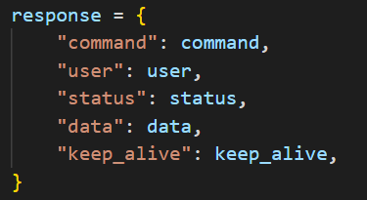

Command: The command for which the request was initially made for.

User: The username of the user that made the request.

Status: A Boolean value indicating whether the command was successfully executed.

Data: Contains the requested data.

Keep-alive: Contains a Boolean value of whether the connection should still be kept alive after the command has been executed.

1. **Program Description**
   1. **Version**

Python 3.10 which should work for Python 3.7 on CSE machines.

* 1. **Usage (On CSE machines)**

**Server**

python3 server.py <server-port> <number-of-consecutive-failed-attempts>

**Client**

python3 client.py <server-IP> <server-port> <client-udp-server-port>

* 1. **Pickling**

The programs server.py and client.py utilise python pickling to convert python objects into byte streams, necessary to transport data as bytes since the sockets only send byte streams.

* 1. **Authentication**

Authentication functionality is handled as soon as a connection is established between the server and the client. The server first requests the client to provide a username, and the client supplies it. This is done infinitely until the username is a valid one. Next, the server then waits for the password for the given username, keeping track of how many more permitted password attempts are available for that particular user. If it the client has exceeded the password attempts, then the user is locked out and cannot log in for another 10 seconds.

* 1. **Commands**

Each command between the client and the server is handled in the following format:

1. Client sends request.
2. Server identifies command request and calls the relevant function that handles the command.
3. Server then sends a response to the client, notifying the client of whether an error has occurred or the command was successfully handled by the server.
   1. **Peer-to-Peer UDP**

Each client can be run on separate directories, and files that the client wishes to send to another client must be inside the same directory as the client program. The client server thread is always running, indicated by the while loop.

**During a file transfer**

First, the client UDP thread sends a dictionary object to the server UDP thread running on the audience user client, which contains the filename being sent as well as the username of the user who is sending the file. Then, the client UDP thread sends all bytes of the file, as well as a final empty byte to the server UDP thread. The server UDP thread detects the final empty byte to signal that the file transfer is done, and as such will start a new loop for other incoming files.

1. **Potential Improvements**
   1. **UDP Command Display**

**Displaying UDP output to client**

The UDP command displays to the user the filename to the audience client after it has been successfully received whole. This causes an issue where the displayed message appears over the command input line.

*Note*: However, commands can still be inputted into the client program despite having text of the downloaded file appearing in the terminal.

Example:

Presenter client sending the file:

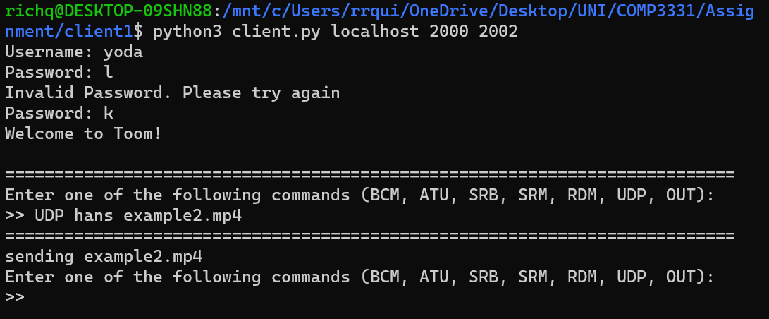

Audience client receiving the file:

**Potential Solution**

Stop client execution by checking whether the client is alive, and only resuming getting input commands from the user once the file has been fully sent and received. However, this would violate the condition that the commands can still be input by the user while the file is downloading, as specified in the specification.

* 1. **UDP Command Code Structure**

**In code**

Since UDP command is a peer-to-peer interaction, the client must also handle the UDP command as opposed to previous commands where the interaction simply involves sending a request and the client printing the data of the response. However, the UDP command breaks this structure in which the command calls the *handle_command_UDP* function inside the client program and sends its own message format, breaking the message format that was previously used.

**Solution**

Use the same message format to retrieve the user details of audience user from the server.

1. **Sample Interaction**
   1. **Login**

**Invalid username supplied**

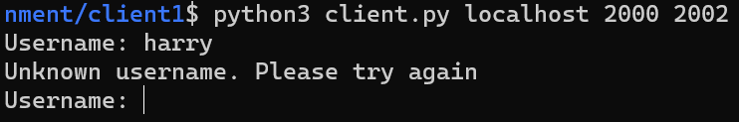

**Blocked user after exceeding the permitted number of failed attempts**

Server input



We have specified the number of allowed failed attempts as 2.

Client Output

Hans cannot login after 10 seconds even on another client.

**Successful Login**

* 1. **RDM Command**

**Creating separate rooms for the active users**

Active users are: yoda, hans vader

Vader creating a room

Vader cannot create the exact same room

Vader creating another room with him and yoda

Users creating messages in the rooms if they are a part of it

Hans creating a message in room 1

Vader displaying all the messages in the rooms that he is a part of

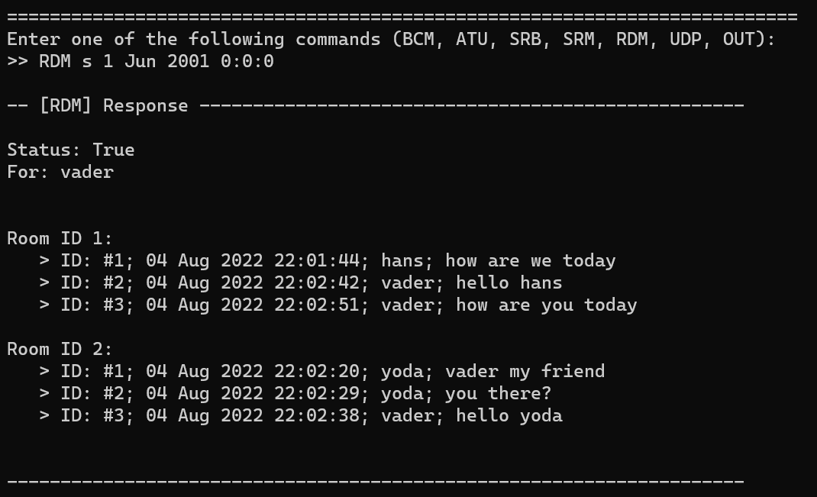

Only displaying messages after 4 Aug 2022 22:02:30

