MLB Pitcher Entry & Leverage Analysis
Technical Case Study: State Reconstruction and Temporal Sequencing

Overview
It’s one of the most critical situations in baseball; the first batter faced by a relief pitcher late in a close game.This analytical tool extracts the exact moment of a pitcher’s entry into a game from a raw pitch-by-pitch event log. By identifying the 'First Batter Faced' and calculating specific inherited game-state pressure, it delivers insights far beyond standard box scores.

Technical Core Competencies
- State Reconstruction: Dynamically calculates ScoreDiff using perspective-aware logic (CASE statements). Distinguishes between entering with a lead or deficit regardless of Home/Visiting team status.
- Temporal Sequencing: Utilizes Window Functions (ROW_NUMBER) to rank game events. Isolates the entry point by filtering for RecordSequence = 1, removing noise from the remainder of the outing.
- Relation Mapping: Employs Dual-Role Joins against the roster table to simultaneously resolve the identities of both the Subject (Pitcher) and the Opponent (Batter).
- Data Hygiene: Implements Common Table Expressions (CTEs) to de-duplicate player records on the fly, preventing row-inflation common in redundant sports databases.

Full Analytical SQL Query
WITH PitcherEvents AS (
SELECT hteamdate, inning, pitcher,
CASE WHEN half=0 THEN left(hteamdate,3) ELSE Visitors END AS PitcherTeam,
CASE WHEN half=0 THEN score_h-score_v ELSE score_v-score_h END AS ScoreDiff
),
UniqueRoster AS (
SELECT DISTINCT ID, Fname, Lname FROM tblRosters2025
),
FirstBatter AS (
SELECT
P.hteamdate, P.pitcher, R.Fname + ' ' + R.Lname AS pitchername, P.PitcherTeam,
CAST(P.inning AS VARCHAR(2)) + ' . ' + CAST(P.outs AS VARCHAR(1)) AS EntryInning,
P.batter, P.inning, P.outs, P.ScoreDiff, P.balls, P.strikes, P.BASERUNNERS,
P.result, P.outsonplay, P.hitvalue
FROM PitcherEvents P
JOIN UniqueRoster R ON P.pitcher = R.ID -- PITCHER join
WHERE P.RecordSequence = 1
)
SELECT
F.hteamdate, F.pitchername, F.PitcherTeam, F.EntryInning,
B.Fname + ' ' + B.Lname AS BatterName, -- BATTER join
F.ScoreDiff, F.balls, F.strikes, F.result, F.outsonplay,
F.BASERUNNERS, F.hitvalue
FROM FirstBatter F
JOIN UniqueRoster B ON F.batter = B.ID -- BATTER join
WHERE F.inning >= 8 AND F.ScoreDiff BETWEEN -3 AND 3
ORDER BY F.pitchername, SUBSTRING(F.hteamdate, 8, 4);

Key Analytical Insights
- Late-Inning High-Leverage: Isolates 'Save Situations' and high-pressure relief appearances by filtering for Inning 8+ and Score Differentials within 3 runs. This WHERE condition can be changed based on user input.
- Inherited Pressure: Captures the number of outs and baserunners to further indicate the pressure on the already on the board to pitcher entering the game.
- Entry Efficiency: Tracks the result of the first batter faced, either improving or worsening the game situation for the team.

Sample Outputs Showing Columns and Value
For ease of display, showing this as two images rather than one wide one.
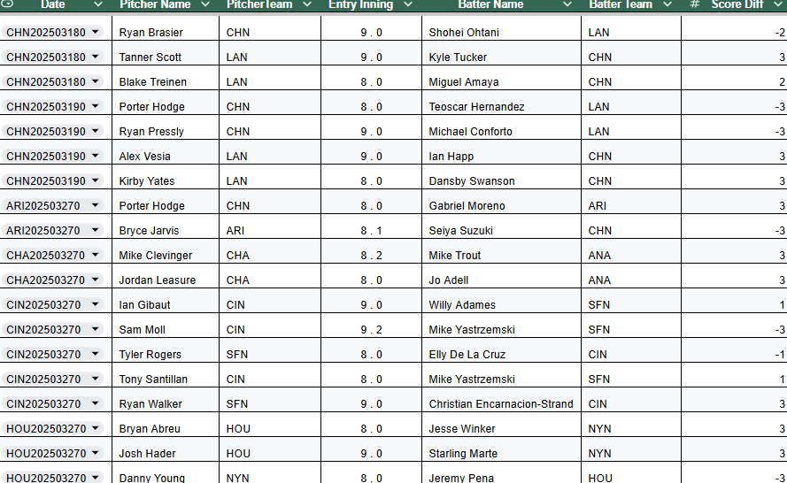
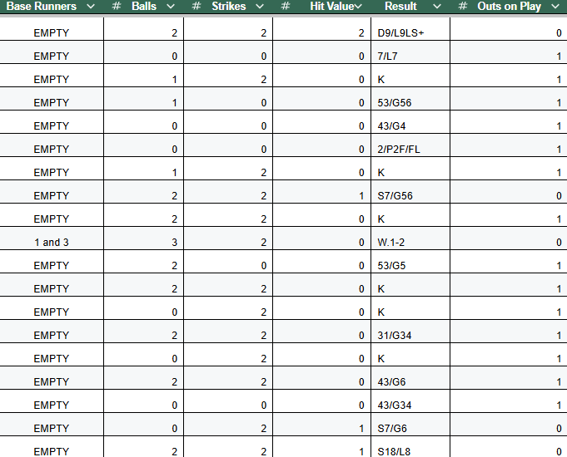

COLUMN | DATA
Date | Shows home team
Pitcher Name
PitcherTeam
Entry Inning | Shown as 'Inning.Outs'
Batter Name
Batter Team
Score Diff | Shows how close was the game
Base Runners | Numbers indicate bases - empty means no runners
Balls | Balls in count
Strikes | Strikes in count
Hit Value | 1 - single, 2- double, 3-triple, 4 -homerun
Result | The scoring for the play
Outs on Play | 0 outs means batter reached based

