**MODULE – 1 (FUNDAMENTALS)**

**1. What is SDLC?**

* **Software development life cycle (SDLC)** is a process used by the software industry to design, develop and test high quality software. The SDLC aims to produce a high-quality software that meets or exceeds customer expectation, reaches completion within times and cost estimation.

**2. Write SDLC phases with basic introduction**

* The graphical representation of SDLC is as shown below. It consists of six phases.

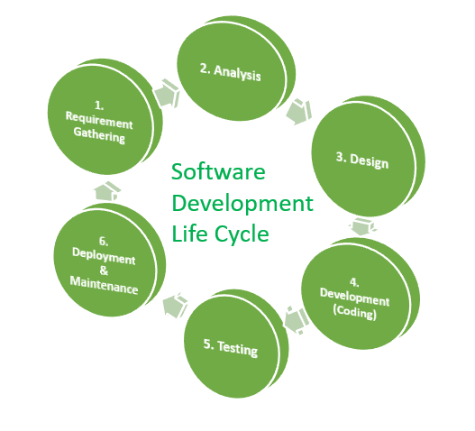

* **1. Requirement gathering phase:** This is a fundamental part of any software development project.
* In this phase Business analyst collects list of requirements (functional, non-functional) from all the stakeholders (customers, vendors, IT staff) as per their needs and document the requirement in **customer requirement specification (CRS)**, because the requirements define the project and poorly written requirements can cause problems during development & can cause projects to fail if the goals have been misunderstood.
* The useful tool for requirement gathering is “**Use case Diagram** “, developing use case diagram, including all the imagined steps in particular process by putting ourselves in the role of user and thinking of how they will go from one step to another step to achieve their goal using software. This can also help us to understand what users should not be doing with software.
* **2. Analysis:** phase includes complete study, analyzing potential risk and describing software requirements so that those requirements which are genuine & needed can be fulfilled to solve problems.
* The main aim of Requirement analysis is to fully understand main objective of requirement that includes, why it is needed, does it add value to product, will it be beneficial, does it will have any other effect, does it increase the quality of product, and help us to fulfill only the essential requirements.
* Next step is to define & document the product requirements & get them approved by the customer, this is done through “**SRS” (Software requirement specification)**document
* SRS consist of all the product requirement to be design & developed during the project life cycle
* Key people involved in this phase are: Project manager, business analyst, senior team members
* The outcome of this phase will be “SRS” document
* **3. Design:** The design phase is a very important & critical phase of SDLC cycle as it can affect the quality of software. it has major impact on the project during later phases, particularly during testing & maintenance.
* in this the requirement included in SRS document is mapped into an architecture by architecture team. The architecture defines the components, their interface & behaviors.
* Here it describes how each & every feature in product should work & how every component should work
* It is the first step in moving from problem domain to solution domain.
* The purpose of this phase is to plan a solution of the problem specified by SRS document. Starting with what is needed, what design takes towards& how to satisfy needs.
* The output of this document is similar to a blueprint or a plan to implement the requirements.
* **4.Development (Coding):**in this phase developer starts to build or implementing the entire software system by writing code using the chosen programming language
* The team should build exactly what has been requested in accordance with the design document & requirement document, though there is still room for innovation & flexibility
* In the coding phase, tasks are divided into units or modules & assigned to various developer
* In this phase developers need to follow certain predefined coding guideline
* The aim is to produce high quality system which can be performed in any situation
* The outcome of this phase is “**source code document & develop product**”
* **5. Testing:** when the software is ready, it is deployed in testing environment & testing team starts testing the functionality of the entire system according to **STLC (Software testing life cycle)**
* This is done to verify that the entire application works according to customer requirement.
* During this phase QA & testing team may find some bugs/defects which they communicate to developers.
* The development team fixes the bug and sends back to QA for re-test.
* This process continues until the software is bug free, stable & works according to business needs of system
* Before testing can begin, the project team develops a **test plan**.
* Test plan includes the types of testing need to be use, resources, for testing, how the software will be tested, who should be the tester during each phase and test scripts, which are instruction each tester uses to test the software.
* There are several types of testing including system integration testing (SIT), user acceptance testing (UAT), unit testing etc.
* **6.Deployment & Maintenance:** After successful testing, product is delivered & deployed to the customer for use
* Software maintenance is the process of modifying a software product after it has been launched &delivered to the customer
* The main purpose of maintenance is to modify & update software application after delivery, to correct faults and to improve performance
* **Need for maintenance**: To correct faults, improve the design, interface with other systems, retire software, accommodate programs so that different hardware, software, system feature & telecommunication facilities can be used, configuration & version management

**3. What is software testing?**

* Software testing is a **“**method of checking whether the actual software product matches expected requirements & to deliver high quality bug/defect free software product to customer**”**
* The purpose of software testing to identify error, gaps or missing requirement in compare with actual one
* Software testing is very important because software bugs could be expensive or even dangerous.
* Even software bugs can potentially cause monetary & human loss
* If there are any bugs in the software, it can be identified early & can be solved before delivery of the product
* And hence properly tested product ensures reliability, security & high performance which further results in time saving, cost effectiveness & customer satisfaction

**4. What is SRS?**

* SRS is “**Software requirement specification**”, it is complete specification & description of requirements of software that needs to be fulfilled for its successful development.
* It establishes the basis for a agreement between customer & supplier on how the software system should perform
* These requirements consists functional, non-functional requirements, set of use cases that describe user interaction that software must provide
* After interaction with customer & gathering requirements ,SRS is developed which describes the software requirements & that may include changes & modification if needed, to increase product quality & satisfy customer demand
* SRS is usually signed off after requirement analysis phase
* **Structure of SRS:**
* 1.Purpose& scope of this documents
* 2.general description
* 3.Interface requirements
* 4.Performance requirements
* 5.Design constrains
* 6.Non-functional attributes
* 7.Preliminay schedule & budge
* **Qualities of SRS:**
* It should be traceable
* It should be consistent
* It should be modifiable & verifiable

**5. What is Agile methodology?**

* Agile model is a combination of iterative and incremental process model, which focuses on process adaptability & customer satisfaction by rapid delivery of working software product
* In this method product is divided into small incremental builds, as shown in below figure

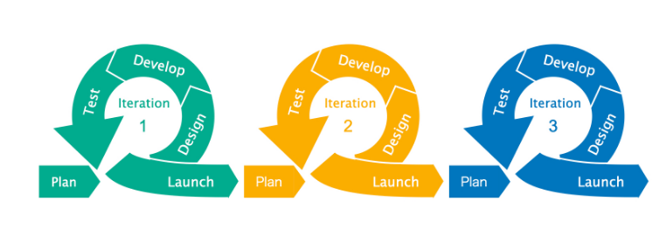

* These builds are provided with iteration
* Each iteration lasts about one to four weeks
* Every iteration involves cross functional teams working simultaneously on various areas like design, coding, testing like unit, integration, acceptance testing
* At the end of the iteration a working product is reviewed by the customer
* If reviewed product still need some modification to be done, then changes are done In existing product, which again passes through design, coding & testing phase & again reviewed by client
* This iteration goes on until the satisfactory product is developed which meets clients requirements but it should be achieved within defined time line

**6. Write Agile manifesto principles?**

* 1. Highest priority is to satisfy the customer through early and continuous delivery of valuable software
* 2. Quick responses to change and continuous development
* 3. Delivering working software frequently, from a couple of week to a couple of months, with a preference to the shorter time period
* 4.Continuous customer interaction is very important to get proper product requirement
* 5.Agile processes promote sustainable development
* 6. Working software is the primary measure of progress
* 7.Continuous attention to technical excellence & good design enhancement

**7. Explain working methodology of Agile model & also write pros & cons**

* Agile is flexible methodology that makes it possible to bring products to users hands as quickly as possible & it is seen as an improvement over other models such as waterfall model

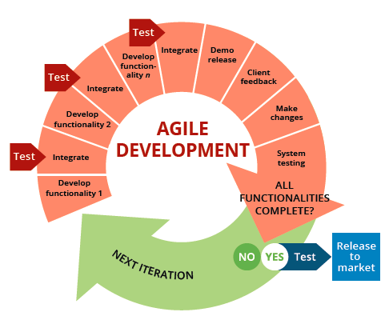

* Agile software development method is a combiation of incremental & iterative method
* In this method project is divided into iterative builds, and there is a design,development & testing team working on each build simultanouly
* At the end of each iteration demo product is relesed, which is reviewed by client & provide necessary feedback to team
* If there need to make any changes to demo product, then it passes through next iteration with modified changes & cycle cotinuous until satisfacory prouct result is achieved
* The important feature of agile model is there is a cotinuous interactio between design,development & tester team on regular interval on the progress & how to become more effective
* **Main Stages of Agile work flow:**
* **1.Requirement analyis**: at this stage requiremet for particular iteration are defined based on the priority, which is decided by the meetimg of stakeholder along with client
* **2**.**Design/Develop:** at this phase, based on the finalized requirements software is design & developed
* **3**.**Test (QA):** In this phase software is tested for any bugs/defects.This phase includes unit testig, system testing,integration testing & acceptance testing
* **4**.**Release/Delievery**: In this phase working product of the corresponding iteration is released
* **5**.**Review/Feedback:** released working product is reviewed by clients & stakeholders, Feedback on released product is accepted from both
* And if any changes required in released product, then it is send to next iteration & cycle cotinuous until satisfacory prouct result is achieved
* **Pros:**
* It is very relistic approach to software developmet
* Need not to wait for the product to be developed completely , as changes can be made at any stage of development cycle
* Gives flexibility to developer
* Agile projects have more scope of continuous improvement,as the life cycle itself has a feedback gatherig session
* Easy to manage
* Minnimum resources required
* Suitable for both fixed or changing requirement
* Faster & high quality delivery within defined time line
* In agile there is a strong team interaction, team take responsibility & work together
* **Cons:**
* Not suitable for complex projects
* Depends heavily on customer interaction, so if customer is not clear,team can be driven in the wrong direction
* More risk of sustaiability,maintainbility

**8.Expain phases of waterfall model**

* This model is called as waterfall because each phases are cascaded to each & process is seen as flowing steadly downwards
* Waterfall model is also konwn as **“classical software life cycle”** or “**linear sequential life cycle”** model
* Differet phases of this model is represented In below figure.

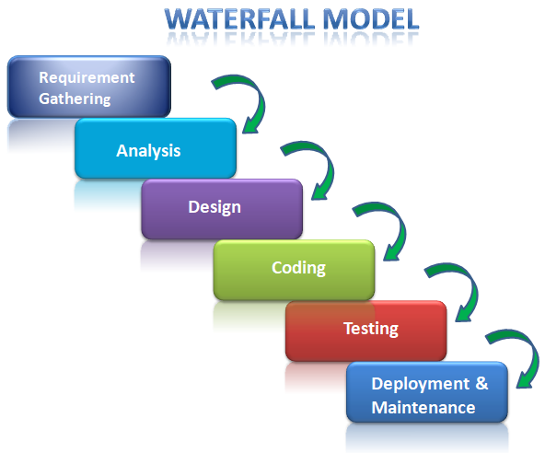

* This model is very simple to uderstand & use, in this model each phase must be completed before the next phase can begin & there is no overlapping in the phases
* The waterfall model illustrates the process in a linear sequencil flow, this means that any phase in the development process begins only if the previous phase is completed.
* In this mode whole procedure is divided into separate phases,in which the outcome of one phase acts as an input for next phase sequentially
* **Different phases of Waterfall model:**
* **1.Requirement Gathering:** all the possible requirement of system to be developed are captured by business analysist after iteraction with clients & documented in requiremet document
* Once the requirements are collected, then it is frozen & not allowing to make any changes after this phase
* **2.Analysis:** analysis is done along with team member on collected requiremets for risk analysis,task alloction,resources,project milestone & all these information is included in SRS
* **3.Design:** In this phase SRS is studied & system design is prepred, which helps In defining system architecture & send to next phase
* **4.Coding:** The system is first developed in small programs called units, each uits are which are then integrated in next phase.
* **5.Testing:** Each unit are tested for its functionality called as unit testing , if defcts found in this phase cant not be send back to previous phase for correction
* After testing, each units are integratd ,then the entire integrated systm is tested for integration testing
* 6.Deployment & mainteance: once the functional & non-functional testig is done, the product is released.
* After deployment, there are some issues which come up In client enviroment, so mintenance is done to resolve those issues
* Also to enhance product services some better version are released
* **Pros:**  simple & easy to understand
* Works well for smaller projects where requirements are well understood & stable
* Milestone is well understood
* Easy to arrange tasks
* Easy to manage due to rigidity of model
* Process & results are well documented
* **Cons:** Working software produced late in life cycle
* Poor model for long & ongoing projects
* Not suitable for projects where requirements are tend to change
* High amount of risk & uncertainity
* Difficult to measure progress within stages
* Once the application is in testing stage ,It does not allow to go back & rectify the defect

**9.Write phases of spiral model**

* Spiral model focuses on **risk assesmet**.
* This model has four phases dividing the model into quadrants, such as planning, risk analysis, engineering, and evaluation.
* The number of loops in the spiral depends on the specific project & its requirement.
* It combines features of the **Waterfall and prototype models**, having phases similar to those in the Waterfall model.

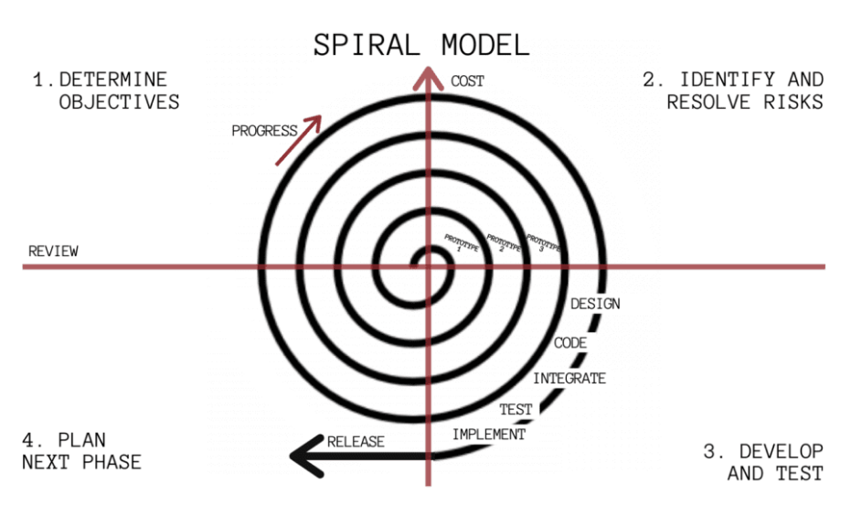

* **Spiral Model Phases:**
* It has four stages or phases: The planning of objectives, risk analysis, engineering or development, and final review. A project passes through all these stages repeatedly and the phases are known as a “**Spiral”** in the model.
* **Determine objectives and find alternate solutions:** This phase includes requirement gathering and analysis. Based on the requirements, objectives are defined and different alternate solutions are proposed.
* **Risk Analysis and resolving:** In this quadrant, all the proposed solutions are analyzed and if there is any potential risk, it is identified, analyzed, and resolved.
* **Develop and test:** This phase includes the actual coding/implementation of the different features in modules. All the implemented features are then verified with the help of testing.
* **Review and planning of the next phase:**In this phase,the software is reviewed by the customer. It also includes risk identification and monitoring like cost overrun or schedule slippage and after that planning of the next phase is started
* **Pros:** The spiral model is perfect for projects that are **large and complex** in nature as continuous prototyping and evaluation help in risk management.
* Continuous and repeated development allows developers to make changes and add new features while managing risks.
* Because of its **risk handling ability**, the model is best suited for projects which are very critical like software related to the health domain, banking etc.
* Since customer gets to see a prototype in each phase, so there are **higher chances of customer satisfaction.**
* **Cons:** Because of the prototype development and risk analysis in each phase, it is very **expensive and time taking**.
* It is **not suitable for a simpler and smaller** project because of multiple phases.
* It requires **more documentation** as compared to other models.
* Spiral may go indefinitely
* Project **deadlines can be missed** since the number of phases is unknown in the beginning and frequent prototyping and risk analysis can make things worse.

**10.What is oops ?**

* Object-oriented programming (OOP) is a [programming paradigm](https://en.wikipedia.org/wiki/Programming_paradigm) based on the concept of "[objects](https://en.wikipedia.org/wiki/Object_(computer_science))", which can contain [data](https://en.wikipedia.org/wiki/Data) and [code](https://en.wikipedia.org/wiki/Computer_program).
* For example, C++, java, python etc
* Data in the form of [fields](https://en.wikipedia.org/wiki/Field_(computer_science)) (known as [attributes](https://en.wikipedia.org/wiki/Attribute_(computing)) or properties) and code, in the form of procedures (known as [methods](https://en.wikipedia.org/wiki/Method_(computer_science))).
* The OOP concept was basically designed to overcome the drawback of the structural & procedural programming methodologies, which were not so close to real-world applications.
* Object-oriented programming (OOP) is nothing but that which allows the writing of programs with the help of certain classes and real-time objects.
* We can say that this approach is very close to the real-world and its applications because the state and behavior of these classes and objects are almost the same as real-world objects
* **Advantage Of OOP:**
* It provides data security
* Memory management
* Code reusability

**11. Write basic concepts of OOPS**

* Object
* CC Class Memory management
* Encapsulation
* Abstraction
* Inheritance
* Polymorphism
* Overriding
* Overloading

**12. What is Object?**

* Object is an instance of a class
* Object is nothing but a self-contained component
* It consists of Code (procedures or methods)&data (properties) to make a particular type of data useful
* It occupies some memory
* **For example**, class vehicle, object – (data member -no. of wheel, color),(method-start, break, accelerate)

**13**. **What is Class?**

* Class is a blueprint or set of instructions to build a specific type of object
* Class determines how an object will behave and what the object will contain
* It doesn’t occupy any memory

**14. What is encapsulation?**

* It is defined as wrapping up of data under a single unit
* In which data of a class is hidden from any other class
* Hence, encapsulation is a protective shield that prevents the data from being accessed by the code outside this shield

**15. What is inheritance?**

* Inheritance is the capability of one class (child) to derive capabilities or properties from another clas**s (**parent)
* Here old class is known as base class/ super class/ parent class
* New class is known as Derived class/sub class/ child class
* **For example**, vehicle is parent class & car is derived class
* **Types of inheritance**
* 1.single
* 2.multiple
* 3.Multilevel
* 4.Hierarchical
* 5.hybrid (combination of multiple & hierarchical)

**16. What is polymorphism?**

* Polymorphism means “having many forms”
* It is the ability of an object to change many forms
* It allows different objects to respond to the same messages in different ways, the response is specific to type of object
* **There are two types of polymorphism**
* 1. **Overloading (compile time):** if a class have two or more methods with the same name & different parameters it is called method overloading
* **2.overriding (runtime):** In this there is one method with same name in both the parent as well as child class

**17**. **Draw use case on online book shopping**

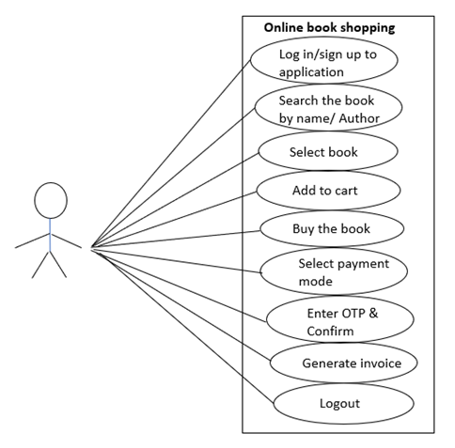

**18. Draw use case on online bill payment system (Paytm)**

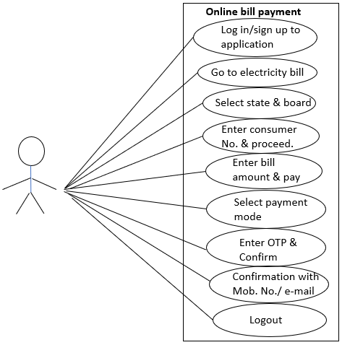

**19. Draw use case on online product shopping using COD**

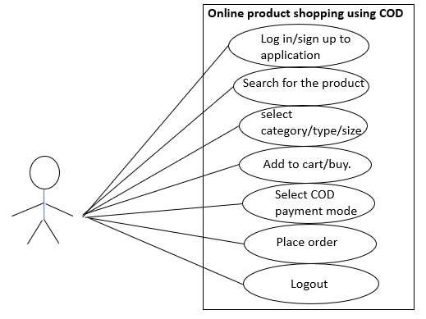

**20. Draw use case on online product shopping using payment gateway**

