* **What is SDLC ?**

SDLC is refered as software development life cycle .

It is a structure imposed on software development which include planning,analysis,design,implementation,testing ,maintenance.

* **What is software testing?**

Software testing is a process of checking the correctness,completeness and quality of developed software system.

* **What is agile methodology?**

Agile methodology is a software development life cycle method. which is based upon iterative and incremental model. It focus on process adaptability and customer satisfaction by rapid delivery of working software product.

* **What is SRS?**

SRS stands for software requirement specification.

It is a description of software system to be developed. It lays out functional and non functional

requirements of software to be developed. It may include a set of use cases.

* **What is OOPS?**

Oops stands for object oriented programming system. It is an approach to solve problem using some programming language.

* **Write Basic Concepts of oops?**

1. Class
2. Object & methods
3. Inheritance
4. Encapsulation
5. Polymorphism
6. Abstraction

* **What is object?**

Object is instance of class. It is a real world entity. Object occupy memory.

Syntax-

classname objectname = new classname ();

* **What is class?**

Class is collection of data members(variables) & member functions(process, methods) with its behaviours.

Syntax-

Class classname{

Variable(data member)

Methods(data member)

}

* **What is encapsulation?**

Encapsulation is a process of wrapping the data and the code acting on the data together.it is also known as data hiding.

* **What is inheritance?**

Inheritance is process when an object occupy all the properties of parent class.It helps in code reusability.

* **What is polymorphism?**

Polymorphism means having many forms.when an object has the ability to take many forms.

* **Draw Use case on Online book shopping.**.

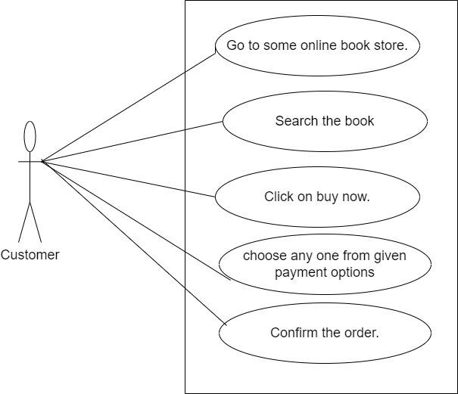

* **Draw Use case on Online bill payment system (paytm).**

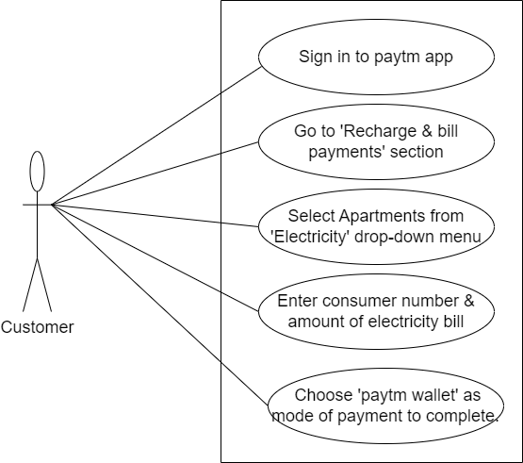

* **Write SDLC phases with basic introduction.**

**Requirement Collection**-Establish customer needs.

**Analysis**-This phase determine the requirements of system ,independent of how these requirements will be accomplished.

**Design**-Model and specify a solution –“Why”.

**Implementation**-Construct a solution in software.

**Testing**-Validate the solution against the requirements.

**Maintenance**-Repair defects and adapt the solution to new requirements.

* **Explain Phases of waterfall model.**

**Requirement Collection**-Establish customer needs.

**Analysis**-This phase determine the requirements of system ,independent of how these

requirements will be accomplished.

**Design**-Model and specify a solution “Why”.

**Implementation**-Construct a solution in software.

**Testing-**Validate the solution against the requirements

**Maintenance**-Repair defects and adapt the solution to

new requirements.

* **Write phases of spiral model.**

**Planning**- It include objective determination & identity alternative solutions.

**Risk Analysis**-Identify & resolve risks(prototype).

**Engineering**-Develop next version of product.

**Customer Evaluation-**Review & plan for next phase.

* **Write agile manifesto principles.**

1. Individuals and interactions over processes and tools.
2. Working product over comprehensive documentation.
3. Customer collaboration over contract negotiation.
4. Responding to change over following a plan.

* **Explain working methodology of agile model and also write pros and cons.**

Agile methodology is a software development life cycle method. which is based upon iterative and incremental model. It focus on process adaptability and customer satisfaction by rapid delivery of working software product.

**Pros-**

1. Promotes teamwork and cross training.
2. It is very realistic.
3. Resource requirements are minimum.
4. Frequent delivery.

**Cons-**

1. High individual dependency.
2. Minimum documentation.
3. Transfer of technology to new team member may be quite challenging.
4. Not suitable for handling complex dependencies.

* **Draw Use case on Online shopping product using COD.**

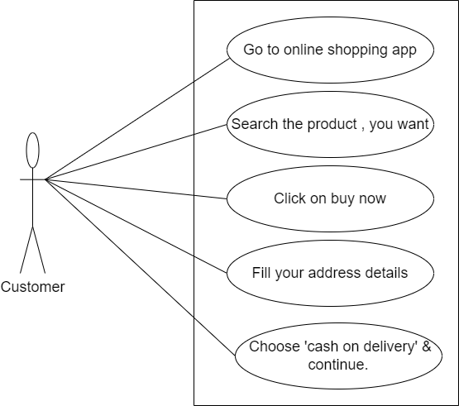

* **Draw Use case on Online shopping product using payment gateway .**

