**ASSIGNMENT-01**

Quick Mask: Quick Mask Mode displays selections visually, allowing you to more accurately view selections. In Quick Mask Mode, filters and tools can be applied to selections. What is a Quick Mask When working in Photoshop, there are a number of different tools available that help you see the effects of your work.

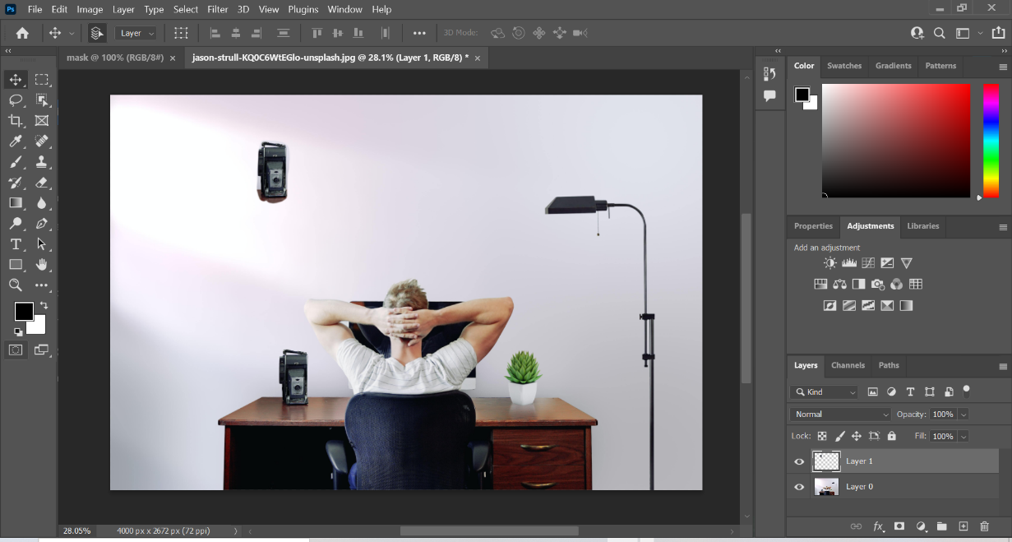

Clipping Mask: Clipping masks in Photoshop is an incredible option to control the visibility of a layer; a clipping screen is secured with a mask, assume, for instance, that you have a layer shape, a layered picture above, and a top layer content, the opacity for the base layer likewise applies when the photo and message just happen in the base layer through the structure sketch – the design piece is cut into the mask’s structure; however, a selection of at least two objects in a layer can be made into a clipping set.

*:*

Vector Mask: A vector mask is a resolution independent path that clips out the contents of the layer. Vector masks are usually more accurate than those created with pixel-based tools.

Layer Mask: Layer masks are a fundamental tool in image manipulations. They allow you to selectively modify the opacity (transparency) of the layer they belong to. This differs from the use of the layer Opacity slider as a mask has the ability to selectively modify the opacity of different areas across a single layer.

