ALGAEGUARD
Algae-Based Carbon Sequestration Monitoring Platform
HACKOUT '26
Submitted by
The Archies

Institution : - Pandit Deendayal Energy University

Academic Year 2026–27

TABLE OF CONTENTS
Abstract 1
1. Introduction 2
1.1 Why This Project Matters 2
1.2 Project Development Approach 2
2. Problem Statement and Objectives 2
2.1 What We Set Out to Do 2
3. System Architecture 3
4. Hardware Used 4
4.1 Sensors and Components 4
5. The AI/ML Engine — Algae Carbon 360 4
5.1 Why This Matters 5
5.2 Model Evaluation 6
6. CO₂ Capture Performance 6
7. Prototype Simulation 7
8. Dashboard and Full Workflow 8
9. Applications, Advantages, and Future Scope 9
9.1 Where This Can Be Used 9
9.2 Advantages 9
9.3 Limitations 10
9.4 What We Plan to Add Next 10
9.5 Practical Impact 10
10. Conclusion 11

Abstract
Clean water is something we all depend on, but monitoring its quality consistently is not always easy. Ponds, lakes, and small water bodies can change quickly because of temperature shifts, pollution, or nutrient build-up, and these changes often create the right conditions for excess algae growth. Checking water quality by hand, sample by sample, takes time and cannot catch problems as they happen.
AlgaeGuard is our practical attempt to address this challenge using low-cost sensors and a simple AI-based approach. The system reads temperature, pH, humidity, light, and turbidity using an Arduino Uno, and then combines all these readings together instead of looking at just one number. This combined view gives a clearer picture of whether the water is healthy or at risk.
On top of the sensor system, we also built an AI/ML layer called Algae Carbon 360. This model takes environmental readings and predicts algae biomass growth and the amount of CO₂ the algae can capture. This turns AlgaeGuard from a simple alert system into a tool that can also show the environmental benefit of healthy algae growth, such as carbon capture.
Our goal is to build a system that is affordable, easy to understand, and useful in both urban and rural settings. By providing early warnings and meaningful environmental insights, AlgaeGuard can support cleaner and more carbon-conscious water management.
Keywords: AIoT, Water Quality, Algae Risk, Arduino Uno, Machine Learning, CO₂ Estimation, IoT
The project is designed around a straightforward principle: collect meaningful environmental information continuously, interpret the combined readings, and present the result in a form that supports timely action. The combination of sensing, prediction, visualization, and environmental impact estimation gives the prototype a broader purpose than conventional periodic water testing.

1. Introduction
Water is one of the most basic resources we have — for drinking, farming, fisheries, and for the health of every aquatic ecosystem. Because of this, keeping an eye on water quality matters a lot, not just for the environment but for the people and communities who rely on it every day.
Over time, water bodies can be affected by pollution, changing temperatures, and nutrients washing in from farms or drains. When these conditions line up, they can trigger excessive algae growth, which in turn can affect fish, drinking water, and the overall health of a pond or lake.
Most traditional methods of checking water quality still rely on manually collecting samples and sending them to a lab. This works, but it is slow, needs trained people, and cannot give continuous updates. By the time a problem is noticed, it may have already grown worse.
This is where the Internet of Things (IoT) becomes useful. By connecting simple sensors to a microcontroller, the system can monitor water and surrounding environmental conditions continuously instead of depending only on occasional site visits. AlgaeGuard builds on this idea, adding an AI/ML layer on top so the system does not just collect data — it also understands and predicts what that data means.
1.1 Why This Project Matters
The practical value of this approach becomes clearer when monitoring is considered as an ongoing activity rather than a one-time measurement. A water body can change because several conditions change together, so a system that observes multiple parameters can provide more context than an isolated reading. The simple HEALTHY, WARNING, and HIGH RISK labels are intended to bridge the gap between technical measurements and everyday decision-making.
In many places, especially rural areas and small communities, proper water-testing labs are not always nearby or affordable. A low-cost sensor system can give people an early warning before conditions get serious. Instead of raw numbers that are hard to interpret, AlgaeGuard gives a simple status — HEALTHY, WARNING, or HIGH RISK — so that even a non-technical user can understand what is happening in their water body at a glance.
1.2 Project Development Approach
The project follows a prototype-first development approach. The hardware and sensor layer establishes the basic data collection process, simulation is used to check the Arduino logic, and the AI/ML layer is then used to interpret the available environmental information. Finally, the dashboard presents the outputs in a practical form. This staged approach helps the team verify each part of the system before considering wider deployment.
2. Problem Statement and Objectives
Water quality monitoring today is mostly manual, periodic, and dependent on labs. This means changes in water condition can go unnoticed for days or weeks. There is a clear need for a system that watches water continuously, looks at several parameters together instead of just one, and gives a simple, understandable result — while also being affordable enough for wide use.
In short: we wanted to build an AIoT-based system that keeps watch on water quality all the time, combines multiple readings intelligently, and warns people early about conditions that could lead to algae risk.
2.1 What We Set Out to Do
The objectives were selected to keep the prototype practical while still demonstrating the role of AI in environmental monitoring. The hardware provides the measurement layer, the processing stage organizes the readings, and the AI/ML component adds prediction. The dashboard then acts as the communication layer so that the outputs can be understood without requiring the user to interpret every sensor value separately.
- Build a working IoT-based water monitoring prototype using Arduino Uno.
- Continuously track temperature, humidity, pH, light, and turbidity.
- Combine all sensor readings together to form one overall water-condition status.
- Add an AI/ML model (Algae Carbon 360) to predict algae growth and CO₂ capture.
- Show live readings, trends, and alerts through a dashboard.
- Keep the whole system low-cost and scalable for both cities and villages.

3. System Architecture
AlgaeGuard works in clear, connected stages. Sensors first collect raw readings from the water and surrounding environment. These readings are cleaned and processed, then passed into the AI/ML engine, which predicts biomass growth, checks for anything unusual, and estimates CO₂ uptake. A verification layer double-checks the results before they reach the dashboard, where health scores, alerts, and visual trends are finally shown to the user.
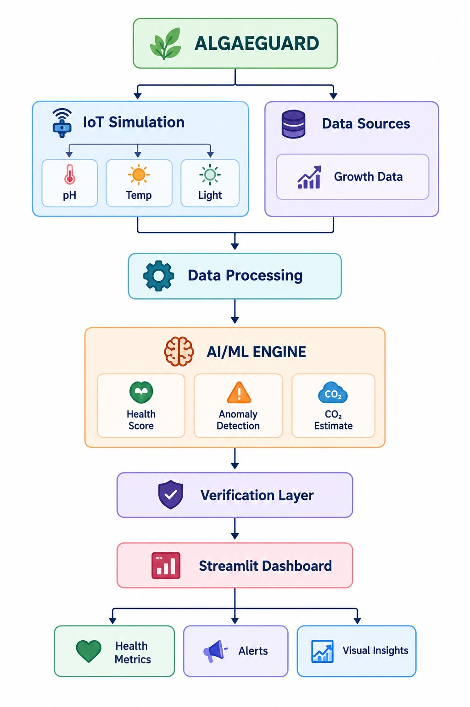
Figure 1: AlgaeGuard system architecture — from sensors to the final dashboard
The architecture follows a clear data path. First, sensors collect measurements from the water and its surrounding environment. These raw readings are then processed so that they can be used consistently by the next stage. The AI/ML engine analyzes the available information, generates predictions, and estimates CO₂ uptake. A verification layer is included before the final information reaches the dashboard. This arrangement creates a logical separation between sensing, analysis, verification, and presentation.
This layered design keeps things simple to build and easy to expand. If we want to add a new sensor or a new type of alert later, we only need to plug it into the existing flow instead of redesigning the whole system.
4. Hardware Used
The prototype is built around an Arduino Uno, which acts as the brain of the system. It reads values from every connected sensor, checks them against simple logic, and sends the results out through the Serial Monitor for testing.
4.1 Sensors and Components
The selected components were chosen because each contributes a different type of information. Temperature and humidity describe environmental conditions, pH provides an indication of acidity or alkalinity, turbidity gives information about water clarity, and light represents an environmental factor that can affect algae growth. The optional TDS sensor can provide an additional indication of dissolved material. Together, these measurements form the input side of the monitoring system.
- Arduino Uno — the main controller that reads and processes all sensor data.
- pH Sensor — measures how acidic or alkaline the water is.
- Turbidity Sensor — checks how clear or cloudy the water is.
- DHT22 Sensor — measures surrounding temperature and humidity.
- Light Sensor — measures how much light is reaching the water, which affects algae growth.
- TDS Sensor (optional) — estimates total dissolved solids in the water.
- Breadboard, jumper wires, and a power supply — for connecting everything together.
Each of these parts plays a small role on its own, but together they give a much more complete picture of the water's condition than any single sensor could.
5. The AI/ML Engine — Algae Carbon 360
Once the sensors collect enough data, we don't just display raw numbers — we feed them into a machine learning model called Algae Carbon 360. This model takes in readings like temperature, sunlight hours, pH, nutrients, CO₂, dissolved oxygen, water quality, and previous biomass, and uses a Random Forest model to predict what comes next.
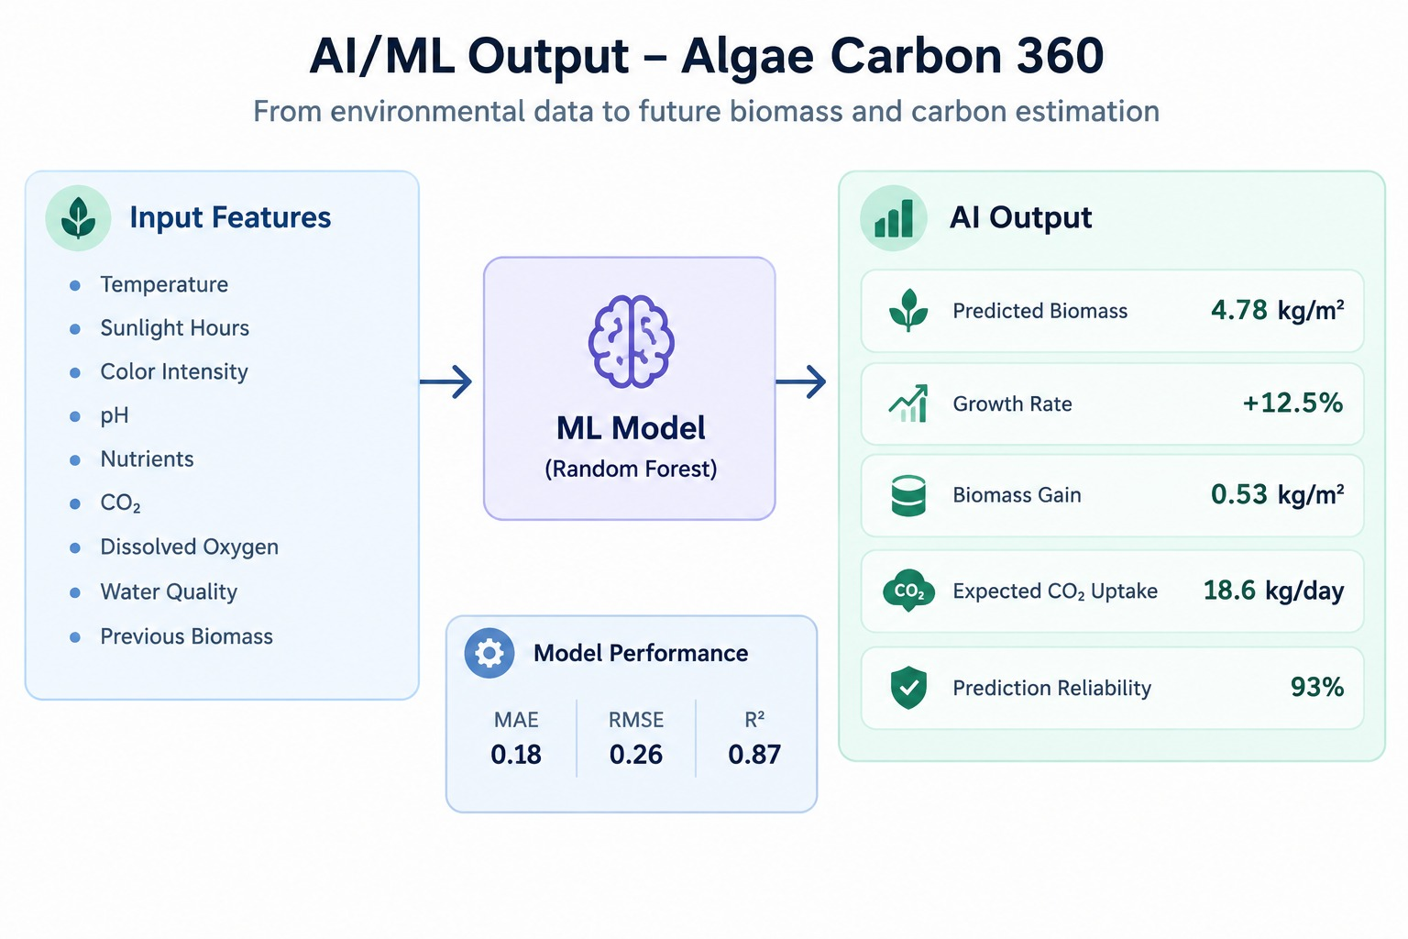
Figure 2: How the Algae Carbon 360 model turns sensor data into predictions
The Algae Carbon 360 workflow is intended to transform several environmental inputs into useful predicted outputs. Instead of treating every measurement independently, the model considers the combined information available from temperature, sunlight hours, pH, nutrients, CO₂, dissolved oxygen, water quality, and previous biomass. The Random Forest approach is used in the prototype to map these inputs to predicted biomass growth and associated CO₂ uptake.
In our test run, the model predicted a biomass of 4.78 kg per square metre, a growth rate of +12.5%, and an expected CO₂ uptake of 18.6 kg per day, with a prediction reliability of 93%. The model's accuracy was checked using standard error metrics — a Mean Absolute Error of 0.18, an RMSE of 0.26, and an R² score of 0.87, which shows the predictions line up well with real growth patterns.
5.1 Why This Matters
The environmental interpretation is an important part of the project. A water-quality monitoring system can tell a user that conditions have changed, but prediction can provide an indication of what those changes may mean for future algae growth. Similarly, estimating CO₂ uptake adds a sustainability dimension to the dashboard. These outputs are intended to make the collected data more meaningful and help users understand trends rather than only individual readings.
This AI/ML layer makes AlgaeGuard more than a simple alert system. Instead of only saying whether water is healthy or not, the AI layer helps us understand how fast algae is growing and how much carbon it could be capturing — turning the project into a small but meaningful step toward carbon-aware water management.
5.2 Model Evaluation
The reported test run includes Mean Absolute Error (MAE), Root Mean Square Error (RMSE), and R² as evaluation measures. These metrics are included to provide a quantitative view of how closely the model's predictions align with the growth patterns used in the project test.
Metric | Reported Value
Predicted Biomass | 4.78 kg/m²
Growth Rate | +12.5%
Estimated CO₂ Uptake | 18.6 kg/day
Prediction Reliability | 93%
Mean Absolute Error (MAE) | 0.18
Root Mean Square Error (RMSE) | 0.26
R² Score | 0.87

6. CO₂ Capture Performance
One of the more exciting outputs of the AI model is tracking how much CO₂ the algae captures as it grows over time. Since algae naturally absorbs CO₂ during photosynthesis, healthier and faster-growing algae means more carbon being captured from the surrounding environment.
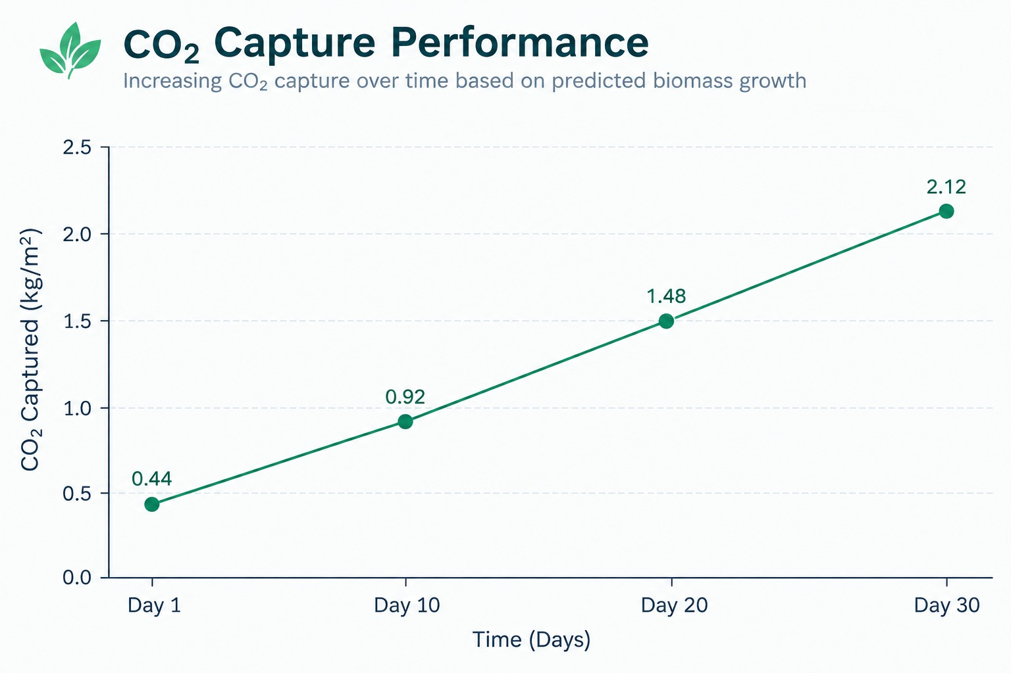
Figure 3: CO₂ capture increasing steadily as predicted biomass grows
The simulated CO₂ trend demonstrates how the project connects predicted biomass with a measurable sustainability indicator. As the predicted biomass increases, the estimated carbon capture also increases in the simulation. This is presented as an estimate from the model rather than a direct physical measurement, and the report notes that such tracking could eventually support evaluation of environmental impact and possible carbon-credit estimation.
In our simulation, CO₂ capture increased from about 0.44 kg per square metre on Day 1 to 2.12 kg per square metre by Day 30. This steady upward trend matches what we would expect biologically — as algae biomass builds up, its carbon capture capacity grows along with it. This kind of tracking can eventually help estimate carbon credits or measure the real environmental impact of a monitored water body.
7. Prototype Simulation
Before testing anything in the field, we simulated the whole Arduino-based setup to make sure the logic and wiring worked correctly. The simulation connects all sensors to the Arduino Uno and streams live readings through the Serial Monitor, letting us test different conditions safely before real-world deployment.

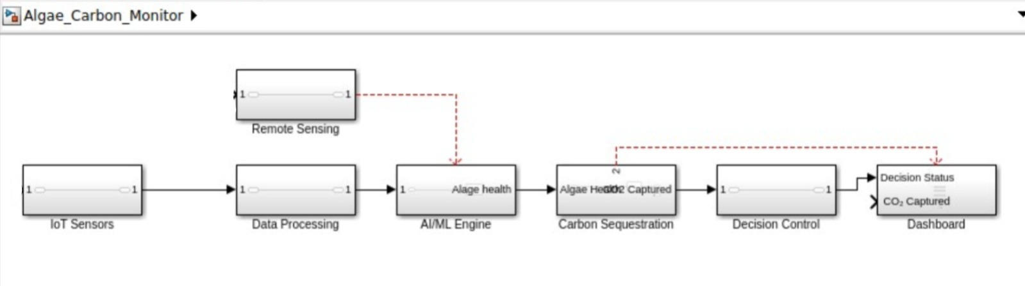
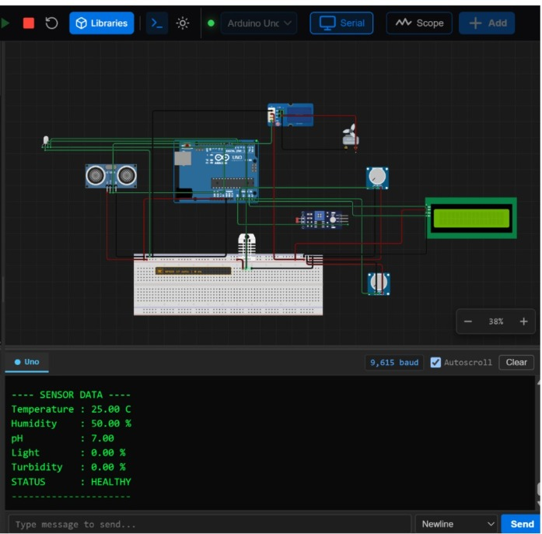
Figure 4: Arduino simulation showing live sensor readings and system status
The simulation stage provides a controlled way to demonstrate the basic monitoring logic. In the reported test, the prototype received the specified simulated values and produced the expected HEALTHY status. This confirms the intended decision flow for the prototype scenario. However, the values are explicitly simulation values, so actual field deployment would require real measurements and validation against appropriate reference instruments.
In this test run, the system read a temperature of 25.00°C, humidity of 50%, pH of 7.00, light at 0%, and turbidity at 0%, and correctly reported the overall status as HEALTHY. These are simulation values used purely to confirm the logic works — real field values will vary once the system is deployed at an actual water body.
8. Dashboard and Full Workflow
The dashboard is where everything comes together — sensor data, AI predictions, and CO₂ estimates are all turned into something simple that a normal user can understand at a glance. It shows live algae growth percentage, carbon sequestered, water quality status, and a growth trend graph, along with smart recommendations and real-time alerts.
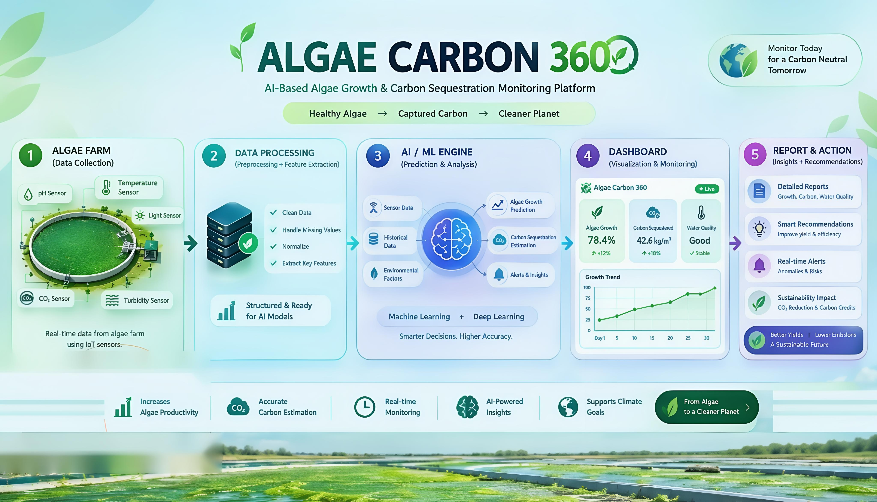
Figure 5: Complete Algae Carbon 360 workflow — from the algae farm to reports and action
The dashboard and reporting stage completes the system workflow. After sensing and processing, the AI/ML layer generates predictions and the dashboard organizes these outputs into live information, trends, alerts, and recommendations. This makes the system easier to use because the user can view the current condition and the longer-term sustainability information in one place.
The full journey starts at the algae farm, where sensors collect raw data. This data is cleaned and processed, then passed to the AI/ML engine for prediction and analysis. The dashboard then visualizes everything live, and finally, the system generates reports and smart recommendations — helping users understand not just current water health, but also long-term sustainability impact like CO₂ reduction.
9. Applications, Advantages, and Future Scope
9.1 Where This Can Be Used
- Public lakes, parks, and city water bodies.
- Village ponds, fisheries, and farm water sources.
- Educational institutions studying environmental monitoring.
- Smart-city and municipal water management programs.
9.2 Advantages
- Continuous, real-time monitoring instead of occasional sampling, allowing changing conditions to be observed more consistently over time.
- Combines multiple sensors for a more reliable overall picture.
- AI-based predictions add real value beyond simple sensor readings.
- Low-cost hardware makes it usable in both cities and villages.
- Simple dashboard that non-technical users can understand easily.
9.3 Limitations
These limitations are important when considering the difference between a working prototype and a field-ready system. Sensor readings depend on calibration and maintenance, and the present prototype estimates algae risk from environmental parameters rather than directly observing algae. The reported AI results also come from the project's test/simulation setup. Therefore, field validation with real water bodies and reference measurements would be an important next step before treating the predictions as operational measurements.
- Sensor accuracy depends on proper calibration and maintenance. Long-term practical deployment would require regular checking of sensor performance to reduce the effect of drift, environmental exposure, or inaccurate readings.
- This prototype cannot directly “see” algae — it estimates risk from water parameters.
- Needs real field testing to confirm accuracy against reference instruments.
9.4 What We Plan to Add Next
The proposed future improvements follow naturally from the current architecture. Camera-based AI could add direct visual information, while solar-powered stations could make remote monitoring more practical. A mobile application would make alerts easier to receive, and GPS-based monitoring could extend the concept from one monitored location to multiple water bodies. These additions would build on the existing sensing, prediction, and dashboard workflow rather than replacing it.
- Camera-based AI to visually detect algae directly in the water.
- Solar-powered sensor stations for remote, off-grid locations.
- A mobile app with instant push notifications for alerts.
- GPS-based monitoring across multiple water bodies at once.
9.5 Practical Impact
The practical impact of AlgaeGuard comes from combining early warning with understandable reporting. For municipalities, educational institutions, fisheries, farms, and community-managed water bodies, the prototype provides a framework for observing changing conditions and communicating them clearly. Its low-cost hardware approach also supports the project's goal of making monitoring more accessible.
10. Conclusion
Overall, AlgaeGuard brings together sensing, IoT, machine learning, simulation, visualization, and carbon-impact estimation in a single prototype. Its main contribution is the attempt to turn several separate environmental measurements into a connected monitoring workflow that is easier for users to interpret. The project is intentionally presented as a prototype, and the next stage is real-world validation, calibration, and further development of the planned features.
AlgaeGuard shows how combining simple, affordable sensors with a smart AI layer can turn basic water readings into something genuinely useful. By connecting temperature, pH, humidity, light, and turbidity sensors to an Arduino Uno, and passing that data through our Algae Carbon 360 model, we could not only flag risky water conditions early but also predict algae growth and estimate CO₂ capture over time.
This project showed us that effective environmental monitoring does not necessarily need to be expensive or complicated. What matters is continuous observation, combining relevant information, and presenting the results in a form that people can understand and act upon. With further field testing, added sensors, and a working mobile app, AlgaeGuard has real potential to grow from a hackathon prototype into a practical tool for communities that need affordable, everyday water quality awareness.
We built this project for Hackout '26 with the hope that even small, low-cost ideas like this one can support a cleaner, healthier, and more carbon-conscious future — one water body at a time.

