AN INTERNSHIP REPORT
ON
BACKEND DEVELOPMENT
AT
MINDRISERS TECHNOLOGY

By:
RICHA MAHARJAN
Exam Roll Number: 10162/19
TU Registration Number: 7-2-410-154-2019
PRIME COLLEGE
Khusibun, Kathmandu, Nepal

Submitted To:
Faculty of Management
Tribhuvan University
Kathmandu

In Partial Fulfillment of the Requirements for the Degree of
BACHELOR OF INFORMATION MANAGEMENT (BIM)

Kathmandu
September, 2024

TITLE PAGE
AN INTERNSHIP REPORT
ON
WEBSITE DEVELOPMENT
AT
MINDRISERS TECHNOLOGY

By:
RICHA MAHARJAN
Exam Roll Number: 10162/19
TU Registration Number: 7-2-410-154-2019
PRIME COLLEGE
Khusibun, Kathmandu, Nepal

Submitted To:
Faculty of Management
Tribhuvan University
Kathmandu

In Partial Fulfillment of the Requirements for the Degree of
BACHELOR OF INFORMATION MANAGEMENT (BIM)

Kathmandu
September, 2024

DECLARATION
I hereby declare that the internship report entitled “"AN INTERNSHIP REPORT ON BACKEND DEVELOPMENT”” submitted to the Faculty of Management, Tribhuvan University, Kathmandu is an original peace of work under the supervision of Er. Narayan G.C., faculty members, PRIME COLLEGE, KHUSIBUN, KATHMANU, and is submitted in partial fulfillment of the requirements for the award of the degree of Bachelor of Information Management (BIM). This internship report has not been submitted to any other university or institution for the award of any degree or diploma.

Signature
Richa Maharjan
Date:

RECOMMENDATION LETTER

(Student should keep the recommendation letter here from concern organization in which they worked as internees mentioning their completion of the internship with internship duration. The letter should be prepared in the organization’s letter head and duly signed by concern authority/senior/supervisor/HR Manager of the organization with office seal.)

Signature: __________________
NAME OF AUTHORITY
DESIGNATION
DATE:
OFFICESEAL:

APPROVAL SHEET

This is to certify that the internship report
Submitted By:
RICHA MAHARJAN
Entitled
BACKEND DEVELOPMENT

I certify that I have read this document and in my opinion, it is satisfactory in scope and quality area as an internship report in partial fulfillment for the undergraduate course, Bachelor of Information Management (BIM) held at Prime College, Tribhuvan University

Date of Approval: _______________________

Signature:_________________________
Er. Narayan G.C.

ACKNOWLEDGEMENT
I would like to express my profound gratitude and deep regards to my respected supervisor Er. Narayan G.C. for his persistence help and clear guidance throughout my academic study and throughout the completion of my internship. His suggestions and guidance in every stage is one of the major reasons of the successful completion of my internship.
I would like to express my deep gratitude to MindeRisers Technology for providing me the exciting opportunity to be the part of the company and providing me immense help, support and guidance to move ahead with the internship objectives.
I am also immensely grateful to my internship supervisor, Mr. Suru Basnet, whose guidance was influential in making things easier and methodical to follow and also for valuable cooperation, guidance, direction and support throughout this period of internship. I would like to extend my gratitude to Ms. Kritika Shah, CEO of MindRisers Technology for being a motivation to me.
I would also like to acknowledge the support of Vice Principle-Management Program, Mr. Rupendra Gopali, for his invaluable assistance and advice. My heartfelt gratitude goes to all the faculty members of Prime College for equipping me with the knowledge and skills that helped me successfully complete this internship.
Finally, my thanks and appreciations go to all of my colleagues, and the entire MindRisers Technology team, who irrespective of the situation, always encouraged and supported me to prepare this report.

Richa Maharjan
BIM 8th Semester
Exam Roll No.: 10162/19
TU Registration No: 7-2-410-154-2019

TABLE OF CONTENTS
TITLE PAGE i
DECLARATION ii
RECOMMENDATION LETTER iii
APPROVAL SHEET iv
ACKNOWLEDGEMENT v
LIST OF TABLE viii
LIST OF FIGURES ix
ABBREVIATIONS x
CHAPTER 1: INTRODUCTION 1
1.1 Background 1
1.2 Current trend of the subject under study 2
1.3 Objectives 2
1.3.1 General Objectives 2
1.3.2 Specific Objectives 2
1.4 Methodology 3
1.4.1 Organization Selection 3
1.4.2 Placement 3
1.4.3 Duration 4
1.4.4 Activities 4
1.5 Tools Used 6
CHAPTER 2: INTRODUCTION OF THE INDUSTRY 8
2.1 Brief Introduction of Industry 8
2.2 Present Situation 9
2.3 Challenges and Opportunities 9
CHAPTER 3: INTRODUCTION OF THE ORGANIZATION 11
3.1 Brief introduction of Organization 11
3.2 Goals/Objectives of the Organization 11
3.3 Service Offered 12
3.3.1 Web Design and Development 12
3.3.2 Software Development 12
3.3.3 Mobile App Development 12
3.3.4 IT Consulting 13
3.3.5 Cloud Computing 13
3.3.6 Software Consulting and QA 13
3.3.7 Data Analysis 13
3.3.8 Infrastructure and DevOps 13
3.3.9 UI/UX Design 14
3.3.10 Graphics Design and Video Editing 14
3.4 Vision and Mission Statement 14
3.5 Organization Structure 15
CHAPTER 4: ANALYSIS OF ACTIVITIES PERFORMED 16
4.1 Introduction of the activities/departments/sections 16
4.2 Analysis of Activities Performed 17
4.2.1 Understanding the Project 17
4.2.2 Understanding Database design 18
4.2.2 API Creation 18
4.2.4 Authentication and Permission 21
4.2.5 API Testing 22
4.3 Emergence/occurrence of issues and how these problem were solved 23
CHAPTER 5: CONCLUSION AND LESSONS LEARNT 24
5.1 CONCLUSION 24
5.2 Overall Experience, learning, knowledge gained 24
BIBLIOGRAPHY 27
APPENDICES

LIST OF TABLE
Table 1: Internship Schedule 4
Table 2: Activities performed 4

LIST OF FIGURES

Figure 1: Organizational Structure of MindRisers Technology 15
Figure 2: Attendees Model 19
Figure 3: Serializers for attendee model 19
Figure 4: ModelViewSet for Attendees Model 20
Figure 5: Function-Based Views for Attendees Model 21
Figure 6: URL routing for Report Model 21
Figure 7: Permission assigned to the user as their role 22
Figure 8: Testing manually for Recipe API 23

ABBREVIATIONS

API | Application Programming Interface
AWS | Amazon Web Services
BIM | Bachelors in Information Management
CEO | Chief Executive Officer
CI/CD | Continuous Integration and Continuous Delivery
CRUD | Create, Read, Update and Delete
CTO | Chief Technology Officer
DevOps | Development and Operations
DRF | Django Rest Framework
EMS | Event Management System
IDE | Integrated Development Environment
IT | Information Technology
ORM | Object Relational Mapping
WTS | Work Tracking System

CHAPTER 1

INTRODUCTION

1.1 Background
This internship report is part of the BIM program under Tribhuvan University, which requires students to complete a practical internship for six credit hours. The internship is designed to provide hands-on experience in applying the theoretical knowledge gained throughout the BIM program. This report focuses on the internship undertaken in the field of Python programming and the Django Rest Framework, Technology that are highly relevant in today's software development industry.
As part of the six-credit-hour requirement, this internship was conducted over a period of 10 weeks, during which the primary focus was on learning and applying the Python programming language in the context of web development using Django. Python, being a versatile and widely used programming language, has significant applications in web development, data science, artificial intelligence, and automation. Django, a high-level Python web framework, is known for its simplicity, scalability, and robust security features, making it an ideal choice for developing modern web applications.
The BIM program emphasizes both theoretical and practical aspects of information management, and this internship provided the opportunity to bridge the gap between classroom learning and real-world application. It allowed for the exploration of Python and Django in a professional setting, with a focus on developing functional web applications and APIs. This report details the tasks performed, skills acquired, challenges encountered, and overall learning experience gained during the internship.
The internship also aimed to enhance the student's ability to work independently, solve complex problems, and contribute to a professional software development environment. It was a valuable opportunity to apply concepts learned in subjects like programming, database management, and system design, providing a solid foundation for a future career in web development or software engineering.

1.2 Current trend of the subject under study
Web development has seen a significant shift towards the use of high-level frameworks that simplify complex tasks, enabling developers to build applications more efficiently. Django, a Python-based web framework, has gained popularity due to its "batteries-included" philosophy, which includes built-in features for security, authentication, and database management. Python's ease of use and Django's ability to streamline web development make them a powerful combination, particularly as organizations increasingly prioritize scalability, security, and speed in their web applications.

1.3 Objectives
Internship is a remarkable chance to experience the real world working environment and work culture where the knowledge gained during the BIM course can be implemented practically. The basic objective of the internship is to apply classroom theory that we have learned to the related real world scenario. The following are the major objectives of the internship program:

1.3.1 General Objectives
- To enhance technical skills in programming languages and frameworks.
- To apply theoretical knowledge to real-world projects.
- To develop problem-solving and critical thinking abilities.
- To learn work culture of the organization.
- To learn how the organization actually operates.
- To improve time management and task prioritization skills.
- To build the better resume as more experience and accomplishments make resume more attractive

1.3.2 Specific Objectives
- To understand project requirements, interpret user stories, and navigate system documentation.
- To design normalized relational databases and implement corresponding Django models.
- To develop secure and efficient APIs with CRUD operations using Django and DRF.
- To test and debug APIs through manual testing, ensuring functionality and robustness.
- To utilize GitHub for version control and collaborative development.

1.4 Methodology
Methodology is a systematic plan or framework that guides the execution of tasks or projects. It defines the steps, tools, techniques, and processes to be followed to achieve specific objectives. By establishing a structured approach, methodology ensures consistency, efficiency, and quality in the work being done. It also helps teams navigate challenges, solve problems, and continuously improve through regular evaluation and feedback, making the process more organized and effective.

1.4.1 Organization Selection
As the part of the internship requirement for the BIM program at Tribhuvan University, students are required to complete an internship equivalent to six credit hours (minimum 8 weeks). For that, students need to choose an IT company to gain practical experience. Selection of organization for the internship program is always a difficult task. Being an IT student I am interested in web development. As an intern I wanted to be in the organization where my interest will be fully appreciated. At very beginning I knew it from my sister’s friend who has been working there since long then he suggested me to drop Curriculum vitae (C.V) to the company HR department. As per my interest and recommendation of my sister’s friend this organization selected me. Afterwards, I was called in and allowed to proceed. MindRisers Technology was the good choice as it has provided a very good learning environment.

1.4.2 Placement
I worked at MindRisers Technology as an intern for ten weeks under the supervision of Mr. Suru Basnet. During the internship period, I was provided with work space with other members at the organization. I was treated with homely and friendly environment and lots of help from my seniors. I also gained an understanding of the importance of teamwork in achieving success. I accessed the detail information of the organization, organizational resources, information and equipment, rules and regulations. I did my work as per the supervisor instructions and discussed about any problems occurred. There were discussion and meetings as per the supervisor requested about the system.

1.4.3 Duration
As part of the Tribhuvan University, the BIM students need to complete their at least eight weeks internship in IT related field within IT industry as to apply their theoretical knowledge gained from learning to the related real life projects. So, I have done my internship from MindRisers Technology and the details of duration are:
Table 1: Internship Schedule
Start Date | 7th June 2024
End Date | 21st August 2024
Working Hours | 8 Hours(10:00AM-6:00PM)
Position | Backend Developer Intern
Days of Work | 6 days
Internship Period | 10 weeks

1.4.4 Activities
While doing internship at MindRisers Technology, the main objective was to gain knowledge on backend development. The supervisor assigned task for a week and that needs to be completed within the given deadline. The interns were encouraged for the self-learning so that they could develop self-learning capabilities and asked to seek for help from supervisor only when they needed.
Table 2: Activities performed
weeks | Tasks/Activities
1st | - Understanding the project Recipe  - Done some research to familiarize with project requirements.  - Understanding about DB and its design
2nd | - Overall understanding of the Django and DRF and setting up the environment  - Creating models as per the database design  - Creating serializers for each models
3rd | - Creating API Views for CRUD operation (using ModelViewSet) and also configuring URLs routing for all APIs.  - Testing APIs  - Adding Authentication and Permissions  - Adding searching and filtering
4th | - Understanding the project EMS  - Done some research to familiarize with project requirements.  - Understanding about DB and its design  - Creating models as per the database design
5th | - Creating serializers for each models  - Creating API View for CRUD operations (using ModelViewSet) and configure URLs routing for all APIs
6th | - Testing APIs  - Adding Authentication and Permissions
7th | - Understanding the project WTS  - Understanding DB Design for Activity, Milestone, Work Progress, and Review models.
8th | - Finalized the design, reviewed relationships, and validated DB design.  - Creating models as per the DB design
9th | - Creating serializers for each models  - Created APIs for CRUD operations of Activity, Milestone, Work Progress and Review models.
10th | - Adding authentication permissions  - Created test cases for WTS project developed APIs.  - Testing of WTS project APIs.

1.5 Tools Used
Tools used refer to the software, platforms, or frameworks that developers utilize to complete specific tasks during a project. These tools assist in tasks such as coding, testing, version control, and collaboration, making development processes more efficient and manageable.
- VS Code
Visual Studio Code (VS Code) was the main editor I used to write edit, and debug my code. It provided features like syntax highlighting, which made the code easier to read, and an integrated terminal to run commands without leaving the editor. VS Code also had tools for debugging, which helped me find and fix errors in the code. Its lightweight nature, combined with powerful features like codieum for code auto completion, Git integration for version control, and track changes in coding, made it an ideal choice for my projects. I also used VS Code’s debugging tools to troubleshoot and resolve issues, and extensions helped with Django-specific development tasks.
- Django
I used Django as my main web framework for building backend applications. It helped me define database models, create views, and configure URL routing. With Django’s built-in features, I was able to efficiently handle the core functionality of my projects, from setting up the initial environment, setting up the project etc.
- DRF
DRF was essential for developing APIs. It provided the tools I needed for serialization, which allowed me to convert data between Python objects and JSON. I used ModelViewSet to automate CRUD operations, implemented authentication and permissions to secure my APIs.
- Postman
I relied on Postman for testing the smooth operation of my APIs. It enabled me to send HTTP requests to my API endpoints, inspect the responses, and verify that everything was working correctly. Using Postman, I was able to ensure that authentication and permission features were implemented properly and to troubleshoot any issues that came up during development.
- Git and GitHub
As interne I used Git to clone the project and track changes in codes with commands like git add, git commit, git push while working on it, worked on different branches and merging using command git merge for work updates without conflicts. I used GitHub to collaborate with team members through branches, pull requests, and code reviews.

CHAPTER 2

INTRODUCTION OF THE INDUSTRY

2.1 Brief Introduction of Industry
Information Technology (IT) refers to the use of computers, networks, and software systems to store, retrieve, transmit, and manage data. IT plays a crucial role in modern businesses, governments, and daily life, providing the infrastructure for communication, digital services, automation, and more. It encompasses a wide range of technological fields that work together to facilitate the development, maintenance, and deployment of computer-based information systems.
The Information Technology (IT) industry has seen significant growth over the past decade, playing a crucial role in the country's economic and social development. Although still in its early stages compared to global IT giants, Nepal’s IT sector is rapidly expanding, driven by an increase in digital transformation efforts across various industries, including finance, education, healthcare, and tourism. Government initiatives such as the "Digital Nepal Framework" are also contributing to the growth of the IT industry by promoting the adoption of digital Technology, enhancing connectivity, and fostering innovation.
Nepal’s IT industry primarily consists of software development, outsourcing services, digital marketing, and telecommunications. The country has become a growing hub for IT outsourcing, with companies offering web development, mobile app development, and software solutions to clients worldwide, thanks to its competitive labor costs and a growing pool of skilled professionals. Many IT startups and firms in Nepal are now leveraging global Technology such as cloud computing, artificial intelligence (AI) and blockchain, which positions the country as an emerging destination for tech solutions.
Despite challenges like inconsistent internet infrastructure and limited access to advanced Technology in rural areas, the IT sector in Nepal holds immense potential. With increasing investment in tech education, a rising number of tech graduates, and support from international and local stakeholders, the industry is poised for future growth, offering new employment opportunities and contributing to the country's digital future.

2.2 Present Situation
The Information Technology (IT) industry is a vast field that encompasses a variety of sectors and disciplines, all focused on the development, management, and implementation of technology solutions to solve real-world problems. IT plays a crucial role in the modern economy, driving innovation, improving operational efficiencies, and enabling businesses and individuals to communicate and process data efficiently.
Python development with the Django framework is thriving due to its simplicity, scalability, and widespread adoption across industries. Python's popularity continues to grow, and Django, being a high-level web framework, leverages Python's strengths to build secure, robust, and scalable web applications quickly. Startups favor Django for its rapid development capabilities, while large enterprises like Instagram and Pinterest rely on it for its reliability and ability to handle high-traffic sites. Django's built-in security features make it a top choice for applications where data protection is a priority.
In recent years, the use of Django for API development has surged, especially with the integration of Django REST Framework (DRF), making it easier to build RESTful APIs. Django also fits well with modern cloud platforms and DevOps tools, allowing seamless integration with services like AWS and Heroku and supporting containerization and CI/CD pipelines. Overall, the demand for Python and Django developers remains high, driven by the need for fast, secure, and scalable web solutions across various sectors.

2.3 Challenges and Opportunities
Challenges
- Managing growing numbers of users and data while maintaining efficiency and speed.
- With rising cyber threats, securing sensitive data and APIs is critical, especially for financial institutions and e-commerce platforms in Nepal.
- Many organizations, including government bodies, still use outdated systems, making the integration of modern backend Technology a challenge.
- Keeping pace with rapid advancements in cloud computing, micro services, and other backend tools.
- Designing well-documented, scalable APIs that cater to local demands while being flexible enough for global standards can be challenging.
- Handling growing amounts of data efficiently and securely, especially in sectors like healthcare and finance, where data privacy is paramount.

Opportunities
- Integrating artificial intelligence and machine learning models into backend systems and services.
- Developing modular, reusable, and scalable APIs to support multiple platforms.
- Serverless platforms like AWS Lambda and GCP offer backend developers in a cost-effective and scalable solution for building robust applications without the need for heavy infrastructure investments.
- With the increasing interest in digital currencies and secure transactions, backend developers can explore blockchain Technology to create decentralized applications and systems for financial services.
- The global shift to remote work offers backend developers opportunities to collaborate on international projects, access better resources, and work with cutting-edge Technology from anywhere.

CHAPTER 3

INTRODUCTION OF THE ORGANIZATION

3.1 Brief introduction of Organization
MindRisers Technology, founded in 2020, is an innovative IT company focused on providing cutting-edge solutions to businesses of all sizes. Built on the core principles of excellence, creativity, and reliability, the company strives to help its clients navigate the digital landscape and achieve success in the rapidly evolving business environment. MindRisers Technology specializes in a broad range of IT services, including software development, web and mobile app development, cloud solutions, and digital transformation strategies tailored to meet the unique needs of each client.

With a team of highly skilled professionals dedicated to exceeding client expectations, the company prides itself on delivering top-notch, reliable services that foster growth and drive business success. Whether working with startups or established enterprises, MindRisers Technology is committed to empowering businesses through innovation and helping them thrive in the digital age.

3.2 Goals/Objectives of the Organization
MindRises Technology is providing services to various national and international clients and it has adequate pool of infrastructure for handling its clients and huge projects. The requirements for the project management and development have been managed by the CEO and CTO of the company. The main objective of the company is to empower companies by offering comprehensive IT and marketing solutions, positioning MindRisers Technology as a global leader in digital transformation and business innovation. The various objectives are enlisted below:
- To provide comprehensive IT solutions to enhance business efficiency.
- To offer tailored marketing strategies to drive business growth.
- To lead digital transformation through innovation and technology.
- To expand global presence across industries and markets.
- To build long-term, successful client partnerships by delivering impactful solutions.

3.3 Service Offered
MindRisers Technology has been providing the various types of IT services in the IT market of Nepal. MindRiser Technology provides custom software and e-business solutions to the worldwide clients. The services provided by MindRisers Technology are:

3.3.1 Web Design and Development
Web Design and Development is the process of creating and maintaining websites that are visually appealing, user-friendly, and fully functional. It covers both the design of the website’s layout and the technical aspects to ensure smooth performance, providing a great user experience across all devices. MindRisers Technology offer services to ensure websites are responsive, adapting to different screen sizes, and optimized for fast loading times. They also build SEO-friendly structures to improve search engine rankings, and integrate APIs and third-party tools to add additional features, ensuring the website aligns with business goals and offers a seamless user experience.

3.3.2 Software Development
Software Development is the process of designing, building, and maintaining programs or applications that solve specific problems or enhance business operations. MindRisers Technology offers custom software solutions tailored to meet your business needs, including web and mobile apps, enterprise software, API integration, and data-driven business intelligence tools. Their focus is on creating software that boosts efficiency, simplifies complex processes, and drives business growth by unlocking new possibilities and enhancing decision-making.

3.3.3 Mobile App Development
Mobile App Development involves creating applications for smartphones and tablets that provide a great user experience and meet business needs. MindRisers Technology designs mobile apps with intuitive UX/UI to captivate users and drive engagement. Their data-driven approach ensures decisions are based on insights, while scalable architectures allow the app to grow with your business. They also focus on optimizing performance to ensure the app runs smoothly and leaves a lasting impression, helping your brand thrive in the mobile space.

3.3.4 IT Consulting
IT consulting involves providing expert advice to help businesses enhance their technology systems and strategies. MindRisers Technology offers IT consulting services that streamline your technology landscape, optimize your budget, and drive success through innovative strategies. We develop a strategic roadmap tailored to your needs, focus on cost optimization, provide proactive support, and implement automation solutions to boost efficiency and performance.

3.3.5 Cloud Computing
Cloud computing involves using online services and resources to manage and store data, moving beyond traditional IT infrastructure. MindRisers Technology helps to leverage cloud computing by designing, implementing, and managing solutions that boost efficiency, ensure strong security, and enable effortless scaling. Their expertise supports dynamic scalability, allowing your business to adapt and grow seamlessly while fully utilizing the potential of the cloud.

3.3.6 Software Consulting and QA
Software Consulting & QA involves guiding and ensuring the quality of software development from start to finish. MindRisers Technology offer expert consulting and quality assurance services to ensure every aspect of the software meets the highest standards. They provide strategic guidance, excel in quality assurance, support API and integration needs, and offer valuable data insights and business intelligence to craft flawless software solutions that deliver on their promises.

3.3.7 Data Analysis
Data Analysis involves examining data to identify trends, make informed decisions, and drive innovation. MindRisers Technology unlocks the power of the data through expert data mining, predictive analytics, and real-time dashboards. They also use AI and machine learning to provide deeper insights and enhance decision-making, turning raw data into actionable strategies.

3.3.8 Infrastructure and DevOps
Infrastructure and DevOps involves creating and managing the technology systems that support your business, ensuring they run smoothly and efficiently. MindRisers Technology goes beyond just building infrastructure; they excel in DevOps practices to deliver secure, scalable solutions. Their services include agile adaptation for flexible and rapid changes, continuous optimization to keep systems running at their best, API management and security to safeguard integrations, and compliance and governance to ensure adherence to regulations and best practices. They help businesses achieve peak performance and reliability.

3.3.9 UI/UX Design
UI/UX Design focuses on creating visually appealing and user-friendly digital experiences that engage users and achieve desired results. At MindRisers Technology, they craft user-centric designs that emphasize intuitive navigation and seamless interactions. Their designs not only improve user satisfaction but also act as conversion catalysts, turning visitors into loyal customers. By using data-driven insights, MindRisers ensures every design decision is aligned with both user needs and business goals, helping brands excel through exceptional user experiences.

3.3.10 Graphics Design and Video Editing
Graphic Design and Video Editing involve transforming concepts into striking visuals and engaging videos. MindRisers Technology specializes in creating eye-catching graphics and cinematic video experiences that elevate your brand. Their services include crafting a visual feast to captivate audiences, utilizing data-driven design for effectiveness, and performing brand alchemy to enhance your brand’s identity.

3.4 Vision and Mission Statement
Vision
To become a one-stop provider of software and marketing services that transforms the global business landscape through technology and innovation.
Mission
The mission of MindRisers Technology is to deliver high-quality software products and effective marketing strategies that enable businesses to achieve their full potential. By focusing on innovation, optimization, and client success, we aim to provide solutions that not only meet immediate needs but also position companies for long-term success in an ever-evolving digital landscape. Through a customer-centric approach, we strive to exceed expectations and build lasting partnerships with our clients.

3.5 Organization Structure
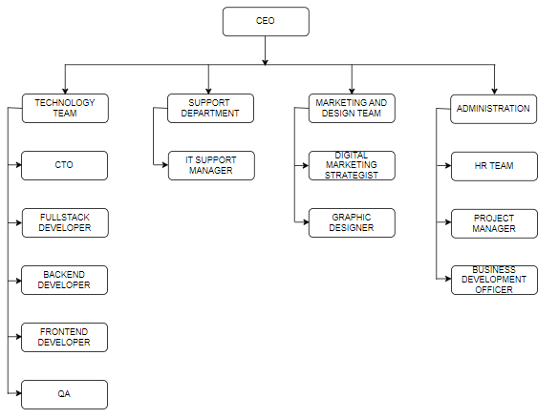
Figure 1: Organizational Structure of MindRisers Technology

Contact Details
Organization : MindRisers Technology
Address : Kumari Galli 2, Kathmandu 4460
Website : https://mindriserstech.com/
Email : mailto:info@mindrisers.com.np
Phone Number: +977- 01-5922250

CHAPTER 4

ANALYSIS OF ACTIVITIES PERFORMED

Introduction of the activities/departments/sections
The Backend Development Department plays a critical role in an IT organization, as it handles the core logic, data processing, and server-side operations. I was placed in the backend development department. This department focuses on building systems that ensure seamless interaction between the database, server, and the frontend interface of applications.
In this department, Django and Django Rest Framework (DRF) are widely used tools, especially for developing robust, scalable, and secure web applications. Django is a high-level Python web framework that encourages rapid development and clean, pragmatic design. DRF extends Django to allow the creation of APIs, enabling efficient data exchanges between clients (like web browsers or mobile apps) and servers.
The department is typically divided into three core sections:
- Database
The database is the backbone of any web application, managing data such as user info and transactions. In Django, models define database structures, and Django's ORM allows seamless interaction between Python code and the database. Backend developers design and optimize databases to ensure data integrity, performance, and scalability. Tasks include setting up migrations, defining relationships (e.g., one-to-one, one-to-many), and indexing. Well-designed databases ensure fast, secure, and error-free data handling.
- API
APIs enable communication between the backend and frontend or external apps. Using Django Rest Framework, developers create APIs for data exchange in formats like JSON. APIs handle CRUD operations, ensure secure access through authentication, and provide error handling and response optimization for smooth user interactions. APIs are crucial for secure, efficient data access, and without them, system usability and scalability would suffer.
- Testing
Testing ensures the reliability of database interactions and APIs. Developers use Django’s testing tools and Postman for comprehensive testing. Postman is particularly useful for API testing, allowing developers to test API endpoints for functionality, performance, and security. It helps verify that both new and old APIs perform as expected under various scenarios. Testing with tools like Postman helps catch bugs early and ensures that the system is stable, secure, and reliable.

Analysis of Activities Performed
During my internship period of 10-weeks in MindRisers Technology I did work in three projects. Firstly I did a small project (Recipe) to understand the flow of work while doing project in Django using DRF for about 3-weeks and after that I gained some knowledge about the flow and worked in another project (EMS) assigned by my superior which took me about 4 weeks to operate in it and after that, my superior involved me in a governmental project called Digital Palika in which I worked under its sub project called WTS for about 3- weeks. During internship I did different task.

Understanding the Project
This phase is all about gaining a deep understanding of the project before jumping into development. It involves analyzing the project’s goals and the requirements from a technical and user perspective
I began by reviewing the documentation provided, such as user stories, project outlines, or feature lists. User stories helped me understand how end-users would interact with the system and what kind of data and actions they required. For example, in the Recipe project, I needed to understand what data was involved (ingredients, process, description, etc.) and how it would be manipulated (get, post, put, deleted). Once I had a good understanding of the project’s requirements, I often did additional research to fill in any knowledge gaps. This included searching for requirements of the system and best practices for similar projects. For example, in the EMS project, I needed to understand what the user requirement features are (Registration, Event Creation, Authentication, ticketingandpayments etc.). Whenever I faced uncertainties, I reached out to senior developers or project managers for clarification. For instance, during the WTS project, I needed more details about the tracking process for Activity and Milestones, so I asked for guidance to ensure I didn’t miss any crucial details. I also discussed the scope and specific features of the project with my team to clear up any ambiguities.

Understanding Database design

Before jumping into creating models or APIs, I focused on understanding designing of the database structure that was given for as per my projects by my superior. I analyzed the relationships between different entities, like Recipe, Ingredients and categories in Recipe project likewise Activity, Milestone, Work Progress, and Review in the WTS project. I ensured the database was normalized to reduce redundancy and maintain data integrity. It was important to finalize these relationships because they defined how the data would interact with each other, whether it was a one-to-many or many-to-many relationship. I reviewed these relationships with the team to make sure they aligned with the project’s requirements before moving forward.

API Creation
Creating APIs, especially with Django Rest Framework (DRF), involves several steps that ensure the API can handle requests from clients (like web or mobile apps) and respond with the appropriate data. Let me break down the detailed process I followed for creating APIs:
- Setting up the Enviromnment
Before starting API development, I ensured my Django project was set up properly. I installed DRF then added 'rest_framework' to the INSTALLED_APPS section in settings.py to make DRF available in the project to build APIs. This setup was essential for creating a consistent and isolated development environment where I could build and test the project effectively.
- Creating models
In the API development process, the models represent the structure of the data that will be stored in the database. The models are essentially Python classes that map to database tables. For example, I created models for attendees, events, ticketing_payments, reviews_feedbacks, event_logistics and vendors. Here’s what the model for attendees look like:
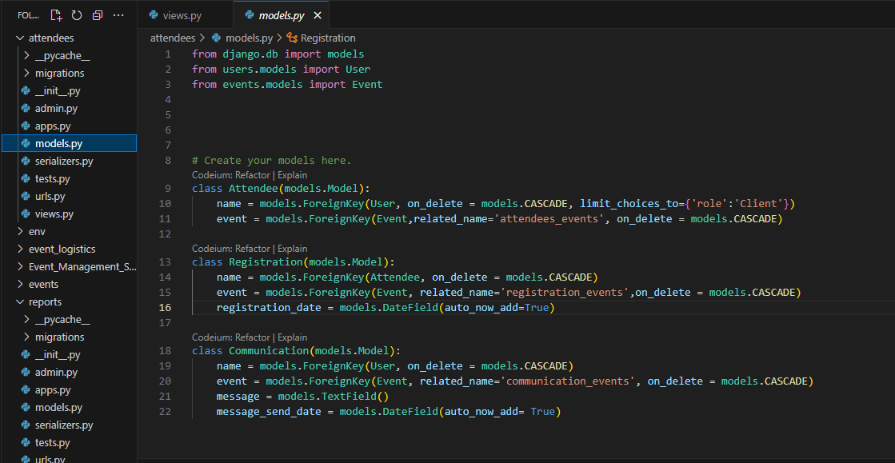
Figure 2: Attendees Model
- Serializing data
After creating models, for each model, I created corresponding serializers to convert the data models into JSON format and vice-versa format for allowing the data to be sent and received by the API. For example I created AttendeeSerializer for Attendee model. Here what Serializers for attendees model look like:
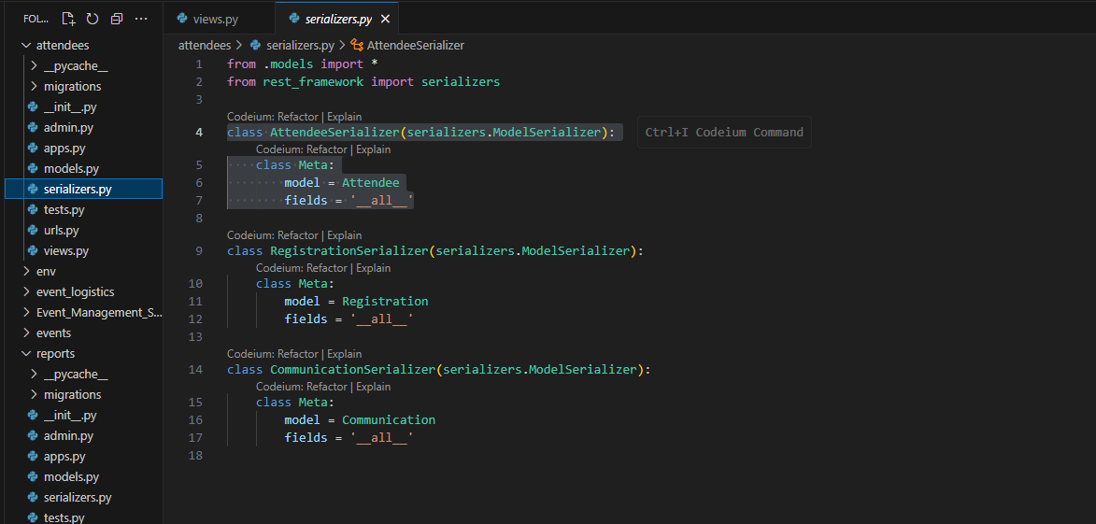
Figure 3: Serializers for attendee model
- Creating Views
Views are where the logic of the API is handled. In DRF, there are several types of views that can be used, but I mainly used ViewSets, which simplify the process of creating CRUD operations. DRF’s ModelViewSet handles most of the work. I didn’t have to manually write all the logic for each operation. It ties the queryset (the data from the model) with the serializer to format and validate the data. But somplaces I used Function-Based Views which offers flexibility to handle specific logic and custom actions that don’t fit into standard CRUD operations. For example to define specific method “POST” and also to AllowAny permission function in login API I used Function-Based Views. Here what ModelViewSet for attendee look like:
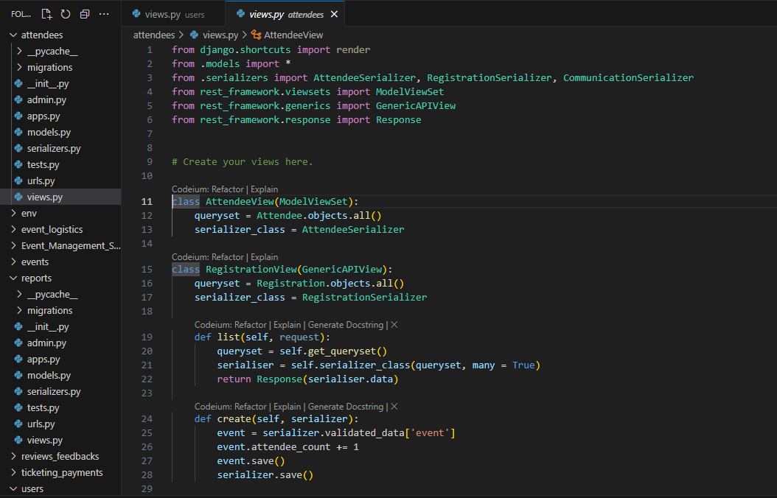
Figure 4: ModelViewSet for Attendees Model
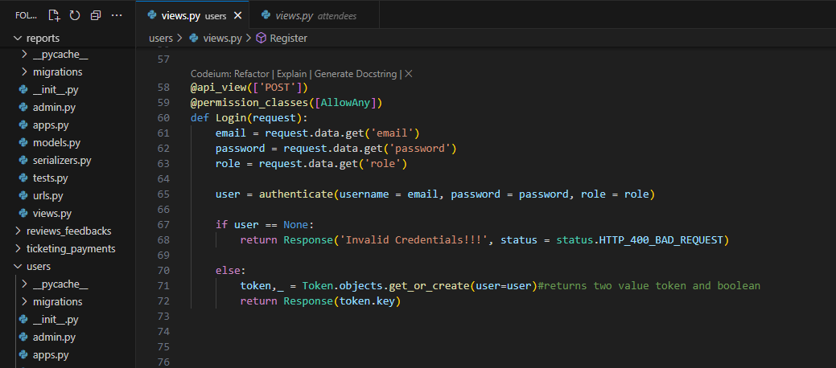
Figure 5: Function-Based Views for Attendees Model
- Routing Urls
After creating the views, I needed to make the API endpoints accessible. This is where URL routing comes in. In DRF, routers are used to automatically generate URL patterns for the viewsets.
I added routing for all the view set I created in urls.py.in every project.
Here is the URL routing for Report model looks like:
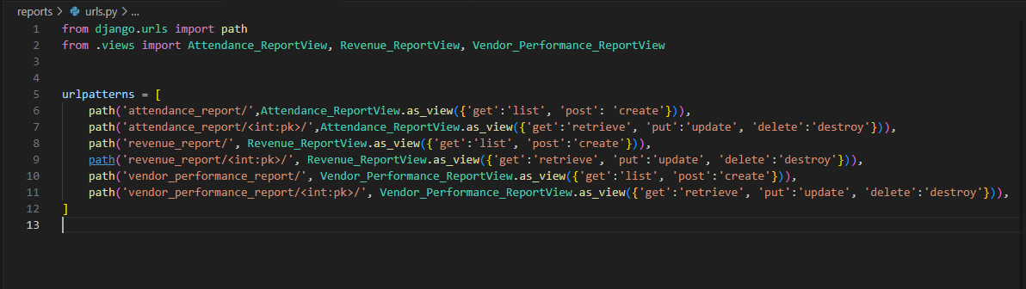
Figure 6: URL routing for Report Model

4.2.4 Authentication and Permission
After the creation of APIs to secure the APIs, I added authentication and permissions .I implemented authentication using DRF’s built-in authentication mechanisms, Token Authentication for all the APIs. This involved implementing mechanism to control access to the APIs and ensure that only authorized users could perform certain actions. I configured Django Rest Framework’s authentication classes and permissions in settings.py to restrict access based on user roles and authentication status.
For instance, I set up token-based authentication to manage user sessions and ensure secure access to the APIs. I also defined custom permissions to control who could view, create, update, or delete records, based on their roles or the specific requirements of the project.
Here the screenshot of assigning the permission for user based on their role
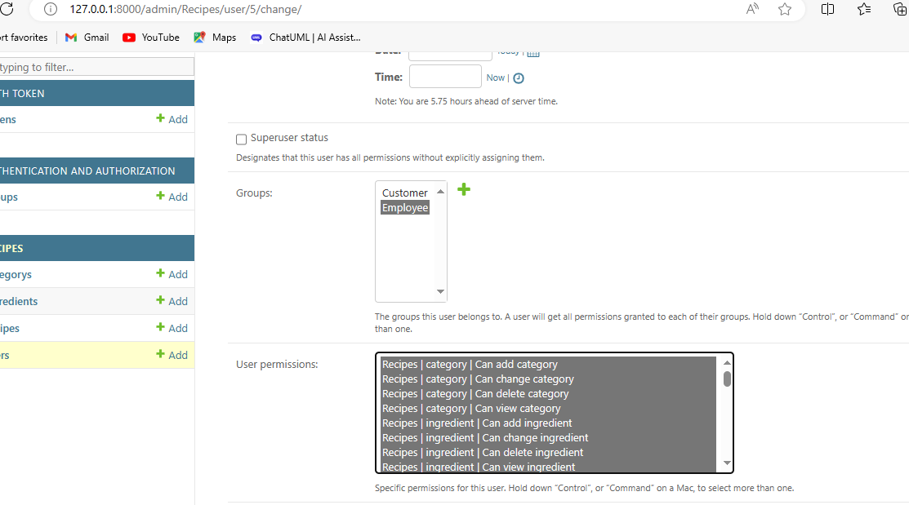
Figure 7: Permission assigned to the user as their role

4.2.5 API Testing
Finally, I focused on unit testing to ensure the reliability and functionality of the APIs. Testing involved running different scenarios to verify that the APIs behaved as expected under various conditions. as I was assigned to create CRUD operation for APIs, I tested whether the CRUD works smoothly or not and also adherence to authentication and permission rules. I used Postman tool for manually testing process and identify any issues and corrected it. Here is the screenshot of testing the Recipe API to verify whether it returns the recipe details only if the authorized user with appropriate permissions makes the request.
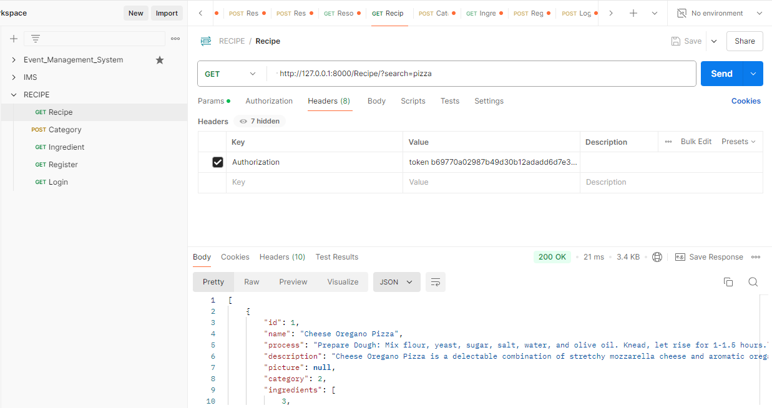
Figure 8: Testing manually for Recipe API

Emergence/occurrence of issues and how these problem were solved
Some of the issues and its solutions that occurred and solved while doing tasks in internship are as follows:
Issue: Creating models
Solution: As models designee is based on database design. I was provided the DB design was given by my mentor and according to it I started to create model but I was confused about how tables are related to each other in complex data models. So, I started to review the principle of normalization (1NF, 2NF and 3NF) to ensure that there is no redundancy and dependency. Visualize the date flow using ER diagram, how each table connects. After that I Also asked for help from superior to understand the database structure more clearly.
Issue: Misconfiguration of Authentication scheme
Solutions: While setting up authentication and token-based authentication it requires careful configuration so I followed the documentation closely to define authtoken module in INSTALLED_APPS and after that creating REST_FRAMEWORK variable configure TokenAuthentication scheme in it. Ensuring that the valid TokenAuthentication scheme was set.
Issue: Problem for authenticated registered user to login
Solutions: Django’s authentication function encrypts the plaintext password that the user entered while registration expects stored passwords to be hashed. When a plain-text password is saved during user registration, it compares with the hashed password which is required for authentication. This mismatch leads to login failure, even if the correct plain-text password is provided. So for this problem while registering the plain text password needs to be hashed for that I used Django's hasher’s module and import make_password() function to encrypt the plain-text password during user registration. This ensures the password is stored in a hashed format, which the authentication system can properly validate during login.

Issue: Problem for giving permission to user
As I used IsAuthenticated permission class for default there occurred issue while login so I needed to specifically define permission class for that, from rest_framework.decorators I imported permission_classes decorator. And with the help of it permission is defined as AllowAny in function bases view of register and login APIs.

CHAPTER 5

CONCLUSION AND LESSONS LEARNT

5.1 CONCLUSION
During my internship at Mindrisers Technology as a Backend Developer, I gained substantial hands-on experience with Django and Django Rest Framework (DRF). My main role involved developing and testing APIs for components like Activity, Milestone, and Work Progress. I began by designing the database using Django’s ORM, ensuring efficient data handling for CRUD operations while maintaining data integrity. This phase required careful planning to manage complex relationships and optimize performance.
As I progressed, I focused on building secure and scalable APIs, incorporating features such as authentication and permissions to control user access. Using DRF, I developed APIs that ensured smooth data exchange while protecting sensitive information. Testing played a key role, and I extensively used Postman to verify API functionality and Django's testing tools to ensure reliability. These efforts helped me create robust and high-performing APIs that could handle real-world usage.
Throughout the internship, I encountered challenges such as understanding the project scope and securing the APIs, but collaborating with my team and seeking guidance from senior developers allowed me to overcome them. This experience significantly improved my technical skills, particularly in API development, database design, and backend security, while also enhancing my problem-solving abilities and understanding of real-world projects. The ten-week program provided valuable industrial exposure, preparing me for future opportunities in software development.

5.2 Overall Experience, learning, knowledge gained
My internship at MindRisers Technology was an enriching experience that allowed me to transition from theoretical knowledge to practical application. The collaborative work environment and the support from my colleagues and mentors made it easier for me to adapt and grow as a backend developer. I was entrusted with real-world tasks, contributing to a government project tracking system, where I conducted unit testing to ensure functionality and reliability and as well as in a work tracking system where I created APIs ,design the DB architecture and perform unit testing to optimize the systems performance and security. This responsibility, coupled with the company’s commitment to innovation and quality, helped me develop a deep sense of accountability and a hands-on understanding of software development processes.
The lessons I learned while doing my internship are:
- Project Understanding and Requirements Gathering: Initially, understanding the project's scope and requirements was a challenge. However, with guidance from my mentor and by thoroughly studying user stories and project documentation, I learned how to effectively comprehend project needs and translate them into development tasks.
- Database Design: One of the key areas of learning for me was database normalization and designing relational databases to ensure data integrity and efficiency. I designed tables for Activity, Milestone, Ward, Work Progress, and Review models and learned how to create relationships between them.
- API Development with Django and DRF: I worked extensively with Django Rest Framework (DRF) to build CRUD operations for various models, gaining hands-on experience in structuring APIs and implementing authentication and permission.
- API Testing: I learned the importance of rigorous API testing. Using tools like Postman, I conducted manual testing to ensure the APIs functioned as expected. Additionally, I tested older projects, such as the Hotel Management System and Event Management System, which helped me understand how to approach projects developed by others.
- Teamwork: Working with experienced backend developers taught me the importance of teamwork and clear communication. I learned to ask for help when needed and share my ideas openly. This involvement helped the team succeed and improved my ability to solve problems independently in a work environment.
In terms of gaining knowledge, my skills in Django and DRF advanced considerably, particularly in handling API views, serializers, and query sets. I also gained experience in using Git and GitHub for version control, allowing me to manage code changes, resolve conflicts, and collaborate with a team effectively. Another valuable aspect of my learning was in API security, where I gained exposure to implementing authentication and permissions. Beyond technical knowledge, I also fostered my soft skills, improving communication, teamwork, and understanding of agile development practices like sprint planning and progress tracking.

BIBLIOGRAPHY

- Database Journal. (n.d.). Database normalization. Retrieved June 24 , 2024, from https://www.databasejournal.com/features/data-modeling/database-normalization/
- Django Rest Framework. (n.d.). Django Rest Framework. Retrieved August 5, 2024, from https://www.django-rest-framework.org/
- MySQL Workbench Documentation. (n.d.). MySQL Workbench. Retrieved June 21, 2024, from https://dev.mysql.com/doc/workbench/en/
- Postman. (n.d.). Postman Documentation. Retrieved August 18, 2024, from https://learning.postman.com/docs/

APPENDICES

