FRAMA C CODES – LOOPS

-Richa Vivek Savant

BL.EN.U4CSE21171

9. Sum of first n numbers using ‘while’ loop with precondition and postcondition

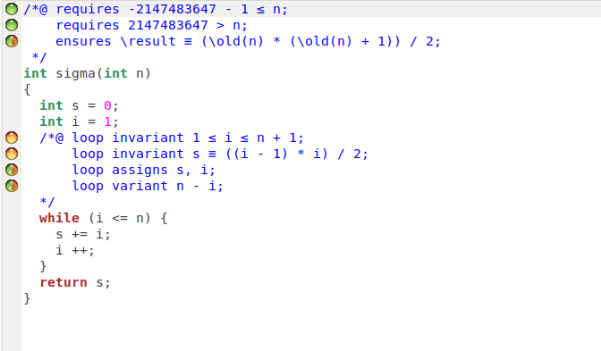

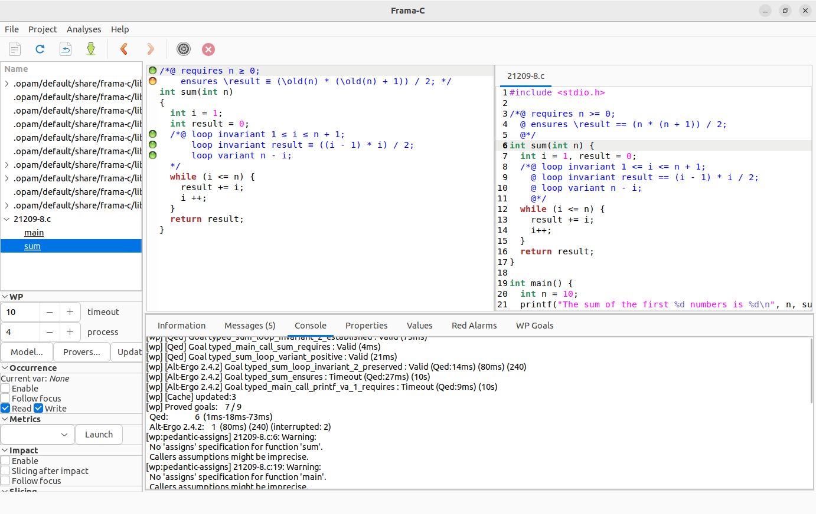

10. Sum series using ‘for’ loop with precondition and postcondition

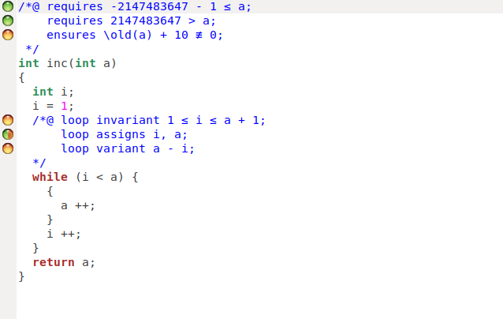

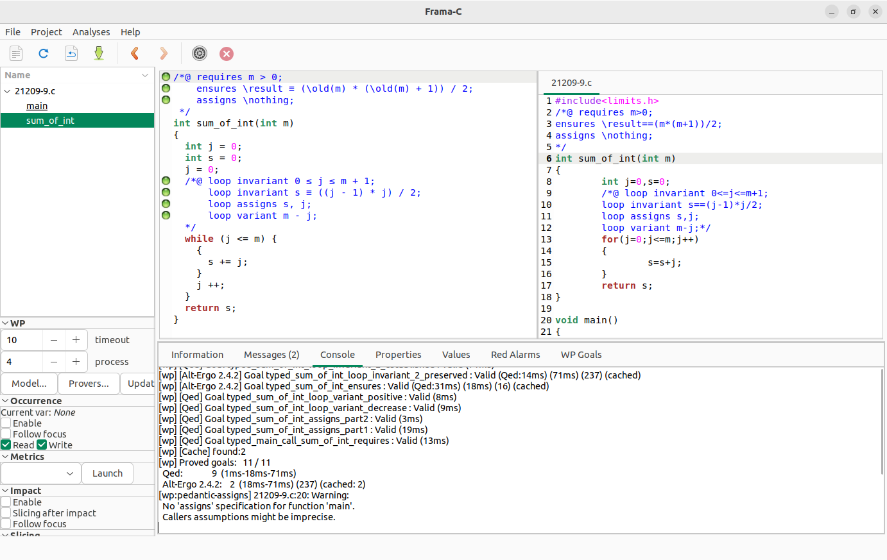

11. Sum of square of the natural numbers in the range

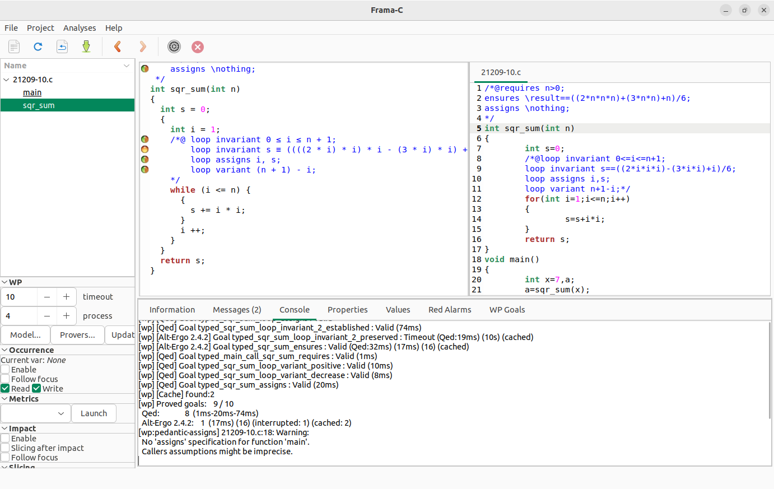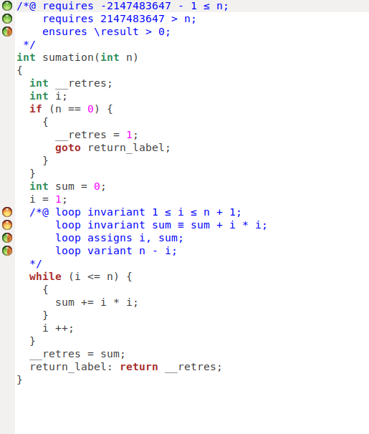

12. Compute the factorial of a given no. with precondition and postcondition.

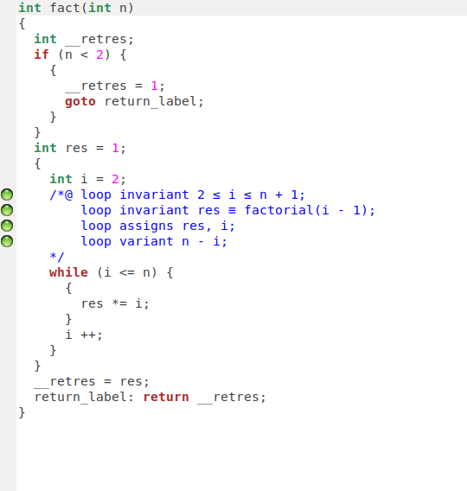

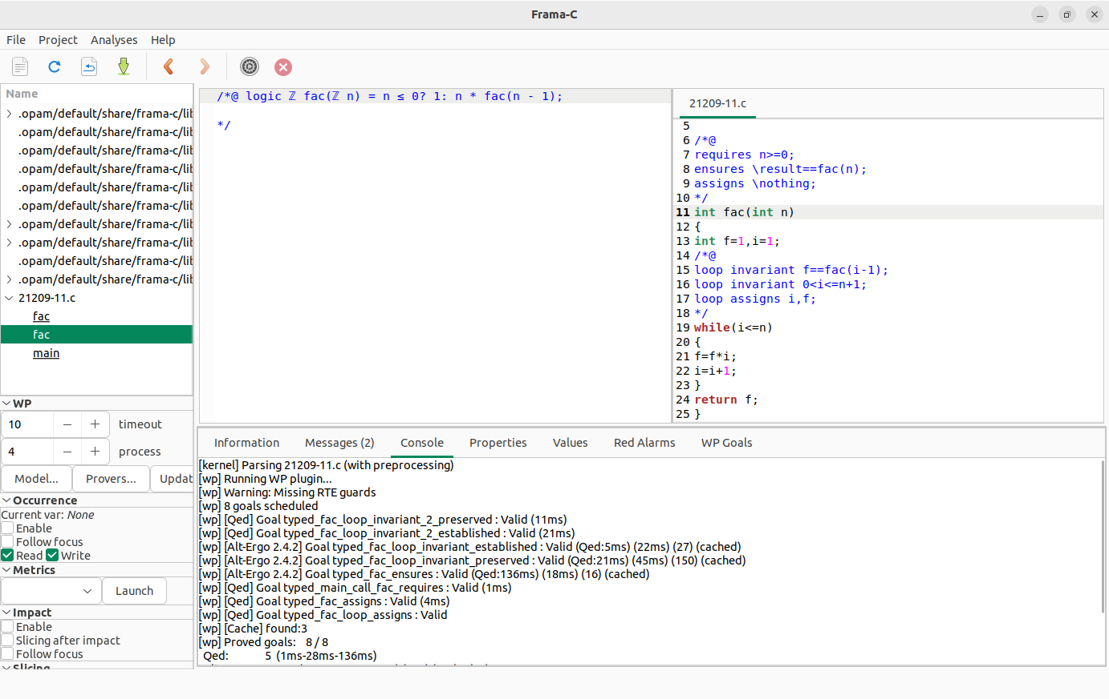

13. Compute the GCD of two numbers with precondition and postcondition.

