Task 1:
1. Experimental Results
- Test Environment Configuration:
  - Dataset Size: 128 MB
  - Number of Blocks (n): 2^7 (128 blocks)
- Single Hash (All-or-Nothing Approach):
  - Resulting SHA-256: 0c05acf58bb36284a9e73f0222f2fd0621954bb8eb5c16ee50a45341b5cd4594
  - Execution Time: 0.088621 seconds
- Merkle Tree Construction:
  - Merkle Root: 3cd74d8d7171cce47fb900a1aca739b74286b6f84e5da9490f54559dbecc8668
  - Execution Time: 0.137790 seconds
  - Internal Node Memory Overhead: 8255 Bytes
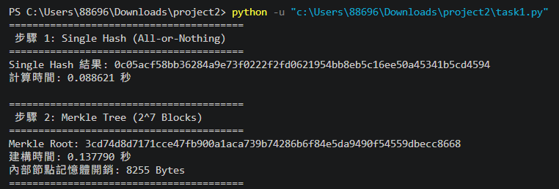2. Discussion and Findings
- Execution Time Comparison:
The Single Hash method completed in approximately 0.088 seconds, while the Merkle Tree construction took 0.137 seconds. The Single Hash approach is inherently faster because it sequentially processes the continuous 128 MB data stream in a single pass. In contrast, the Merkle Tree incurs a slight time penalty. This delay is expected, as the algorithm must slice the file into 128 distinct blocks, compute 128 individual leaf hashes, and then execute iterative loops to concatenate and hash the internal nodes upward to the root.
- Memory Overhead Analysis: To fulfill the requirement of analyzing the memory overhead of the tree's internal nodes, the measured overhead is 8255 Bytes. Mathematically, a binary Merkle Tree with n = 128 leaf nodes requires n - 1 = 127 internal parent nodes. Storing 127 SHA-256 hash objects in Python perfectly aligns with this ∼8 KB footprint.

