MFC Application

- To create an application, we need to derive a class from the MFC's CwinApp.
- We also need a frame/window to show the content of our application.
- For this, we need to add another class and derive it from the MFC's CFrameWnd class and implement its constructor and a call the Create() method, which will create a frame/window as shown in the following code.
- As you can see that Create() method needs two parameters, the name of the class, which should be passed as NULL, and the name of the window, which is the string that will be shown on the title bar.

#include <afxwin.h>

class CMyFrame : public CFrameWnd {
public:
CMyFrame() {
Create(NULL, _T("MFC Application Tutorial"));
}
};

class CExample : public CWinApp {
BOOL InitInstance() {
CMyFrame *Frame = new CMyFrame();
m_pMainWnd = Frame;

Frame->ShowWindow(SW_NORMAL);
Frame->UpdateWindow();

return TRUE;
}
};

CExample theApp;
Window Location
typedef struct tagPOINT {
LONG x;
LONG y;
} POINT;
This provides the same functionality as the POINT structure. As a C++ class, it adds more functionality needed to locate a point. It provides two constructors.
CPoint();
CPoint(int X, int Y);
Windows Size
typedef struct tagSIZE {
int cx;
int cy;
} SIZE;
Besides the Win32's SIZE structure, the MFC provides the CSize class. This class has the same functionality as SIZE but adds features of a C++ class. It provides five constructors that allow you to create a size variable in any way of your choice.
CSize();
CSize(int initCX, int initCY);
CSize(SIZE initSize);
CSize(POINT initPt);
CSize(DWORD dwSize);
Windows Dimensions
typedef struct _RECT {
LONG left;
LONG top;
LONG right;
LONG bottom;
} RECT, *PRECT;
Besides the Win32's RECT structure, the MFC provides the CRect class which has the following constructors −
CRect();
CRect(int l, int t, int r, int b);
CRect(const RECT& srcRect);
CRect(LPCRECT lpSrcRect);
CRect(POINT point, SIZE size);
CRect(POINT topLeft, POINT bottomRight);
Let us look into a simple example in which we will specify the location and the size of the window
class CMyFrame : public CFrameWnd {
public:
CMyFrame() {
Create(NULL, _T("MFC Application Tutorial"), WS_SYSMENU, CRect(90, 120,
550, 480));
}
};
- If the Window you are creating is dependent of another, you can specify that it has a parent.
- This is done with the pParentWnd argument of the CFrameWnd::Create() method.
- If the Window does not have a parent, pass the argument with a NULL value.
Let us look into an example which has only one Window, and there is no parent Window available, so we will pass the argument with NULL value as shown in the following code −
class CMyFrame : public CFrameWnd {
public:
CMyFrame() {
Create(NULL, _T("MFC Application Tutorial"), WS_SYSMENU,
CRect(90, 120, 550, 480), NULL);
}
};

Dialog Box Creation
- To create a dialog box, right-click on the Resource Files folder in solution explorer and select Add → Resource.
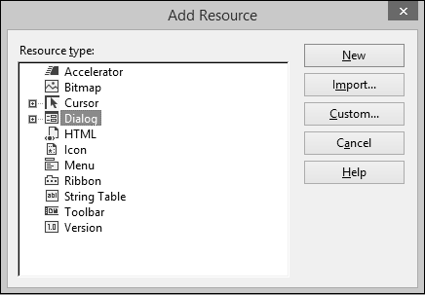
- In the Add Resource dialog box, select Dialog and click New.
- Step 3 − A dialog box requires some preparation before actually programmatically creating it.
- Step 4 − A dialog box can first be manually created as a text file (in a resource file).
- Step 5 − You can now see the MFCDialogDemo.rc file created under Resource Files.
- The resource file is open in designer. The same can be opened as a text file. Rightclick on the resource file and select Open With.
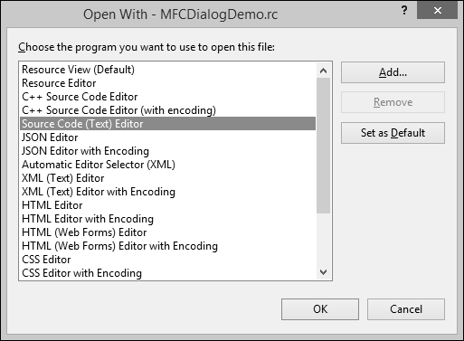
- Select the Source Code (Text) editor and click Add button.
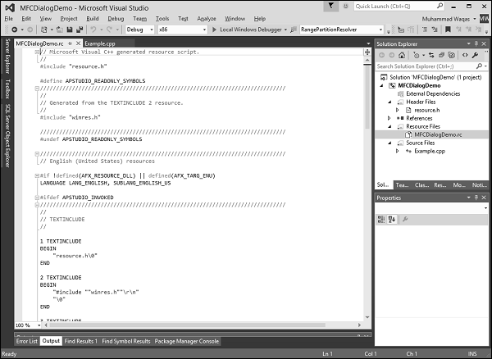
- Go back to the designer and right-click on the dialog and select Properties.
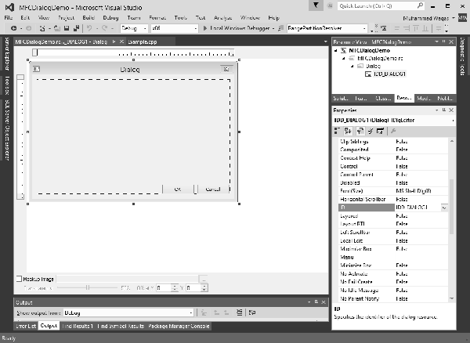
- You need to choose out of the many options.
- Like most other controls, a dialog box must be identified. The identifier (ID) of a dialog box usually starts with IDD_, Let us change the ID to IDD_EXAMPLE_DLG.

Dialog Box Methods
The base class used for displaying dialog boxes on the screen is CDialog class. To create a dialog box, we need to derive a class from CDialog. The CDialog class itself provides three constructors which are as follows −
CDialog();
CDialog(UINT nIDTemplate, CWnd* pParentWnd = NULL);
CDialog(LPCTSTR lpszTemplateName, CWnd* pParentWnd = NULL);
Let us create another class CExampleDlg and derive it from CDialog. We will implement its default constructor destructor as shown in the following code.
class CExampleDlg : public CDialog {
public:
enum { IDD = IDD_EXAMPLE_DLG };

CExampleDlg();
~CExampleDlg();
};

CExampleDlg::CExampleDlg():CDialog(CExampleDlg::IDD) {

}

CExampleDlg::~CExampleDlg() {

}
We need to instantiate this dialog on CExample::InitInstance() method as shown in the following code.
BOOL CExample::InitInstance() {
CExampleDlg myDlg;
m_pMainWnd = &myDlg;

return TRUE;
}

Modal Dialog Boxes

There are two types of dialog boxes − modeless and modal. Modal and modeless dialog boxes differ by the process used to create and display them.
Modeless Dialog Box
- For a modeless dialog box, you must provide your own public constructor in your dialog class.
- To create a modeless dialog box, call your public constructor and then call the dialog object's Create member function to load the dialog resource.
- You can call Create either during or after the constructor call. If the dialog resource has the property WS_VISIBLE, the dialog box appears immediately.
- If not, you must call its ShowWindow member function.

Modal Dialog
- To create a modal dialog box, call either of the two public constructors declared in Cdialog.
- Next, call the dialog object's DoModal member function to display the dialog box and manage interaction with it until the user chooses OK or Cancel.
- This management by DoModal is what makes the dialog box modal. For modal dialog boxes, DoModal loads the dialog resource.

- To display the dialog box as modal, in the CExample::InitInstance() event call the DoModal() method using your dialog variable −
BOOL CExample::InitInstance() {
CExampleDlg myDlg;
m_pMainWnd = &myDlg;
myDlg.DoModal();
return TRUE;
}
- Here is the complete implementation of Example.cpp file
#include <afxwin.h>
#include "resource.h"

class CExample : public CWinApp {
public:
BOOL InitInstance();
};

class CExampleDlg : public CDialog {
public:
enum { IDD = IDD_EXAMPLE_DLG };

CExampleDlg();
~CExampleDlg();
};

CExampleDlg::CExampleDlg():CDialog(CExampleDlg::IDD) {

}

CExampleDlg::~CExampleDlg() {

}

BOOL CExample::InitInstance() {
CExampleDlg myDlg;
m_pMainWnd = &myDlg;
myDlg.DoModal();
return TRUE;
}
CExample MyApp;
MFC – Windows Resources
A resource is a text file that allows the compiler to manage objects such as pictures, sounds, mouse cursors, dialog boxes, etc. Microsoft Visual Studio makes creating a resource file particularly easy by providing the necessary tools in the same environment used to program. This means, you usually do not have to use an external application to create or configure a resource file. Following are some important features related to resources.

- Resources are interface elements that provide information to the user.
- Bitmaps, icons, toolbars, and cursors are all resources.
- Some resources can be manipulated to perform an action such as selecting from a menu or entering data in dialog box.
- An application can use various resources that behave independently of each other, these resources are grouped into a text file that has the *.rc extension.
- Most resources are created by selecting the desired one from the Add Resource dialog box.

Add Resource

The Add Resource dialog box provides an extensive list of resources which can be used as per requirements, but if you need something which is not available then you can add it manually to the *.rc file before executing the program.

Identifiers

An identifier is a symbol which is a constant integer whose name usually starts with ID. It consists of two parts − a text string (symbol name) mapped to an integer value (symbol value).

Symbols provide a descriptive way of referring to resources and user-interface objects, both in your source code and while you're working with them in the resource editors.

When you create a new resource or resource object, the resource editors provide a default name for the resource, for example, IDC_DIALOG1, and assign a value to it.

The name-plus-value definition is stored in the Resource.h file.

Step 1 − Let us look into our CMFCDialogDemo example from the last chapter in which we have created a dialog box and its ID is IDD_EXAMPLE_DLG.
CMFCDialogDemo

Step 2 − Go to the Solution Explorer, you will see the resource.h file under Header Files. Continue by opening this file in editor and you will see the dialog box identifier and its integer value as well.
Identifiers2
Icons

An icon is a small picture used on a window which represents an application. It is used in two main scenarios.

On a Window's frame, it is displayed on the left side of the Window name on the title bar.

In Windows Explorer, on the Desktop, in My Computer, or in the Control Panel window.

If you look at our MFCModalDemo example, you will see that Visual studio was using a default icon for the title bar as shown in the following snapshot.
Icons

You can create your own icon by following the steps given below −

- Right-click on your project and select Add → Resources, you will see the Add Resources dialog box. Select Add Resources.
- Select Icon and click New button and you will see the following icon.
- In Solution Explorer, go to Resource View and expand MFCModalDemo > Icon. You will see two icons. The IDR_MAINFRAME is the default one and IDI_ICON1 is the newly created icon.
- Right-click on the newly Created icon and select Properties.
- IDI_ICON1 is the ID of this icon, now Let us change this ID to IDR_MYICON.
- You can now change this icon in the designer as per your requirements. We will use the same icon.
- Save this icon.
- Go to the CMFCModalDemoDlg constructor in CMFCModalDemoDlg.cpp file which will look like the following code.

CMFCModalDemoDlg::CMFCModalDemoDlg(CWnd* pParent /* = NULL*/)
: CDialogEx(IDD_MFCMODALDEMO_DIALOG, pParent) {
m_hIcon = AfxGetApp() -> LoadIcon(IDR_MAINFRAME);
}

- You can now see that the default icon is loaded in the constructor. Let us change it to IDR_ MYICON as shown in the following code.

CMFCModalDemoDlg::CMFCModalDemoDlg(CWnd* pParent /* = NULL*/)
: CDialogEx(IDD_MFCMODALDEMO_DIALOG, pParent) {
m_hIcon = AfxGetApp() -> LoadIcon(IDR_ MYICON);
}

- When the above code is compiled and executed, you will see the new icon is displayed on the dialog box.
Modal Demo
Menus

Menus allow you to arrange commands in a logical and easy-to-find fashion. With the Menu editor, you can create and edit menus by working directly with a menu bar that closely resembles the one in your finished application. To create a menu, follow the steps given below −

Step 1 − Right-click on your project and select Add → Resources. You will see the Add Resources dialog box.
Add Resources Menu

Step 2 − Select Menu and click New. You will see the rectangle that contains "Type Here" on the menu bar.
Type Here on Menu Bar

Step 3 − Write some menu options like File, Edit, etc. as shown in the following snapshot.
Menu Options

Step 4 − If you expand the Menu folder in Resource View, you will see the Menu identifier IDR_MENU1. Right-click on this identifier and change it to IDM_MAINMENU.
Menu Identifier

Step 5 − Save all the changes.

Step 6 − We need to attach this menu to our dialog box. Expand your Dialog folder in Solution Explorer and double click on the dialog box identifier.
Dialog Folder

Step 7 − You will see the menu field in the Properties. Select the Menu identifier from the dropdown as shown above.

Step 8 − Run this application and you will see the following dialog box which also contains menu options.
Menu Option
Toolbars

A toolbar is a Windows control that allows the user to perform some actions on a form by clicking a button instead of using a menu.

A toolbar provides a convenient group of buttons that simplifies the user's job by bringing the most accessible actions as buttons.

A toolbar can bring such common actions closer to the user.

Toolbars usually display under the main menu.

They can be equipped with buttons but sometimes their buttons or some of their buttons have a caption.

Toolbars can also be equipped with other types of controls.

To create a toolbar, following are the steps.

Step 1 − Right-click on your project and select Add → Resources. You will see the Add Resources dialog box.
Toolbar

Step 2 − Select Toolbar and click New. You will see the following screen.
Select Toolbar

Step 3 − Design your toolbar in the designer as shown in the following screenshot and specify the IDs as well.
Design Toolbar

Step 4 − Add these two variables in CMFCModalDemoDlg class.

CToolBar m_wndToolBar;
BOOL butD;

Step 5 − Following is the complete implementation of CMFCModalDemoDlg in CMFCModalDemoDlg.h file −

class CMFCModalDemoDlg : public CDialogEx {
// Construction
public:
CMFCModalDemoDlg(CWnd* pParent = NULL); // standard constructor
// Dialog Data
#ifdef AFX_DESIGN_TIME
enum { IDD = IDD_MFCMODALDEMO_DIALOG };
#endif

protected:
virtual void DoDataExchange(CDataExchange* pDX); // DDX/DDV support

// Implementation
protected:
HICON m_hIcon;
CToolBar m_wndToolBar;
BOOL butD;

// Generated message map functions
virtual BOOL OnInitDialog();
afx_msg void OnPaint();
afx_msg HCURSOR OnQueryDragIcon();
DECLARE_MESSAGE_MAP()

public:
afx_msg void OnBnClickedOk();
};

Step 6 − Update CMFCModalDemoDlg::OnInitDialog() as shown in the following code.

BOOL CMFCModalDemoDlg::OnInitDialog() {
CDialogEx::OnInitDialog();

// Set the icon for this dialog. The framework does this automatically
// when the application's main window is not a dialog
SetIcon(m_hIcon, TRUE); // Set big icon
SetIcon(m_hIcon, FALSE); // Set small icon

if (!m_wndToolBar.Create(this)
|| !m_wndToolBar.LoadToolBar(IDR_TOOLBAR1))
//if (!m_wndToolBar.CreateEx(this, TBSTYLE_FLAT, WS_CHILD |
// WS_VISIBLE | CBRS_TOP | CBRS_GRIPPER | CBRS_TOOLTIPS |
// CBRS_FLYBY | CBRS_SIZE_DYNAMIC) ||
// !m_wndToolBar.LoadToolBar(IDR_TOOLBAR1)) {
TRACE0("Failed to Create Dialog Toolbar\n");
EndDialog(IDCANCEL);
}
butD = TRUE;
CRect rcClientOld; // Old Client Rect
CRect rcClientNew; // New Client Rect with Tollbar Added

// Retrive the Old Client WindowSize
// Called to reposition and resize control bars in the client area of a window
// The reposQuery FLAG does not really traw the Toolbar. It only does the calculations.
// And puts the new ClientRect values in rcClientNew so we can do the rest of the Math.

GetClientRect(rcClientOld);
RepositionBars(AFX_IDW_CONTROLBAR_FIRST, AFX_IDW_CONTROLBAR_LAST, 0, reposQuery, rcClientNew);
// All of the Child Windows (Controls) now need to be moved so the Tollbar does not cover them up.
// Offest to move all child controls after adding Tollbar
CPoint ptOffset(rcClientNew.left - rcClientOld.left, rcClientNew.top - rcClientOld.top);

CRect rcChild;
CWnd* pwndChild = GetWindow(GW_CHILD); //Handle to the Dialog Controls

while (pwndChild) // Cycle through all child controls {
pwndChild -> GetWindowRect(rcChild); // Get the child control RECT
ScreenToClient(rcChild);

// Changes the Child Rect by the values of the claculated offset
rcChild.OffsetRect(ptOffset);
pwndChild -> MoveWindow(rcChild, FALSE); // Move the Child Control
pwndChild = pwndChild -> GetNextWindow();
}

CRect rcWindow;
// Get the RECT of the Dialog
GetWindowRect(rcWindow);

// Increase width to new Client Width
rcWindow.right += rcClientOld.Width() - rcClientNew.Width();

// Increase height to new Client Height
rcWindow.bottom += rcClientOld.Height() - rcClientNew.Height();
// Redraw Window
MoveWindow(rcWindow, FALSE);

// Now we REALLY Redraw the Toolbar
RepositionBars(AFX_IDW_CONTROLBAR_FIRST, AFX_IDW_CONTROLBAR_LAST, 0);

// TODO: Add extra initialization here

return TRUE; // return TRUE unless you set the focus to a control
}

Step 7 − Run this application. You will see the following dialog box which also contains the toolbar.
Toolbar4
Accelerators

An access key is a letter that allows the user to perform a menu action faster by using the keyboard instead of the mouse. This is usually faster because the user would not need to position the mouse anywhere, which reduces the time it takes to perform the action.

Step 1 − To create an access key, type an ampersand "&" on the left of the menu item.
Create an Access Key

Step 2 − Repeat this step for all menu options. Run this application and press Alt. You will see that the first letter of all menu options are underlined.
Menu Option
Shortcut Key

A shortcut key is a key or a combination of keys used by advanced users to perform an action that would otherwise be done on a menu item. Most shortcuts are a combination of the Ctrl key simultaneously pressed with a letter key. For example, Ctrl + N, Ctrl + O, or Ctrl + D.

To create a shortcut, on the right side of the string that makes up a menu caption, rightclick on the menu item and select properties.

In the Caption field type \t followed by the desired combination as shown below for the New menu option. Repeat the step for all menu options.
Shortcut Key
Accelerator Table

An Accelerator Table is a list of items where each item of the table combines an identifier, a shortcut key, and a constant number that specifies the kind of accelerator key. Just like the other resources, an accelerator table can be created manually in a .rc file. Following are the steps to create an accelerator table.

Step 1 − To create an accelerator table, right-click on *.rc file in the solution explorer.
Accelerator Table

Step 2 − Select Accelerator and click New.
Select Accelerator

Step 3 − Click the arrow of the ID combo box and select menu Items.
Accelerator Table

Step 4 − Select Ctrl from the Modifier dropdown.

Step 5 − Click the Key box and type the respective Keys for both menu options.

We will also add New menu item event handler to testing. Right-click on the New menu option.
Event Handler

Step 6 − You can specify a class, message type and handler name. For now, let us leave it as it is and click Add and Edit button.
Message Type Handler Name

Step 7 − Select Add Event Handler.

Step 8 − You will now see the event added at the end of the CMFCModalDemoDlg.cpp file.

void CMFCModalDemoDlg::OnFileNew() {
// TODO: Add your command handler code here
MessageBox(L"File > New menu option");
}

Step 9 − Now Let us add a message box that will display the simple menu option message.

To start accelerator table in working add the HACCEL variable and ProcessMessageFilter as shown in the following CMFCModalDemoApp.

class CMFCModalDemoApp : public CWinApp {
public:
CMFCModalDemoApp();

// Overrides
public:
virtual BOOL InitInstance();
HACCEL m_hAccelTable;

// Implementation

DECLARE_MESSAGE_MAP()
virtual BOOL ProcessMessageFilter(int code, LPMSG lpMsg);
};

Step 10 − Load Accelerator and the following call in the CMFCModalDemoApp::InitInstance().

m_hAccelTable = LoadAccelerators(AfxGetInstanceHandle(),
MAKEINTRESOURCE(IDR_ACCELERATOR1));

Step 11 − Here is the implementation of ProcessMessageFilter.

BOOL CMFCModalDemoApp::ProcessMessageFilter(int code, LPMSG lpMsg) {
if (code >= 0 && m_pMainWnd && m_hAccelTable) {
if (::TranslateAccelerator(m_pMainWnd -> m_hWnd, m_hAccelTable, lpMsg))
return TRUE;
}
return CWinApp::ProcessMessageFilter(code, lpMsg);
}

Step 12 − When the above code is compiled and executed, you will see the following output.
Accelerator Result

Step 13 − Press Alt button followed by F key and then N key or Ctrl + N. You will see the following message.
Accelerator Table

Multi-threading
// MFCMultithreadingDlg.cpp : implementation file
//

#include "stdafx.h"
#include "MFCMultithreading.h"
#include "MFCMultithreadingDlg.h"
#include "afxdialogex.h"

#ifdef _DEBUG
#define new DEBUG_NEW
#endif

// CMFCMultithreadingDlg dialog

int currValue;
int maxValue;
BOOL stopNow;

CMFCMultithreadingDlg::CMFCMultithreadingDlg(CWnd* pParent /* = NULL*/)
: CDialogEx(IDD_MFCMULTITHREADING_DIALOG, pParent) {
m_hIcon = AfxGetApp() -> LoadIcon(IDR_MAINFRAME);
}
void CMFCMultithreadingDlg::DoDataExchange(CDataExchange* pDX) {
CDialogEx::DoDataExchange(pDX);
DDX_Control(pDX, IDC_STATIC_TEXT, m_ctrlStatus);
}

BEGIN_MESSAGE_MAP(CMFCMultithreadingDlg, CDialogEx)
ON_WM_PAINT()
ON_WM_QUERYDRAGICON()
ON_BN_CLICKED(IDC_BUTTON_START,
&CMFCMultithreadingDlg::OnBnClickedButtonStart)
ON_WM_TIMER()
ON_BN_CLICKED(IDC_BUTTON_STOP,
&CMFCMultithreadingDlg::OnBnClickedButtonStop)
END_MESSAGE_MAP()

// CMFCMultithreadingDlg message handlers

BOOL CMFCMultithreadingDlg::OnInitDialog() {
CDialogEx::OnInitDialog();

// Set the icon for this dialog. The framework does this automatically
// when the application's main window is not a dialog
SetIcon(m_hIcon, TRUE); // Set big icon
SetIcon(m_hIcon, FALSE); // Set small icon

// TODO: Add extra initialization here

return TRUE; // return TRUE unless you set the focus to a control
}

// If you add a minimize button to your dialog, you will need the code below
// to draw the icon. For MFC applications using the document/view model,
// this is automatically done for you by the framework.

void CMFCMultithreadingDlg::OnPaint() {
if (IsIconic()) {
CPaintDC dc(this); // device context for painting
SendMessage(WM_ICONERASEBKGND,
reinterpret_cast<WPARAM>(dc.GetSafeHdc()), 0);

// Center icon in client rectangle
int cxIcon = GetSystemMetrics(SM_CXICON);
int cyIcon = GetSystemMetrics(SM_CYICON);
CRect rect;
GetClientRect(&rect);
int x = (rect.Width() - cxIcon + 1) / 2;
int y = (rect.Height() - cyIcon + 1) / 2;

// Draw the icon
dc.DrawIcon(x, y, m_hIcon);
}else {
CDialogEx::OnPaint();
}
}
// The system calls this function to obtain the cursor to display while the user drags
// the minimized window.
HCURSOR CMFCMultithreadingDlg::OnQueryDragIcon() {
return static_cast<HCURSOR>(m_hIcon);
}

UINT /*CThreadDlg::*/MyThreadProc(LPVOID Param) //Sample function for using in
AfxBeginThread {
while (!stopNow && (currValue < maxValue)) {
currValue++;
Sleep(50); // would do some work here
}
return TRUE;
}
void CMFCMultithreadingDlg::OnBnClickedButtonStart() {
// TODO: Add your control notification handler code here
currValue = 0;
maxValue = 5000;
stopNow = 0;
m_ctrlStatus.SetWindowText(L"Starting...");
SetTimer(1234, 333, 0); // 3 times per second

AfxBeginThread(MyThreadProc, 0); // <<== START THE THREAD
}

void CMFCMultithreadingDlg::OnTimer(UINT_PTR nIDEvent) {
// TODO: Add your message handler code here and/or call default
CString sStatusMsg;
sStatusMsg.Format(L"Running: %d", currValue);
m_ctrlStatus.SetWindowText(sStatusMsg);

CDialogEx::OnTimer(nIDEvent);
}

void CMFCMultithreadingDlg::OnBnClickedButtonStop() {
// TODO: Add your control notification handler code here
stopNow = TRUE;
KillTimer(1234);
m_ctrlStatus.SetWindowText(L"Stopped");
}

