**This lab is worth 3% of your final AI4G grade.**

**Due Friday February 4th 17:00**

**Training an Artificial Neural Network via Backpropagation**

**Lab 8**

Follow the instructions in “Back Propagation Solution Walk Through.docx”.

Type your name here 🡪 Richard Fleming

Copy in screen shots here to demonstrate completion of the following:

1. The TensorFlow training showing the 15 predictions it makes at the end of the training process.

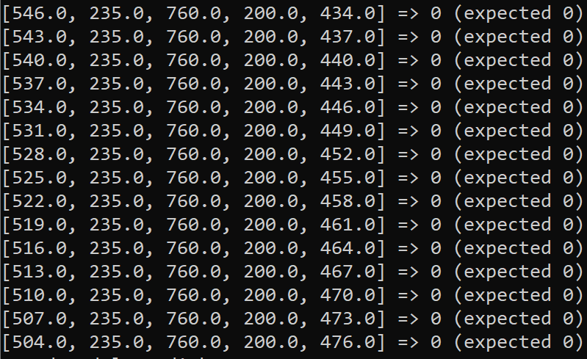

1. Successful execution of the “convert_flappy_model_weights_to_csv.py” script.

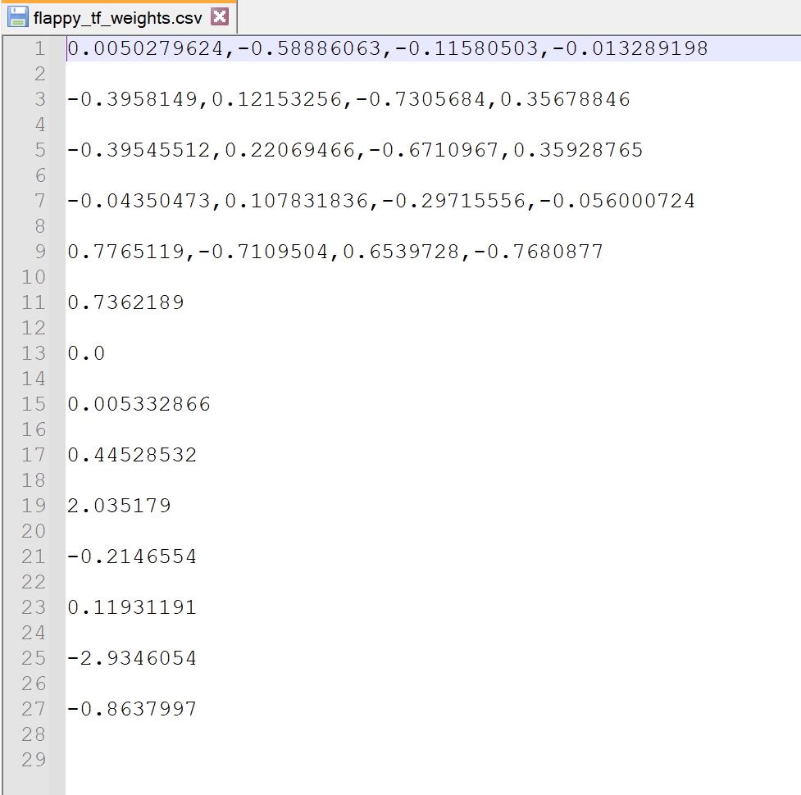

1. The AI playing the game with the trained weights showing at least one bird with a fitness > 100.

