IP Header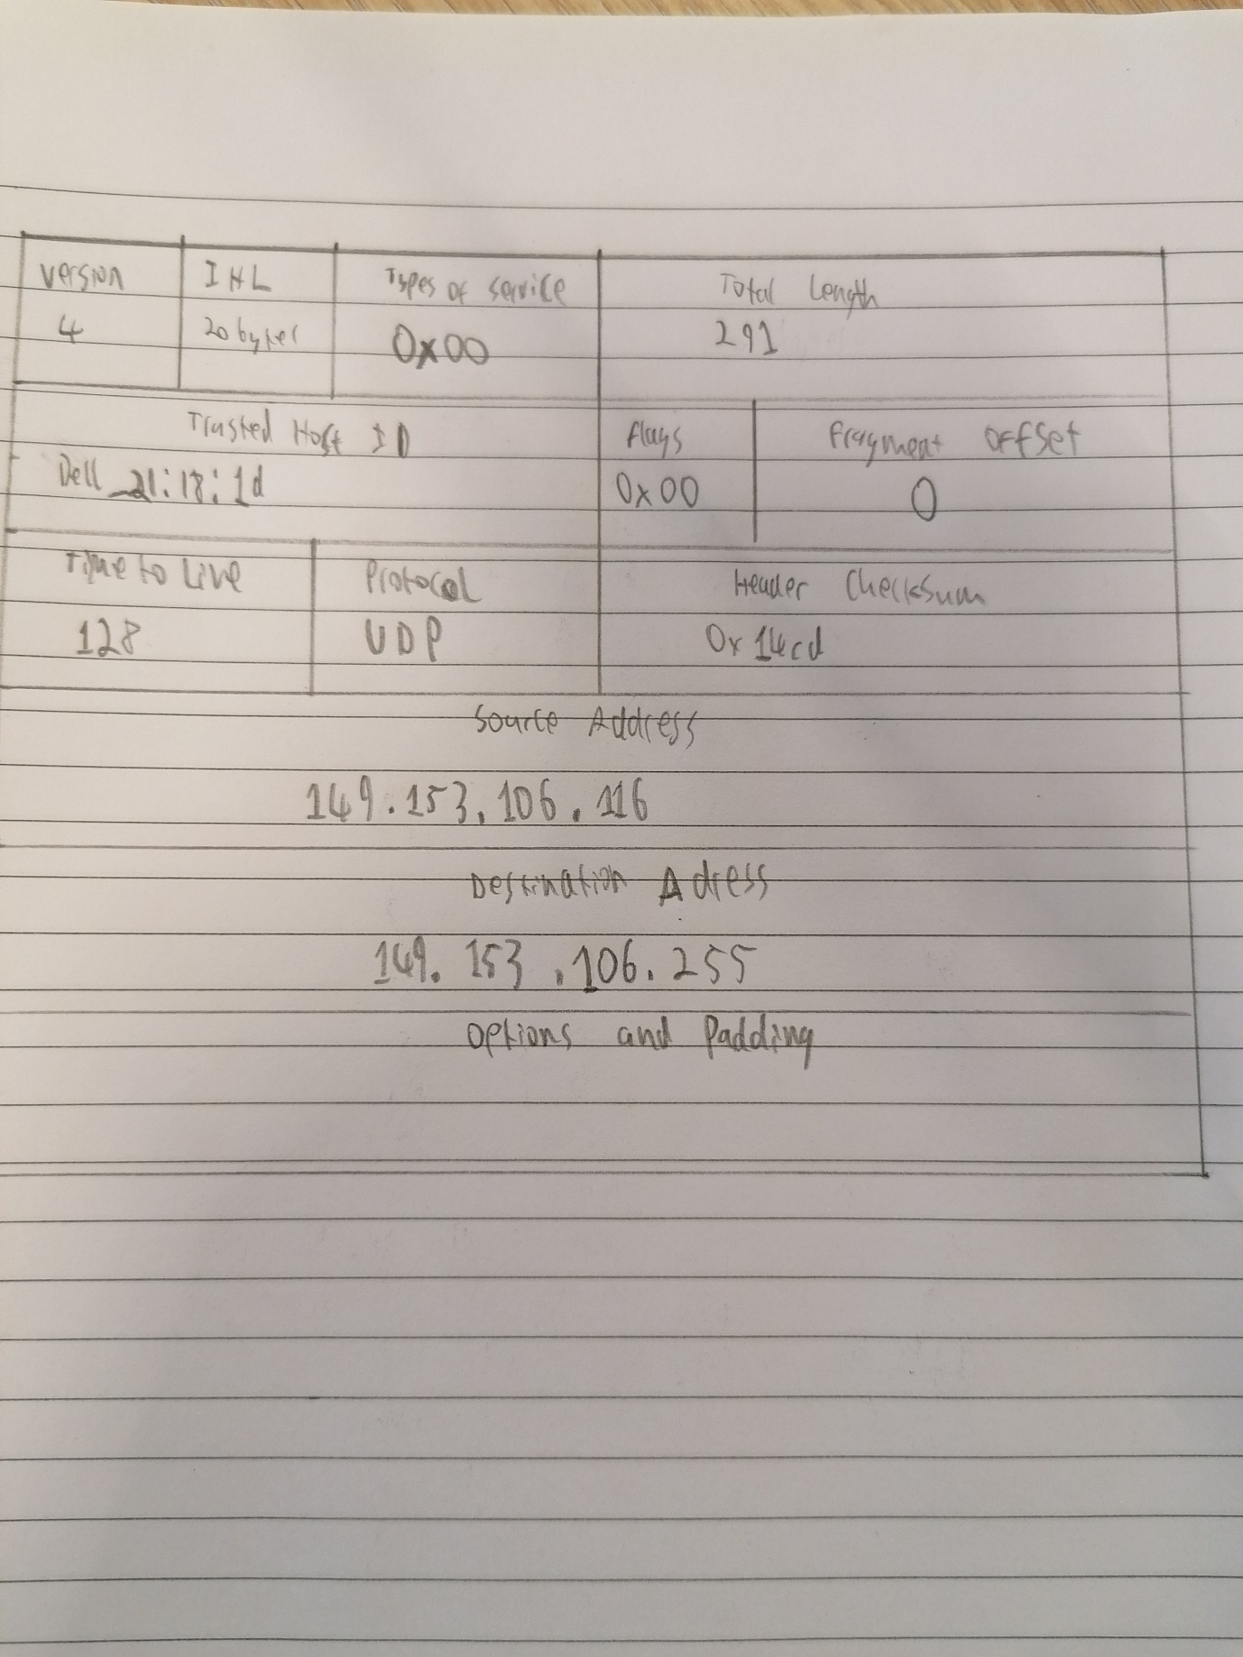

# Fields

**Version** - A 4-bit field that identifies the IP version being used. The current version is 4.

**Length** - A 4-bit field containing the length of the IP header in 32-bit increments. The minimum length of an IP header is 20 bytes, or five 32-bit increments. The maximum length of an IP header is 24 bytes, or six 32-bit increments. Therefore, the header length field should contain either 5 or 6.

**Type of Service (ToS)** - The 8-bit ToS uses 3 bits for IP Precedence, 4 bits for ToS with the last bit not being used. The 4-bit ToS field, although defined, has never been used.

**Total Length** - Specifies the length of the IP packet that includes the IP header and the user data. The length field is 2 bytes, so the maximum size of an IP packet is 216 – 1 or 65,535 bytes.

**Identifier, Flags, and Fragment Offset** - As an IP packet moves through the Internet, it might need to cross a route that cannot handle the size of the packet. The packet will be divided, or fragmented, into smaller packets and reassembled later. These fields are used to fragment and reassemble packets.

**Time to Live (TTL)** - It is possible for an IP packet to roam aimlessly around the Internet. If there is a routing problem or a routing loop, then you don't want packets to be forwarded forever. A routing loop is when a packet is continually routed through the same routers over and over. The TTL field is initially set to a number and decremented by every router that is passed through. When TTL reaches 0 the packet is discarded.

**Protocol** - In the layered protocol model, the layer that determines which application the data is from or which application the data is for is indicated using the Protocol field. This field does not identify the application, but identifies a protocol that sits above the IP layer that is used for application identification.

**Header Checksum** - A value calculated based on the contents of the IP header. Used to determine if any errors have been introduced during transmission.

**Source IP Address** - 32-bit IP address of the sender.

**Destination IP Address** - 32-bit IP address of the intended recipient.

**Options and Padding** - A field that varies in length from 0 to a multiple of 32-bits. If the option values are not a multiple of 32-bits, 0s are added or padded to ensure this field contains a multiple of 32 bits.

# Packet Difference

The main difference I saw was that my previous packet’s protocol was UDP while the provided packet was IPv4.