Reproducible O-RU Power Measurement (Software Proxy)
TEEP Final Report Draft (Markdown-first)
Jesaya David
2026-02-05

Abstract
This work develops a reproducible power-measurement methodology for an O-RAN Radio Unit (O-RU), with an initial software-first proxy executed on a general-purpose Linux host. Because RU hardware and lab-grade instrumentation were not always available, we measure platform power using Intel/AMD RAPL energy counters exposed via Linux and collected by Scaphandre.
We define repeatable workload states (Idle, Active-Idle, Load-L/M/H), synchronize scenario boundaries via explicit UTC markers, and compute power/energy statistics on trimmed steady-state windows. A multi-round sweep shows a strong Idle→Active step and a narrower active band across load levels. A “burst vs smooth” proxy experiment demonstrates that race-to-sleep (TDM-style duty cycling) can reduce average platform power by ~48% at iso-throughput, motivating scheduler-level future work.
Scope note: Reported power values are platform power under RU-like workload, not RU AC/DC input power.

1. Background and Goal

1.1 Problem statement
Energy consumption in RAN infrastructure is dominated by the base station and radio unit. To compare energy behavior across configurations and ultimately across vendors/hardware, we need a measurement procedure that is: - repeatable (same scenario → same result within noise), - traceable (clear measurement point, units, timestamps), - reviewer-safe (explicit windowing, clear limitations).

1.2 Project goal
Establish a reproducible methodology that can be executed now (software proxy) and later transferred to hardware-grade RU input power measurement without changing the scenario structure.

2. Measurement Point and Metrics

2.1 Measurement point (software proxy)
- Device under test (DUT): General-purpose compute host running RU-like workload proxy.
- Power instrument: Scaphandre (Prometheus exporter) reading Linux RAPL counters.
- Signal: scaph_host_power_microwatts scraped at ~10 s cadence.

2.2 Metrics
We compute per-state metrics on steady-state windows: - Average power: $P_{avg}$ (W) - Energy: $E$ (J) - Throughput: $T$ (Gbps) - Efficiency (proxy): $η=T/P_{avg}$ (Gbps/W)
Energy is approximated from samples as:
E≈i​PiΔt

3. Scenario Definition

3.1 States
- Idle: OS baseline, no traffic.
- Active-Idle: measurement/stack active, traffic off.
- Load-L/M/H: offered load steps (nominally 30% / 60% / 100%).

3.2 Run structure
To avoid boundary transients, we: - record explicit Start_* / Stop_* markers in UTC, - trim 10 s from the start and end of each marked segment, - score only the trimmed windows.

4. Tooling and Data Formats

4.1 Toolchain
- Scaphandre (power estimator)
- iperf3 (traffic generation)
- Bash scripts for orchestration
- Python scripts for parsing/plotting

4.2 Artifact conventions
- Raw runs live under runs/YYYY-MM-DD/...
- Plots and summaries live under assets/YYYY-MM-DD/plots/

5. Experimental Results

5.1 Pilot: Power-enabled pipeline validation (2026-01-20)
A pilot run validated end-to-end logging, markers, and per-state scoring.
Per-state summary (pilot)
State | Mean Power (W) | Energy (J) | Duration (s) | Throughput (Gbps) | Efficiency (Gbps/W)
Pure Idle | 1.023 | 91.6 | 100
Active-Idle | 1.859 | 319.7 | 181
Load-M | 37.631 | 10704.6 | 292 | 97.464 | 2.590
Source artifacts: runs/2026-01-20/.

5.2 Week 3: Load sweep statistics (2026-01-22)
A multi-state sweep (Idle + Load-L/M/H) demonstrates repeatability and the “step-function” behavior:
State | Mean (W) | Std (W) | CV (%)
Idle | 1.4920 | 0.7964 | 53.38
Load-L | 50.5983 | 2.9533 | 5.84
Load-M | 50.2996 | 3.4350 | 6.83
Load-H | 48.8443 | 8.3225 | 17.04
Key observation: once traffic begins, platform power jumps from ~1–2 W to ~50 W, with only modest separation between L/M/H compared to the Idle→Active jump.
Supporting plots: - Timeline: 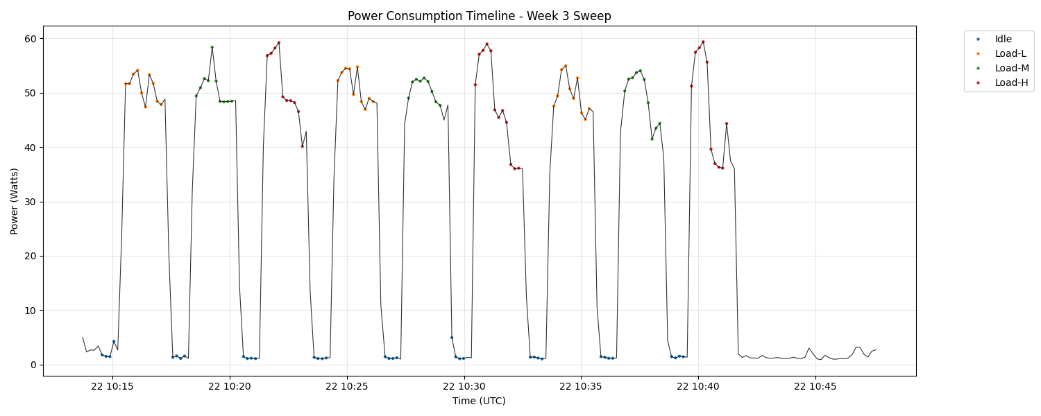 - Linearity: 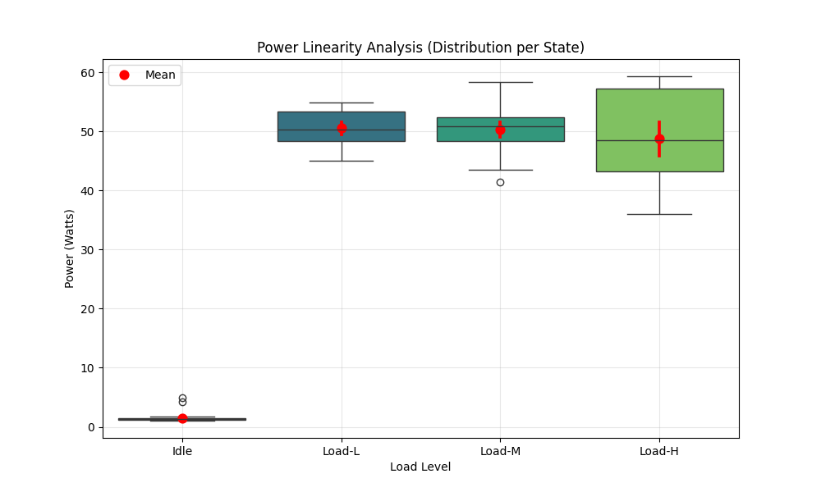

5.3 Week 4: Gap analysis vs RU anchor classes (2026-01-28)
We produced a publishable sensitivity plot and a gap overlay comparing the proxy power trace to modeled RU classes.
Key trimmed-window medians (proxy): - Idle median: 5.696 W - Active median: 24.983 W - 30% load median: 23.353 W - 60% load median: 24.983 W - 100% load median: 26.926 W
RU anchors used (P12-style classes): - Micro RU: $P_{min}=59$ W, $P_{max}=110$ W - Macro RU: $P_{min}=197$ W, $P_{max}=531$ W
Derived ratios (RU / proxy): - $59/5.696≈10.36×$ (micro idle vs proxy idle) - $197/5.696≈34.59×$ (macro idle vs proxy idle)
Figures: - Sensitivity: 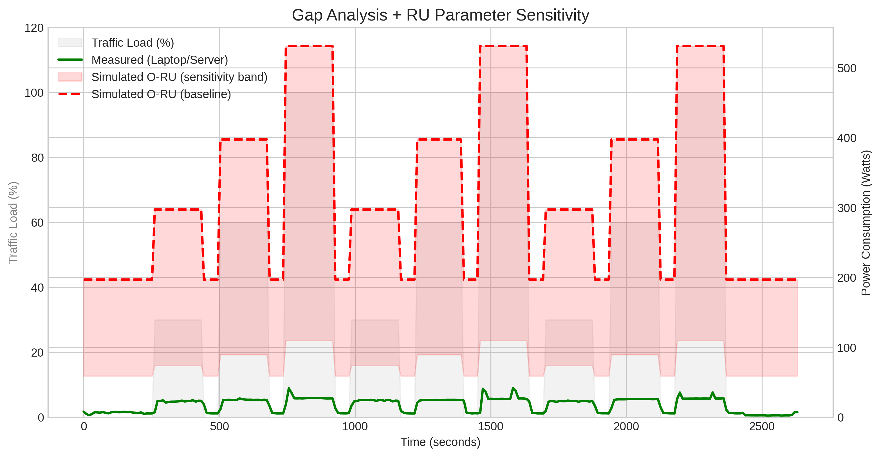 - Gap overlay: 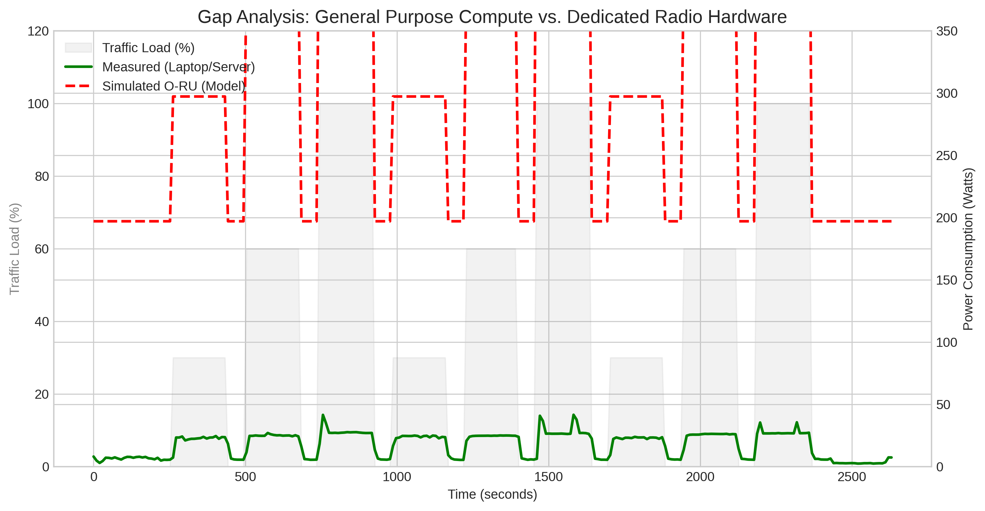

5.4 Two-host sweep (Windows sink) (2026-02-05)
To increase credibility beyond localhost/loopback, we repeated the sweep with two hosts: - Measured host (Linux laptop): power logging + iperf3 client - Sink (Windows PC): iperf3 server
Artifacts: - Run folder: runs/2026-02-05/sweep-120233/ - Stats table: assets/2026-02-05/plots/stats_summary.md - Repeatability table: assets/2026-02-05/plots/repeatability_per_run.md - Throughput table (client logs): runs/2026-02-05/sweep-120233/iperf_client_summary.md
Trimmed-window power summary:
State | Mean (W) | Std (W) | CV (%) | Min (W) | Max (W)
Idle | 3.4075 | 0.2798 | 8.21 | 2.9361 | 4.1295
Load-L | 6.1682 | 0.3811 | 6.18 | 5.0077 | 6.8600
Load-M | 6.1960 | 0.3657 | 5.90 | 5.3906 | 7.3279
Load-H | 6.5841 | 1.4690 | 22.31 | 5.3178 | 16.3342
Notes: - This run used TCP mode (best-effort). The L/M/H labels are nominal; achieved throughput depends on link capacity and TCP behavior. - Offered throughput was Wi‑Fi-limited in this run; achieved receiver rates were ~51–61 Mbps across L/M/H. - Load-H shows a high CV due to a single large spike (max 16.33 W) concentrated in Run 2; repeatability per-run statistics isolate this event.
Supporting plots: - Timeline: 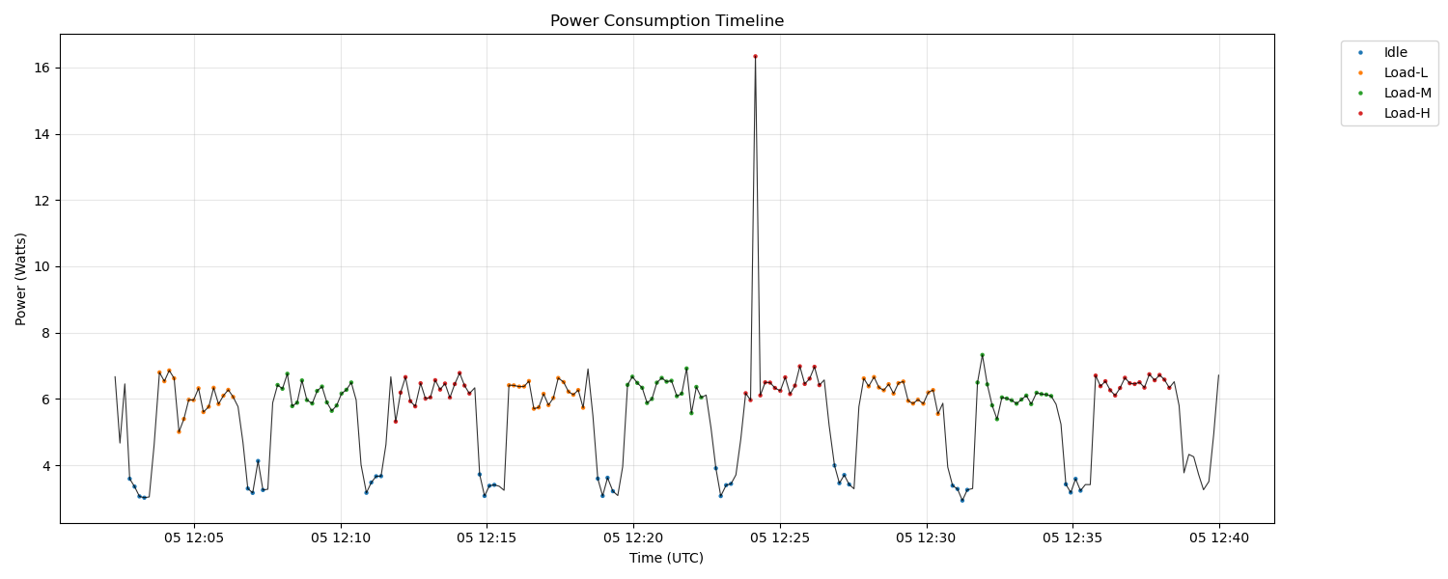 - Linearity: 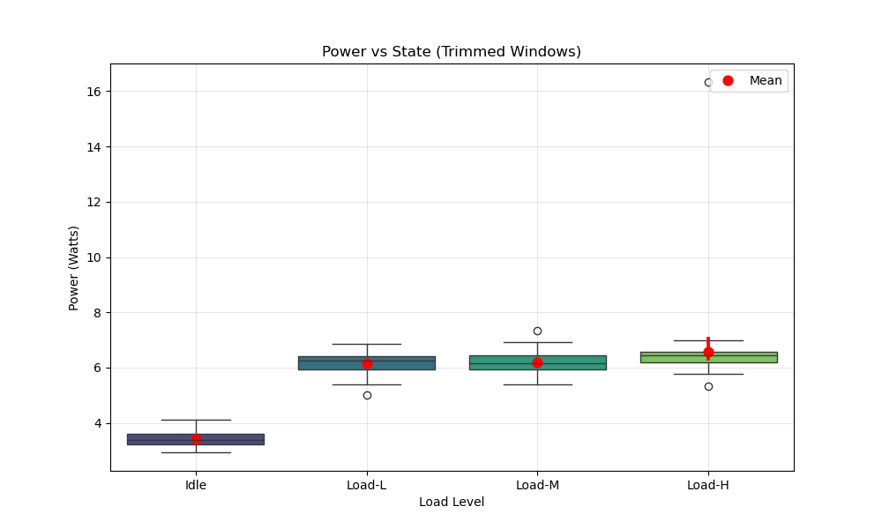

5.5 Validation: Burst vs smooth at iso-throughput (2026-02-04)
We tested a “race-to-sleep” proxy using duty-cycled traffic.
Phase | Duration (s) | Avg Power (W)
Idle baseline | 60.0 | 4.79
Smooth (30%) | 180.0 | 21.78
Burst (30% duty) | 180.2 | 11.25
Savings: $21.78−11.25=10.53$ W (48.4%).

6. Discussion

6.1 What the proxy can and cannot claim
This methodology reliably measures platform power response to workload state changes. It does not directly measure: - RU power amplifier behavior, - RU AC/DC input power, - RF output power or EIRP.

6.2 Interpreting step-function behavior
The Week 3/4 sweeps suggest the platform enters a high-power operating regime as soon as sustained traffic begins (CPU frequency/uncore/NIC activity), after which incremental throughput changes do not strongly increase platform power.

6.3 Relation to prior work (context for the “gap”)
Our observations are consistent with the recurring theme in base-station power modeling literature: static/offset power dominates at low load, so efficiency gains require enabling real sleep states rather than only reducing utilization.
For an annotated literature bridge (working notes), see: - “How Much Energy is Needed to Run a Wireless Network?” (E³F framework; static power issue) - “Energy Efficiency Improvements through Micro Sites …” (offset power importance) - “A Parameterized Base Station Power Model” (load/bandwidth/antenna parameterization) - “Deploying Dense Networks for Maximal Energy Efficiency …” (circuit power dominance; multiplexing)

7. Limitations and Threats to Validity
- Software proxy only (no RU AC/DC input).
- Sampling cadence (~10 s) limits transient analysis.
- Loopback/localhost traffic can overemphasize CPU/network stack vs NIC/PHY behavior.
- Background OS tasks and CPU governor can bias the “active band.”

8. Data Quality and Acceptance Criteria (Proposed)
These criteria are chosen to be practical for an internship report while still being reviewer-safe.

8.1 Repeatability (power)
For each state (Idle, Active-Idle, Load-L/M/H), compute the coefficient of variation:
$$CV=\frac{σ}{μ}×100\%$$
Proposed thresholds (steady-state, trimmed windows): - Load states (L/M/H): target $CV≤10\%$ (good), $CV≤5\%$ (strong). - Active-Idle: target $CV≤10\%$. - Idle: may exhibit higher CV due to low absolute power; accept if Idle is clearly separated from Active band and the windowing policy is consistent.

8.2 State separability (sanity)
- Ordering check (typical): $P_{idle}<P_{active}<P_{load}$.
- Practical check: state-to-state differences should be visually obvious in the timeline plot and supported by per-state statistics (mean/median).

9. Reproducibility (How to Run)

9.1 Prerequisites (Ubuntu / native Linux on the measured host)
- RAPL must be available (typically /sys/class/powercap).
- Scaphandre Prometheus exporter running and reachable at http://localhost:8080/metrics.
- iperf3 installed.
Start Scaphandre (Docker example):
sudo docker run --rm --privileged --pid=host \
-p 8080:8080 \
-v /proc:/proc:ro \
-v /sys:/sys:ro \
hubblo/scaphandre prometheus --address 0.0.0.0 --port 8080
Start iperf3 server (same host for loopback experiments):
iperf3 -s

9.2 Two-host topology (recommended for credibility)
Use a separate sink host to avoid loopback artifacts.
- Host A (Measured DUT, Ubuntu): runs Scaphandre + the iperf3 client + the sweep scripts.
- Host B (Traffic sink, Windows/WSL acceptable): runs an iperf3 server.
Notes for Windows/WSL sink: - Simplest: run iperf3 server natively on Windows (better throughput, fewer networking surprises). - If you run the server inside WSL2, inbound connections may require Windows port forwarding due to WSL2 NAT.

9.3 Week 4 sweep (gap analysis inputs)
This produces a new run folder containing power_uw.txt, markers.csv, and per-segment iperf logs.
./scripts/run_week4_gap_run.sh
Optional overrides (choose targets that match your link; e.g., 1 GbE cannot sustain 30G):
TARGET_HOST=127.0.0.1 MODE=udp TARGET_L=30G TARGET_M=60G TARGET_H=90G \
OUTPUT_DIR=runs/$(date -u +%Y-%m-%d)/sweep-01 \
./scripts/run_week4_gap_run.sh
Analyze and generate plots/stat summaries:
python3 scripts/analyze_week3_data.py runs/2026-01-28/sweep-01

9.4 Burst experiment
Run:
./scripts/run_burst_experiment.sh
Notes: - The run artifacts go under runs/YYYY-MM-DD/burst-experiment/. - The analysis script currently reads power_uw.txt from the repository root (not from the run folder). If your power log is stored elsewhere, copy/symlink it to ./power_uw.txt before running the analysis.
Analyze:
python3 scripts/analyze_burst_experiment.py

9.5 Export to PDF (optional)
If you have pandoc installed:
pandoc docs/FinalReport/00_Final_Report_Draft.md -o final_report.pdf

9. Conclusions
- A marker-aligned, trimmed-window procedure yields stable, reviewer-safe per-state power statistics.
- The proxy platform shows a strong Idle→Active jump and a narrower active band across L/M/H.
- Duty-cycled “bursting” reduces average platform power substantially at iso-throughput, motivating scheduler-level TDM approaches.

10. Future Work
- Hardware-in-loop measurement at RU input power (PDU/analyzer), preserving the same scenario states and marker policy.
- Multi-host (real NIC path) validation to reduce loopback artifacts.
- Scheduler modifications to create controllable idle gaps (TDM) and verify micro-sleep entry on RU hardware.

References (draft)

Internal (repo)
- Methodology, SOP, and results drafts under docs/FinalReport/.
- Study notes and experiment logs under docs/StudyNotes/.
- Raw artifacts under runs/ and derived plots under assets/.

Literature notes (need full BibTeX later)
- assets/2026-02-02/Paper1.md
- assets/2026-02-02/Paper2.md
- assets/2026-02-02/Paper3.md
- assets/2026-02-02/Paper4.md

