Smart parking

Phase 1: Project Definition and Design Thinking

**Project Definition**:

The project involves integrating IoT sensors into public transportation vehicles to monitor ridership, track locations, and predict arrival times. The goal is to provide real-time transit information to the public through public platform, enhancing the efficiency and quality of public transportation services. This project includes defining objectives, designing the IoT sensor system, developing the real-time transit information platform, and integrating them using IoT technology and Python.

Design thinking:

Objective:

* An IoT-based parking system is a centralized management that enables drivers to search for and reserve a parking spot remotely through their smartphones.
* It offers a convenient arrangement for drivers to park their cars when they are looking to avoid potential traffic congestion.

IOT device design:

* Building an advanced parking system is essential in a developing country like India where population and automobiles are increasing rapidly.
* Usage of the automobiles is increasing very rapidly, but the efficient parking slots are not available to park an automobile, which force the driver to park a vehicle on the roads, which is the reason for heavy congestion on the roads and slow movement of traffic.
* Although, lot of time is wasted in searching for parking slot. Also, while searching parking slots, movement of traffic becomes slow. To overcome all the problems mentioned above, we need an efficient parking system which would help to reduce traffic congestion at important locations where traffic rush is more. Arduino based car parking will provide automatic management of parking lots without any error.
* This problem cannot be solved by adding parking spaces or by making multi-storey parking spaces. Instead we need to enhance our available parking system to advanced monitoring parking system.
* This project will help to ensure the security of a vehicle, reduce corruption, man power and makes the whole parking as an automated system which will be error free and can reduce time of users in parking their vehicle. Because of, not properly maintained parking spaces, peoples are forced to park their vehicle on the roads which result in heavy congestion as well as road blockage. Our automated parking provides the user-friendly environment to park a vehicle in a safe place because only an authorized person can park their vehicle.
* As congestion on a road reduces, it will automatically reduce pollution generated by vehicle in traffic.

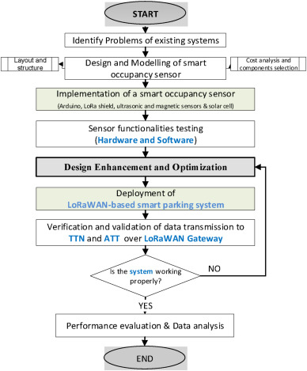

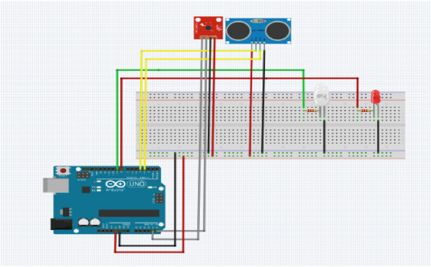

DATA SHARING PLATFORM:

