**Motion Sensor Glove**

**Contents**

1. Hardware: 2

1.1 9DoF Sensor Stick (LSM9DS1) 2

1.2 TCA9548A multiplex 2

1.3 Flex Sensor 3

1.4 Arduino Uno 4

1.5 Arduino Mega 2560 4

2. Components: 5

3. Workflow: 5

4. Instructions for Use: 6

4.1 Add library documents 6

4.2 Upload the code to the Arduino Uno 6

4.3 Upload the code to the Arduino Mega2560 8

4.4 Open the Serial Monitor 9

4.5 Initialize the Flex sensors 10

4.6 Start 11

# 1. Hardware:

## 1.1 9DoF Sensor Stick (LSM9DS1)

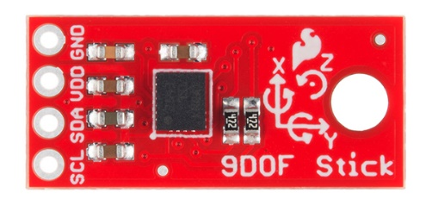LSM9DS1 Details:

* 3 acceleration channels, 3 angular rate channels, 3 magnetic field channels
* ±2/±4/±8/±16 g linear acceleration full scale
* ±4/±8/±12/±16 gauss magnetic full scale
* ±245/±500/±2000 dps angular rate full scale
* I2C serial interface
* Operating Voltage: 3.3V

More details:

[**https://learn.sparkfun.com/tutorials/9dof-sensor-stick-hookup-guide/all**](https://learn.sparkfun.com/tutorials/9dof-sensor-stick-hookup-guide/all)

## 1.2 TCA9548A multiplex

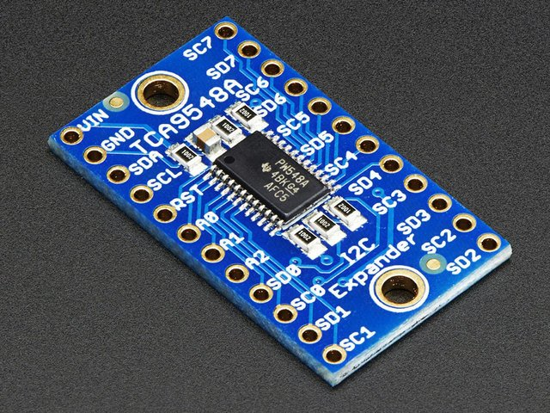We basically send it a command to tell it which I2C multiplexed output we want to talk to, then we can address the board you want to address.

**More details:**

[**https://learn.adafruit.com/adafruit-tca9548a-1-to-8-i2c-multiplexer-breakout**](https://learn.adafruit.com/adafruit-tca9548a-1-to-8-i2c-multiplexer-breakout)

**Wiring & Test**

[**Wiring & Test | Adafruit TCA9548A 1-to-8 I2C Multiplexer Breakout | Adafruit Learning System**](https://learn.adafruit.com/adafruit-tca9548a-1-to-8-i2c-multiplexer-breakout/wiring-and-test)

## 1.3 Flex SensorFlex Sensor 2.2"

The conductive ink printed on the sensor acts as a resistor. When the sensor is straight, this resistance is about 25k. When the sensor is bent, conductive layer is stretched, resulting in reduced cross section (imagine stretching a rubber band). This reduced cross section results in an increased resistance. At 90° angle, this resistance is about 100KΩ. When the sensor is straightened again, the resistance returns to its original value.

More details:

[**Flex Sensor Features, Working, Circuit & Datasheet (components101.com)**](https://components101.com/sensors/flex-sensor-working-circuit-datasheet)

## 1.4 Arduino Uno

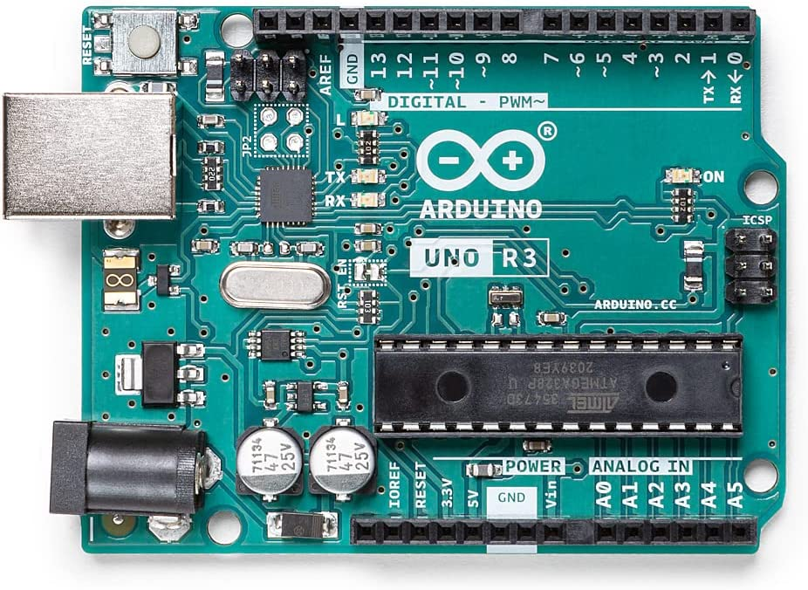

**More Details:**

[**https://store-usa.arduino.cc/products/arduino-uno-rev3**](https://store-usa.arduino.cc/products/arduino-uno-rev3)

## 1.5 Arduino Mega 2560

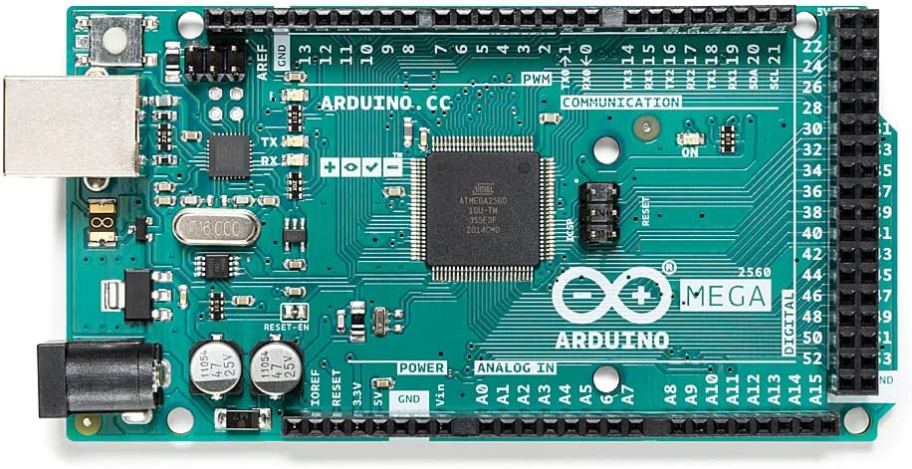

**More details：**

[**https://store-usa.arduino.cc/products/arduino-mega-2560-rev3**](https://store-usa.arduino.cc/products/arduino-mega-2560-rev3)

# 2. Components:

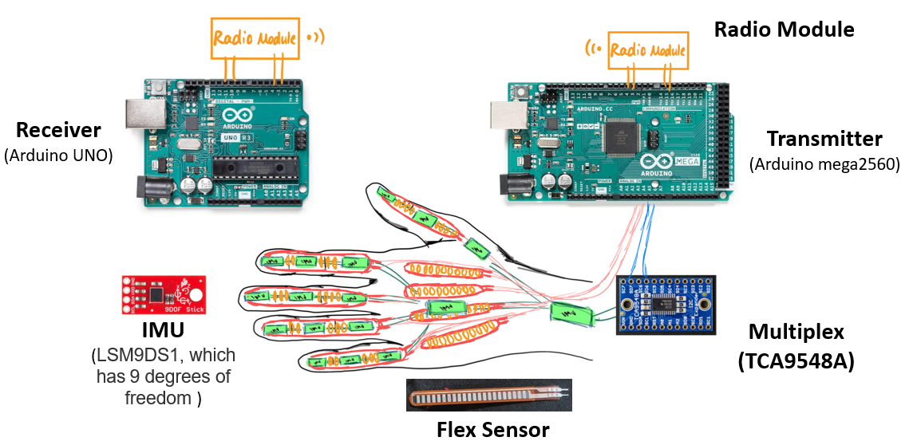

# 3. Workflow:

1. 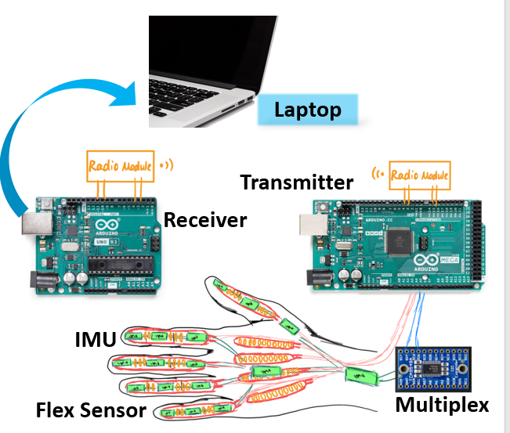The data from the 16 IMUs and 9 Angle Sensors will be read by the Arduino mega2560.
2. The data read from the sensors will be processed by the Arduino mega2560. Then we can get the acceleration, angular rate, magnetic field, direction data (from IMU) and angle data (from flex sensors)
3. After the Arduino mega2560 get the data, it will work as a transmitter and send the data to the receiver (Arduino Uno), which is connected to the laptop. Then we can see the data from the laptop and do further analysis.

# 4. Instructions for Use:

## 4.1 Add library documents

You need to move the *SparkFun_LSM9DS1_Arduino_Library folder* and the *RadioHead* into a libraries folder within your Arduino sketchbook or use the Library Manger to install.

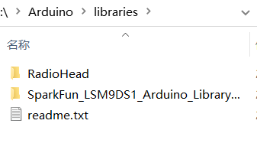

## 4.2 Upload the code to the Arduino Uno

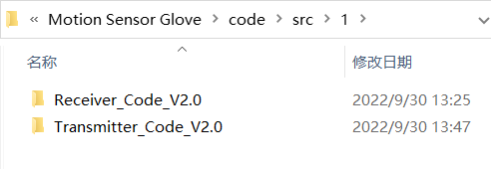I wrote two codes to choose from. The code in the first folder which function has been shown in the workflow has two codes. The receiver code should be upload to the Arduino Uno. The transmitter code should be upload to the Arduino Mega2560.

*Here is the receiver part:*

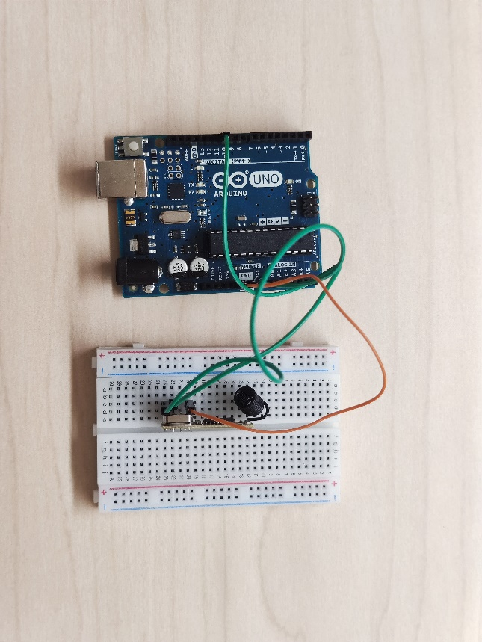

**Choose the board in Arduino IDE and connect the Arduino Uno to your laptop.**

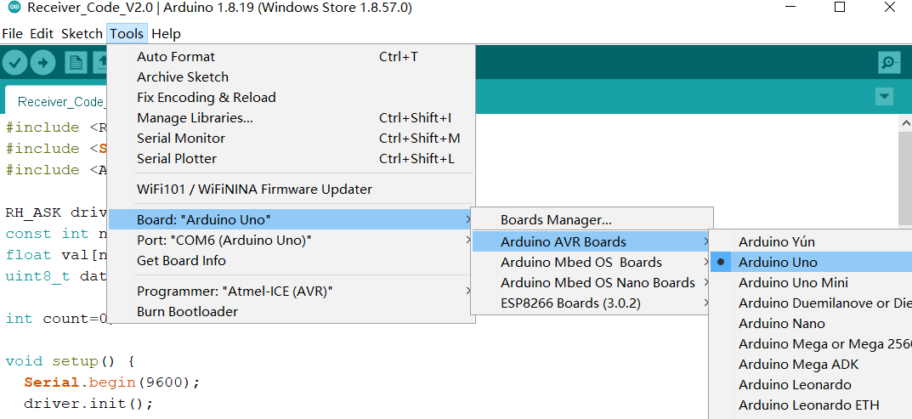

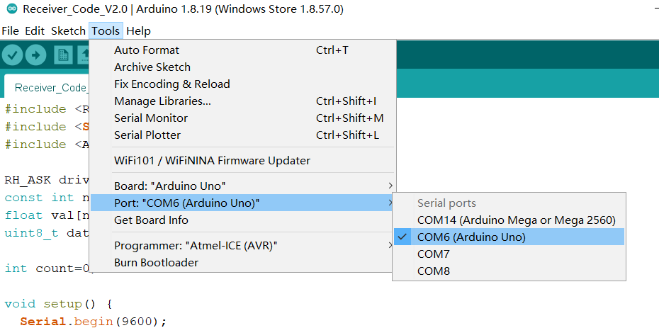

**If you have connected it successfully, you will see this:**

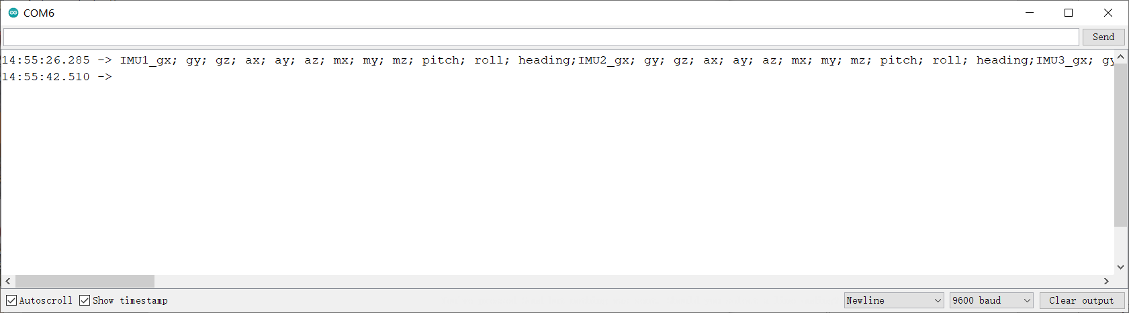

## 4.3 Upload the code to the Arduino Mega2560

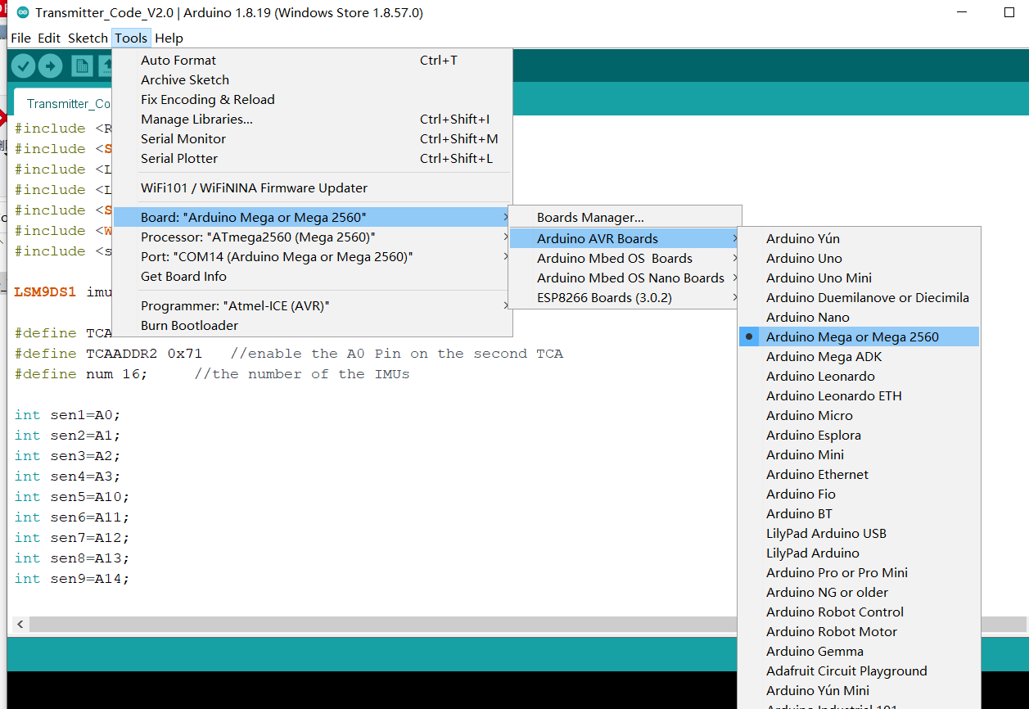

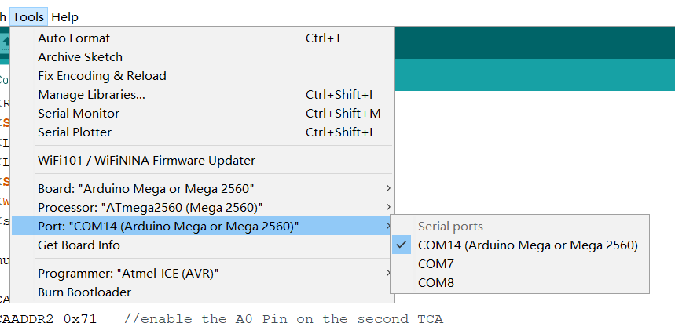

## 4.4 Open the Serial Monitor

You will see some data sent by the Arduino Mega2560, like the picture below. This means it has initialized successfully.

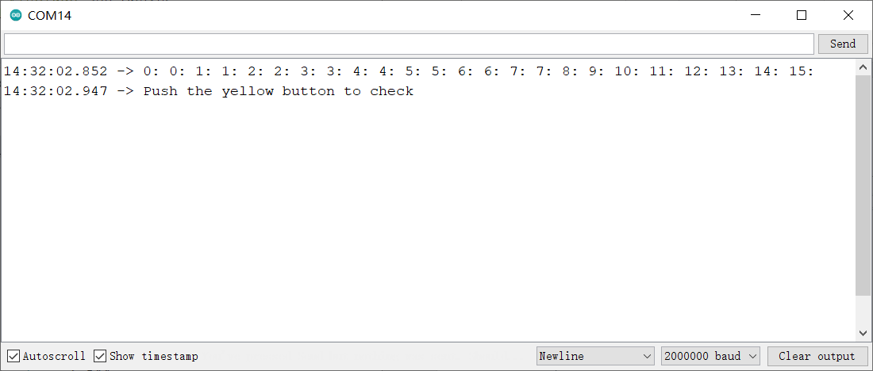

**Remember to set the baud rate according to different code. The baud rate used in the code is showed below:**

|  |  |
| --- | --- |
| **Code filename** | **Baud rate** |
| Receiver_Code_V2.0 | 9 600 |
| Transmitter_Code_V2.0 | 115 200 |
| Transmitter_Code_V2.7 | 2 000 000 |
| testonIMUs_8 | 115 200 |
| testonIMUsfor16v2.0 | 115 200 |

## 4.5 Initialize the Flex sensors

Press once the yellow button

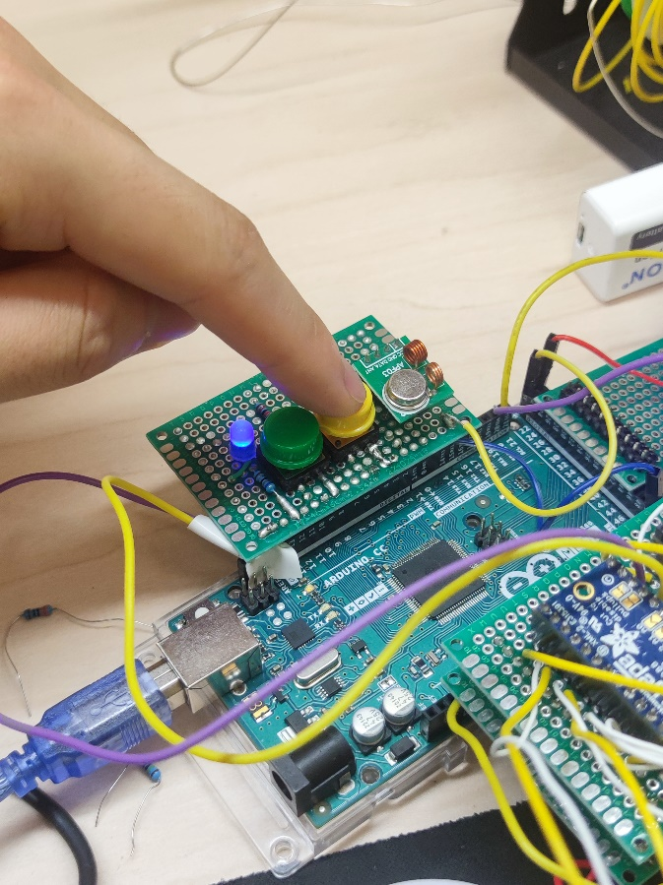

About 2 seconds later, you will see this

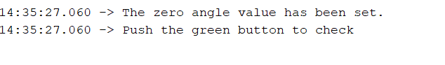

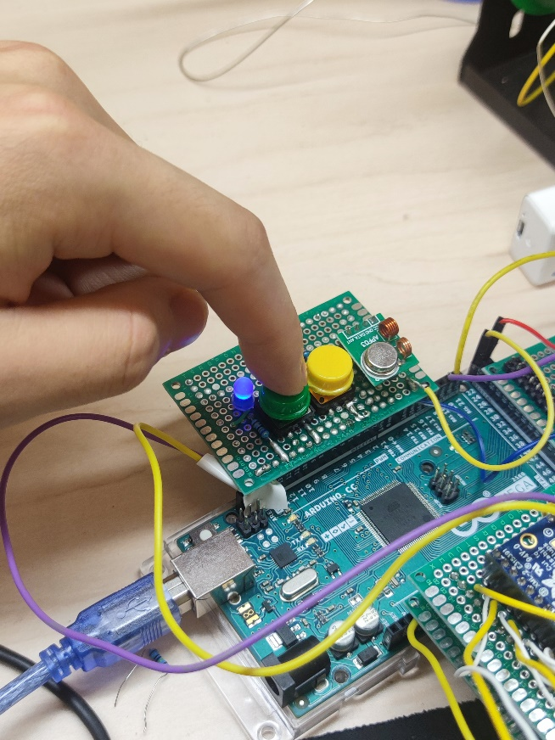

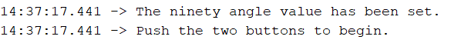

Then we can begin.

## 4.6 Start

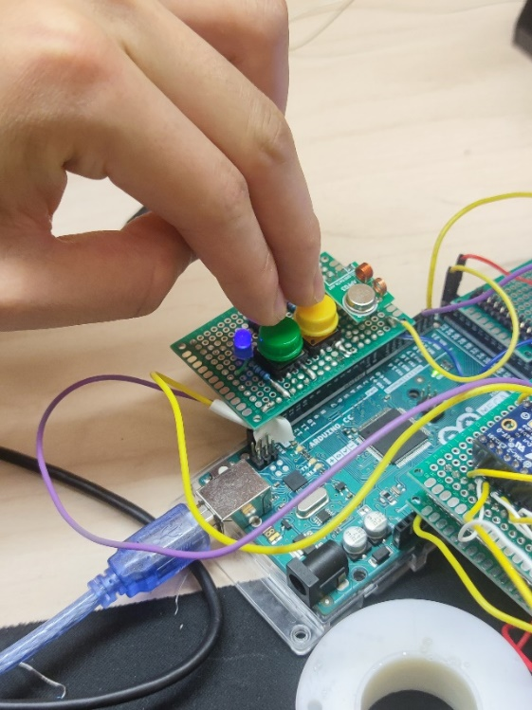

**Mode1**

Form the transmitter (Arduino Mega2560) Serial Monitor, you can result see like this:

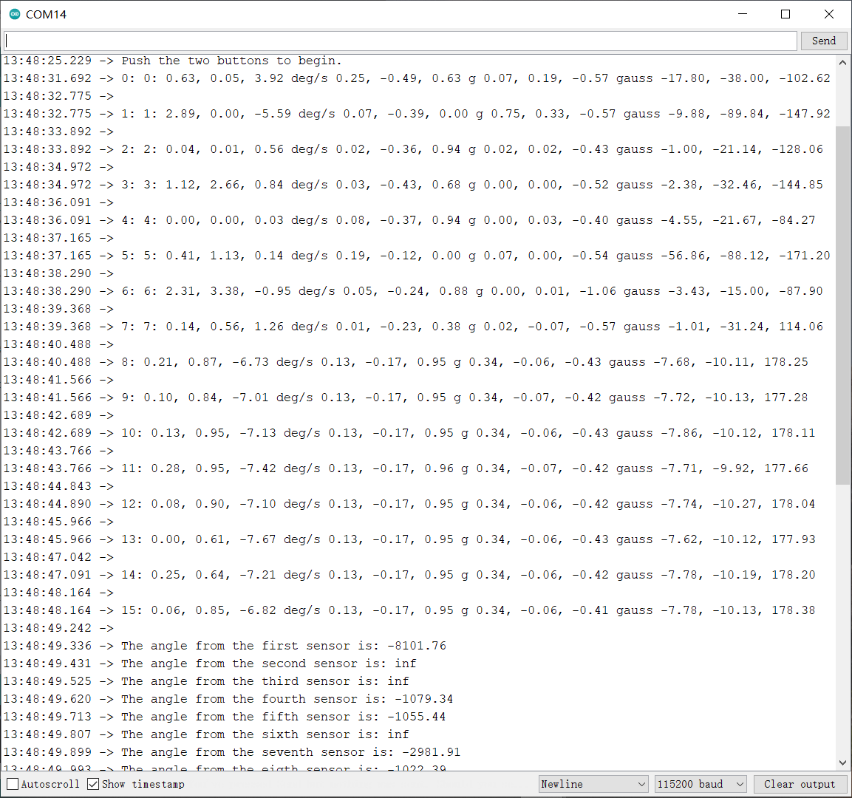

Form the receiver (Arduino Uno) Serial Monitor, you can result see like this:

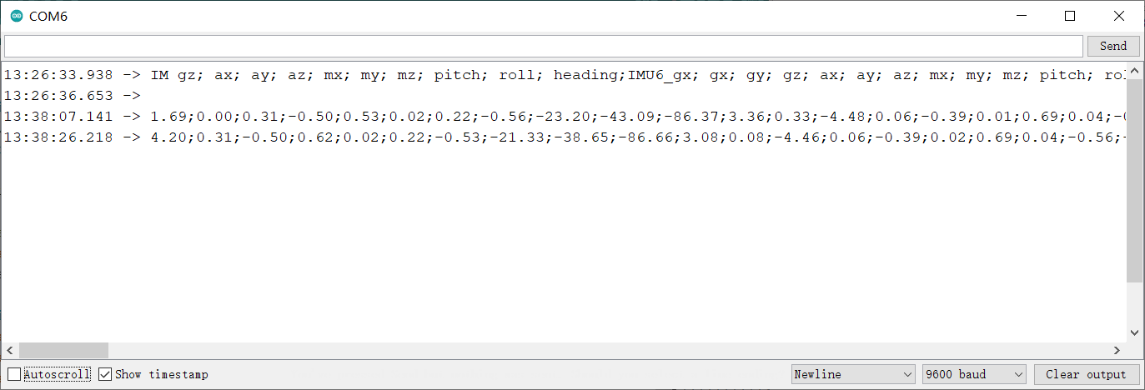

**Mode2**

To improve the data printing speed, we can connect the Transmitter (Arduino Mega2560) to the laptop. Other operations of this mode are the same as mode 1, the difference is that we don’t use the receiver Arduino. The code used is the second one.

