**SVKM’s NMIMS**

**School of Technology Management & Engineering, Chandigarh**

A.Y. 2023 - 24

**Course: Database Management Systems**

**Project Report**

|  |  |  |
| --- | --- | --- |
| Program | MBA-Tech(CE) | |
| Semester | 4 | |
| Name of the Project: | Database Project | |
|  | | |
| Details of Project Members |  |  |
| Batch | Roll No. | Name |
| 2 | A192 | Richard Dsouza |

**Contribution of each project Members:**

|  |  |  |
| --- | --- | --- |
| Roll No. | Name: | Contribution |
| A192 | Richard Dsouza | Normalization , SQL ,queries ,  Entity relation in ER Diagram, 10 questions |

**Github link of your project:**

**Note:**

1. Create a readme file if you have multiple files
2. All files must be properly named (Example:R004_DBMSProject)
3. Submit all relevant files of your work ( Report, all SQL files, Any other files)
4. **Plagiarism is highly discouraged (Your report will be checked for plagiarism)**

**Rubrics for the Project evaluation:**

|  |  |
| --- | --- |
| First phase of evaluation:  Innovative Ideas (5 Marks)  Design and Partial implementation (5 Marks) | 10 marks |
| Final phase of evaluation  Implementation, presentation and viva, Self-Learning and Learning Beyond classroom | 10 marks |

**Project Report**

**Selected Topic**

**by**

**Student 1, Roll number: A194**

**Student 2, Roll number: A192**

**Course: DBMS**

**AY: 2023-24**

**Table of Contents**

|  |  |  |
| --- | --- | --- |
| **Sr no.** | **Topic** | **Page no.** |
| **1** | Storyline |  |
| **2** | Components of Database Design |  |
| **3** | Entity Relationship Diagram |  |
| **4** | Relational Model |  |
| **5** | Normalization |  |
| **6** | SQL Queries |  |
| **7** | Learning from the Project |  |
| **8** | Project Demonstration |  |
| **9** | Self-learning beyond classroom |  |
| **10** | Learning from the project |  |
| **8** | Challenges faced |  |
| **9** | Conclusion |  |

**I. Storyline**

This section should describe the requirements for the chosen database topic. Form a storyline and describe in detail.

Car Models and Brands:

Entities: CarModelDetails, CompanyDetails

Attributes: ModelID, ModelName, BodyStyle, EngineType, Horsepower, CompanyID, CompanyName, HeadquartersLocation, Website, YearFounded, CompanyRevenue.

Sales Process:

Entities: SalesDetails

Attributes: SaleID, VIN, CustomerID, SalespersonID, SaleDate, SalePrice, PaymentMethod.

Inventory Management:

Entities: VehicleDetails, VehicleInventoryDetails

Attributes: VIN, PurchaseDate, WarrantyExpiryDate, InsuranceDetails, Mileage, Color, MadeDate, SupplyDate, Location.

Customer Relationship Management (CRM):

Entities: CustomerDetails, TestDriveDetails

Attributes: CustomerID, Name, Email, PhoneNumber, DateOfBirth, CarModel, TestDriveID, Feedback.

Supplier and Inventory Management:

Entities: InventoryDetails, VehiclePartDetails, SupplierDetails

Attributes: PartID, PartName, Description, Supplier, CostPrice, StockQuantity, Quantity, InstalledDate, WarrantyPeriod, MaintenanceSchedule, SupplierID, CompanyName, ContactName, ContactEmail, PhoneNumber, Address.

Employee Management:

Entities: EmployeeDetails

Attributes: EmployeeID, Name, JobTitle, HireDate, Department, Salary.

**II. Components of Database Design**

Describe all entities along with their attributes here. Also, mention the primary keys for each entity.

Describe all relationships among various entities. Also, specify the cardinality and participation for all relationships.

**Entities and Attributes**

CustomerDetails

CustomerID (Primary Key)

Name

Email

PhoneNumber

DateOfBirth

CarModel (Foreign Key)

CarModelDetails

ModelID (Primary Key)

ModelName

BodyStyle

EngineType

Horsepower

CompanyID (Foreign Key)

CompanyDetails

CompanyID (Primary Key)

CompanyName

HeadquartersLocation

Website

YearFounded

CompanyRevenue

VehicleDetails

VIN (Primary Key)

ModelID (Foreign Key)

VehicleAttributes

VIN (Foreign Key)

PurchaseDate

WarrantyExpiryDate

InsuranceDetails

Mileage

VehicleInventoryDetails

VIN (Foreign Key)

DealerID (Foreign Key)

VehicleInventoryAttributes

VIN (Foreign Key)

DealerID (Foreign Key)

Color

MadeDate

SupplyDate

SalesDetails

SaleID (Primary Key)

VIN (Foreign Key)

CustomerID (Foreign Key)

SaleDate

SalePrice

PaymentMethod

DealerDetails

DealerID (Primary Key)

Name

Location

PhoneNumber

BrandID (Foreign Key)

OwnerName

BrandDetails

BrandID (Primary Key)

BrandName

CountryOfOrigin

BrandAmbassador

AnnualSales

MarketShare

InventoryDetails

PartID (Primary Key)

PartName

Description

Supplier

CostPrice

StockQuantity

VehiclePartDetails

VIN (Foreign Key)

PartID (Foreign Key)

Quantity

InstalledDate

WarrantyPeriod

MaintenanceSchedule

SupplierDetails

SupplierID (Primary Key)

CompanyName

ContactName

ContactEmail

PhoneNumber

Address

EmployeeDetails

EmployeeID (Primary Key)

Name

JobTitle

HireDate

Department

Salary

TestDriveDetails

TestDriveID (Primary Key)

CustomerID (Foreign Key)

VIN (Foreign Key)

Date

SalespersonID (Foreign Key)

Feedback

Relationships

CustomerDetails to CarModelDetails

**Relation:** A customer can own multiple car models, but a car model is owned by one customer.

**Cardinality:** One-to-Many (1:N)

**Participation:** Customer is mandatory, CarModel is optional.

CarModelDetails to CompanyDetails

**Relation:** A company can produce multiple car models, but each car model is produced by one company.

**Cardinality:** One-to-Many (1:N)

**Participation:** Company is mandatory, CarModel is optional.

CarModelDetails to VehicleDetails

**Relation:** A car model can have multiple vehicles, but each vehicle corresponds to one car model.

**Cardinality:** One-to-Many (1:N)

**Participation:** CarModel is mandatory, Vehicle is optional.

CustomerDetails to SalesDetails

**Relation:** A customer can have multiple sales, but each sale is associated with one customer.

**Cardinality:** One-to-Many (1:N)

**Participation:** Customeris mandatory, Sale is optional.

VehicleDetails to VehicleAttributes

**Relation:** A vehicle can have one set of attributes.

**Cardinality:** One-to-One (1:1)

**Participation:** Vehicle is mandatory, VehicleAttributes is optional.

VehicleDetails to VehicleInventoryDetails

**Relation:** A vehicle can be in multiple inventories, and an inventory can have multiple vehicles.

**Cardinality:** Many-to-Many (M:N)

**Participation:** Both are mandatory.

DealerDetails to VehicleInventoryDetails

**Relation:** A dealer can have multiple vehicles in inventory, but each vehicle in inventory belongs to one dealer.

**Cardinality:** One-to-Many (1:N)

**Participation:** Dealer is mandatory, VehicleInventory is optional.

BrandDetails to DealerDetails

**Relation:** A brand can have multiple dealers, but each dealer represents one brand.

**Cardinality:** One-to-Many (1:N)

**Participation:** Brand is mandatory, Dealer is optional.

InventoryDetails to VehiclePartDetails

**Relation:** An inventory part can be used in multiple vehicle parts, but each vehicle part corresponds to one inventory part.

**Cardinality:** One-to-Many (1:N)

**Participation:** Inventory is mandatory, VehiclePart is optional.

SupplierDetails to InventoryDetails

**Relation:** A supplier can supply multiple inventory parts, but each inventory part is supplied by one supplier.

**Cardinality:** One-to-Many (1:N)

**Participation:** Supplier is mandatory, Inventory is optional.

EmployeeDetails to SalesDetails

**Relation:** An employee can handle multiple sales, but each sale is handled by one employee.

**Cardinality**: One-to-Many (1:N)

**Participation**: Employee is mandatory, Sale is optional.

CustomerDetails to TestDriveDetails

**Relation:** A customer can have multiple test drives, but each test drive is associated with one customer.

**Cardinality**: One-to-Many (1:N)

**Participation**: Customer is mandatory, TestDrive is optional.

VehicleDetails to TestDriveDetails

**Relation:** A vehicle can have multiple test drives, but each test drive is associated with one vehicle.

**Cardinality**: One-to-Many (1:N)

**Participation**: Vehicle is mandatory, TestDrive is optional.

EmployeeDetails to TestDriveDetails

**Relation:** An employee can conduct multiple test drives, but each test drive is conducted by one employee.

**Cardinality**: One-to-Many (1:N)

**Participation**: Employee is mandatory, TestDrive is optional.

**III. Entity Relationship Diagram**

Draw the ER diagram here. An example is shown:

You can also use software for drawing ER diagram

Before Normalization:

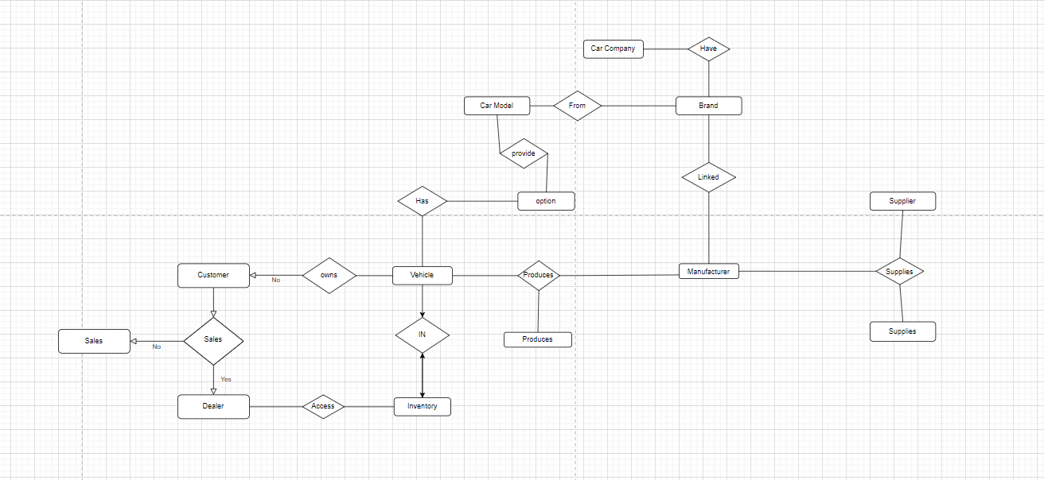

After Normalization:

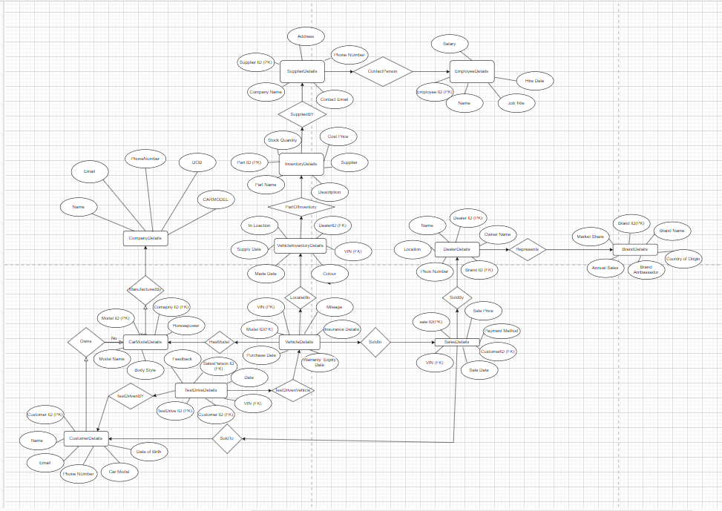

**IV. Relational Model**

Convert the ER diagram to the relational model using the concepts learned in the class.

List the various tables obtained.

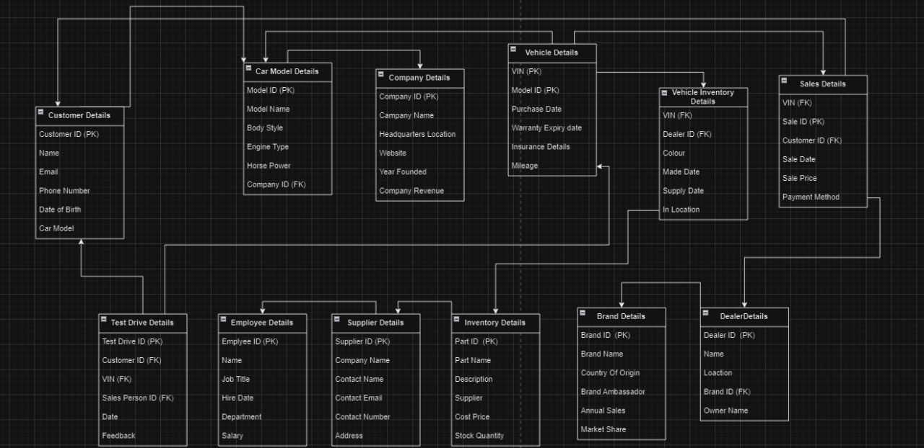

**V. Normalization**

Perform normalization (1NF, 2NF, 3NF, BCNF) as applicable for the entire database.

* **Customer** table: This table likely stores information about customers such as their name, address, phone number, gender, and annual income.
* **Car Model** table: This table likely stores information about car models such as the model ID, model name, body style, and model year.
* **Company** table: This table likely stores information about car companies such as their company ID, company name, and number of employees. It also has a foreign key that references the Brand Name table.
* **Vehicle** table: This table likely stores information about vehicles such as their VIN (Vehicle Identification Number), brand name, and number of employees. It also has foreign keys that reference the Model Name table, Inventory table, and COMID table.
* **Sales** table: This table likely stores information about sales such as the VIN, date, price, color, and supplier. It also has foreign keys that reference the Customer ID table, Model Name table, and Inventory table.
* **Dealer** table: This table likely stores information about dealers such as their dealer ID, name, and location. It also has a foreign key that references the Model ID table.
* **Inventory** table: This table likely stores information about car inventory such as the VIN, in name (possibly the location of the car), in location (possibly the specific location of the car within a dealership or lot), part type, part ID, made date, and supply date. It also has a foreign key that references the Dealer ID table.
* **Brand** table: This table is not fully depicted in the ERD, but based on the foreign keys from other tables, it likely stores information about car brands.

Described in the ER Diagram

**VI. SQL Queries**

Using a DBMS software (SQLite3 or MySQL or any other of your choice):

* Create the tables
* Populate the tables (insert some meaningful data, at least 10 tuples for each relation)
* Run SQL queries (minimum 20) covering **all concepts** learned in the class

This section should contain the question, SQL code, and the output snapshot for each query.

create database project;  
use project ;

-- 1. CustomerDetails  
CREATE TABLE CustomerDetails (  
 CustomerID INT PRIMARY KEY,  
 Name VARCHAR(255),  
 Email VARCHAR(255),  
 PhoneNumber VARCHAR(15),  
 DateOfBirth DATE,  
 CarModel VARCHAR(255)  
);  
  
-- 2. CarModelDetails  
CREATE TABLE CarModelDetails (  
 ModelID INT PRIMARY KEY,  
 ModelName VARCHAR(255),  
 BodyStyle VARCHAR(50),  
 EngineType VARCHAR(50),  
 Horsepower INT,  
 CompanyID INT,  
 FOREIGN KEY (CompanyID) REFERENCES CompanyDetails(CompanyID) ON DELETE CASCADE  
);  
  
-- 3. CompanyDetails  
CREATE TABLE CompanyDetails (  
 CompanyID INT PRIMARY KEY,  
 CompanyName VARCHAR(255),  
 HeadquartersLocation VARCHAR(255),  
 Website VARCHAR(255),  
 YearFounded INT,  
 CompanyRevenue DECIMAL(15, 2)  
);  
  
-- 4. VehicleDetails  
CREATE TABLE VehicleDetails (  
 VIN VARCHAR(17) PRIMARY KEY,  
 ModelID INT,  
 PurchaseDate DATE,  
 WarrantyExpiryDate DATE,  
 InsuranceDetails TEXT,  
 Mileage INT,  
 FOREIGN KEY (ModelID) REFERENCES CarModelDetails(ModelID) ON DELETE CASCADE  
);  
  
-- 5. VehicleInventoryDetails  
CREATE TABLE VehicleInventoryDetails (  
 VIN VARCHAR(17),  
 DealerID INT,  
 Color VARCHAR(50),  
 MadeDate DATE,  
 SupplyDate DATE,  
 InLocation VARCHAR(255),  
 PRIMARY KEY (VIN, DealerID),  
 FOREIGN KEY (VIN) REFERENCES VehicleDetails(VIN) ON DELETE CASCADE,  
 FOREIGN KEY (DealerID) REFERENCES DealerDetails(DealerID) ON DELETE CASCADE  
);  
  
-- 6. SalesDetails  
CREATE TABLE SalesDetails (  
 SaleID INT PRIMARY KEY,  
 VIN VARCHAR(17),  
 CustomerID INT,  
 SaleDate DATE,  
 SalePrice DECIMAL(10, 2),  
 PaymentMethod VARCHAR(50),  
 FOREIGN KEY (VIN) REFERENCES VehicleDetails(VIN) ON DELETE CASCADE,  
 FOREIGN KEY (CustomerID) REFERENCES CustomerDetails(CustomerID) ON DELETE CASCADE  
);  
  
-- 7. DealerDetails  
CREATE TABLE DealerDetails (  
 DealerID INT PRIMARY KEY,  
 Name VARCHAR(255),  
 Location VARCHAR(255),  
 PhoneNumber VARCHAR(15),  
 BrandID INT,  
 OwnerName VARCHAR(255),  
 FOREIGN KEY (BrandID) REFERENCES BrandDetails(BrandID) ON DELETE CASCADE  
);  
  
-- 8. BrandDetails  
CREATE TABLE BrandDetails (  
 BrandID INT PRIMARY KEY,  
 BrandName VARCHAR(255),  
 CountryOfOrigin VARCHAR(100),  
 BrandAmbassador VARCHAR(255),  
 AnnualSales DECIMAL(15, 2),  
 MarketShare DECIMAL(5, 2)  
);  
  
-- 9. InventoryDetails  
CREATE TABLE InventoryDetails (  
 PartID INT PRIMARY KEY,  
 PartName VARCHAR(255),  
 Description TEXT,  
 Supplier VARCHAR(255),  
 CostPrice DECIMAL(10, 2),  
 StockQuantity INT  
);  
  
-- 10. VehiclePartDetails  
CREATE TABLE VehiclePartDetails (  
 VIN VARCHAR(17),  
 PartID INT,  
 Quantity INT,  
 InstalledDate DATE,  
 WarrantyPeriod INT,  
 MaintenanceSchedule TEXT,  
 PRIMARY KEY (VIN, PartID),  
 FOREIGN KEY (VIN) REFERENCES VehicleDetails(VIN) ON DELETE CASCADE,  
 FOREIGN KEY (PartID) REFERENCES InventoryDetails(PartID) ON DELETE CASCADE  
);  
  
-- 11. SupplierDetails  
CREATE TABLE SupplierDetails (  
 SupplierID INT PRIMARY KEY,  
 CompanyName VARCHAR(255),  
 ContactName VARCHAR(255),  
 ContactEmail VARCHAR(255),  
 PhoneNumber VARCHAR(15),  
 Address TEXT  
);  
  
-- 12. EmployeeDetails  
CREATE TABLE EmployeeDetails (  
 EmployeeID INT PRIMARY KEY,  
 Name VARCHAR(255),  
 JobTitle VARCHAR(100),  
 HireDate DATE,  
 Department VARCHAR(100),  
 Salary DECIMAL(10, 2)  
);  
  
-- 13. TestDriveDetails  
CREATE TABLE TestDriveDetails (  
 TestDriveID INT PRIMARY KEY,  
 CustomerID INT,  
 VIN VARCHAR(17),  
 Date DATE,  
 SalespersonID INT,  
 Feedback TEXT,  
 FOREIGN KEY (CustomerID) REFERENCES CustomerDetails(CustomerID) ON DELETE CASCADE,  
 FOREIGN KEY (VIN) REFERENCES VehicleDetails(VIN) ON DELETE CASCADE,  
 FOREIGN KEY (SalespersonID) REFERENCES EmployeeDetails(EmployeeID) ON DELETE CASCADE  
);  
  
  
-- 1. CustomerDetails  
INSERT INTO CustomerDetails (CustomerID, Name, Email, PhoneNumber, DateOfBirth, CarModel)  
VALUES  
(1, 'John Doe', 'johndoe@email.com', '123-456-7890', '1990-01-01', 'Sedan'),  
(2, 'Jane Smith', 'janesmith@email.com', '987-654-3210', '1992-05-15', 'SUV'),  
(3, 'Alice Johnson', 'alice@email.com', '111-222-3333', '1985-07-20', 'Hatchback'),  
(4, 'Bob Williams', 'bob@email.com', '444-555-6666', '1988-03-10', 'Coupe'),  
(5, 'Charlie Brown', 'charlie@email.com', '777-888-9999', '1995-11-25', 'Sedan'),  
(6, 'David Davis', 'david@email.com', '666-555-4444', '1980-09-30', 'SUV'),  
(7, 'Eva Green', 'eva@email.com', '222-333-4444', '1993-12-15', 'Hatchback');  
  
-- 2. CarModelDetails  
INSERT INTO CarModelDetails (ModelID, ModelName, BodyStyle, EngineType, Horsepower, CompanyID)  
VALUES  
(1, 'Model S', 'Sedan', 'Electric', 500, 1),  
(2, 'Model X', 'SUV', 'Electric', 450, 1),  
(3, 'Model 3', 'Hatchback', 'Electric', 350, 1),  
(4, 'Model Y', 'SUV', 'Electric', 450, 1),  
(5, 'Civic', 'Sedan', 'Gasoline', 180, 2),  
(6, 'CR-V', 'SUV', 'Gasoline', 190, 2),  
(7, 'Accord', 'Coupe', 'Gasoline', 200, 2);  
  
-- 3. CompanyDetails  
INSERT INTO CompanyDetails (CompanyID, CompanyName, HeadquartersLocation, Website, YearFounded, CompanyRevenue)  
VALUES  
(1, 'Tesla', 'Palo Alto, CA', 'https://www.tesla.com', 2003, 40000000000),  
(2, 'Honda', 'Tokyo, Japan', 'https://www.honda.com', 1946, 10000000000),  
(3, 'Toyota', 'Toyota City, Japan', 'https://www.toyota.com', 1937, 20000000000),  
(4, 'Ford', 'Dearborn, MI', 'https://www.ford.com', 1903, 30000000000),  
(5, 'Chevrolet', 'Detroit, MI', 'https://www.chevrolet.com', 1911, 25000000000),  
(6, 'BMW', 'Munich, Germany', 'https://www.bmw.com', 1916, 35000000000),  
(7, 'Mercedes-Benz', 'Stuttgart, Germany', 'https://www.mercedes-benz.com', 1926, 30000000000);  
  
-- 4. VehicleDetails  
INSERT INTO VehicleDetails (VIN, ModelID, PurchaseDate, WarrantyExpiryDate, InsuranceDetails, Mileage)  
VALUES  
('VIN12345678901234', 1, '2023-01-15', '2026-01-15', 'Full Coverage', 5000),  
('VIN23456789012345', 2, '2022-05-20', '2025-05-20', 'Liability Only', 6000),  
('VIN34567890123456', 3, '2023-03-10', '2026-03-10', 'Full Coverage', 4000),  
('VIN45678901234567', 4, '2022-07-05', '2025-07-05', 'Liability Only', 5500),  
('VIN56789012345678', 5, '2021-11-30', '2024-11-30', 'Full Coverage', 7000),  
('VIN67890123456789', 6, '2020-09-25', '2023-09-25', 'Liability Only', 8000),  
('VIN78901234567890', 7, '2022-04-15', '2025-04-15', 'Full Coverage', 6500);  
  
-- 5. VehicleInventoryDetails  
INSERT INTO VehicleInventoryDetails (VIN, DealerID, Color, MadeDate, SupplyDate, InLocation)  
VALUES  
('VIN12345678901234', 1, 'Red', '2023-01-10', '2023-01-12', 'Warehouse A'),  
('VIN23456789012345', 2, 'Blue', '2022-05-15', '2022-05-18', 'Warehouse B'),  
('VIN34567890123456', 3, 'White', '2023-03-05', '2023-03-08', 'Warehouse C'),  
('VIN45678901234567', 4, 'Black', '2022-07-01', '2022-07-03', 'Warehouse D'),  
('VIN56789012345678', 5, 'Silver', '2021-11-25', '2021-11-28', 'Warehouse E'),  
('VIN67890123456789', 6, 'Gray', '2020-09-20', '2020-09-23', 'Warehouse F'),  
('VIN78901234567890', 7, 'Green', '2022-04-10', '2022-04-13', 'Warehouse G');  
  
-- 6. SalesDetails  
INSERT INTO SalesDetails (SaleID, VIN, CustomerID, SaleDate, SalePrice, PaymentMethod)  
VALUES  
(1, 'VIN12345678901234', 1, '2023-01-20', 60000.00, 'Credit Card'),  
(2, 'VIN23456789012345', 2, '2022-05-25', 70000.00, 'Bank Transfer'),  
(3, 'VIN34567890123456', 3, '2023-03-15', 55000.00, 'Cash'),  
(4, 'VIN45678901234567', 4, '2022-07-10', 65000.00, 'Credit Card'),  
(5, 'VIN56789012345678', 5, '2021-12-05', 75000.00, 'Bank Transfer'),  
(6, 'VIN67890123456789', 6, '2020-10-01', 50000.00, 'Cash'),  
(7, 'VIN78901234567890', 7, '2022-04-20', 68000.00, 'Credit Card');  
  
-- 7. DealerDetails  
INSERT INTO DealerDetails (DealerID, Name, Location, PhoneNumber, BrandID, OwnerName)  
VALUES  
(1, 'Tesla Palo Alto', 'Palo Alto, CA', '123-456-7890', 1, 'Elon Musk'),  
(2, 'Honda Tokyo', 'Tokyo, Japan', '987-654-3210', 2, 'Takahiro Hachigo'),  
(3, 'Toyota Toyota City', 'Toyota City, Japan', '111-222-3333', 3, 'Akio Toyoda'),  
(4, 'Ford Dearborn', 'Dearborn, MI', '444-555-6666', 4, 'Jim Farley'),  
(5, 'Chevrolet Detroit', 'Detroit, MI', '777-888-9999', 5, 'Mary Barra'),  
(6, 'BMW Munich', 'Munich, Germany', '666-555-4444', 6, 'Oliver Zipse'),  
(7, 'Mercedes-Benz Stuttgart', 'Stuttgart, Germany', '222-333-4444', 7, 'Ola Källenius');  
  
-- 8. BrandDetails  
INSERT INTO BrandDetails (BrandID, BrandName, CountryOfOrigin, BrandAmbassador, AnnualSales, MarketShare)  
VALUES  
(1, 'Tesla', 'USA', 'Elon Musk', 100000, 25.0),  
(2, 'Honda', 'Japan', 'Takahiro Hachigo', 2000000, 15.0),  
(3, 'Toyota', 'Japan', 'Akio Toyoda', 3000000, 20.0),  
(4, 'Ford', 'USA', 'Jim Farley', 1500000, 10.0),  
(5, 'Chevrolet', 'USA', 'Mary Barra', 1200000, 10.0),  
(6, 'BMW', 'Germany', 'Oliver Zipse', 800000, 7.0),  
(7, 'Mercedes-Benz', 'Germany', 'Ola Källenius', 1000000, 13.0);  
  
-- 9. InventoryDetails  
INSERT INTO InventoryDetails (PartID, PartName, Description, Supplier, CostPrice, StockQuantity)  
VALUES  
(1, 'Tire', 'All-weather tire', 'Supplier A', 100.00, 200),  
(2, 'Brake Pad', 'High-performance brake pad', 'Supplier B', 50.00, 300),  
(3, 'Battery', 'Electric vehicle battery', 'Supplier C', 2000.00, 100),  
(4, 'Oil Filter', 'Premium oil filter', 'Supplier D', 20.00, 400),  
(5, 'Headlight', 'LED headlight', 'Supplier E', 150.00, 250),  
(6, 'Windshield Wiper', 'Rain-sensing wiper', 'Supplier F', 30.00, 350),  
(7, 'Radiator', 'High-efficiency radiator', 'Supplier G', 300.00, 150);  
  
-- 10. VehiclePartDetails  
INSERT INTO VehiclePartDetails (VIN, PartID, Quantity, InstalledDate, WarrantyPeriod, MaintenanceSchedule)  
VALUES  
('VIN12345678901234', 1, 4, '2023-01-18', 5, 'Every 6 months'),  
('VIN23456789012345', 2, 2, '2022-05-22', 4, 'Every 4 months'),  
('VIN34567890123456', 3, 1, '2023-03-12', 6, 'Every 7 months'),  
('VIN45678901234567', 4, 3, '2022-07-07', 5, 'Every 5 months'),  
('VIN56789012345678', 5, 2, '2021-11-28', 4, 'Every 4 months'),  
('VIN67890123456789', 6, 1, '2020-09-28', 6, 'Every 8 months'),  
('VIN78901234567890', 7, 2, '2022-04-17', 5, 'Every 6 months');  
  
-- 11. SupplierDetails  
INSERT INTO SupplierDetails (SupplierID, CompanyName, ContactName, ContactEmail, PhoneNumber, Address)  
VALUES  
(1, 'Supplier A Co.', 'John Doe', 'john.doe@supplierA.com', '123-456-7890', '123 Supplier St, City A'),  
(2, 'Supplier B Co.', 'Jane Smith', 'jane.smith@supplierB.com', '987-654-3210', '456 Supplier St, City B'),  
(3, 'Supplier C Co.', 'Alice Johnson', 'alice.johnson@supplierC.com', '111-222-3333', '789 Supplier St, City C'),  
(4, 'Supplier D Co.', 'Bob Williams', 'bob.williams@supplierD.com', '444-555-6666', '012 Supplier St, City D'),  
(5, 'Supplier E Co.', 'Charlie Brown', 'charlie.brown@supplierE.com', '777-888-9999', '345 Supplier St, City E'),  
(6, 'Supplier F Co.', 'David Davis', 'david.davis@supplierF.com', '666-555-4444', '678 Supplier St, City F'),  
(7, 'Supplier G Co.', 'Eva Green', 'eva.green@supplierG.com', '222-333-4444', '901 Supplier St, City G');  
  
-- 12. EmployeeDetails  
INSERT INTO EmployeeDetails (EmployeeID, Name, JobTitle, HireDate, Department, Salary)  
VALUES  
(1, 'John Doe', 'Sales Manager', '2015-01-10', 'Sales', 80000.00),  
(2, 'Jane Smith', 'Mechanic', '2017-03-15', 'Service', 50000.00),  
(3, 'Alice Johnson', 'Finance Manager', '2018-05-20', 'Finance', 85000.00),  
(4, 'Bob Williams', 'HR Manager', '2016-04-10', 'Human Resources', 75000.00),  
(5, 'Charlie Brown', 'Marketing Manager', '2019-02-28', 'Marketing', 82000.00),  
(6, 'David Davis', 'Service Advisor', '2020-06-10', 'Service', 55000.00),  
(7, 'Eva Green', 'Parts Manager', '2017-08-15', 'Parts', 60000.00);  
  
-- 13. TestDriveDetails  
INSERT INTO TestDriveDetails (TestDriveID, CustomerID, VIN, Date, SalespersonID, Feedback)  
VALUES  
(1, 1, 'VIN12345678901234', '2023-01-22', 1, 'Excellent driving experience'),  
(2, 2, 'VIN23456789012345', '2022-05-28', 2, 'Smooth ride but expensive'),  
(3, 3, 'VIN34567890123456', '2023-03-18', 3, 'Great handling and features'),  
(4, 4, 'VIN45678901234567', '2022-07-12', 4, 'Good performance but noisy'),  
(5, 5, 'VIN56789012345678', '2021-12-08', 5, 'Comfortable seats and good mileage'),  
(6, 6, 'VIN67890123456789', '2020-10-03', 6, 'Powerful engine but lacks features'),  
(7, 7, 'VIN78901234567890', '2022-04-22', 7, 'Decent car for the price');  
  
  
-- 1. CustomerDetails  
SELECT * FROM CustomerDetails;  
  
-- 2. CarModelDetails  
SELECT * FROM CarModelDetails;  
  
-- 3. CompanyDetails  
SELECT * FROM CompanyDetails;  
  
-- 4. VehicleDetails  
SELECT * FROM VehicleDetails;  
  
-- 5. VehicleInventoryDetails  
SELECT * FROM VehicleInventoryDetails;  
  
-- 6. SalesDetails  
SELECT * FROM SalesDetails;  
  
-- 7. DealerDetails  
SELECT * FROM DealerDetails;  
  
-- 8. BrandDetails  
SELECT * FROM BrandDetails;  
  
-- 9. InventoryDetails  
SELECT * FROM InventoryDetails;  
  
-- 10. VehiclePartDetails  
SELECT * FROM VehiclePartDetails;  
  
-- 11. SupplierDetails  
SELECT * FROM SupplierDetails;  
  
-- 12. EmployeeDetails  
SELECT * FROM EmployeeDetails;  
  
-- 13. TestDriveDetails  
SELECT * FROM TestDriveDetails;  
  
  
  
-- 10 Question  
-- 1st (Retrieve the total sales amount from the SalesDetails table.  
  
SELECT *SUM*(SalePrice) AS TotalSalesAmount FROM SalesDetails;  
  
-- 2nd (Calculate the average mileage of all vehicles in the VehicleDetails table.  
SELECT *AVG*(Mileage) AS AverageMileage FROM VehicleDetails;  
  
-- 3rd (SELECT MAX(WarrantyPeriod) AS MaxWarrantyPeriod FROM VehiclePartDetails;  
  
SELECT *MAX*(WarrantyPeriod) AS MaxWarrantyPeriod FROM VehiclePartDetails;  
  
-- 4th (Count the number of dealers associated with each brand in the DealerDetails table.  
SELECT BrandName, *COUNT*(DealerID) AS NumberOfDealers  
FROM BrandDetails  
JOIN DealerDetails ON BrandDetails.BrandID = DealerDetails.BrandID  
GROUP BY BrandName;  
  
-- 5th (Calculate the total cost of all parts in the inventory from the InventoryDetails table.  
SELECT *SUM*(CostPrice * StockQuantity) AS TotalInventoryCost FROM InventoryDetails;  
  
-- 6th (Retrieve the names of customers along with the car models they own.  
SELECT c.Name AS CustomerName, cmd.ModelName AS CarModel  
FROM CustomerDetails c  
JOIN VehicleDetails vd ON c.CarModel = vd.VIN  
JOIN CarModelDetails cmd ON vd.ModelID = cmd.ModelID;  
  
-- 7th (List the sales made by each dealer from the SalesDetails table.  
  
SELECT dd.Name AS DealerName, *COUNT*(sd.SaleID) AS NumberOfSales  
FROM DealerDetails dd  
LEFT JOIN VehicleInventoryDetails vid ON dd.DealerID = vid.DealerID  
LEFT JOIN SalesDetails sd ON vid.VIN = sd.VIN  
GROUP BY dd.Name;  
  
-- 8th (Find the customers who have not made any purchases.  
SELECT Name  
FROM CustomerDetails  
WHERE CustomerID NOT IN (SELECT DISTINCT CustomerID FROM SalesDetails);  
  
  
-- 9th (Identify the car model with the highest sale price.v  
  
SELECT ModelName  
FROM CarModelDetails  
WHERE ModelID = (  
 SELECT ModelID  
 FROM SalesDetails  
 ORDER BY SalePrice DESC  
 LIMIT 1  
);  
 -- 10th(Find the suppliers of the most commonly used part in the inventory.  
 SELECT CompanyName  
FROM SupplierDetails  
WHERE SupplierID = (  
 SELECT PartID  
 FROM VehiclePartDetails  
 GROUP BY PartID  
 ORDER BY *COUNT*(VIN) DESC  
 LIMIT 1  
);

**VI. Project demonstration**

* Tools/software/ libraries used
* Screenshot and Description of the Demonstration of project ( If GUI is made)

**VII. Self -Learning beyond classroom**

:

* What new aspects did you learn on your own ? You have to mention learning beyond the classroom

**VIII. Learning from the Project**

Include learning from the project:

* How this project helped you?

**IX. Challenges Faced**

**X. Conclusion**

* What are the key takeaways from the project?