**Gundog Behaviours**

***Data input***

Data needs to be formatted with each column being a seperate variable and each row being a separate observation, incrementing through time (acceptable separators = comma, semi-colon, and tab). Input variables include (red = compulsory; green = optional)

* Total event number column. An ID column of the row observation number
* Date. Required format = **dd/mm/yyyy**, e.g., 20/05/2022
* Time. Required format = **hh:mm:ss.ddd**, e.g., 12:19:45.125 (with decimal seconds)
* Acceleration X-axis. Units in *g.*
* Acceleration Y-axis. Units in *g.*
* Acceleration Z-axis. Units in *g.*
* Magnetism X-axis
* Magnetism Y-axis
* Magnetism Z-axis
* Pressure. Units in mbar*.*
* Depth. Units in m
* Temperature. Units in °C
* GPS Longitude. Units in decimal format e.g., 26.31989
* GPS Latitude. Units in decimal format e.g., -06.11995
* Marked events. A column of integer numbers which could code for certain behaviours, e.g., 0 = ‘resting’, 1 = walking, 2 = running, etc.

***Background***

Acceleration is the first derivative (rate of change) of an object’s velocity with respect to time (eqn 1). Velocity is a vector quantity (it has both magnitude and direction) that refers to the rate of change of an objects position with respect to a frame of reference. A rate of change is simply the recorded change between two time points – *ti*, and *ti+1,* divided by the time between them.

*,* (1)

where is the change in velocity and is the elapsed time period over which the measured change took place. Taken together, a change in an objects speed and/or direction per unit time, relative to a reference frame, constitutes a change in its velocity and thus an acceleration. An object that is moving at a constant speed and direction has no recorded acceleration (besides acceleration due to gravity – see later), whilst an object that is turning, even at a constant rate, is accelerating, because it is constantly changing its direction. Measurement of acceleration has proven to be a highly sensitive metric to discern fine-scale and sub-second changes in peripheral movements and postures and consequently, accelerometers have been widely applied on humans and other animals for determining specific behaviours and associated bout lengths. An accelerometer is a small, flexible piezoelectric sensor, capable of generating wave-like signals when a force caused by vibration or a change in motion (acceleration) is applied. The sensor contains a known mass held in place by elements such as springs that deflects when a force is applied, causing the mass to "squeeze" (deform) the piezoelectric crystal (such as quartz), producing an electrical charge with the voltage produced proportional to the change in velocity of the mass relative to the device. Accelerometers measure in an axis-specific direction so complete measurement of movement requires a tri-axial system of measurement. Vertebrates move by contracting muscles and typically impart accelerations and decelerations as they do so due to the interplay between the kinematics of their movement cycle and the properties of the medium that they are moving on/within. Units of acceleration are expressed as metres per second squared (m/s2) or in G-forces (*g*). A single G-force on Earth (though this does vary slightly with elevation) is ~9.82 m/s2. Tri-axial accelerometers measure acceleration in three orthogonal (perpendicular) planes (**surge** – ‘anterior-posterior’ or ‘forward-back’, **sway** – ‘medio-lateral’ or ‘side-to-side’ and **heave** – ‘dorsal-ventral’ or ‘up-down’).

Under non-moving conditions, relative to gravity, the device tilt (e.g., as represented usingpitch and roll Euler angles) can be calculated directly from raw accelerometery values since they are composed entirely of the gravity (‘static’) force. The static component of acceleration can therefore reflect body posture when the accelerometer is positioned near the animal’s Centre of Mass (CoM – its centre of gravity) (typically on/near the dorsal surface of the body trunk), assuming that the tag and animal body frame are in alignment. Note then, that device orientation derived from a collar mounted tag may not necessarily reflect the posture of the animal, given that collars can roll independently of the body and be more indicative of neck attitude which can vary substantially from that of the body. Under linear (‘dynamic’) acceleration, ‘moving’ forces applied to the device are superimposed to the static readings and as such, measured animal acceleration is typically comprised of both a static and dynamic component. The dynamic component reflects body movements arising from the limbs (e.g., wing, flipper, tail, leg), spine and/or environmental induced acceleration such as external force vectors (e.g., tidal–/air turbulence/currents). Generally, the greater the extent of movement, the more energy is required for muscular contraction and the greater the inertial displacement of the attached sensor (with respect to an animal’s CoM). Based on this premise, it not surprising that various acceleration-based proxies for activity, traveling speed and activity-specific energy expenditure have been validated (*cf.* Fig. 1). Furthermore, stylised patterns in the periodicity, amplitude and/or direction of acceleration (and derivatives) can reveal various frequencies/patterns of movement, indicative of behaviour-specific activities, and the relative whereabouts these behaviours may be performed. For example, there would be recognisable differences in the acceleration waveform signatures between a penguin that is commuting *vs* chasing prey at sea, or walking *vs* tobogganing on land, or resting *vs* preening at its brooding nest site.

*Figure 1. The acceleration waveforms (raw = Acc_x,y,z; smoothed = Acc_x,y,z.sm) from a free-ranging lion dataset during four different 20 s behavioral bouts (resting, walking, running, and feeding).*

The dynamic component of acceleration which is typically induced by the limb and/or spine kinematics of the animal. Various single integrated metrics of acceleration have been used in the literature to quantify ‘general’ activity using accelerometers, including counts, vector magnitude, overall dynamic body acceleration (ODBA), and vectorial dynamic body acceleration (VeDBA). The most utilised acceleration-based proxy for activity-specific energy expenditure has been ODBA. ODBA is the sum of the (absolute) dynamic values from each of the multi-axial channels during a given inertial frame – (eqn 2). To date this relationship has been validated for every study that has tested the relationship between bodily acceleration and oxygen consumption () (predominately aerobic metabolic pathways), with significant correlations existing across a range of aquatic, aerial, and terrestrial species. The reason for this is relationship based on the theoretical understanding that movement of most vertebrates is the main factor in modulating energy expenditure. The more vigorously an individual moves, the more energy it has to expend in muscular contraction, with any change in measured body acceleration being proportional to the muscular forces that displaced the animal’s body (and therefore the attached sensor) (according to Newton’s first law). is considered proportional to the force exerted by the muscle and given that Force = mass × acceleration and it is typically the animal that supplies the force through muscular contraction, if we assume that the mass (i.e., muscle mass), stays constant, then the force directly equates to acceleration. Consequently, the integrated measure of dynamic acceleration from each of the three spatial dimensions has been posited as a useful proxy for the mechanical equivalent to energy expenditure involved in movement for free-ranging animals.

Recently, the use of VeDBA has begun attracting more popularity. VeDBA is a single integrated measure of the vector sum of dynamic acceleration from the three spatial dimensions during a given inertial frame – (eqn 3). ODBA and VeDBA metrics are thus very closely linked - they correlate very strongly with one another as a function of movement levels, with any discrepancies (residuals) from the trendline (regression) being comparably miniscule. Conceptually then, it should not matter which metric is used, although some studies have shown that ODBA has a statistically marginally better predictive capacity for . Despite this, VeDBA has been posited as the ‘more mathematically correct’ formulation because force magnitude (or ‘net force’) arising from movement is often the result from multiple muscles working tangentially to one another and the VeDBA metric recognises this as a vectorial quantity (net force is defined as vector sum of all the forces that act upon an object). ODBA, however, treats each axis separately, and thus work done as three distinct straight-line paths which can overestimate the work done for any specific movement. Moreover, ODBA values are expected to differ according to discrepancies in the alignment of the tag axes with respect to the major body axes of the equipped animal, whereas the VeDBA formation is supposed to contend with this. To avoid ambiguity, the specific derivation of DBA used should be outlined from the start. Both ODBA and VeDBA are computed within *Gundog Behaviours*.

(2)

, (3)

where , and are the dynamic values of acceleration from each axis, themselves obtained by subtracting each axis’ static component of acceleration from their raw equivalent. Note, the term ‘vector magnitude of acceleration’ or, as otherwise said, ‘acceleration vector magnitude’, should be strictly assumed as utilising raw acceleration (comprising both dynamic and static components) in its derivation (analogous to the computation of VeDBA).

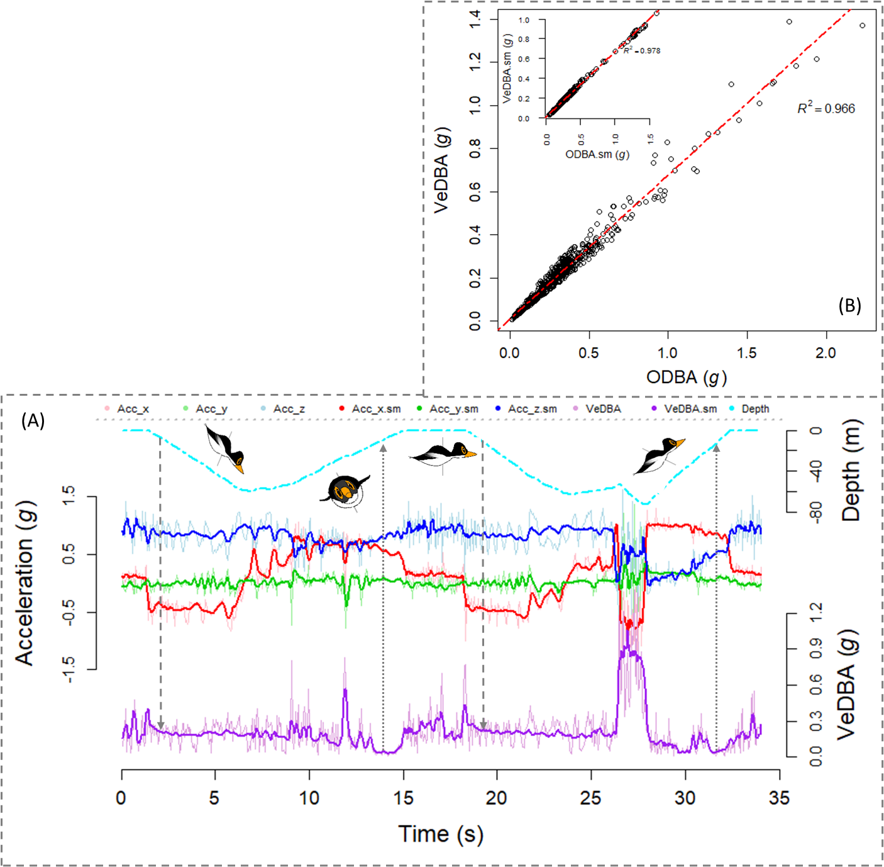

*Figure 2. (A) Raw- (Acc_x, Acc_y, Acc_z) and smoothed- (Acc_x.sm, Acc_y.sm, Acc_z.sm) values of acceleration (representing the surge-, sway- and heave body axes), depth, and VeDBA plotted as 2-D waveforms vs time across a period of two foraging dives from Magellanic penguin data. (B) The relationship between raw ODBA and VeDBA values during the period denoted in (A), with the associated R2 from a spearman rank correlation. The insert shows the relationship between these metrics subsequent to applying a 2 s running mean. Smoothed acceleration values (reflecting the static component) were also smoothed by 2 s. The penguin images reflect its orientations at the given moment in time, with respect to its surge- (side on) and sway- (face on) axis. Note the difference of VeDBA magnitude between the early stages of descent (downward pointing dashed grey arrow) and the latter stages of ascent (upward pointing dotted grey arrow).*

Notably, DBA metrics are not perfect - values can be confounded by discrepancies in the position of the tag deployment site (i.e., different positions of the body trunk can move at different rates as a function of different types of behaviour-specific movements). Ideally, the tag should be positioned as close to the animal’s CoM, as possible and placement position standardised between individuals. DBA values can also incorporate movements brought about by the instability of the tag (e.g., tag wobble when attached using tape, or tag roll when affixed to loose collars). Arguably though, the biggest issue is environmentally induced DBA (e.g., flow in fluid media, such as variation in the strength, direction, and turbulence of tidal and wind action). Environmentally induced DBA is particularly problematic when assessing acceleration in terms of energy expenditure because the magnitude of recorded acceleration may not necessarily correspond with the movements invoked by the animal. The magnitude of mechanical energy expenditure may also be overestimated at times of high Inertia force generated by behaviour-induced start-stop momentum of tags, e.g., when an animal collapses to the ground, scratches/preens, interacts with a conspecific or an inanimate object, such as rubbing against a tree, etc. Furthermore, limb extension, flexion, and recovery/release of stored elastic energy during movement, can be heavily modulated according to the type, gradient, and deformability of the substrate that an animal is moving on, which again, may not be accurately reflected in the recorded acceleration estimates. For example, walking up an incline requires additional muscular exertion to counteract the effects of gravity which DBA may not fully incorporate, whilst more negative work may be performed when walking down a decline, thus altering the relationship between DBA and mechanical power. The efficiency of positive work also decreases as a function of substrate penetrability because additional muscular forces are required to deform the substrate. Discernible differences in the energy landscape may increase the chances of obtaining erroneous estimates of energy expenditure using acceleration both in a within-individual and between-individual context. And this may be particularly problematic for species inhabiting complex, heterogenous landscapes, for species that elicit a variety of locomotion modes (usingdifferent muscle groups), and species that move through/across more than one type of media. Lastly, recorded acceleration cannot account for isometric stress related to load bearing, and critically, movement is not the only modulator of metabolism. Non-DBA-related metabolic costs can also be appreciable, for example, thermoregulation, for some species, induces a substantially greater metabolic rate during rest than during moving due to thermal substitution.

DBA has also been validated as a proxy of (horizontal) speed, leveraging on the principles that mechanical power is correlated with speed. Given the approximate linear relationship between DBAand terrestrial animal speed, DBA estimates (e.g., VeDBA) can be multiplied by a gradient, *m* (the multiplicative coefficient) and summed with an intercept, *c* (the constant) to derive speed – (eqn 4):

(4)

Estimates of speed derived from DBA suffer from the same limitations as DBA-based estimates of activity and mechanical energy expenditure. For example, measured acceleration may scale non-linearly with a change in stride gait. DBA-derived speed estimates are particularly susceptible to error in aerial and aquatic environments, whereby animals can significantly alter their mechanical workload, irrespective of their travelling speed by exploiting external energy current flow vectors. For example, DBA does not scale reliably with speed for animals that glide or ‘thermal’ at constant velocity whereby little to no wing propulsion is used, or for animals that bank sharply because the more a gliding bird pitches down, the faster it will travel, even though there is little change in DBA. Moreover, the DBA~speed relationship can change significantly for species that hold appreciable quantities of air underwater due to the compression of the air that takes place with increasing depth and the consequences of this to changes in upthrust and power allocation according to swim angle (note the difference of VeDBA magnitude between ascent and descent phases of the penguin dives in Fig. 2).

During fast manoeuvres, such as banking or concerning acutely, animals experience increased inertial acceleration (in this case, centripetal acceleration) in addition to gravitational acceleration (excluding certain [electromagnetic force](https://en.wikipedia.org/wiki/Electromagnetic_force) influences) – gravitational acceleration being of about 9.8 [m/s2](https://en.wikipedia.org/wiki/Metre_per_second_squared) on Earth which reflects object's [acceleration](https://en.wikipedia.org/wiki/Acceleration) in relation to [free fall](https://en.wikipedia.org/wiki/Free_fall). At times of highly dynamic activities, the gravitational constant (the vectorial sum of the static component of acceleration from each axis) may not equal 1 *g* (1 *g* corresponding to the Earth’s gravitation field) because it becomes harder to differentiate the static- from the dynamic component of acceleration (see ‘Static accleration’ section). Any difference (between recorded value and 1) is not incorporated within DBA. Moreover, during free-fall behaviour animals’ gravitational acceleration tend towards 0 *g* and this difference is incorporated within DBA (even though freefall involves no muscle-driven force). The reason why acceleration measurements tend towards zero during free-fall is because accelerometers measure proper acceleration and not gravity. This is the property that enables them to detect the direction of gravity. In effect, accelerometers are device that senses deviation from freefall. Since free-fall would be 1 g straight down, a device stationary on the ground would sense this deviation as an upward acceleration vector of 1 g, due to the normal force exerted by the ground which it can sense. The g-force experienced by an animal is the vector sum of all non-gravitational forces acting on it and the expression ‘pulling g’ is related to experiencing a pull due to increased inertia (the g-force), i.e., pulling 3 *g* is equivalent to experiencing 3 times the normal gravitational force ( 3 9.82 [m/s2](https://en.wikipedia.org/wiki/Metre_per_second_squared)).

A measured acceleration signal consists of a gravitational (static) component, a movement (dynamic) component, and noise (from the circuitry that is converting the motion into a voltage signal and the mechanical noise from the sensor itself). Assuming that the axes of an accelerometer are aligned with the major body axes of an animal, then during static (non-moving) conditions or conditions of steady-state non-rotational movement, the gravitational component is discernible as the vector sum of the recorded acceleration from each channel. And any offset of one or more sensor axes, is used to deduce the sensor inclination with respect to the vertical plane (the posture of the device relative to gravity). For example, if we assume a perfectly calibrated accelerometer at steady-state motion with no sensor noise, deployed using a NED coordinate frame, then a -0.5 *g* reading of the x-axis, 0 *g* reading of the y-axis and +0.5 *g* reading of the z-axis would indicate that the device is tilted upwards 45° against the gravity vector. Changes in posture (the static component) are usually recorded as low frequency changes in the acceleration signal, juxtaposed with changes in translational movements which are generally recorded as higher frequency signals. As such, current methods for separating out the gravity-based acceleration from the raw equivalent of each channel, typically (though not always – see later) involve employing a low pass- (‘removing the dynamic component’), or high pass- (‘removing the static component’) filter.

Low pass filters are designed to allow all signal frequencies from 0 Hz to the user-defined cut-off frequency, to pass through (the ‘passband’) and eliminate the signal frequencies past the cut-off (‘the stop band’), essentially ‘denoising’ the signal. On the other hand, high pass filters are designed to allow high frequency signals after the user-defined cut-off frequency to pass and eliminate the signal frequencies below the cut-off. The intermediate option is to use a band Pass Filter which only allows signal frequencies falling within a certain frequency band (between a lower and upper frequency limit) to pass through. At least, these are the ideal scenario definitions for the ‘perfect’ filter - that the magnitude of the signal frequency just after (low pass) or just before (high pass) the cut-off gets completely eliminated, and signal frequency in the passband are completely kept - however this is never truly realized in the real world due to stability concerns in the time domain. What this means, is that first order filters generally have a broad transition band, meaning that there is a band of frequencies close to the cut off value where signals ae neither kept nor stopped, but attenuated to some degree (whereby signals are reduced in magnitude but not eliminated). Generally, for low pass filters, the signal is more attenuated at higher frequencies beyond the cut-off, and the phase delay (the time lag between the filtered signal and the raw equivalent) caused by the filter also increases as a function of signal frequency. This trend is mirrored for high pass filters, given that they are just the exact opposite of low pass filter, except in their instance, the increase in attenuation and phase shift relates to before the cut-off value. The precise pattern of attenuation and phase delay across the signal component frequencies depends on the design of the filter. A running mean/median is a type of ‘Finite response’ filter which is currently implemented in *Gundog Behaviours.*

The orientation of a device is typically expressed in terms of a sequence of Euler angle (roll (Φ), pitch (θ), yaw (Ψ)) rotations relative to the Earths fixed frame of reference (*cf.* Fig. 3,4). Pitch defines the angle of device’s anterior-posterior inclination or declination, relative to the horizontal plane of the Earth’s surface. If we assume the aerospace (x-North, y-East, z-Down), or ‘NED’ (Fig. 3,4) coordinate frame is used, which correspond to the surge, sway and heave major body axes of the animal (see ‘Coordinate frame’ section), then pitch involves rotation about the y-axis (which causes the x-axis to tilt up or down). Roll defines the device’s medio-lateral inclination or declination, relative to the horizontal plane of the Earth’s surface, also termed the ‘bank angle’. In the case of the NED coordinate frame, this is the degree of rotation about the x-axis. In the absence of ‘linear’ or ‘dynamic’ acceleration, values of the x,y & z accelerometery channels reflect the device inclination with respect to the earth’s reference frame and thus can be used to deduce pitch and roll angles. Accelerometers however are insensitive to rotations about the gravity vector (or the z-axis in this instance), and so the computation of yaw requires a tri-axial magnetometer sensor. Yaw is calculated using the arctangent of the ratio between the two normalised horizontal magnetic vectors. Specifically (assuming the NED coordinate frame), this is between the positive x-axis and the normalised magnetic vector from the origin to the x~y values (Fig. 5). For the correct computation of yaw, magnetic vectors are required to be ‘de-rotated’, or ‘corrected’, or ‘compensated’ according to pitch and roll angles of the device, so that resultant values between these two channels reflect being aligned parallel to the earth’s surface. Any required magnetic declination angle is summed to resultant heading so that it resembles rotation with respect to true North rather than magnetic North, which then reflects ‘animal heading’ or just, ‘heading’; terms often synonymously exchanged with yaw.

*Figure 3. Schematic diagram showing a tri-axial sensor set up, with the right-hand rule for describing the angle of rotations.*

Rotating a device using Euler angles requires three rotation sequences, using 3 by 3 rotation matrices (eqn 5:7) and involves two intermediate frames. The aerospace (NED) sequence is as follows:

1. A right-handed rotation (), about the z-axis axis of the device’s frame (), through angle Ψ (eqn 5), to get to the first intermediate frame (F1)
2. A right-handed rotation () about the y-axis at , through angle θ (eqn 6), to get to the second intermediate frame ()
3. A right-handed rotation () about the x-axis at , through angle Φ (eqn 7), to get to the animal’s body frame ().

(5)

(6)

(7)

A positive reflects a clockwise (right-handed) rotation of the dorsal-ventral axis (z-axis in fig. 3), a positive reflects a clockwise rotation about the medio-lateral axis (y-axis in fig. 3), causing a nose-upward tilt of the anterior-posterior axis (x-axis in fig. 3), and a positive reflects a clockwise rotation about the anterior-posterior axis, causing a bank angle tilt to the right of the medio-lateral axis. Rotation matrices are orthogonal (unitary), with every row and column being linearly independent to one another which means that the inverse of a rotation matrix is its transpose enabling ‘de-rotation’ (switching the ‘handedness’ of rotation) by a given set of Euler angles. Importantly, because rotation matrices are not symmetric, the order of matrix multiplication is important, otherwise Euler angles are meaningless describing orientation. The product of the aerospace rotation sequence can be expressed as (eqn 8).

(8)

Note the left-handed rule of reading the vectorial notation of ordered rotations. When matrix multiplied out, this yields (eqn 9) - referred to as a Direction Cosine Matrix (DCM). As alluded to above, the composition of this DCM may vary according to the ordering of the three rotation matrices (eqn 5:7), the direction of intended rotation relative to the direction of measured *g* and the local coordinate frame used.

(9)

Device offset, as parametrised by roll, pitch and/or yaw angles relative to the major axes of the animal’s body frame, can therefore be corrected for by de-rotating the accelerometer and magnetometer vectors according to the transpose of (eqn 10)

(10)

,

where  reflect the normalised static component of acceleration from the x,y, and z-channels, respectively. Substituting with would be the equivalent of de-rotating the normalised magnetic vectors. Acceleration and magnetic vectors are first normalised according to (eqn 11).

(11)

Where reflect the raw static acceleration readings from the x,y, and z-channels, respectively. Substituting with would be the equivalent of normalising the magnetic vectors.

Multiplying (eqn 9) by the measured Earth’s gravitational field vector (+1 g when initially aligned downwards along the z-axis) simplifies to (eqn 12). As such the accelerometer output for the NED aerospace rotation sequence does not have any dependence on yaw rotation. Pitch and roll angles can thus be solved *via* (eqn 13:14) which restricts pitch angles within the range -90° to +90°, with the roll axis of rotation able to lie between -180o and 180o, thereby eliminating duplicate solutions at multiples of 360°.

(12)

*⇒*  (13)

*⇒*  (14)

Note, standard trigonometric functions operate in radians, not degrees. In base R, π = pi. Multiplying values by *pi*/180 coverts degrees into radians, whilst multiplying values by 180/*pi* does the reverse. The issue with using Euler angles is that a loss of a degree of freedom occurs when two axes become parallel to each other (locked in the same attitude, reflecting the same rotation). For example, if the anterior-posterior axis (‘surge’ - x-axis for NED coordinate frames) points in the plane as the gravity vector (pitched 90o up or down), then the dorsal-ventral (‘heave’ - z-axis for NED coordinate frames) and the medio-lateral axis (‘sway’– y-axis for NED coordinate frames) become parallel to each other. The equation for roll (eqn 14) therefore, has a region of instability at obtuse pitch angles and whilst there is no ‘gold standard’ solution to this problem of singularity, a possible circumvention is to modify (eqn 14) and add a very small percentage () of the reading into the denominator, preventing it ever being zero and thus driving roll angles to zero when pitch approaches -/+ 90o for stability (eqn 15).

, (15)

where, is allocated the value +1 when is non-negative and -1, when is negative (recovers directionality of , following the square-root).

As mentioned above, prior to calculating animal heading (yaw) the magnetic vectors of the device are required to de-rotated to the Earth frame (tilt-compensated) according to pitch and roll angles of the device. This is achieved by pre-multiplying by the product of the inverse roll multiplied by inverse pitch rotation matrices, which when expanded out gives (eqn 16).

(16)

where, are the calibrated, normalised magnetometry data after tilt-correction. Yaw (ψ) (heading – now defined by the compass convention, relative to magnetic North) is then computed from and *via* (eqn 17):

(17)

Where is the local magnetic declination angle to covert readings from magnetic North to True North. Throughout this glossary, direction is expressed with respect to true North in the 0° to 360° scale: North equating to a heading of 0° or 360°, South to 180° and thus East and West to 90° and 270°, respectively (*cf.* Fig. 5). The () function output is in the scale -180° to +180° (both representing South) subsequent to converting from radians to degrees. To convert this output to the 0° to 360° scale, 360° is added to values less than 0°. Note, rather than having to constantly make logical corrections to the 0° to 360° circular scale (e.g., by subtracting 360° from values > 360° after summing values, or by summing 360° to values < 360° after subtracting values), the modulus () can be used (*cf.* eqn 18), which in base R takes the form *%%*. The modular arithmetic is a type of arithmetic where numbers "wrap around" (in either circular direction) after reaching a certain number (a certain ‘modulus’) – 360 being used here, to give the remainder. For example, in R, -100 %% 360 = 260, and 460 %% 360 = 100.

, (18)

here, is the dividend, is the divisor, the quotient is defined by truncation (rounding down the result of to the nearest integer - towards zero, i.e., ‘removing the decimal part’). The square-root of the squared result is to just make the resultant remainder value absolute. There are different ways in which the syntax for modulus is written within mathematical equations. In our equations involving the modulus, we have specified it as , where in our cases, is always 360, because we are only concerned with wrapping the resultant degrees in the 0° to 360° scale. Note that the term ‘direction’ is often synonymously interchanged with ‘orientation’, ‘yaw’, ‘bearing’ and ‘heading’. Yaw is commonly referred to in an Euler angle context, i.e., when talking about angular rotations of the device (*cf.* Fig. 3), and ‘bearing’ is typically referred to when talking about displacement in direction between track coordinates. We prefer to use the term ‘heading’ throughout this package. Some studies umbrella heading within the term ‘attitude’, although here we differentiate attitude to strictly refer to posture (pitch and roll angles of the body).

The scalar dot product between any two vectors and gives the angle between the two vectors. Angular velocity (from say, consecutive static acceleration readings or magnetometry readings) is thus computed *via* (eqn 19):

(19)

Alternative measures include calculating differentials from each rotational axis using a given stepping range (e.g., 1 second (°/s)); AVeP, AVeR and AVeY (Angular Velocity about the Pitch, Roll and Yaw axis, respectively). Though, since heading is circular in nature, with no true zero and any designation of low or high values being arbitrary, logical expressions should be implemented on the derivative AVeY to ensure rate of change never exceeds 180 °/s, whereby 360 is added to values less than -180 and 360 is subtracted from values greater than 180. It is more likely that (over a given ‘restrictive temporal stepping range’ - dependent on the species in question) an animal that caused the compass heading to change from 25° to 355°, turned 30° anticlockwise, rather than 330° clockwise. Another metric is absolute angular velocity (AAV), derived from the integration of each of the rotational axes’ absolute instantaneous angular velocity measurement (eqn 19).

AAV = (19)

Alternative to the tilt-compensated compass method using Euler angles, an alternative approach is to use quaternions. Quaternions are complex numbers that can encode information about an axis-angle rotation about an arbitrary axis, and compared to rotation matrices, are more compact, efficient, and numerically stable. Given that quaternions are a four-parameter representation of attitude they do not suffer from the mathematical singularity issue that Euler angles do. The following equations are based on the SAAM (Super-fast attitude from accelerometer and magnetometer) algorithm - simplified version of Davenport’s solution for solving Wahba’s problem with the magnetic and gravitational reference vectors.

In 3-D space, this is a set of three vectors (x-, y-, z-axes) perpendicular (orthogonal) to each other of unit length (*cf.* Fig. 4). A unit length refers to each vector’s ‘length’, or ‘magnitude‘, or ‘norm’ being 1 unit – equal to the square root of the squared sums of all its components). The North-East-Down (NED) system is an example of a non-inertial 3-D coordinate frame, often used in aerospace engineering, in which the origin is affixed as the device’s centre of gravity and its axes are oriented along the geodetic directions defined by the Earth surface (the x- and y-axis pointing true north and East, respectively, parallel to the geoid surface and the z-axis pointing downwards towards the Earth’s surface). In terms of coordinates frames of that the device orientation is assed in reference to, the common one is the Earth-Centre, Earth-Fixed (ECEF) system – This defines a non-inertial reference coordinate frame that rotates with the Earth. This is often simplified to ‘Earth frame of reference’ or ‘Earths fixed frame’ and so with respect to us observers on Earth it appears inertial (non-moving). Its origin is fixed at the Earth’s centre (the x-axis points towards the intersection of the Earth’s Greenwich Meridian and equatorial plane, the y-axis pointing 90 degrees East of the x-axis and the z pointing north, along the Earth’s rotation axis). Note, this is different to the Earth-Centred Inertial (ECI) system, which is non-rotating (and the x-axis instead always points towards the vernal equinox).

*Figure 4. A schematic diagram comparing two different IMU coordinate frames. The aerospace North-East-Down (NED) coordinate frame (also termed ’coordinate system’) (top) and the Daily Diary (DD) North-West-Up (NWU). Each channel’s static (or gravitational) acceleration is referred to as ’G’ and magnetometry is referred to as ‘M’. In the case of these orientations, the x-axis (red) represents the surge plane, the y-axis (green) represents the sway plane, and the z-axis (blue) represents the heave plane of movement. Both systems here assume that the x-, y- and z channels of the accelerometer and magnetometer are in alignment. Dotted arrows reflect a 180o inversion of each channel. Note the difference in the direction of measured acceleration (-1 g/ +1 g) between the two coordinate systems when pointing downward in relation to the earth’s gravitational vector. For the DD, a calibrated accelerometer measures +1 g when facing directly upwards, -1 g when facing directly downwards and 0 g when orientated parallel to the earth’s surface. Readings of the magnetometer x- and y-axis are at a maximum and minimum when they are pointed at magnetic North and South, respectively. Assuming that the orientation of the encapsulated DD (positioned flat on*

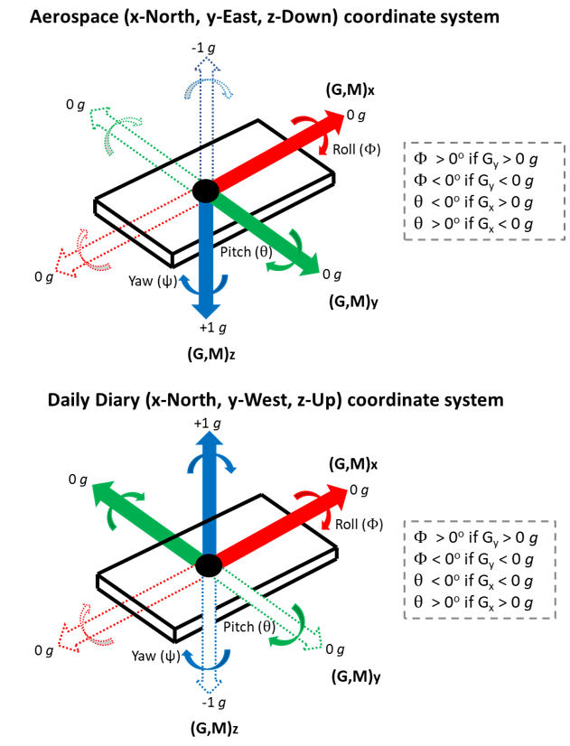

**\*Figure adapted from Gunner et al., (2021)**

*a table) starts at North, readings of the y-axis will* *be at a maximum and minimum when the device is rotated* *90o East and 90o West, respectively, with the z-axis remaining constant. For the NED coordinate frame however), or indeed, any other coordinate frame system, accelerometer and magnetometer readings can differ at a given device orientation due to variations in the direction of the axes and direction in which +g is measured. For example, here the NED frame measures -1 g when facing directly upwards and +1 g when facing directly downward, which is opposite to that of the DD, The direction of measured geomagnetism from both the y- and z-axes also differ to that of the DD. For both coordinate frames here, a clockwise rotation about the y-axis results in a positive inversion of the x-axis (pitch ()) and a clockwise rotation about the x-axis results in a positive inversion of the y-axis (roll ()), though note that a positive increase in measured g results in a decreasing for the NED coordinate system, whereas for the DD, a positive increase in measured g results in an increasing . Device orientation is expressed in terms of a sequence of Euler angle rotations - roll (**Φ), pitch (**θ), yaw (**Ψ). However, depending on the coordinate frame of the device, relative to the (inertial) Earths fixed frame of reference, and the ordering and direction of the three rotation sequences about each axis used, there can be variant Euler angle outputs for equivalent inputs. Consequently, there is no one ‘set’ rotation matrix to derive accurate Euler angles or to convert readings to be expressed in a different local coordinate frame (e.g., NWU to NED). In essence, it is essential that tri-axial accelerometer and magnetometer readings are aligned to a designated tag coordinate system with a known direction of measured g and corresponding direction- (left-handed vs right-handed) and channel order sequence of rotations for accurate delineation of 3-D rotation with respect to the fixed Earth’s surface (with respect to the gravity vector). Put simply though, due to the layout of perpendicular (orthogonal) channels, any required coordinate frame transformations just involve swapping and/or negating the measurements from accelerometer and/or magnetometer channels. As a case in point here, to convert from the DD-NWU frame to the NED frame (assuming the device is lying flat on a table), y- and z- axis of the magnetometer are required to be negated, since they are measuring magnetism in the opposite direction to that governed by the NED system. As for acceleration, despite the y-axis being opposite in direction from that of NED local frame, raising the left side of the device results in a positive increase of measured acceleration, which transcends to a positive roll, which is the same as the NED coordinate frame, because g is positive towards the downward component of earth vector for NED but negative for the DD axis configuration. As the DD y-axis tilts up, the corresponding NED y-axis tilts down, but both are measuring increasing g and thus depicted as rolling right. As such the y-axis does not need to be negated and in a similar manner, the z-axis also remains the same, but the x-axis does require negation, since a downward tilt (pitch) measures negative g for the DD configuration and positive g for the NED system.*

*Figure 5. A schematic diagram showing the relationship between the ‘math’ direction (red values - top graph reflects the equivalent polar coordinates) required for trigonometric functions including* *, and the typical geographical direction - whether it be* *expressed* *in the scale 0° to 360° (blue values) or* *-180° to +180° (green values). Note, outputs heading in the -180° to +180° scale. The blue barbed flag demonstrates the typical meteorological convention of displaying wind speed, with the barb end pointing in the direction the wind is coming from (South), the arrow pointing in the direction the wind is blowing towards (North) and the number/shape of barbs reflecting the relative magnitude. The function returns the radian* *arctangent ratio between the positive x-axis and the vector from the origin to (u,v). Unlike the inverse trigonometric function of tan, (, or ’), deals with issues such as when the u-component denominator is zero and determines the quadrant of the result. The red-, green-, blue arrows in the top graph represent the x-, y-, z axes of a tri-axial magnetometer (M), respectively, with an NED coordinate frame and units in Gauss (G). The process of computing heading (or ‘yaw’, ) from IMU magnetometry is analogous to that of a current vector with u-, v-components, in that the arctangent ratio between the positive x-axis and the normalised magnetic vector from the origin to (Mx, My) represents heading with respect to magnetic North, which can be made true North by summing any required magnetic declination angle. But for the correct computation of heading, these two channels need to be aligned parallel to the earth’s surface and so the magnetic vectors are required to de-rotated using a process known as ‘tilt-compensated compass’, which is essentially correcting, or compensating them, according to pitch and roll angles of the device.*

