Goose-GMSE Simulation summary

Generated on 2019-04-26 16:18:59

## Input parameters

Parameter

Value

No. of simulations

5

Number of years projected

2

Maximum no. culled

2000

Population target

32000

## Output

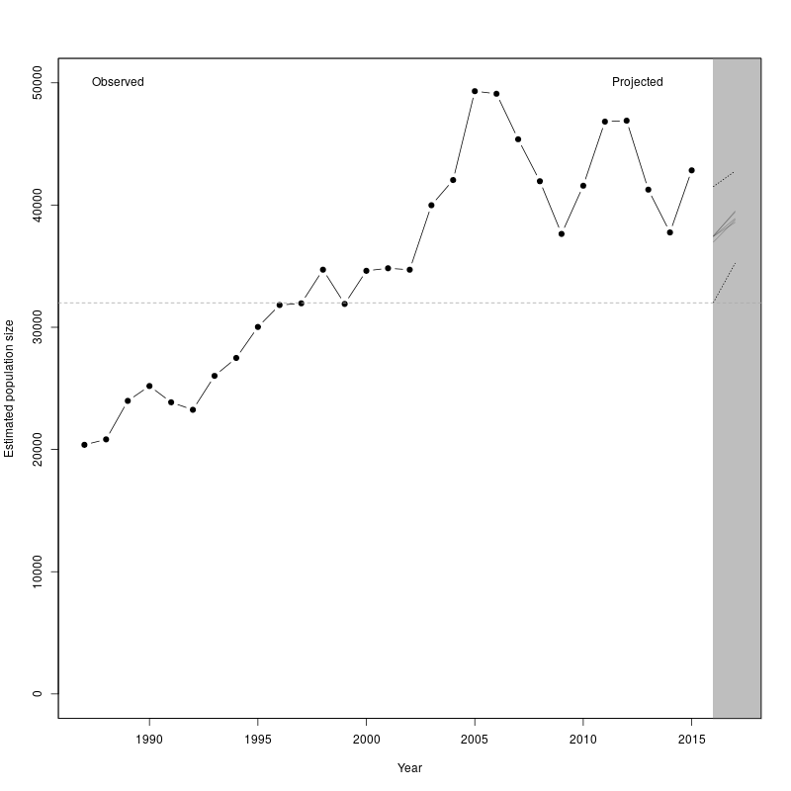

In 2017 the projected population size was between 38581 and 39502 individuals.

The projected population in 2017 does not overlap with the population target of 32000

After 2 projected years, the mean population size is predicted to be 7034 individuals above the population target of 32000

The projected population does not overlap the target in any of the projected years

## Numbers culled per projected year

Year

Mean projected pop. size

Mean no. culled

SD culled

Min. culled

Max. culled

2016

37356

2000

0

2000

2000

2017

39034

2000

0

2000

2000