Graphics Project Proposal
(Draft)
Richard Bruce

Motivation
As the number of transistors on a chip continues to increase their power consumption and performance are ceasing to improve. This means that individual processor and thus single threaded software performance will no longer scale as it has done in the past. To combat this problem computer architects are turning to ever more parallel hardware architectures. The challenges for computer architects designing these platforms are power dissipation and memory bandwidth.

As processor platforms become more parallel without showing an increase in single threaded performance software engineers are left with the issue of how to make their algorithms more parallel. If an algorithm can be made parallel, either at data level or thread level, the software engineer can exploit very powerful architectural features. The principal examples of these features are SIMD, (Single Instruction Multiple Data) for data level parallelism and hyper threading and multi threading for thread level parallelism. Software engineers may need to radically rethink algorithms in order to make them parallel and must also take care to avoid memory bottlenecks.

Technical Proposal
Ray tracing is a naturally “embarrassingly parallel” algorithm, both at thread and data levels. Ray tracing is capable of producing photorealistic images with physically accurate soft shadows and complex multi level reflections and refractions. These are effects that are difficult or even impossible to raster. Any primitive that can be mathematically defined (cones, cylinders, ellipses, spheres, tori, paraboloids, hyperboloids, etc) may be used to construct ray traced image whereas rastered images are limited to triangles. Ray tracing scales favourable with the number of primitives compared to rastering (O(Nlog(N)) vs. O(N)). Examples of ray traced images may be found in appendix A.

The ray tracing algorithm shoots a ray of light from the camera though each pixel of the screen, the red arrows in Figure 1. These rays will hit the nearest object in their path if such an object exists. If such an object does exist then rays will be cast from the point of intersection to the light source, the blue rays in Figure 1. If these ray reach the light source without first hitting another object then this pixel is lit and will be shaded, otherwise the pixel is left black. If the object is reflective or transparent then further rays may be cast in the direction computed by the relevant laws of physics and the whole process repeats itself. As rays are cast from the camera only visible objects are rendered.
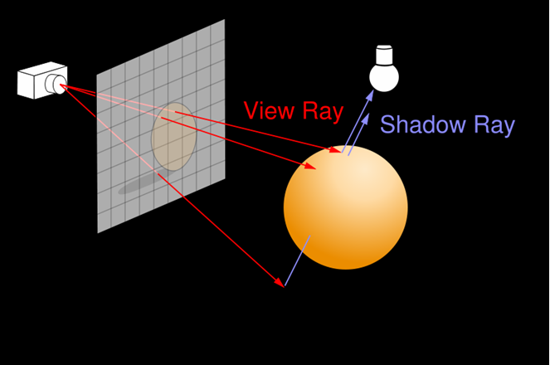
Figure 1 Ray Tracing

In the past ray tracing has been unrealisable as a real-time algorithm because of its shear computational requirement. Over the years research into ray tracing has moved in leaps and bounds developing algorithms that reduce the computational work load of the algorithm [1], exploit data level parallelism through increasingly tightly coupled and wider SIMD engines [2, 3], exploit thread level parallelism through larger multiprocessor architectures and smarter scheduling algorithms[9] and reduce memory and memory bandwidth requirements through the use of machine friendly algorithms and more compact data structures [1, 4, 5]. Work done by a ray tracer is also useful to other parts of a game engine. For example the acceleration structures built by a ray tracer are also of use to a physics engine and visibility queries for AI may be computed by shooting rays.

Ray tracing is now finding its way into main stream computer graphics as a real-time algorithm and is dominant in offline rendering (Disney Pixar and Dreamworks) because of its superior image quality.

From a hardware point of view the choice of a processor for use in a “many core” platform is an interesting one. It has been concluded by some in the research community that the best processor shouldn't have the highest single threaded performance, but more the best compromise of area and power consumption versus performance [7]. This is due to the saturating nature of optimisation were a lot of the gain can be had for little effort, but further gains will require increasingly large efforts. This decision can also be seen in Intel’s product range were their small embedded processors are used for many core designs [8]. The processors used in this design are in-order, dual pipeline processors similar to an ARM cortex A10, but with hyper threading and a wider SIMD unit.

This project proposes to design a ray tracing system consisting of an optimised software ray tracer and a hardware platform containing many small processors. There is also the option to extend the project to physics processing and artificial intelligence on the same platform because these tasks can also be made very parallel.

Business Proposal
Fast, high image quality ray tracers are of interest to companies involved in movie production and effects, still graphics creation, computer graphics and eBook authorship. These companies including Disney Pixar, Dream Works and the Hong Kong company Centro Digital Pictures Limited (Address: Unit 801-805 L8 Core C-D Cyberport 3, Tel 2319 6688). Image quality is very important to these companies. They may keep large clusters to render films or be satisfied with longer rendering times for shorter image sequences. The proposal for such companies is to be able to provide a “cluster on chip” combined with highly optimised ray tracer. This would allow each designer to have a large amount of processing power on his desk thus improving creativity and productivity. It will also be cost effective because there is no need to maintain air conditioned server rooms and their associated IT infrastructure.

The hardware solution would attach to the PCI slot of the graphics designer’s computer, Figure 2, and the software would be installed as usual. The complete design would then work “black box style” with the designer providing scene descriptions and the ray tracer returning the rendered scene or animation. A configuration file may be provided to support additional features not supported in the designer’s chosen modeling format. Some file formats already have support for advanced modeling and animation. An example of such a format is the Sony backed COLLADA format [6]. The file format used by the graphics designer is only of concern to the ray tracer as far as the ray tracer must be able to parse that file format and support its features. The second of these concerns is a must in any case and the first of these concerns is not technically challenging.

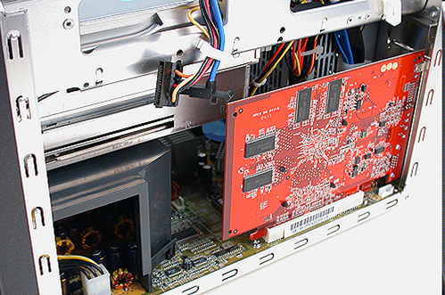
Figure 2 Hardware Installation

The output format of the ray tracer is of little consequence to the main ray tracer kernel, which will simply produce an array of RGB values. (RGB is used in computer graphics as apposed to YUV, which is prevalent in video because there is no advantage in under sampling the colour components). The ray tracers output may therefore be combined with still or moving picture compression and converted into a desired format (including eBook). If colour space conversion is required this maybe performed on outputting the image. An example design flow can be seen below.

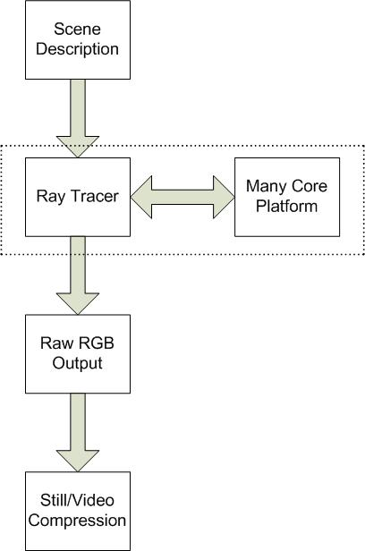
Figure 3 Ray Tracer Flow Diagram

This project need not ultimately be limited to ray tracing or indeed graphics. Such a high performance platform could find uses in fields as diverse as super computing, finance and wireless base stations. More closely related applications would include real-time computer graphics if OpenGL or a standard ray tracing API were supported and console gaming if a console manufacturer could be approached. This project could also diversify to hardware accelerated physics, again by supporting a standard API.

Timeline
The first task of this project is to develop an optimised ray tracer that contains the major parts of the final product for example acceleration structure construction and traversal algorithms, primitive intersections tests, shading and texture mapping. This software may be developed in x86, possibly on Intel’s Larrabee platform [8], and migrated to another platform later. It is also important to investigate the high level topology of the hardware and propose some possible designs based on the expect characteristics of the ray tracer. This work would be completed as part of the seed project and can be seen in Table 2.

Date | Y0Q1 | Y0Q2
Task | Y0Q1 | Y0Q2
Initial Ray Tracer Design (proof of concept)
Hardware Investigation
FPGA Design
Table 1 Seed Project Timeline

The ray tracer will be used to benchmark a prototype system in FPGA. Developing the prototype system in FPGA will allow the design to be rapidly re-spun and the effects of any optimisations tested. This is important in order to ensure that memory bandwidth and computational resource requirements are met. This time can also be used to further optimise the ray tracer. In parallel a physics engine will be developed to provide extra benchmarking for the FPGA platforms and support for animation features in the ray tracer. Later a higher performance ASIC platform with more cores can be developed. The full project should follow immediately from the seed project. The full project timeline can be seen in Table 2.

Date | Y0Q3 | Y0Q4 | Y1Q1 | Y1Q2 | Y1Q3 | Y1Q4
Task
Ray Tracer Optimisation
FPGA Design
Physics Engine Design
Table 2 Full Project Timeline

Reference

- V. Havran. “Heuristic Ray Shooting Algorithms”. November 2000.
- A. Reshetov. “Faster Ray Packets-Triangle Intersection Through Vertex Culling”. IEEE/EG Symposium on Interactive Ray Tracing 2007.
- H. Dammertz, J. Hanika and A. Keller. “Shallow Bounding Volume Hierarchies for Fast SIMD Ray Tracing of Incoherent Rays”. IEEE/EG Symposium on Interactive Ray Tracing 2008.
- I. Wald, S. Boulos and P. Shirley. “Ray tracing Deformable Scenes using Dynamic Bounding Volume Hierarchies”. SIGGRAPH 2006.
- W. Hunt, W. R. Mark and G Stoll. “Fast KD-tree Construction with an Adaptive Error- Bounded Heuristic”. IEEE Symposium on Interactive Ray Tracing 2006.
- M. Barnes and E. L. Finch. “COLLADA – Digital Asset Schema Release 1.5.0”. April 2008
- K. Asanovic et al. “The Landscape of Parallel Computing Research: A View from Berkeley”. Technical Report No. UCB/EECS-2006-183 http://www.eecs.berkeley.edu/Pubs/TechRpts/2006/EECS-2006-183.html, December 18, 2006
- L. Seiler et al. “Larrabee: A Many-Core x86 Architecture for Visual Computing”. ACM Transactions on Graphics, Vol. 27, No. 3, Article 18, August 2008.
- R. D. Blumofe and C. E. Leiserson. “Scheduling Multithreaded Computations by Work Stealing”. Journal of the ACM, Volume 46 , Issue 5, September 1999.

Appendix A

This image was created by Gilles Tran with POV-RAY 3.6 using Radiosity.


This images was generated by nVidia Quadro Plex

