Files:

Apache Tomcat 8.0.53 Server (Download core binary distribution) – Installer one if available (.msi, .exe): <https://tomcat.apache.org/download-80.cgi>

Java SE – Installer one if available (.msi, .exe):

<https://www.oracle.com/technetwork/java/javase/downloads/jdk11-downloads-5066655.html>

Mysql Community Server – Installer one if available (.msi, .exe):

<https://dev.mysql.com/downloads/mysql/>

Instalation order:

1. Java JDK
2. Apache Tomcat
3. Mysql Community Server

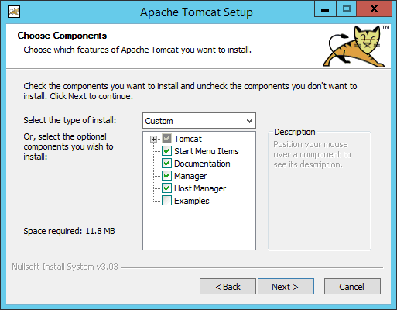

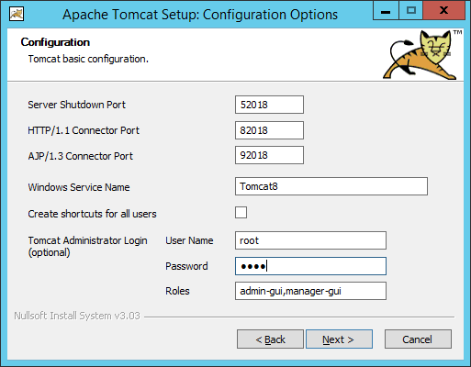

Set a default root access data (I used root for both username and password)

Take note of this port number

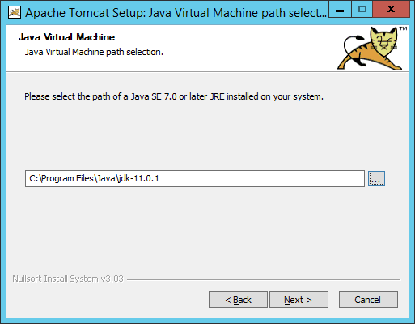

Point to the Java Jdk installation path

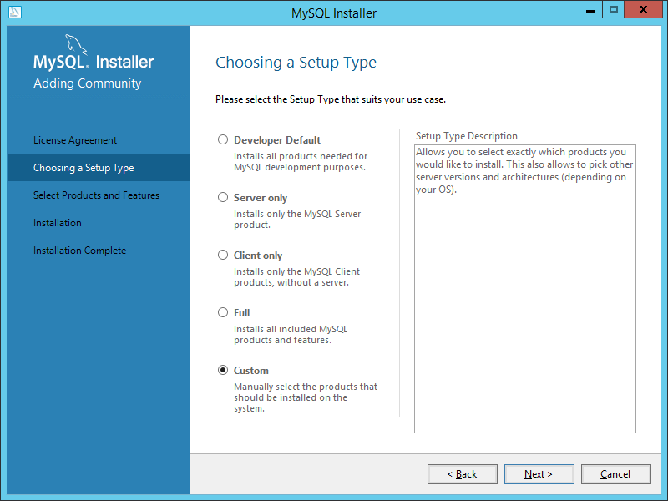

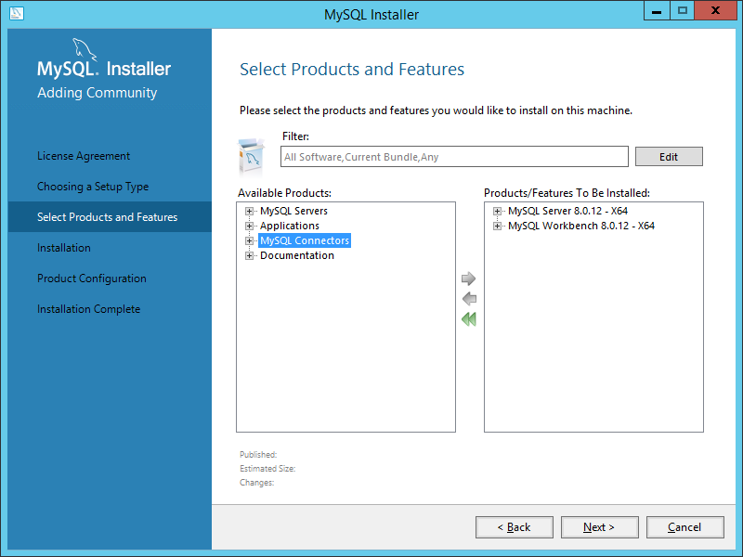

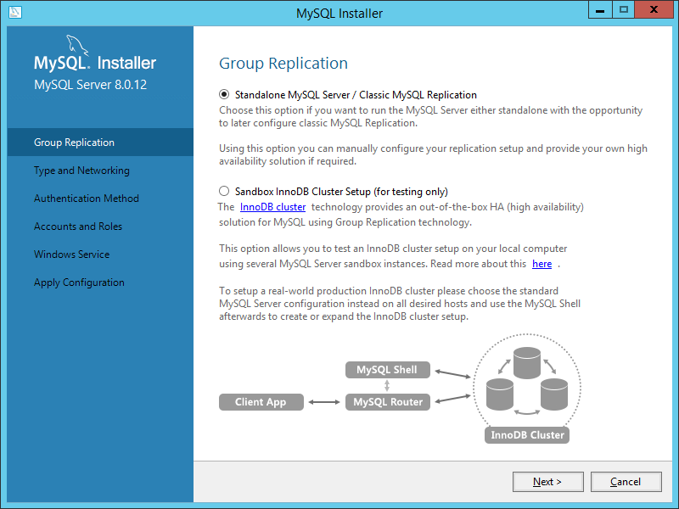

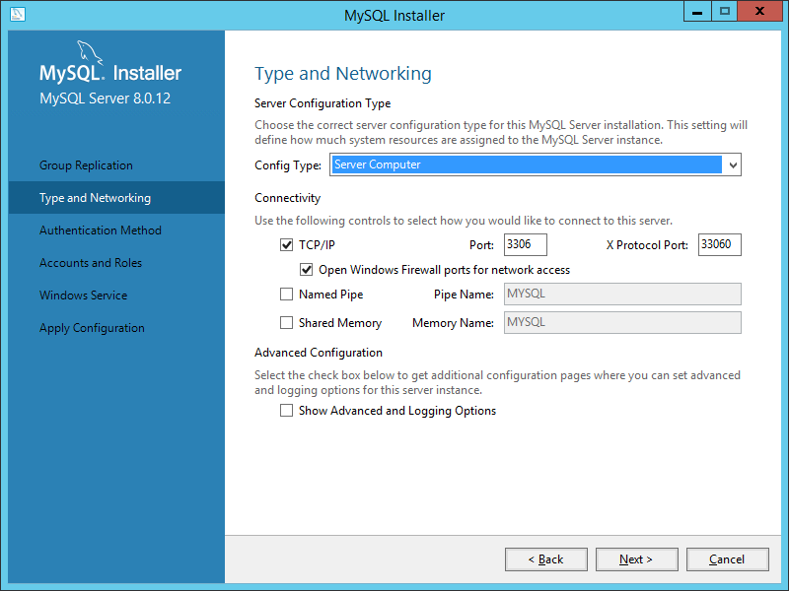

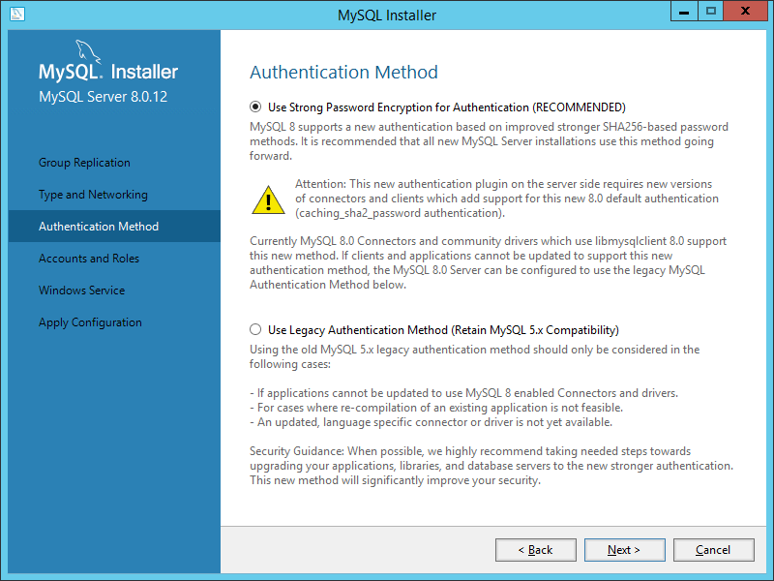

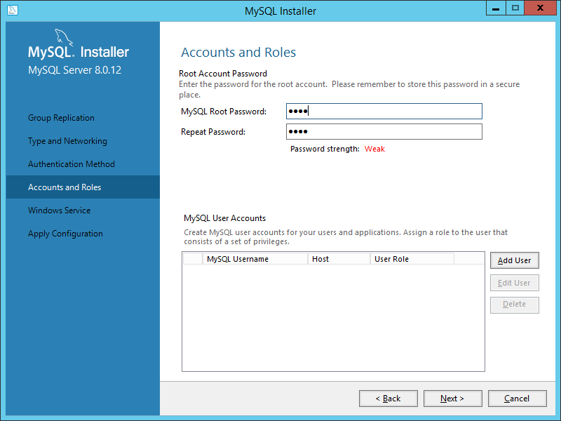

Set a default root access data (For now, this MUST be root for both username and password, otherwise it’ll not work)

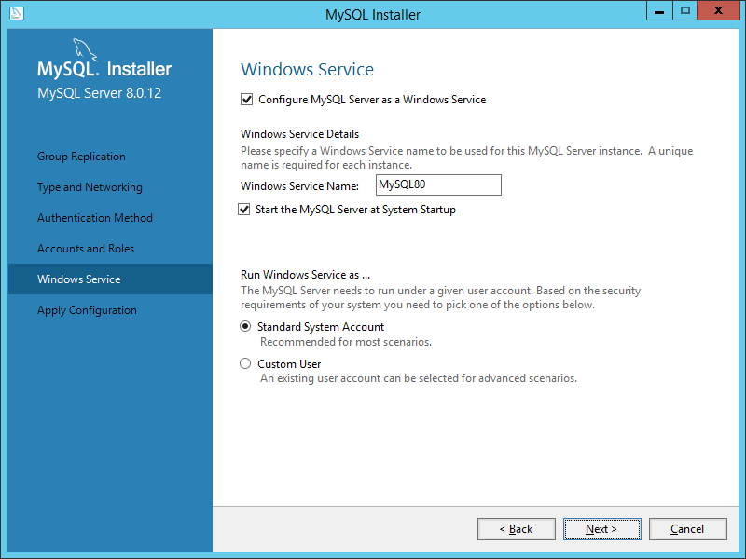

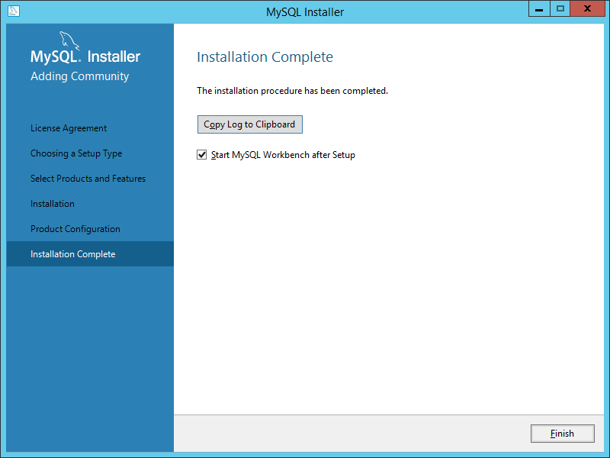

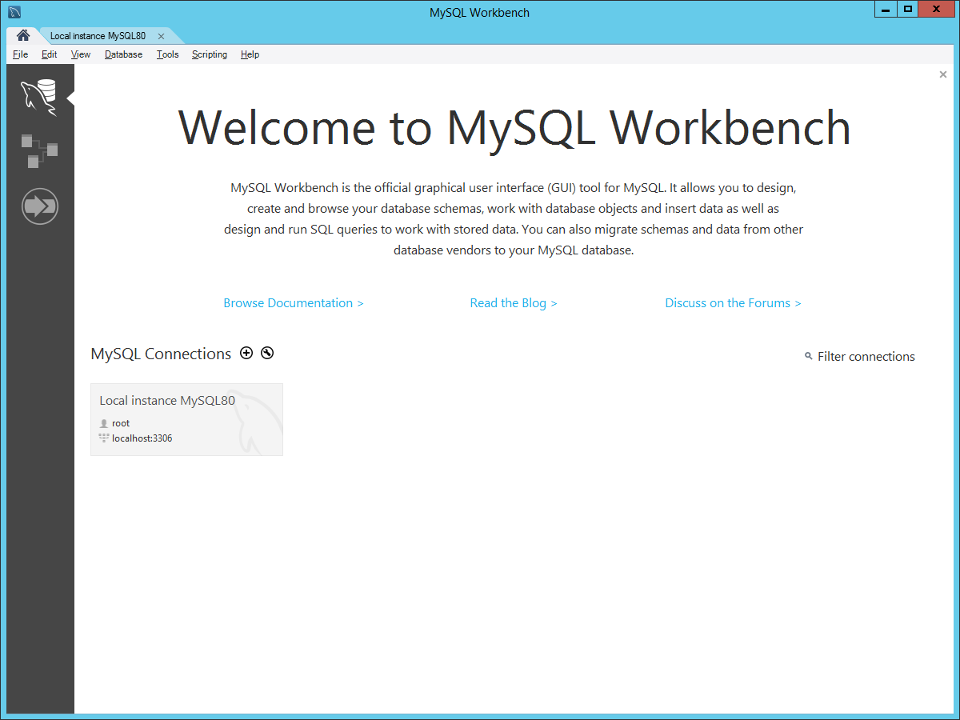

Click on the local instance

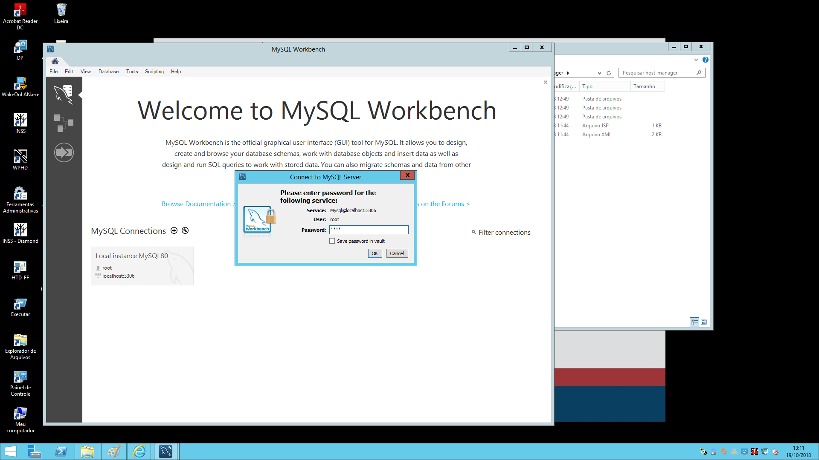

Put the previous used username and password

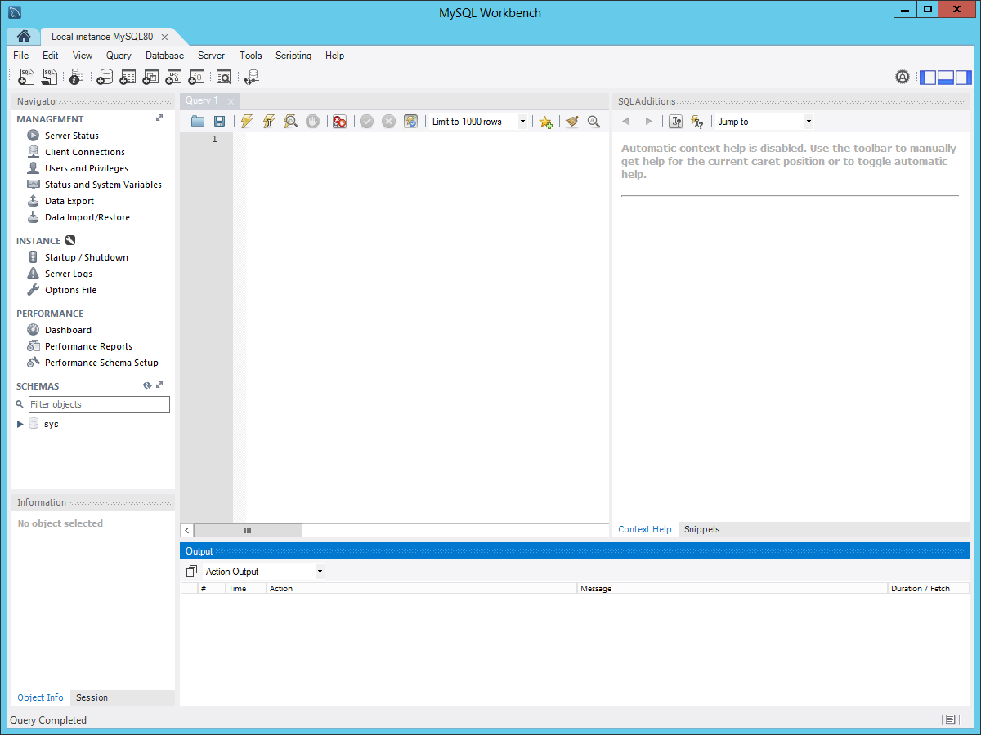

2) Click here after entering the command

1. Type this command in the blank area (without quotes):

“create database wqc2_0;”

This screen will show up

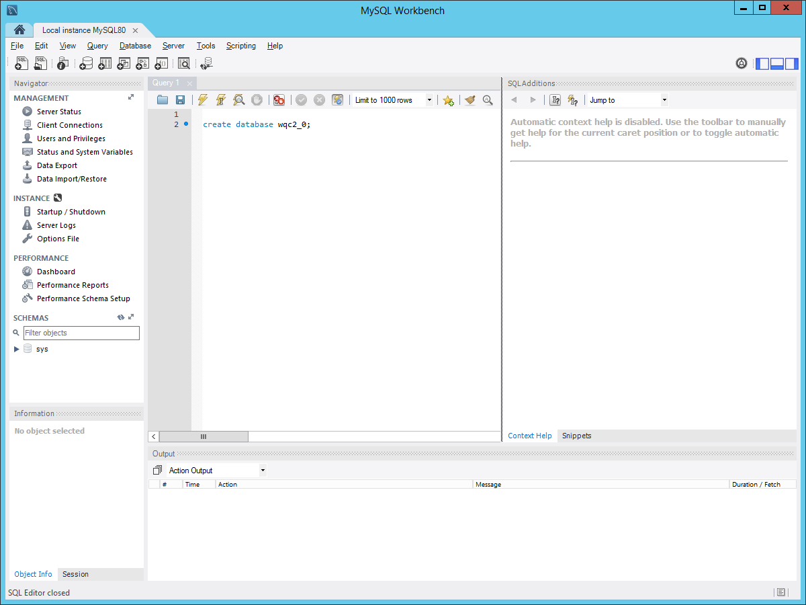

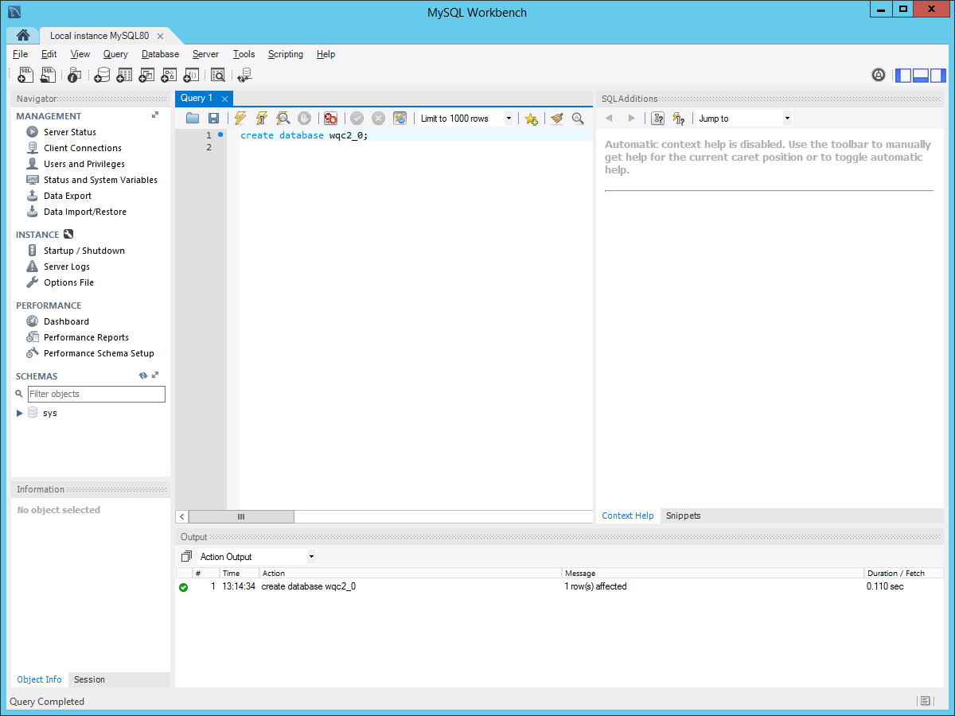

Result will show up here.

Setup is done if the result says that “1 row was affected”.

You can close the workbench now.