First, you must copy the “.war” file to the tomcat’s webapps directory (usually at - without quotes- “C:\Program Files\Apache Software Foundation\Tomcat 8.0\webapps”. After you do this, you must wait some time (maybe two to five minutes – it depends on your server configuration) and a new folder should appear at the same location with the “.war” file’s name.

After this, within a web browser, access the following address (without quotes / spaces): <http://localhost:8080/WQC-2.0/web/>

* Replace localhost by your server’s name or ip address (whatever you think it’s best)
* Replace 8080 by the http port number which you took note while installing Apache tomcat

If everything is ok (including the installation), the following screen will show up:

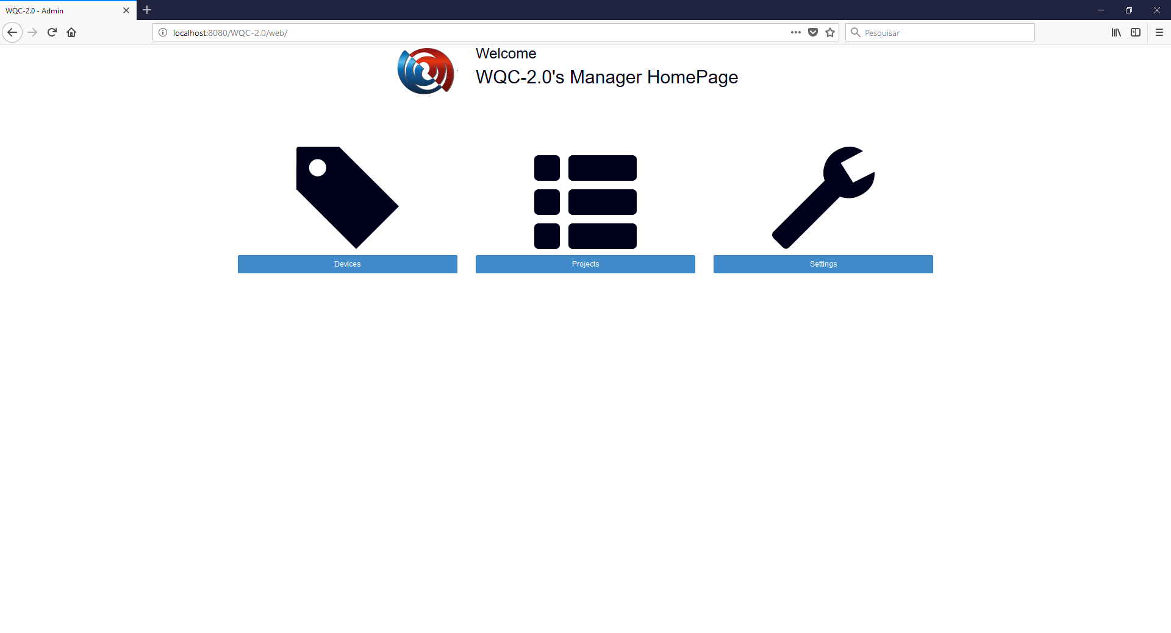

Click on settings and when the next screen shows up, enter your own settings.

In this screen, you must change only the ‘server path’ (replace it with your server name).

When you are done with the changes, click save to go back to the previous screen.

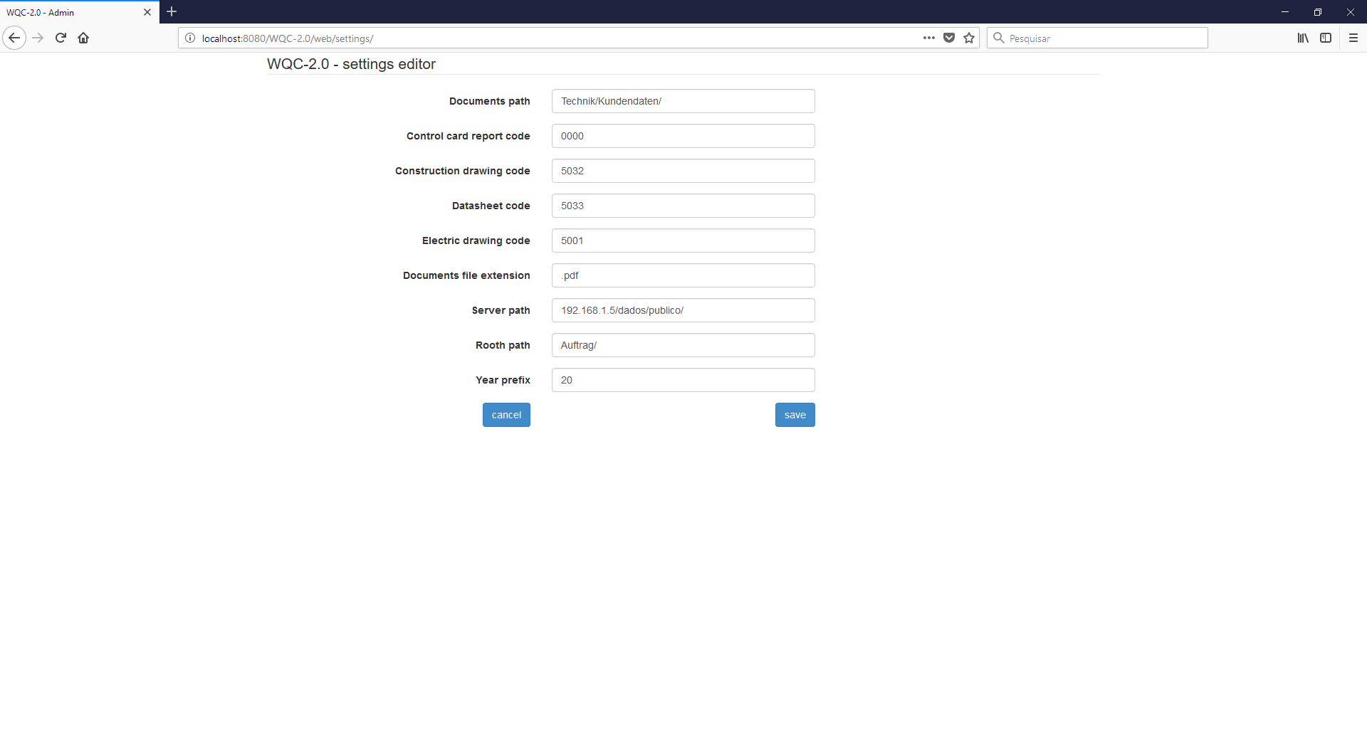

Now you can install (if not done yet) and open the client’s app.

On first run:

1. It will ask you to give it access to the camera and to the external storage

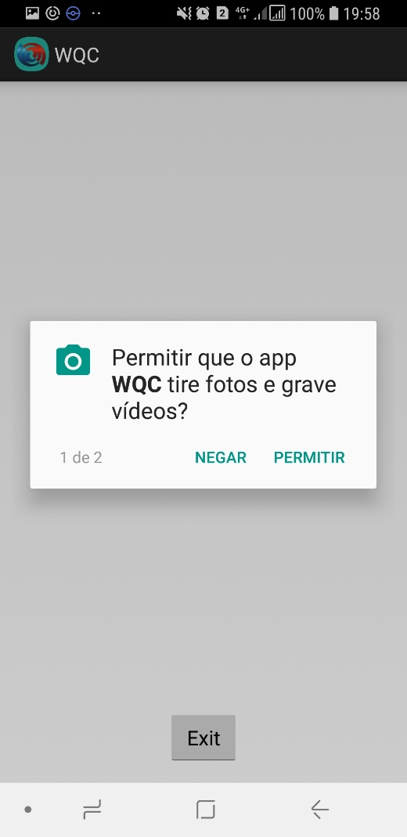 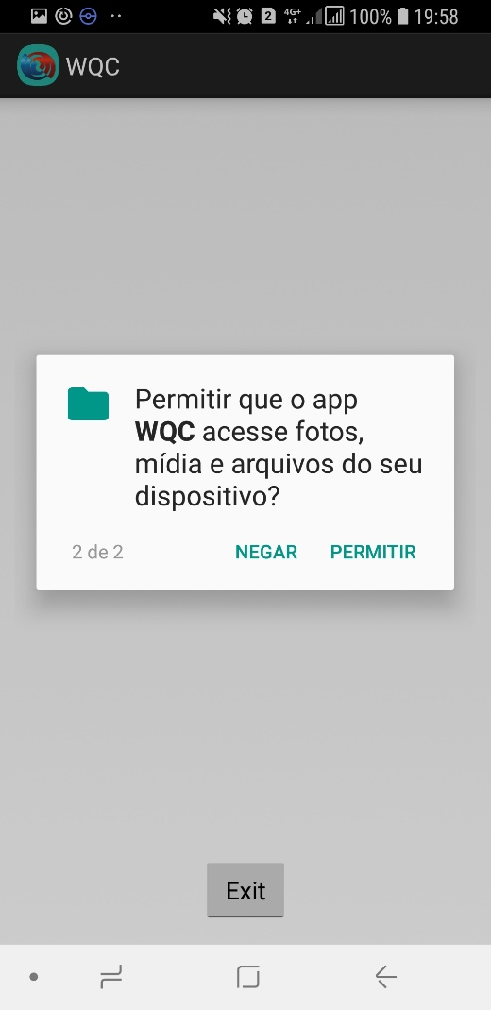

1. It will ask you the server address, which you must type exactly as the following (without quotes / spaces): “localhost:8080”
   * Replace localhost by your server’s name or ip address (whatever you think it’s best)
   * Replace 8080 by the http port number which you took note while installing Apache tomcat

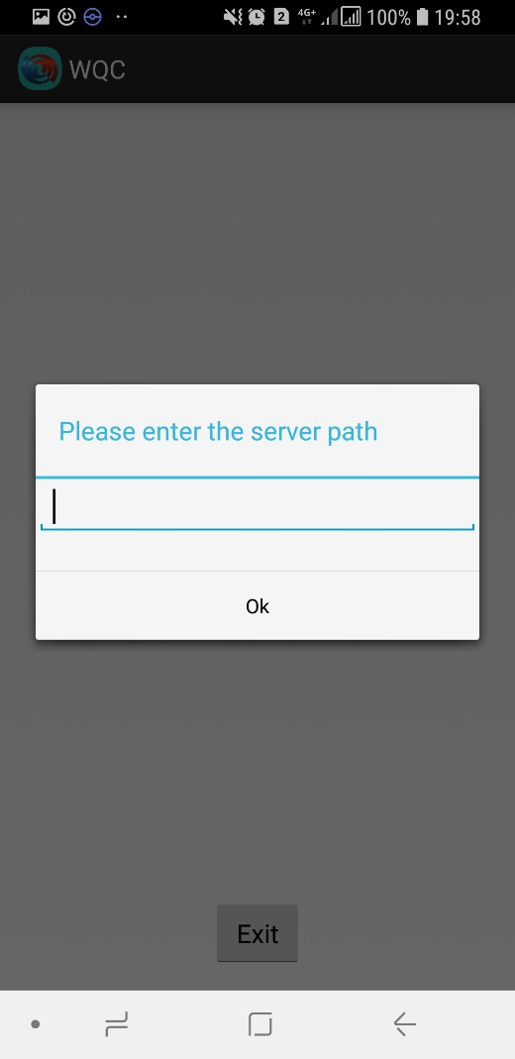

1. When the connection is successful, you will see a message saying that this device was not given the needed server permissions to run. This will happen every time the app is installed on a new device.

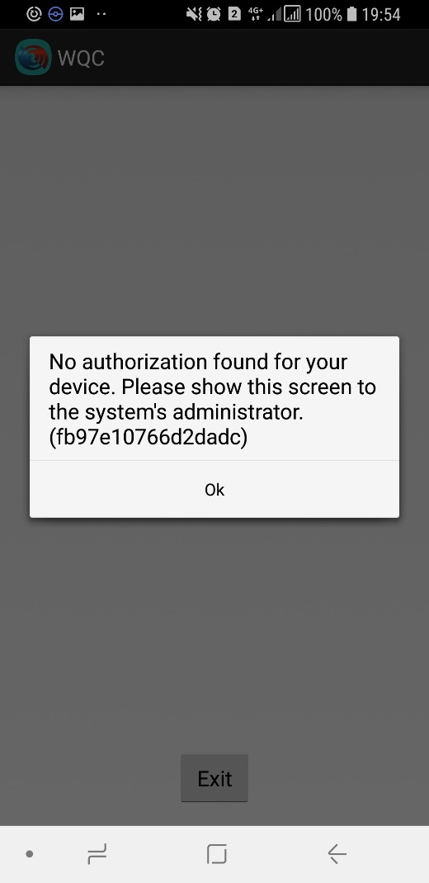

To solve that you need to access the “WQC-2.0’s Manager HomePage” using the same address as before (maybe its better when you create a shortcut to this address).

In this page, you must click on the “Devices” button. When you do that, the following screen will show up:

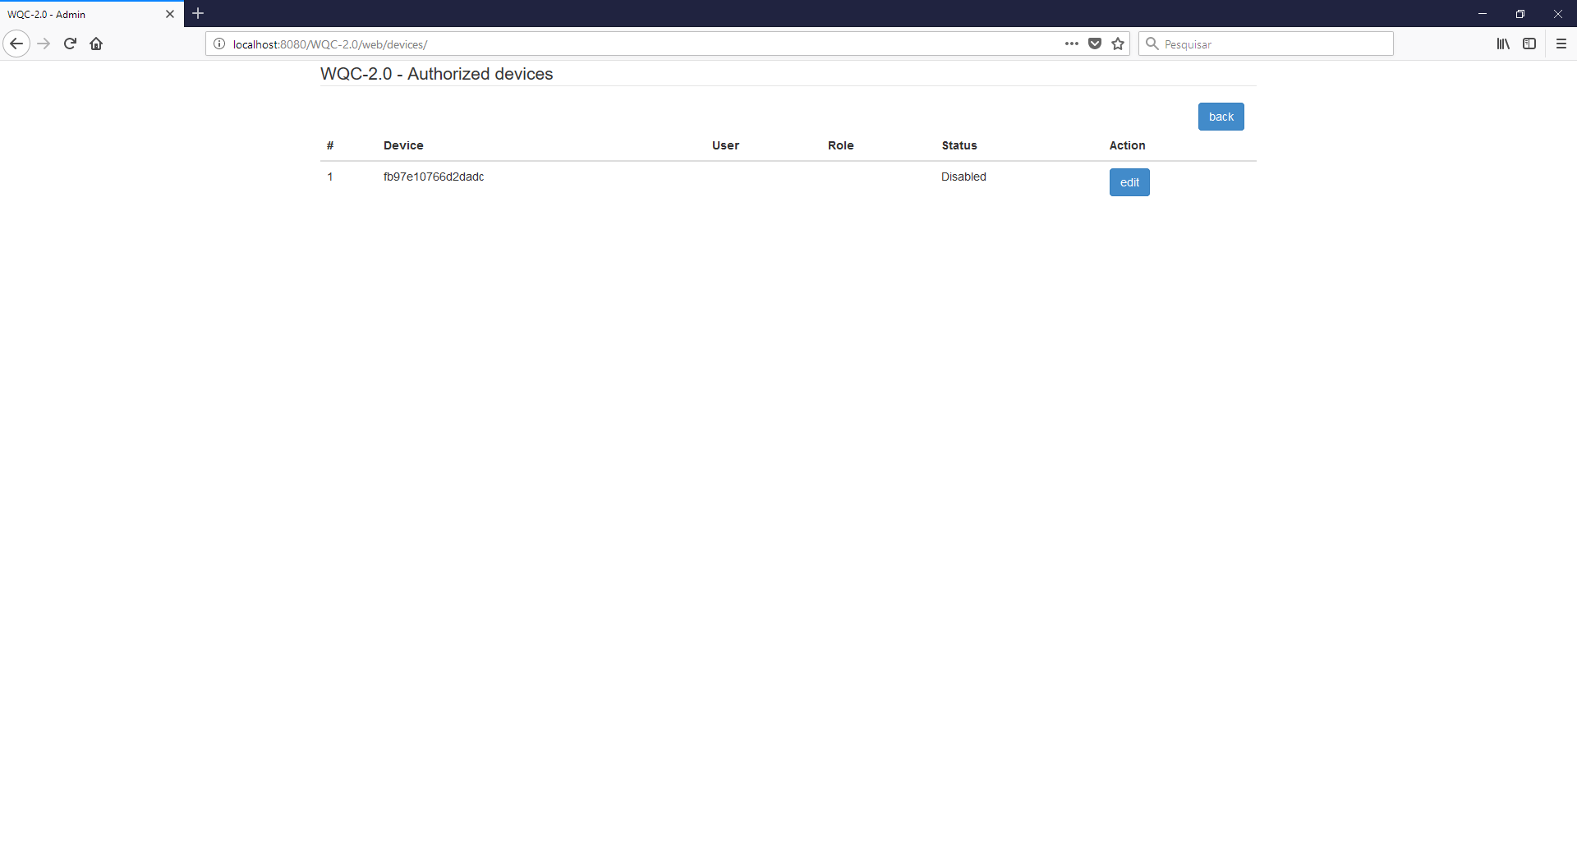

Here is a list of all devices that asked for permissions and were granted or not those permissions. Remember that the devices will only be shown within this list after they are executed for the first time and no permission is set for them yet.

Those “permissions granting” just means that you need to configure the device’s username and role, plus say if it’s “enabled” (allowed) to use the app or not.

Now, click on the edit button of the device you would like to configure. You can check its code at the message that is shown up when you open the app. When you do that, the following screen will show up:

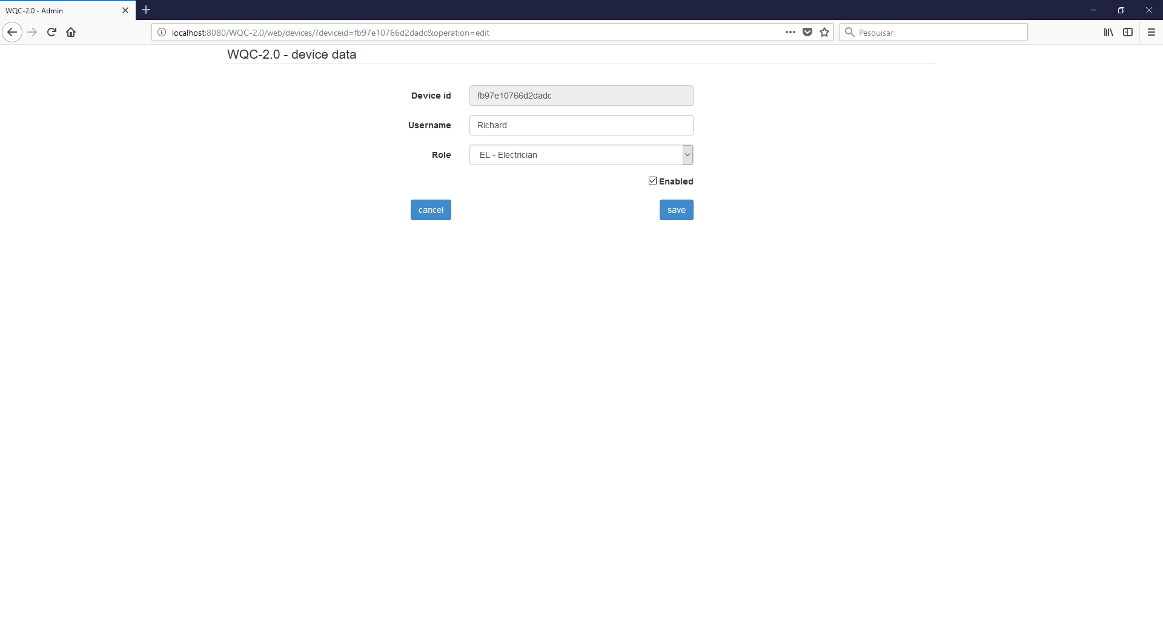

Here you must fill the ‘username’ field, select one of the available roles (QC – the ‘ok’ from the previous app version, EL – electrician, MG – for the storage / warehouse – “magazine”) and click on the ‘Enabled’ checkbox. If the checkbox is not selected / enabled, the device will not be allowed to use the app. You can use this for future users / devices deactivations. When you are done, click on the ‘save’ button to go back to the list and see the changes that were made.

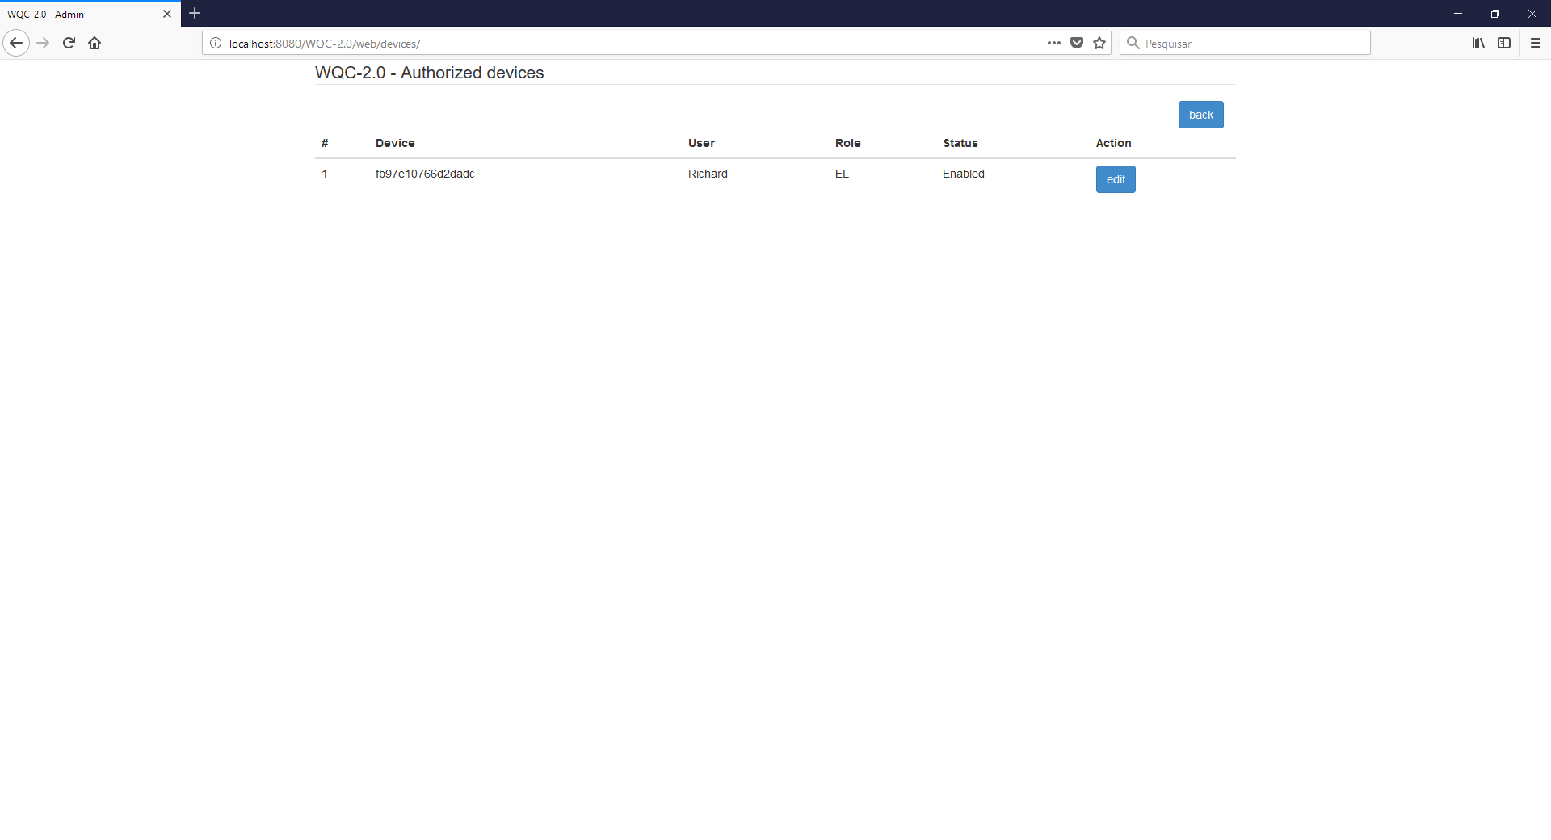

1. After granting the permissions the device will be able access the app normally.

Notes:

1. Whenever a random user tries to do any changes, the system will check if the drawing is being edited or not. If it’s not, it’ll be locked for 9 seconds and the changes will be made. During this time, no one else than this user will be able to do any changes to this drawing. This timer refreshes every time this user does a new change. If the timer goes over and the user has made no more changes, the drawing will be unlocked and the first user to do a new change will cause this process to repeat.
2. Now, data is saved whenever you do a significative action (adding a mark, changing a *Kontrollkarte* item)
3. The SMB protocol is no longer needed to do the file transfers. All is done using HTTP protocol. This way, no server account (user+password) is needed to get the files.