1)

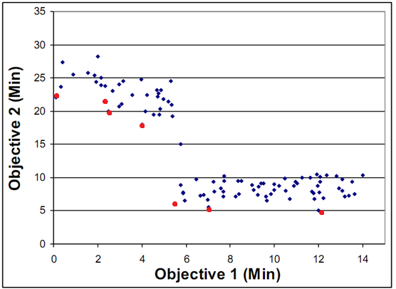

There are 7 non-dominated solutions

The tradeoff curve is not convex.

The Pareto-optimal set consists of {University of Disney Land, Bedlam College, Hard Knocks U}. Space Cadet Academy is dominated by University of Disney Land. Other three in the optimal set are not dominated.

2)

a)

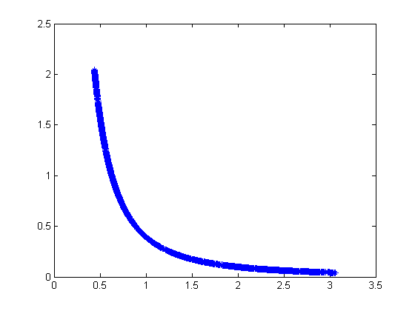

b)

mean of weight: 1.253507; standard deviation of weight: 0.789607

*load solution.txt*

*weight = solution(:, 3);*

*fprintf('mean of weight: %f; standard deviation of weight: %f\n', mean(weight), std(weight));*

c)

mean of deflection: 0.684455; standard deviation of deflection: 0.625754

*load solution.txt*

*deflection = solution(:,4);*

*fprintf('mean of deflection: %f; standard deviation of deflection: %f\n', mean(deflection), std(deflection));*

d)

There is no best solution for this problem unless addition information is given. For example, if you are given how much weight and deflection value to you relatively.

3)

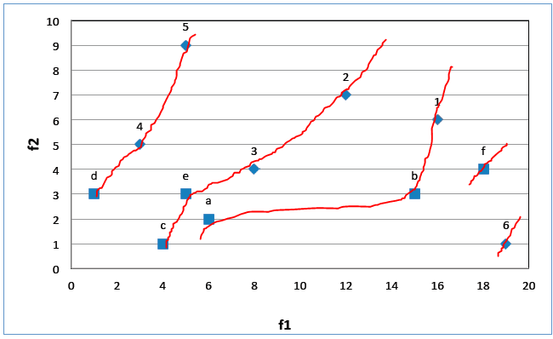

1. Since we had 6 parents, we are looking for a new generation of size 6.

We add d, 4, and 5 to the new generation because they are in the first front, so they are the best.

We add c and 2 to the new generation because they have infinite distance (they have no neighbors on the front).

Lastly, we need to pick between e and 3 by looking at which has a bigger distance. In this case, we pick 3. Just by looking at the graph, we can see that e’s neighbors are closer to it than 3.

Therefore, the new parents are {d, 4, 5, c, 3, 2}.



(f,c): pick c, since inf>2.15 (they are both in front1)

(2,e): pick 2, since front1 > front2

(3,5): pick 3, since inf>2.51 (they are both in front2)

(5,f): pick f, since front1 > front2

(c,3): pick c, since front1 > front2

(e,2): pick 2, since front1 > front2

We’re left with the mating pool {c, 2, 3, f}