## Problem 1

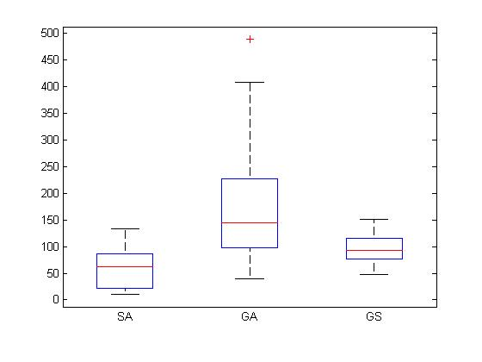

From the boxplot for the given data, we can see that GA has the worst performance with highest mean and variance. SA has lower mean but with larger variance comparing with GS. There is an obvious outlier for the data of GA with value 488.83. We think that SA has the best performance as 1. It has the lowest mean, 2. It has a fairly stable performance and 3. Among all 3 algorithms, SA is more likely to reach the lowest objective value.

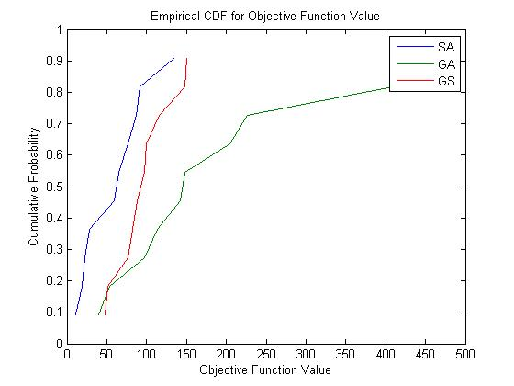

From the Empirical CDF above, we can see that SA gives the most vertical plot, which means it has the highest probability to produce the lowest objective value. GS gives the second best plot, with a relatively high probability of finding the lowest objective value. And GA has the worst performance over the 3, as its empirical CDF is more flat, which means it often produces very large objective value.

The empirical CDF also indicates the spread of the solutions. SA and GS have more than 0.8 probability of performing well, while GA only performs 7 out of 10 trials. Therefore from both perspectives, SA and GS are better than GA in performance, and SA is relatively better than GS.

There is evidence of stochastic dominance from looking at the graph, because if you look at any objective function value, the current data suggests that SA always achieves the same or better results than the other algorithms with a higher probability.

1. We do pairwise comparison of all 3 algorithms
2. **SA vs. GA**

Let the mean of the lowest objective function value generated by SA be , standard deviation be

Let the mean of the lowest objective function value generated by GS be , standard deviation be

If we calculate this, we see that

And so

***Hypothesis Test 1***

Let (2 algorithms are the same)

(2 algorithms are not same)

*2 = 0.0228

Since we chose α = 0.05 > p-Value, so we reject null hypothesis. These 2 algorithms are not same.

***Hypothesis Test 2***

Let (2 algorithms are the same)

(SA is better)

So as we are doing one-sided test.

Since we chose α = 0.05 > p-Value, so we reject null hypothesis. , so SA is better than GA.

1. **GA vs. GS**

Let the mean of the lowest objective function value generated by GS be , standard deviation be

Let the mean of the lowest objective function value generated by GS be , standard deviation be

If we calculate this, we see that

And so

***Hypothesis Test 1***

Let (2 algorithms are the same)

(2 algorithms are not same)

So

Since we chose α = 0.05<p-Value, so we accept the null hypothesis. These 2 algorithms give the same performance.

***Hypothesis Test 2***

Let (2 algorithms are the same)

(GS is better)

Since we chose α = 0.05 > p-Value, so we reject null hypothesis. , so GS is better than GA.

1. **SA vs. GS**

Let D = for *I* = 1, 2, ..., 10

= 36.29

= stdev( for *i* = 1,2,…,10 = 47.5066

***Hypothesis Test 1***

Let (2 algorithms are the same)

(2 algorithms are not same)

So

Since we chose α = 0.05>p-Value, so we reject the null hypothesis. These 2 algorithms do not give the same performance.

***Hypothesis Test 2***

Let (2 algorithms are the same)

(SA is better)

So

Since we chose α = 0.05 > p-Value, so we reject null hypothesis. , so SA is definitely better than GS.

1. Yes. I would perform a different test. Since SA only requires a starting solution while GA requires an initial population to start with, we cannot pair these 2 samples.

So instead, we perform a 2-Sample t-test

Let the mean of the lowest objective function value generated by SA be , standard deviation be

Let the mean of the lowest objective function value generated by GS be , standard deviation be

Let

< α Therefore we reject the hypothesis test.

. These 2 algorithms are not the same.

1. We do pairwise non-parametric comparison of all 3 algorithms

Let SA be algorithm 1, GA be algorithm 2, GS be algorithm 3.

1. **SA vs. GA**

|  |  |  |  |  |  |  |  |  |  |  |
| --- | --- | --- | --- | --- | --- | --- | --- | --- | --- | --- |
| Rank | 1 | 2 | 3 | 4 | 5 | 6 | 7 | 8 | 9 | 10 |
| Value | 10.93 | 18.6 | 22.23 | 28.63 | 39.76 | 53.76 | 59.75 | 64.58 | 77.13 | 86.52 |
| SA/GA | 1 | 1 | 1 | 1 | 2 | 2 | 1 | 1 | 1 | 1 |

|  |  |  |  |  |  |  |  |  |  |  |
| --- | --- | --- | --- | --- | --- | --- | --- | --- | --- | --- |
| Rank | 11 | 12 | 13 | 14 | 15 | 16 | 17 | 18 | 19 | 20 |
| Value | 91.94 | 97.88 | 113 | 134.11 | 141.97 | 147.9 | 204.48 | 226.95 | 408.2 | 488.83 |
| SA/GA | 1 | 2 | 2 | 1 | 2 | 2 | 2 | 2 | 2 | 2 |

In this case m = n = 10.

***Hypothesis Test 1***

Let

So we reject null hypothesis. These 2 algorithms are not the same.

***Hypothesis Test 2***

Let

(SA is better)

< α/2 = 0.0025 so Therefore we reject the null hypothesis and accept . SA is better than GA.

1. **GA vs. GS**

|  |  |  |  |  |  |  |  |  |  |  |
| --- | --- | --- | --- | --- | --- | --- | --- | --- | --- | --- |
| Rank | 1 | 2 | 3 | 4 | 5 | 6 | 7 | 8 | 9 | 10 |
| Value | 39.76 | 47.66 | 51.73 | 53.76 | 76.52 | 82.62 | 87.84 | 97.04 | 97.88 | 99.89 |
| GA/GS | 2 | 3 | 3 | 2 | 3 | 3 | 3 | 3 | 2 | 3 |
| Rank | 11 | 12 | 13 | 14 | 15 | 16 | 17 | 18 | 19 | 20 |
| Value | 113 | 115.98 | 141.97 | 147.51 | 147.9 | 150.53 | 204.48 | 226.95 | 408.2 | 488.83 |
| GA/GS | 2 | 3 | 2 | 3 | 2 | 3 | 2 | 2 | 2 | 2 |

In this case m = n = 10.

127

***Hypothesis Test 1***

Let

So we failed to reject null hypothesis. These 2 algorithms are the same.

***Hypothesis Test 2***

Let

(GA is better)

> α/2 = 0.0025 so Therefore we failed to reject the null hypothesis. These 2 algorithms have the same performance.

1. **SA vs. GS**

|  |  |  |  |  |  |  |  |  |  |  |
| --- | --- | --- | --- | --- | --- | --- | --- | --- | --- | --- |
| Rank | 1 | 2 | 3 | 4 | 5 | 6 | 7 | 8 | 9 | 10 |
| Value | 10.93 | 18.6 | 22.23 | 28.63 | 47.66 | 51.73 | 59.75 | 64.58 | 76.52 | 77.13 |
| SA/GS | 1 | 1 | 1 | 1 | 3 | 3 | 1 | 1 | 3 | 1 |
| Rank | 11 | 12 | 13 | 14 | 15 | 16 | 17 | 18 | 19 | 20 |
| Value | 82.62 | 86.52 | 87.84 | 91.94 | 97.04 | 99.89 | 115.98 | 134.11 | 147.51 | 150.53 |
| SA/GS | 3 | 1 | 3 | 1 | 3 | 3 | 3 | 1 | 3 | 3 |

In this case m = n = 10.

79

***Hypothesis Test 1***

Let

So

So these 2 algorithms are close. We reject null hypothesis. These 2 algorithms are not the same but very close. Probably due to statistic error and we need a larger sample to make conclusion.

***Hypothesis Test 2***

Let

(SA is better)

≈ α/2 = 0.0025 so But they are very close. Again we reject the null hypothesis but SA and GA are close. We need a larger sample to make conclusion.

Problem 2



Channels

|  |  |  |  |  |
| --- | --- | --- | --- | --- |
| 0 | 0 | 1 | 0 | 0 |
| 0 | 0 | 0 | 0 | 1 |
| 0 | 0 | 1 | 0 | 0 |
| 0 | 0 | 0 | 0 | 1 |
| 0 | 0 | 1 | 0 | 0 |
| 0 | 0 | 0 | 0 | 1 |
| 1 | 0 | 0 | 0 | 0 |

The minimal channel number we need is 5 to satisfy the interference matrix. We know this must be the optimal number of channels because of the following:

We assume there is a max of 4 channels. Without loss of generality, we put channel x in cell 1.

Given , cells 2 and 7 must each have either a channel or . Since we said there is a max of 4 channels, cell 2 and 7 must have the same channel number (both or both ).

Given , cells 2 and 7 must have channel numbers two apart.

But we just showed that cells 2 and 7 must have the same channel. This is a contradiction, so there must be at least 5 channel numbers to satisfy the interference matrix.

Since we showed 5 channels is possible, that must be a optimal solution.

1. Here are the conflicts:

which is 11.

However, if we count (x,y) and (y,x) as two conflicts, since the interference matrix is not necessarily symmetrical (in this case, it is), then we have the following conflicts:

Where the bolded pairs are the newly introduced conflicts. In this case, we would have 17 conflicts.

1. In each (cell, channel) pair, you can either have a 1 (meaning that channel exists in that cell), or a 0 (meaning there isn’t that channel in that cell). Since there are (cell, channel) pairs, there needs to be 91 decision variables.