### Problem. 1

### Part a)

Denote type0 as a string of the form 0xxxx, and type1 as a string of the form 1xxxx.

Since probability of crossover=1, and the first part of the genes of the child will come from the first parent, whether a child will be type0 or type1 is completely dependent on parent 1. That is, if parent 1 is type1, the child will be type1, and if parent 1 is type0, there is a 30/50 chance for parent 1 to be type1(being member 1 or 2) and 20/50 chance for parent 1 to be type0(being member 3 or 4). Therefore, if roulette wheel selection is employed with no mutation, the chance that a member in generation 1 will be of the form 1xxxx is 3/5. The chance that a member in generation 1 will be of the form 0xxxx is 2/5.

### Part b)

Again, there is a 3/5 chance to choose a string of form 1xxxx, and a 2/5 chance to choose a string of form 0xxxx. We also know that there is a 0.01 chance for the first bit to mutate. So to get a child of form 1xxxx, we either select a string of form 1xxxx and not mutate or select a string of form 0xxxx and mutate, and vice versa for a child of form 0xxxx. Therefore there is a (3/5)(0.99)+(2/5)(0.01)= 0.598 chance to get a child of form 1xxxx, and a (2/5)(0.99)+(3/5)(0.01)= 0.402 chance to get a child of form 0xxxx.

## Problem. 2

### Part a)

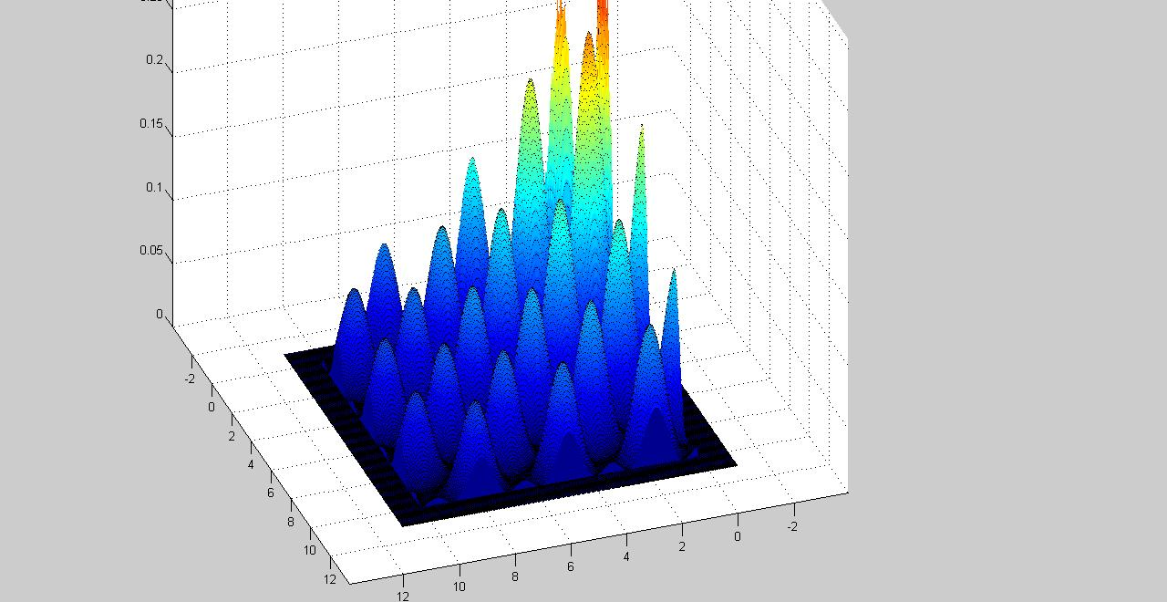



### Part b)

See code

### Part c)

Our experiment is basically as follows:

Define pMutation, pCrossover, and V as some arbitrary value (i.e. 0.5, 0.5, 5).

Repeat:

For each variable:

Fix the other two variables at their default values and for 10 values of the current variable, calculate the elite solution (averaged over 10 runs).

Adjust the default pMutation, pCrossover, and V until the solution looks consistent.

The following graphs shows one such step in the experiment. Note that the higher graph shows the best elite solution over the 10 runs and the lower graph shows the average elite solution over the 10 runs.

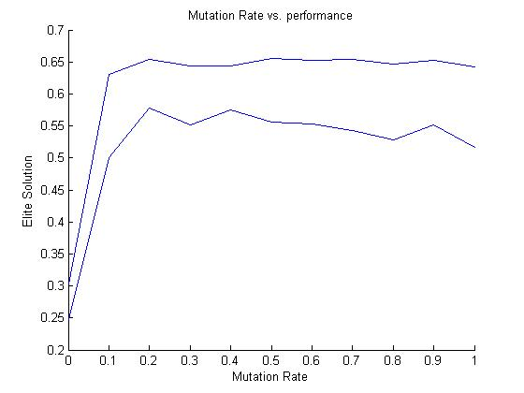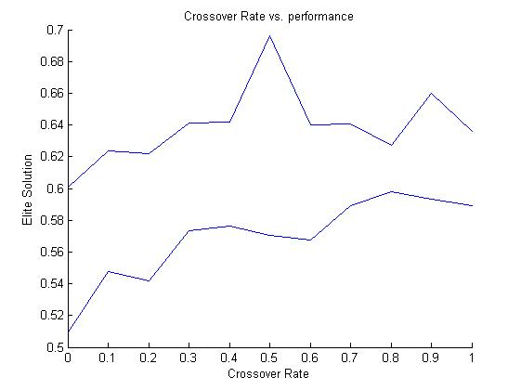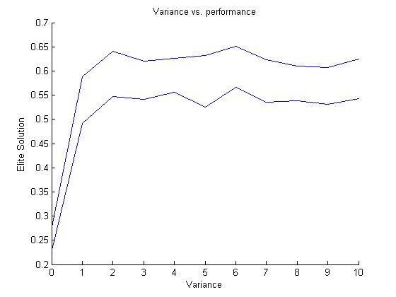

The best values for mutation rate is: 0.2.

The best values for crossover rate is: 0.5.

The best values for V is: 2.

### Part d)

0.554237 is the average and 0.053893 is the standard deviation of the fitness of the fittest member of the population (elite solution) over the 20 trials.

0.647607 is the best and 0.466554 is the worst elite solution from the 20 trials after 200 generations.



Figure 1: dotted line denotes part 3. solid line denotes part 2

### Part e)

I think either a geometrical crossover or an arithmetic crossover would work slightly better. (or perhaps a weighted geometrical or arithmetic crossover with a one point swap). That is, we do a geometric/arithmetic crossover with high weight placed on each parent biased towards the original value; then we do a one point crossover. I feel that this would work better because if we only use one point crossover, we would be depending completely on mutation to change the value of the variables. Without mutation, we can only permute the variables in the solution and not change the variables themselves.

## Problem 3

### Part a)

See code

### Part b)

0.555870 is the average and 0.045103 is the standard deviation of the fitness of the fittest member of the population (elite solution) over the 20 trials.

0.647607 is the best and 0.466554 is the worst elite solution from the 20 trials after 200 generations.

See 2d for plot

### Part c)

Method two works better, although just slightly.