1a) Random Walk

1. Given that you visit your neighbors with equal probability:

N(S1) = {S1, S2, S3}

N(S2) = {S1, S2}

N(S3) = {S1, S3}

So the configuration graph (for both $Θ$ and $P$) looks like this

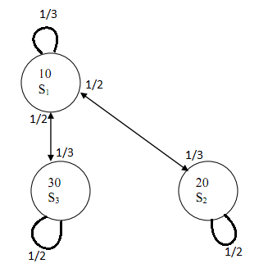

1. Since acceptance is guaranteed for random walk, $Θ=P$:
$$P_{11}=\frac{1}{3};P_{12}=\frac{1}{3};P_{13}=\frac{1}{3}$$

$$P_{21}=\frac{1}{2};P_{22}=\frac{1}{2};P_{23}=0$$

$$P_{31}=\frac{1}{2};P_{32}=0;P_{33}=\frac{1}{2}$$

$$Θ_{11}=\frac{1}{3};Θ_{12}=\frac{1}{3};Θ_{13}=\frac{1}{3}$$

$$Θ_{21}=\frac{1}{2};Θ_{22}=\frac{1}{2};Θ_{23}=0$$

$$Θ_{31}=\frac{1}{2};Θ_{32}=0;Θ_{33}=\frac{1}{2}$$

$$Θ=\left[ \begin{matrix}\frac{1}{3} & \frac{1}{3} & \frac{1}{3} \\ \frac{1}{2} & \frac{1}{2} & 0 \\ \frac{1}{2} & 0 & \frac{1}{2}\end{matrix}\right]$$

2. $π={\left[\begin{matrix}\frac{1}{3} \\ \frac{1}{3} \\ \frac{1}{3}\end{matrix}\right]}^{T}$ by intuition

To confirm: $πΘ={\left[\begin{matrix}\frac{1}{3} \\ \frac{1}{3} \\ \frac{1}{3}\end{matrix}\right]}^{T}\left[ \begin{matrix}\frac{1}{3} & \frac{1}{3} & \frac{1}{3} \\ \frac{1}{2} & \frac{1}{2} & 0 \\ \frac{1}{2} & 0 & \frac{1}{2}\end{matrix}\right]={\left[\begin{matrix}\frac{1}{3}\left(\frac{1}{3}\right)+\frac{1}{3}\left(\frac{1}{3}\right)+\frac{1}{3}\left(\frac{1}{3}\right) \\ \frac{1}{3}\left(\frac{1}{2}\right)+\frac{1}{3}\left(\frac{1}{2}\right)+0 \\ \frac{1}{3}\left(\frac{1}{2}\right)+0+\frac{1}{3}\left(\frac{1}{2}\right)\end{matrix}\right]}^{T}={\left[\begin{matrix}\frac{1}{3} \\ \frac{1}{3} \\ \frac{1}{3}\end{matrix}\right]}^{T}=π$

$π_{i}$ are all equal because this is a random walk with guaranteed acceptance. Meaning the rate at which you arrive at a state and the rate at which you leave a state are equal. Note, for state 1, even though there is a higher chance for you to arrive at that state, you also leave that state with a higher probability, so the probability for you to remain in that state is the same as the other states

b) Greedy Search

1. Given that you visit your neighbors with equal probability:

N(S1) = {S1, S2, S3}

N(S2) = {S1, S2}

N(S3) = {S1, S3}

So the configuration graph for P looks like this



The configuration graph for $Θ$ looks like this

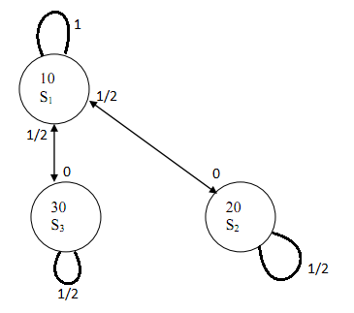

$$P_{11}=\frac{1}{3};P_{12}=\frac{1}{3};P_{13}=\frac{1}{3}$$

$$P_{21}=\frac{1}{2};P_{22}=\frac{1}{2};P_{23}=0$$

$$P_{31}=\frac{1}{2};P_{32}=0;P_{33}=\frac{1}{2}$$

$$A_{12}=0;A_{13}=0;A_{21}=1;A_{31}=1$$

$$Θ_{11}=1-0-0=1;Θ_{12}=\frac{1}{3}\left(0\right)=0;Θ_{13}=\frac{1}{3}\left(0\right)=0$$

$$Θ_{21}=\frac{1}{2}\left(1\right)=\frac{1}{2};Θ_{22}=1-\frac{1}{2}-0=\frac{1}{2};Θ_{23}=0$$

$$Θ_{31}=\frac{1}{2}\left(1\right)=\frac{1}{2};Θ_{32}=0;Θ_{33}=1-\frac{1}{2}-0=\frac{1}{2}$$

$Θ=\left[ \begin{matrix}1 & 0 & 0 \\ \frac{1}{2} & \frac{1}{2} & 0 \\ \frac{1}{2} & 0 & \frac{1}{2}\end{matrix}\right]$

1. $π={\left[\begin{matrix}1 \\ 0 \\ 0\end{matrix}\right]}^{T}$ by intuition

To confirm: $πΘ={\left[\begin{matrix}1 \\ 0 \\ 0\end{matrix}\right]}^{T}\left[ \begin{matrix}1 & 0 & 0 \\ \frac{1}{2} & \frac{1}{2} & 0 \\ \frac{1}{2} & 0 & \frac{1}{2}\end{matrix}\right]={\left[\begin{matrix}1\left(1\right)+0\left(\frac{1}{2}\right)+0\left(\frac{1}{2}\right) \\ 1\left(0\right)+0\left(\frac{1}{2}\right)+0\left(0\right) \\ 1\left(0\right)+0\left(0\right)+0\left(\frac{1}{2}\right)\end{matrix}\right]}^{T}={\left[\begin{matrix}1 \\ 0 \\ 0\end{matrix}\right]}^{T}=π$

$π_{2}$ and $π_{3}$ are both 0 since no state can transition to them (they are not each other’s neighbors and S1 going to them are uphill moves). $π_{1}$ is one because S2 and S3 will eventually move to S1 (since $Θ_{21}$ and $Θ_{31}$ are nonzero).