2

Write a program that calculates the stuff:

|  |
| --- |
| import sys;  import math;  def gcd(a, b):  if (a > b):  return gcd(b, a)  else:  if (a == 0):  return b  return gcd(b % a, a)  result = range(0,7)  def main():  s = [0, 15, 20, 10, 13, 14, 11, 16]  T = 2  for x in range(0, 7):  result[x] = range(0, 7)  for t in range(0,7):  for t2 in range(0,7):  result[t][t2] = "0"  for t in range(1, 8):  count = 0  for diff in range(-2, 3):  if diff != 0:  count += 1  for diff in range(-2, 3):  if diff != 0:  nxt_ind = ((t + diff - 1) % 7) + 1  if s[nxt_ind] - s[t] > 0:  gg = gcd(100*(s[nxt_ind] - s[t]), T)  ss = ""  if T/gg != 1:  ss = ("(-%d/%d)" % (100*(s[nxt_ind] - s[t])/gg, T/gg))  else:  ss = ("-%d" % (100*(s[nxt_ind]-s[t])/gg))  result[t-1][nxt_ind-1] = ("0.25*e^%s" % ss)  sys.stdout.write('S%d -> S%d [ label = "0.25*e^%s" ];\n' % (t, nxt_ind, ss))  else:  result[t-1][nxt_ind-1] = "0.25"  sys.stdout.write('S%d -> S%d [ label = "0.25" ];\n' % (t, nxt_ind))  sys.stdout.write("MATRIX: \n")  for t in range(0,7):  for t2 in range(0,7):  sys.stdout.write("%s " % result[t][t2])  sys.stdout.write("\n")  main() |

Which generates:

|  |
| --- |
| digraph temp {  S1;S2;S3;S4;S5;S6;S7  S1 -> S6 [ label = "0.25" ];  S1 -> S7 [ label = "0.25*e^(-1/2)" ];  S1 -> S2 [ label = "0.25*e^(-5/2)" ];  S1 -> S3 [ label = "0.25" ];  S2 -> S7 [ label = "0.25" ];  S2 -> S1 [ label = "0.25" ];  S2 -> S3 [ label = "0.25" ];  S2 -> S4 [ label = "0.25" ];  S3 -> S1 [ label = "0.25*e^(-5/2)" ];  S3 -> S2 [ label = "0.25*e^-5" ];  S3 -> S4 [ label = "0.25*e^(-3/2)" ];  S3 -> S5 [ label = "0.25*e^-2" ];  S4 -> S2 [ label = "0.25*e^(-7/2)" ];  S4 -> S3 [ label = "0.25" ];  S4 -> S5 [ label = "0.25*e^(-1/2)" ];  S4 -> S6 [ label = "0.25" ];  S5 -> S3 [ label = "0.25" ];  S5 -> S4 [ label = "0.25" ];  S5 -> S6 [ label = "0.25" ];  S5 -> S7 [ label = "0.25*e^-1" ];  S6 -> S4 [ label = "0.25*e^-1" ];  S6 -> S5 [ label = "0.25*e^(-3/2)" ];  S6 -> S7 [ label = "0.25*e^(-5/2)" ];  S6 -> S1 [ label = "0.25*e^-2" ];  S7 -> S5 [ label = "0.25" ];  S7 -> S6 [ label = "0.25" ];  S7 -> S1 [ label = "0.25" ];  S7 -> S2 [ label = "0.25*e^-2" ];  } |

We have the configuration graph as:

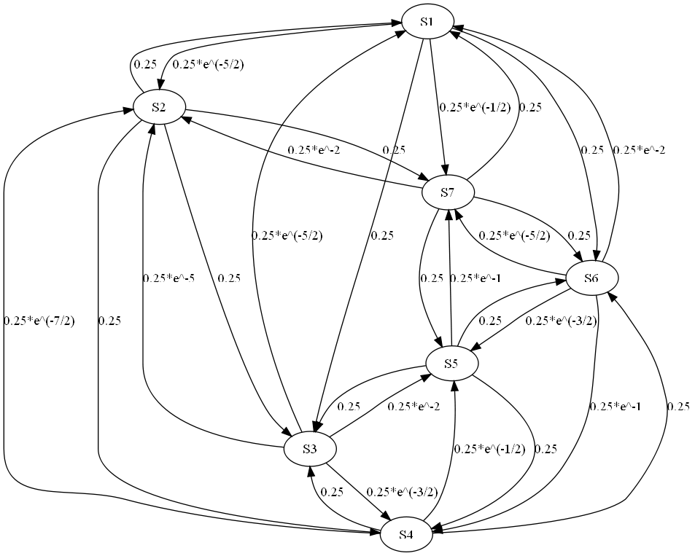

We can then extract the transition matrix as:

|  |  |  |  |  |  |  |
| --- | --- | --- | --- | --- | --- | --- |
|  | 0.25*e^(-5/2) | 0.25 | 0 | 0 | 0.25 | 0.25*e^(-1/2) |
| 0.25 |  | 0.25 | 0.25 | 0 | 0 | 0.25 |
| 0.25*e^(-5/2) | 0.25*e^-5 | 0 | 0.25*e^(-3/2) | 0.25*e^-2 | 0 | 0 |
| 0 | 0.25*e^(-7/2) | 0.25 |  | 0.25*e^(-1/2) | 0.25 | 0 |
| 0 | 0 | 0.25 | 0.25 |  | 0.25 | 0.25*e^-1 |
| 0.25*e^-2 | 0 | 0 | 0.25*e^-1 | 0.25*e^(-3/2) | 0 | 0.25*e^(-5/2) |
| 0.25 | 0.25*e^-2 | 0 | 0 | 0.25 | 0.25 |  |

Next part:

We have graph:

|  |
| --- |
| digraph temp {  S1;S2;S3;S4;S5;S6;S7  S1 -> S6 [ label = "0.25" ];  S1 -> S7 [ label = "0.25*e^-50" ];  S1 -> S2 [ label = "0.25*e^-250" ];  S1 -> S3 [ label = "0.25" ];  S2 -> S7 [ label = "0.25" ];  S2 -> S1 [ label = "0.25" ];  S2 -> S3 [ label = "0.25" ];  S2 -> S4 [ label = "0.25" ];  S3 -> S1 [ label = "0.25*e^-250" ];  S3 -> S2 [ label = "0.25*e^-500" ];  S3 -> S4 [ label = "0.25*e^-150" ];  S3 -> S5 [ label = "0.25*e^-200" ];  S4 -> S2 [ label = "0.25*e^-350" ];  S4 -> S3 [ label = "0.25" ];  S4 -> S5 [ label = "0.25*e^-50" ];  S4 -> S6 [ label = "0.25" ];  S5 -> S3 [ label = "0.25" ];  S5 -> S4 [ label = "0.25" ];  S5 -> S6 [ label = "0.25" ];  S5 -> S7 [ label = "0.25*e^-100" ];  S6 -> S4 [ label = "0.25*e^-100" ];  S6 -> S5 [ label = "0.25*e^-150" ];  S6 -> S7 [ label = "0.25*e^-250" ];  S6 -> S1 [ label = "0.25*e^-200" ];  S7 -> S5 [ label = "0.25" ];  S7 -> S6 [ label = "0.25" ];  S7 -> S1 [ label = "0.25" ];  S7 -> S2 [ label = "0.25*e^-200" ];  } |

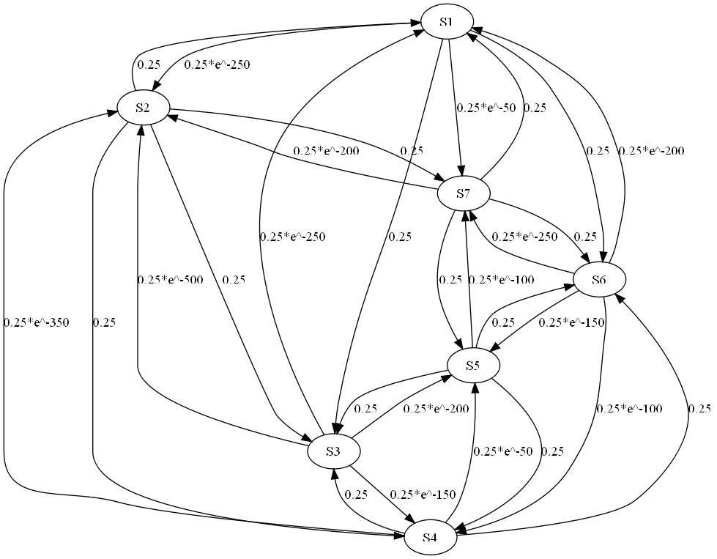

|  |  |  |  |  |  |  |
| --- | --- | --- | --- | --- | --- | --- |
|  | 0.25*e^-250 | 0.25 | 0 | 0 | 0.25 | 0.25*e^-50 |
| 0.25 |  | 0.25 | 0.25 | 0 | 0 | 0.25 |
| 0.25*e^-250 | 0.25*e^-500 | 0 | 0.25*e^-150 | 0.25*e^-200 | 0 | 0 |
| 0 | 0.25*e^-350 | 0.25 |  | 0.25*e^-50 | 0.25 | 0 |
| 0 | 0 | 0.25 | 0.25 |  | 0.25 | 0.25*e^-100 |
| 0.25*e^-200 | 0 | 0 | 0.25*e^-100 | 0.25*e^-150 | 0 | 0.25*e^-250 |
| 0.25 | 0.25*e^-200 | 0 | 0 | 0.25 | 0.25 |  |