## Problem.1

### Part a)

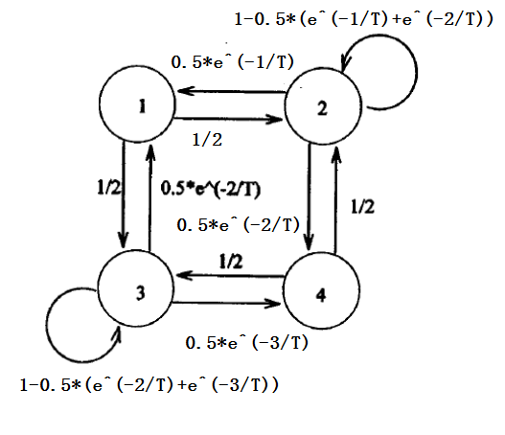

For both 1 and 4, all the neighbors cost less than the current state. Thus, whenever selecting a neighbor, the move will always happen. Thus it's impossible to stay at the current state.

### Part b)

We have Θ=

|  |  |  |  |
| --- | --- | --- | --- |
| 0.000 | 0.500 | 0.500 | 0.000 |
| 0.184 | 0.748 | 0.000 | 0.068 |
| 0.068 | 0.000 | 0.907 | 0.025 |
| 0.000 | 0.500 | 0.500 | 0.000 |

### Part c)

We have

|  |  |  |  |
| --- | --- | --- | --- |
| 0.098 | 0.325 | 0.541 | 0.036 |
| 0.120 | 0.495 | 0.341 | 0.044 |
| 0.073 | 0.126 | 0.774 | 0.027 |
| 0.098 | 0.325 | 0.541 | 0.036 |

We have

|  |  |  |  |
| --- | --- | --- | --- |
| 0.092 | 0.272 | 0.602 | 0.034 |
| 0.100 | 0.341 | 0.522 | 0.037 |
| 0.082 | 0.192 | 0.697 | 0.030 |
| 0.092 | 0.272 | 0.602 | 0.034 |

We have

|  |  |  |  |
| --- | --- | --- | --- |
| 0.087 | 0.237 | 0.644 | 0.032 |
| 0.087 | 0.237 | 0.644 | 0.032 |
| 0.087 | 0.237 | 0.644 | 0.032 |
| 0.087 | 0.237 | 0.644 | 0.032 |

### Part d)

For T = 10, we have Θ=

|  |  |  |  |
| --- | --- | --- | --- |
| 0.000 | 0.500 | 0.500 | 0.000 |
| 0.452 | 0.138 | 0.000 | 0.409 |
| 0.409 | 0.000 | 0.220 | 0.370 |
| 0.000 | 0.500 | 0.500 | 0.000 |

|  |  |  |  |
| --- | --- | --- | --- |
| 0.128 | 0.368 | 0.388 | 0.116 |
| 0.333 | 0.165 | 0.200 | 0.302 |
| 0.317 | 0.181 | 0.215 | 0.287 |
| 0.128 | 0.368 | 0.388 | 0.116 |

|  |  |  |  |
| --- | --- | --- | --- |
| 0.277 | 0.221 | 0.251 | 0.251 |
| 0.200 | 0.297 | 0.322 | 0.181 |
| 0.206 | 0.291 | 0.316 | 0.186 |
| 0.277 | 0.221 | 0.251 | 0.251 |

|  |  |  |  |
| --- | --- | --- | --- |
| 0.236 | 0.261 | 0.289 | 0.214 |
| 0.236 | 0.261 | 0.289 | 0.214 |
| 0.236 | 0.261 | 0.289 | 0.214 |
| 0.236 | 0.261 | 0.289 | 0.214 |

### Part e)

For T = 0.2, we have Θ=

|  |  |  |  |
| --- | --- | --- | --- |
| 0.000 | 0.500 | 0.500 | 0.000 |
| 0.003 | 0.997 | 0.000 | 0.000 |
| 0.000 | 0.000 | 1.000 | 0.000 |
| 0.000 | 0.500 | 0.500 | 0.000 |

|  |  |  |  |
| --- | --- | --- | --- |
| 0.002 | 0.496 | 0.503 | 0.000 |
| 0.003 | 0.990 | 0.007 | 0.000 |
| 0.000 | 0.000 | 1.000 | 0.000 |
| 0.002 | 0.496 | 0.503 | 0.000 |

|  |  |  |  |
| --- | --- | --- | --- |
| 0.002 | 0.492 | 0.507 | 0.000 |
| 0.003 | 0.982 | 0.015 | 0.000 |
| 0.000 | 0.000 | 1.000 | 0.000 |
| 0.002 | 0.492 | 0.507 | 0.000 |

|  |  |  |  |
| --- | --- | --- | --- |
| 0.000 | 0.096 | 0.903 | 0.000 |
| 0.001 | 0.187 | 0.813 | 0.000 |
| 0.000 | 0.005 | 0.994 | 0.000 |
| 0.000 | 0.096 | 0.903 | 0.000 |

### Part f)

Yes, as we see that the lower the temperature is, the more likely we will converge to the global optimum as time tends to infinity. We need to set the temperature high enough so that the algorithm reaches the optimal solution for any initial conditions within reasonable amount of iterations. But we also need to set the temperature low enough so that we reach the global minimum with high enough probability.

## Problem.2

### Part a)

This is greedy search. Since the probability of moving is always for all potential moves, it cannot be a simulated annealing, where the probability of uphill move is

### Part b)

The neighbors of 1 are {2, 4, 5}, since the move probability from 1 to these states are 1/3 each.

### Part c)

The neighbors of 2 are {1, 3, 4}. We firstly notice that = = 1/3, this means that 3 and 4 are neighbors of 2 and are better solution than 2. That leaves up with one unknown neighbor that is worse than 2. We also notice that > 0, meaning 5 is better than 3, and therefore it cannot be the neighbor of 2(otherwise, will > 0, as it's a better solution.) Thus 5 cannot be the other neighbor. We notice that 6 cannot be the other neighbor, as we noticed = 1, meaning 6 is a local minimum. And therefore 6 has to be better than at least 3 of its neighbors. If 6 is to be a neighbor of 2, then 2 will need to be better than 4 states(including 6 and its 3 neighbors). This is impossible as we showed both 3, 4, and 5 are better than 2. Thus, the remaining neighbor can only be 1.

### Part d)

1/3, as the possibilities of moving to all states has to sum to 1.

### Part e)

0, for the same reason as d)

### Part f)

We know from matrix that we have the following inequalities:

J(1) < J(2), J(1) < J(3), J(1) < J(4), J(1) < J(5), J(1) < J(6), J(2) < J(3), J(2) < J(4), J(2) < J(5), J(2) < J(6), J(3) < J(4), J(3) < J(5), J(3) < J(6).

We cannot conclude any relationships between 4, 5, or 6.

### Part g)

Yes. Both 5 and 6 are local optimum. 4 Could also be a local optimum. As we have identified the sequence of 1, 2, 3. For the rest, we could assign 4, 5, 6 to have neighbors 1, 2, 3. Then, all of them are local optimum. We could not infer from the table which one is better/equal to each other for 4, 5, 6.

## Problem.3

### Part a)

### Part b)

### Part c)

## Code used for problem.1

|  |
| --- |
| function t = getMatrix(T)  t = zeros(4, 4);  t(1, 2) = 1/2;  t(1, 3) = 1/2;  t(2, 1) = 0.5*exp(-1/T);  t(2, 4) = 0.5*exp(-2/T);  t(2, 2) = 1 - t(2, 1) - t(2, 4);  t(3, 1) = 0.5*exp(-2/T);  t(3, 4) = 0.5*exp(-3/T);  t(3, 3) = 1 - t(3, 1) - t(3, 4);  t(4, 2) = 1/2;  t(4, 3) = 1/2; |