Earthquakes and Moon Phase

Richard Curran

L00144762

**Earthquake Location & Frequency**

The first thing done was to view the dataset in Data Window to investigate the columns of interest.

Data category for earthquake.longitude and earthquake.latitude were changed to Longitude and Latitude, respectively. These columns were then merged into a single lat_long column for ease of use.

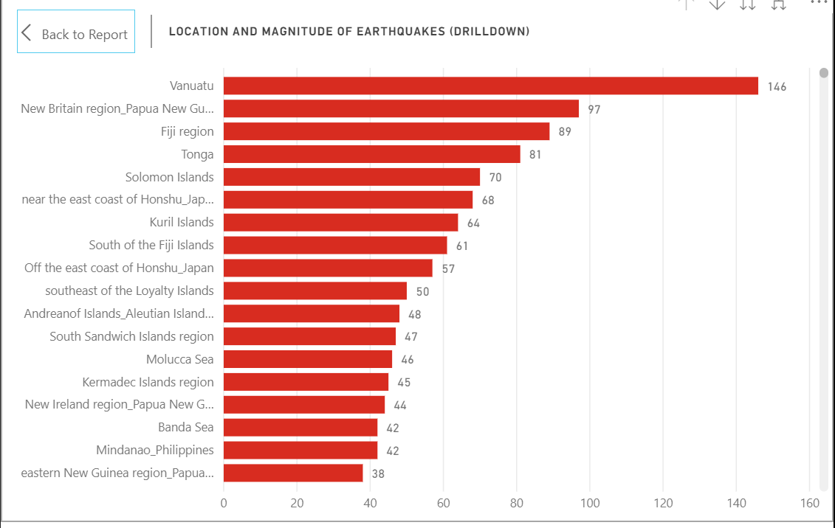

Figure

Fig 1. Graphs each location and which has the highest number of earthquakes. It is labelled with the number of earthquakes per location and can be drilled down to reveal the magnitude of each earthquake and the lat_long coordinates.

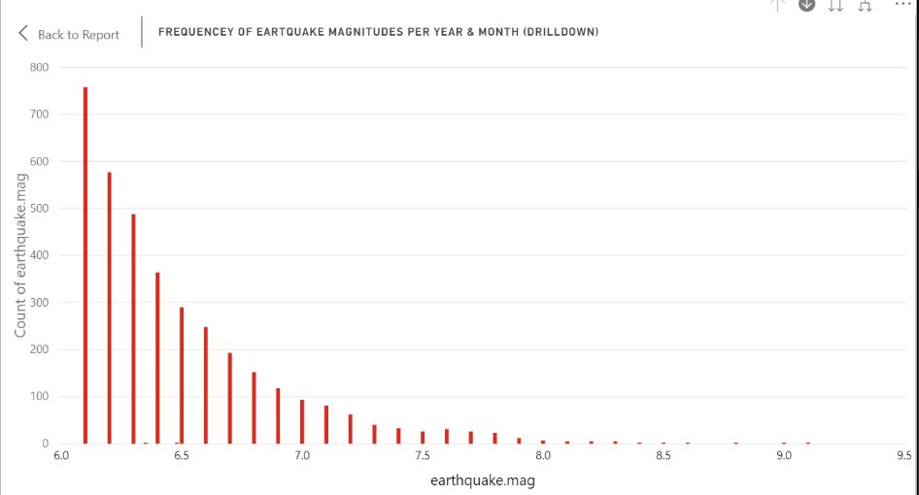

Figure

Fig. 2: Magnitude of close to 6.0 are most frequent. Drilling down each magnitude reveals the year and month of each earthquake as well as the place and lat_long coordinates.

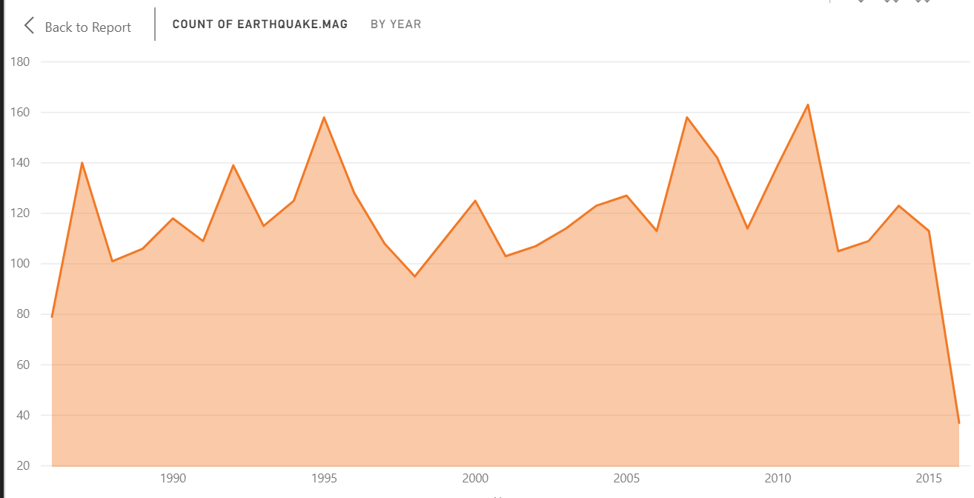

Figure

There doesn’t seem to be any trend in earthquake frequency over time, as can be seen from Fig.3

**Moon Phase Data**

According to (‘Phases of the Moon and Percent of the Moon Illuminated’ 2019), A New Moon occurs every 29.5 days (MoonPhase.value = 29.5) and only last for an instant as it immediately beings to wane although it is visible to the naked for several days after it occurs. This led to various filters being applied in the analysis of the dataset.

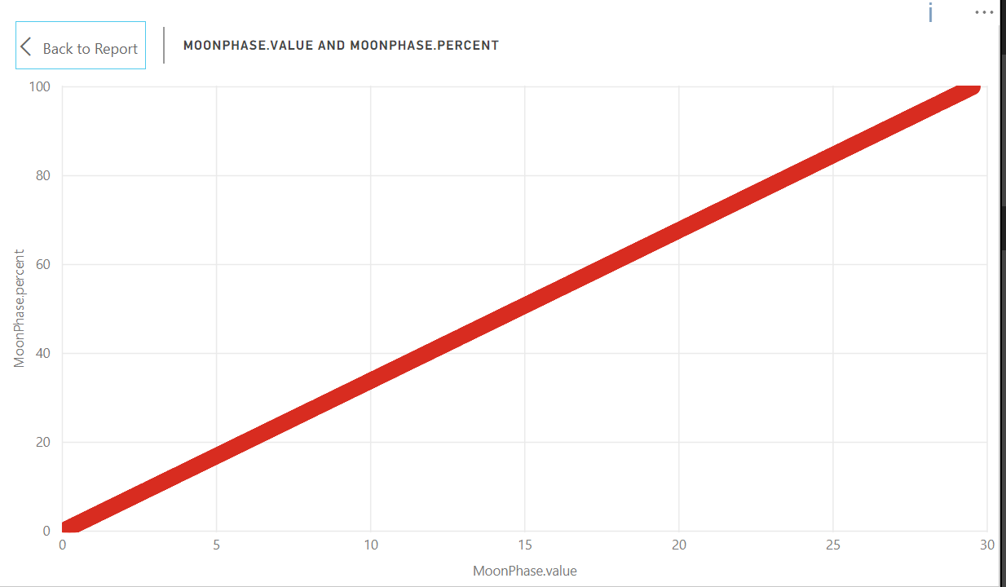

Figure

Fig.4 shows the relationship between MoonPhase.value and MoonPhase.percent. These are directly related, as was expected. The closer the value is to 29.5 then the closer the Moon is to New Moon phase (higher MoonPhase.percent).

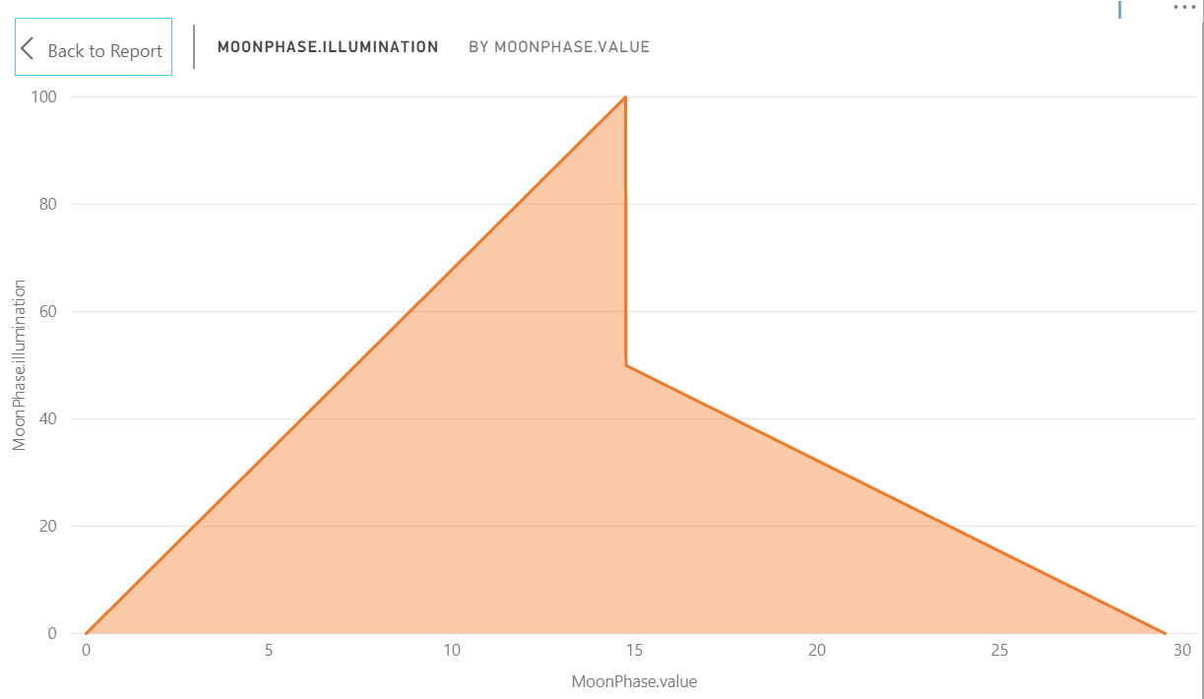

Figure

Fig.5 shows the relationship between MoonPhase.value and MoonPhase.illumination. During a New Moon phase, MoonPhase.vale < 3, there is only a very small portion of the moon illuminated and as the moon goes through its cycle, its illumination grows. The Moon is illuminated 100% halfway through its cycle (Full Moon). As the Moon enters a New Moon phase (MoonPhase.value tends to 29.5), its illumination drops.

**Earthquake & Moon Phase**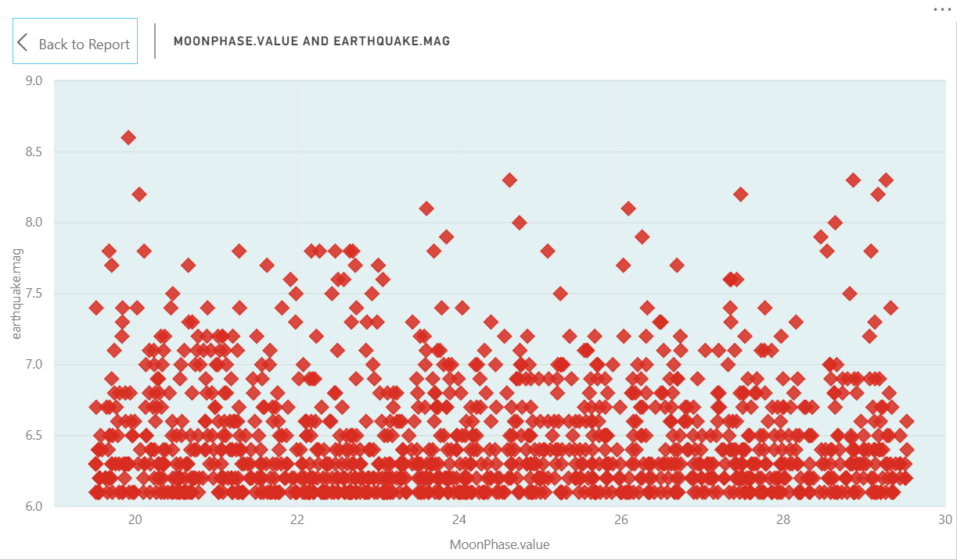

**Figure 6: 10 days before New Moon**

MoonPhase.value column was filtered to only consider data >= 19.5. These are the Earthquakes that occurred in the days leading up to a New Moon. There is no trend in the MoonPhase.Value and earthquake.mag (Fig. 4)

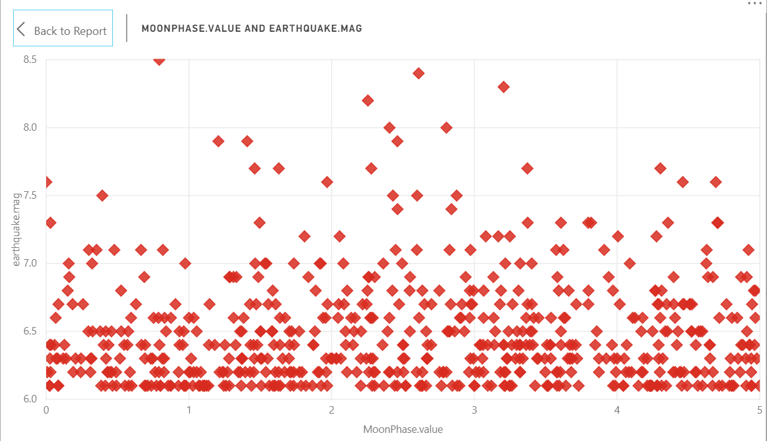

**Figure 7: 5 days after a New Moon**

MoonPhase.value <= 5. This is a graph of the earthquakes that occurred 5 days after a New Moon. There is no trend

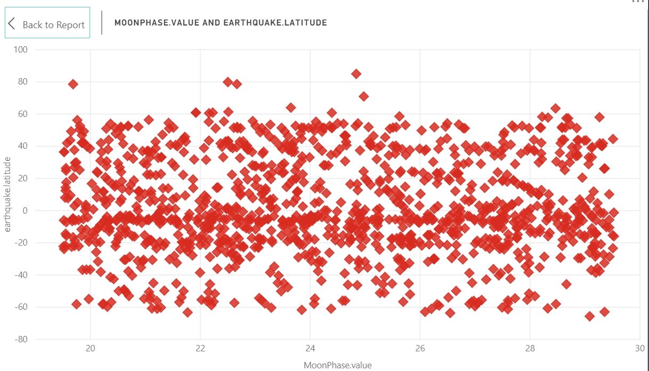**Earthquake Location & Moon Phase**

**Figure 5: 10 days before New Moon (Latitudinal)**

There is no sign of correlation between Moon phase and latitudinal location of earthquakes during the days before a New Moon phase. (Fig. 5)

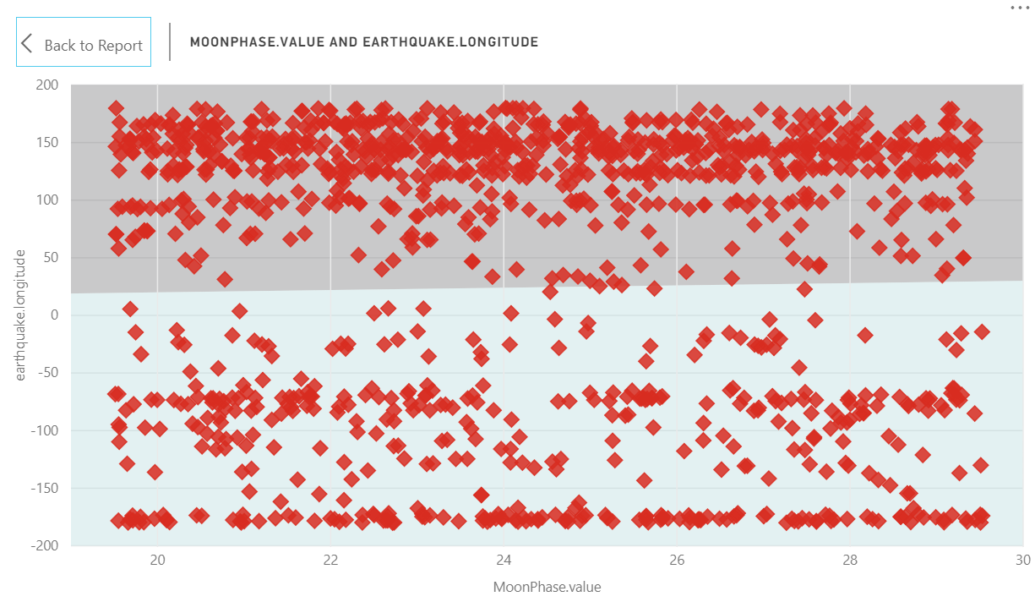There is no sign of correlation between Moon phase and longitudinal location of earthquakes during a New Moon phase. (Fig. 6). Although with symmetry shading, there appears to be more earthquakes in the northern hemisphere during New Moon phase. This was result was expected; it can be seen from Fig.1 that the highest number of earthquakes occurred around Vanuatu.

**Figure 8: 10 days before New Moon (Longitudinal)**

Figure 6

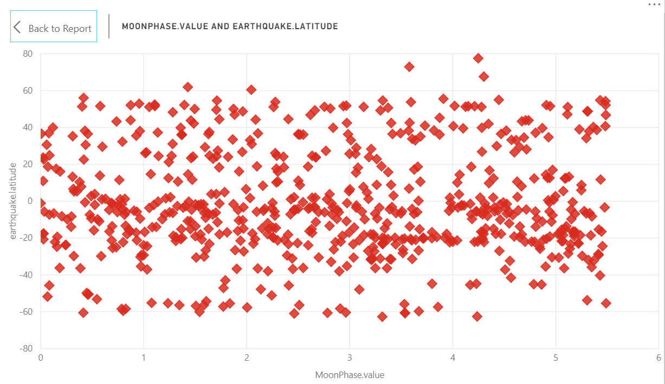

**Figure 9: 5 days after New Moon (Latitudinal)**

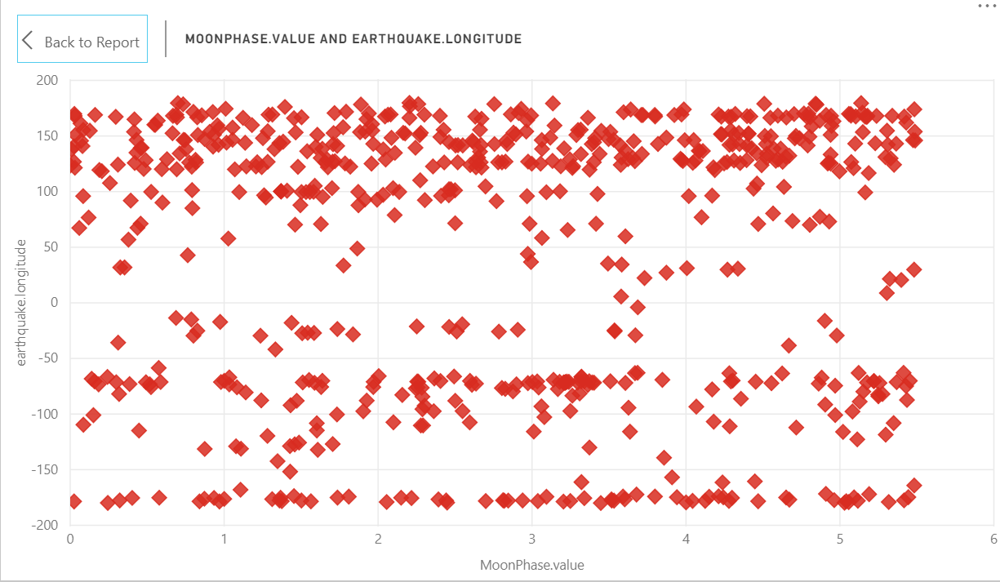

**Figure 10: 5 days after New Moon (Longitudinal)**

There is no trend *during* New Moon phase.

**Conclusion**

I found no solid evidence that there is any correlation between and Earthquake occurring and Moon phase. Therefore no prediction can be made of whether or not an Earthquake will occur during a New Moon phase. This coincides with (Hough 2018) which concluded there is no evidence that indicates a relationship between the occurrence of an earthquake and the Earths position relative to the Moon or the Sun.

I found PowerBI to be a useful analytical tool with good graphical representation of the data. Representing the lat_long column as a map of the world was informative and successfully displayed the earthquake data, although it was a very busy graph with a lot of datapoints overlapping. I found the drill down feature to be especially informative as several different columns could be represented on the same graph. Filtering the data was easily done using the built in filter functions.

I found the number of visualizations limiting for this task of prediction as I could only really use a scatter plot to represent the important data pertaining to earthquake and Moon phase. I believe carrying out this same task with a professional PowerBI account might give greater insight to the data and result in a more thorough analysis.

**References**

Hough, S.E. (2018) ‘Do Large (Magnitude ≥8) Global Earthquakes Occur on Preferred Days of the Calendar Year or Lunar Cycle?’, *Seismological Research Letters*, 89(2A), 577–581.

Phases of the Moon and Percent of the Moon Illuminated [online] (2019) available: https://aa.usno.navy.mil/faq/docs/moon_phases.php [accessed 3 Mar 2019].