M&F 4th, Chapter 1

Richard Dooling

Notes, Slide Text, Links, Optional Readings.

# M&F 4th, Chapter 1

###### Lawyers: Role & Regulation

### Preamble & Scope

The Preamble tells us that the lawyer is:

* a member of the legal profession,
* a representative of clients,
* an officer of the legal system
* and a public citizen having special responsibility for the quality of justice.

This says a lot. But what happens when being a representative of a client (who just lied on the witness stand) clashes with being an officer of the legal system (owing a duty to of candor to the tribunal)? What happens to the lawyer’s special responsibility for the quality of justice when she successfully defends a sex offender or a drunk driver, who then “goes free,” only to drink, drive, and injure or kill others by driving under the influence?

#### Preamble & Scope Comment 3

As we’ll soon learn, an attorney may be disciplined for fraud or dishonesty, even if the fraud was unrelated to the practice of law.

For example, a lawyer who commits fraud in the conduct of a business is subject to discipline for engaging in conduct involving dishonesty, fraud, deceit or misrepresentation. See [Model Rule 8.4.](http://www.americanbar.org/groups/professional_responsibility/publications/model_rules_of_professional_conduct/rule_8_4_misconduct.html)

#### Preamble & Scope Comment 20

A lawyer violates one or more Model Rules while representing client. Is the client now entitled to file a malpractice suit against the unethical or incompetent lawyer? Lawyers have fought this notion for decades.

Violation of a Rule should not itself give rise to a cause of action against a lawyer nor should it create any presumption in such a case that a legal duty has been breached.

Sounds like the answer is no, but it comes with a lawyerly caveat:

Nevertheless, since the Rules do establish standards of conduct by lawyers, *a lawyer’s violation of a Rule may be evidence* of breach of the applicable standard of conduct.

So if the lawyer is sued for malpractice, the client may introduce the Model Rules as evidence of the standard of conduct?

## What Do You Do?

In [Plato’s *Gorgias*](http://en.wikipedia.org/wiki/Gorgias_(dialogue)), several famous ancient Greek orators and philosophers have brought Socrates to watch Gorgias, the most famous teacher of rhetoric and oratory in Athens, put on a display of his oratorical powers.

Gorgias is eager to get started displaying his rhetorical prowess, but Socrates won’t let him, because Socrates keeps asking Gorgias difficult questions about this “high art” of which he speaks.

“What is it you do?” Socrates asks Gorgias. “Cobblers make shoes, and coaches train athletes, and doctors heal the sick, but what do you do? You teach oratory and rhetoric? Are those knacks or crafts? Or are they higher arts? Professional skills?”

Socrates also says, “Tell me, Gorgias, do you teach your young orators about about right and wrong?”

Gorgias says essentially: Not my department. “I teach rhetoric. I’m not responsible if my students take that skill use it to commit a wrong.”

How convenient. But Socrates won’t let that pass unchallenged, and the whole dialogue is really a discussion among professionals about the ethics of teaching and employing rhetorical skills.

Those in attendance revere Gorgias, and Gorgias is not the least bit modest about his powers of persuasion.

When Socrates asks him what is the highest good? Gorgias answers: That’s easy! The power of rhetoric is the greatest good and the only expertise any orator need master.

Well, Socrates asks, “What about health or business or politics? What do orators (lawyers) really know about those?”

Gorgias says orators don’t need to know about any of those, because once you master rhetoric: “You will have the doctor as your slave, and that businessman? He will be working for you.”

This is an early display of what might be called a classic lawyer’s superiority complex.

Lawyers are super fiduciaries above and beyond everything else, but lawyers are also human beings, often with moral scruples. We don’t leave that part of ourselves behind when we practice law.

Socrates ultimately wants Gorgias to answer the ancient question: Does rhetorical might make right?

### Possible Lessons

Socrates plainly feels that it’s not enough to have technical skills. One also must consider whether one is using those skills to commit a wrong.

Freedman and Smith: Is there a single point of view that can be identified as “the moral” one?

Rhode: Lawyers should assess their obligations in light of all societal interests at issue in particular practice contexts.

ABA: Have to balance lawyer’s interests with the bar’s image, “justice” and the client’s interests

Dooling: The time to have a moral dilemma is when the lawyer is deciding whether to take the case.

## Types/Roles of Lawyers

* Instrument – “Hired Guns” Tool for the clients; lawyer is limited only by law and legal system.
* Director – “Moral Actors” Legal expert capable of determining how to handle client’s affairs with little client input. Also often “Lawyer to the Situation,” instead of Lawyer to the Client.
* Collaborator/Translator – Client is best able to make decisions for herself, but needs the perspective of lawyers to know both her own interests and the effect of her decisions on others
* Obey your own conscience, not your client’s?

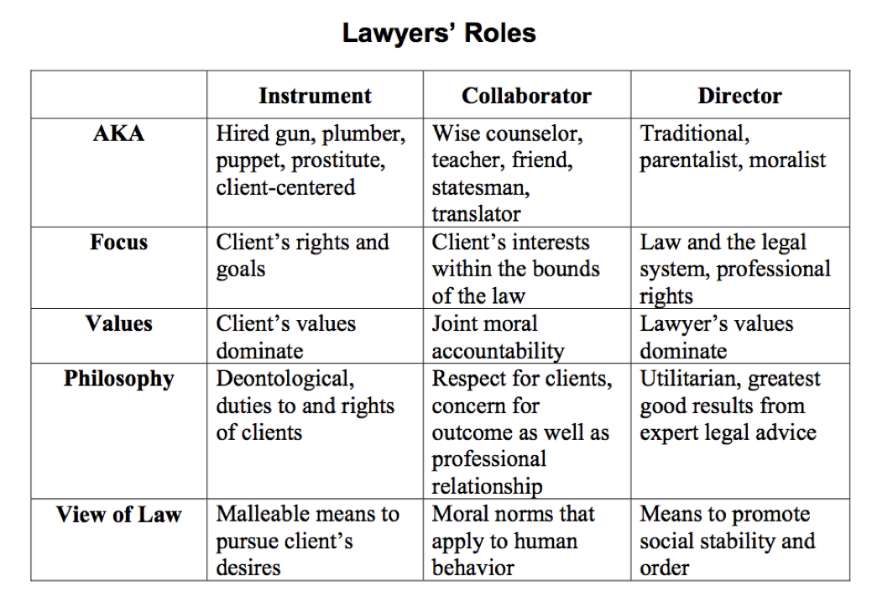

Lawyer_Roles

## Recommended Reading & Viewing

* [RLGL “Professional Discipline” § 5](https://a.next.westlaw.com/Document/Ieee1576edc6111e28a48c0d45341c37f/View/FullText.html?originationContext=documenttoc&transitionType=CategoryPageItem&contextData=(sc.Default))
* [Plato’s *Gorgias*](http://classics.mit.edu/Plato/gorgias.html) - Probably the oldest book we have about lawyers, though in ancient Greece they were called *orators*. We read *Gorgias* in Law and Literature, a course Professor Lawson or I teach every other year. I talk just a little about *Gorgias* in our first Legal Profession class. [Gorgias at Wikipedia](http://en.wikipedia.org/wiki/Gorgias_(dialogue)).
* [*To Kill A Mockingbird* by Harper Lee (1960)](http://en.wikipedia.org/wiki/To_Kill_a_Mockingbird) and [the 1962 movie version](http://en.wikipedia.org/wiki/To_Kill_a_Mockingbird_(film)), starring Gregory Peck (DVD on reserve in Schmid Law Library).
* [Malcom Gladwell’s “The Courthouse Ring: Atticus Finch and the limits of Southern liberalism,”](http://www.newyorker.com/reporting/2009/08/10/090810fa_fact_gladwell) *The New Yorker* (10 August 2009). Deified as the epitomy of legal rectitude for fifty years, Atticus Finch has recently come in for reexamination. He plainly violates at least one of the Model Rules, shows no compunction whatsoever about employing the she-wanted-it defense to defend his appointed client in a rape trial, and some believe accommodates racial prejudice more than he fights it. Malcom Gladwell summarizes some of the recent criticism in his article in [*The New Yorker*](http://www.newyorker.com/reporting/2009/08/10/090810fa_fact_gladwell).