

S3C6400/6410
Scenario Based APPLICATIONS
User’s Manual
(Linux)

S3C6400/6410
July 5, 2008
REV 1.00

Important Notice

The information in this publication has been carefully checked and is believed to be entirely accurate at the time of publication. Samsung assumes no responsibility, however, for possible errors or omissions, or for any consequences resulting from the use of the information contained herein.
Samsung reserves the right to make changes in its products or product specifications with the intent to improve function or design at any time and without notice and is not required to update this documentation to reflect such changes.
This publication does not convey to a purchaser of semiconductor devices described herein any license under the patent rights of Samsung or others.
Samsung makes no warranty, representation, or guarantee regarding the suitability of its products for any particular purpose, nor does Samsung assume any liability arising out of the application or use of any product or circuit and specifically disclaims any and all liability, including without limitation any consequential or incidental damages.
"Typical" parameters can and do vary in different applications. All operating parameters, including "Typicals" must be validated for each customer application by the customer's technical experts.
Samsung products are not designed, intended, or authorized for use as components in systems intended for surgical implant into the body, for other applications intended to support or sustain life, or for any other application in which the failure of the Samsung product could create a situation where personal injury or death may occur.
Should the Buyer purchase or use a Samsung product for any such unintended or unauthorized application, the Buyer shall indemnify and hold Samsung and its officers, employees, subsidiaries, affiliates, and distributors harmless against all claims, costs, damages, expenses, and reasonable attorney fees arising out of, either directly or indirectly, any claim of personal injury or death that may be associated with such unintended or unauthorized use, even if such claim alleges that Samsung was negligent regarding the design or manufacture of said product

S3C6400/6410 RISC Microprocessor
User’s manual
Copyright © 2008 Samsung Electronics Co.,Ltd.
All rights reserved. No part of this publication may be reproduced, stored in a retrieval system, or transmitted in any form or by any means, electric or mechanical, by photocopying, recording, or otherwise, without the prior written consent of Samsung Electronics Co.,Ltd.
Samsung Electronics Co., Ltd.
San #24 Nongseo-Dong, Giheung-Gu
Yongin-City Gyeonggi-Do, Korea
446-711

Home Page: http://www.samsungsemi.com/
E-Mail: mobilesol.cs@samsung.com

Printed in the Republic of Korea

Revision History
Revision No | Description of Change | Refer to | Author(s) | Date
1.00 | Initial Version | - | Jiun Yu | 2008-07-05

Contents
1 Introduction 1
1.1 Purpose 1
1.2 Scope 1
1.3 Intended Audience 1
1.4 Definitions, Acronyms, and Abbreviations 1
1.5 References 1
2 Data flow of Applcations 1
2.1 Overview 1
2.2 Basic display application 1
2.3 H.264 display using local path 2
2.4 H.264 display using double buffering 2
2.5 Camera preview & MFC encoding 3
2.6 H.264 display & Camera preview 3
2.7 Camera preview & MFC encoding/decoding 4
2.8 Camera input and JPEG encoding 4
2.9 JPEG file display on LCD 5
3 Package Guidelines 6
3.1 Directory Structure 6
4 How to test Scenario based applications 7
4.1 Procedure to build kernel, API and test application 7
4.2 Procedure to test 7
4.2.1 Kernel configuration and building 7
4.2.2 Module compilation 9
4.2.3 Test application compilation 12
4.2.4 Test application execution(In target side) 12

Introduction

Purpose
The purpose of the document explains how to test applications.

Scope
The scope of this document is to describe
- Data flow of applications
- How to test applications

Intended Audience
Intended Audience | Tick whenever Applicable
Project Manager | Yes
Project Leader | Yes
Project Team Member | Yes
Test Engineer | Yes

Definitions, Acronyms, and Abbreviations

Abbreviations | Description
JPEG | Joint Photographic Exports Grout
MFC | Multi Format Codec
API | Application Program Interface

References
Number | Reference | Description

Data flow of Applcations

Overview
There are 12 scenario based applications. It uses several drivers these are Camera, MFC, post processor, display and JPEG driver. Each application has own scenario.

- H.264 display
- MPEG4 display
- H.263 display
- VC-1 display
- 4 windows display(H.264, MPEG4, H.263, VC-1)
- H.264 display using local path
- H.264 display using double buffering
- Camera preview & MFC encoding
- H.264 display & Camera preview
- Camera preview & MFC encoding/decoding
- Camera input and JPEG encoding(Capture)
- JPEG file dispaly on LCD

Basic display application
It includes
- H.264 display
- MPEG4 display
- H.263 display
- VC-1 display
- 4 windows display(H.264, MPEG4, H.263, VC-1)
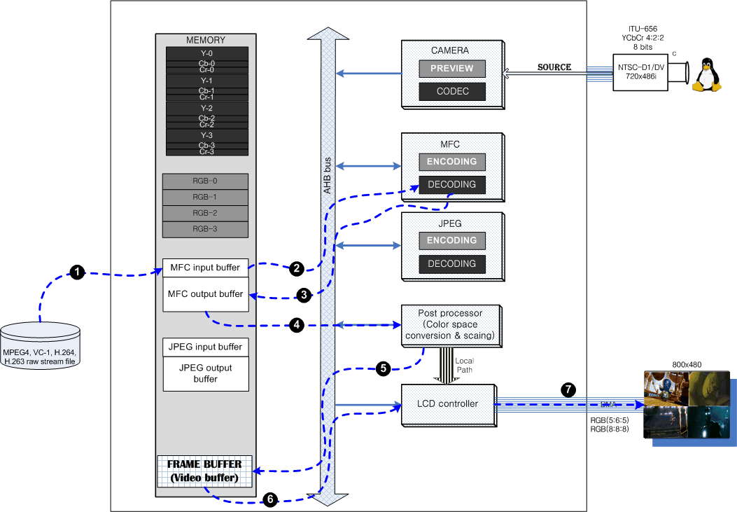

H.264 display using local path
This application uses local path between post processor and display controller. Post processor’s output data go through LCD controller directly. But it has 2 limitations.
These are :
- Only Window 0 can be used when application uses local path
- Only 24bpp support(RGB888)

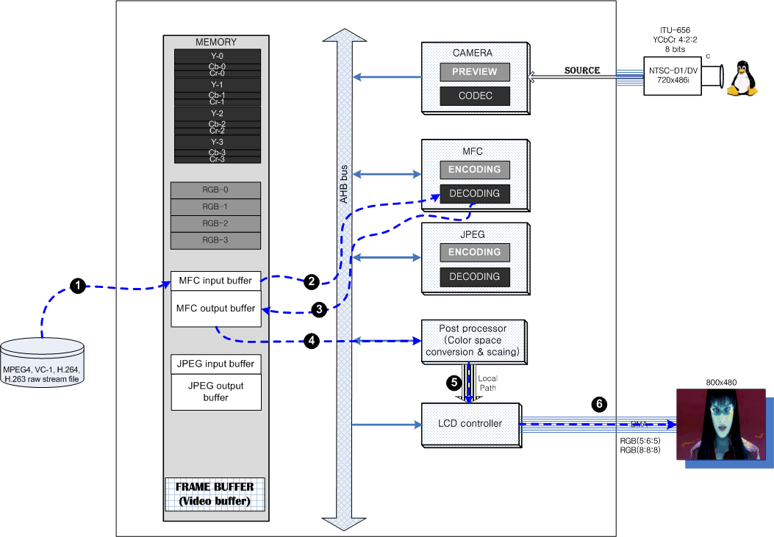

H.264 display using double buffering
This application uses 2 frame buffers(RGB buffer). LCD controller read data from frame buffer alternately.
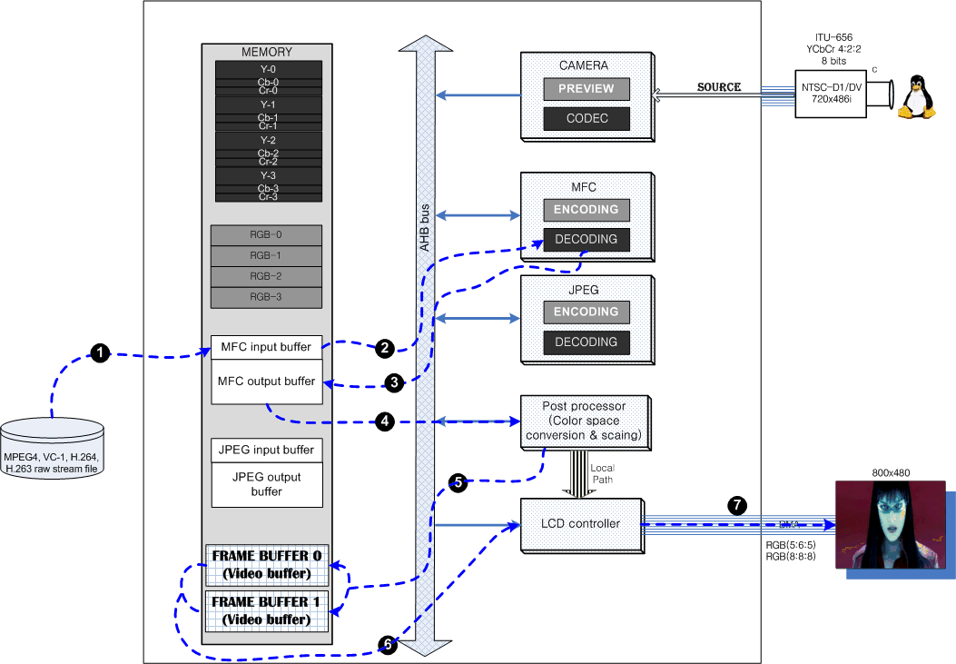

Camera preview & MFC encoding
This application does previewing and encoding the current frame simultaneously. Blue line is previewing in below figure and red line is to encode the current frame from camera codec path. Each path is developed as independent thread
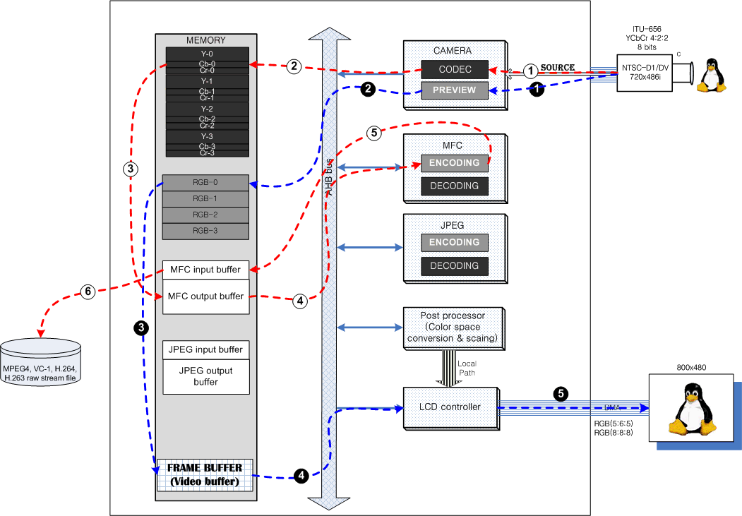

H.264 display & Camera preview
Camera previewing, MFC’s encoding and decoding are operated in this application at the same time.
Brown line’s path displays on LCD using MFC
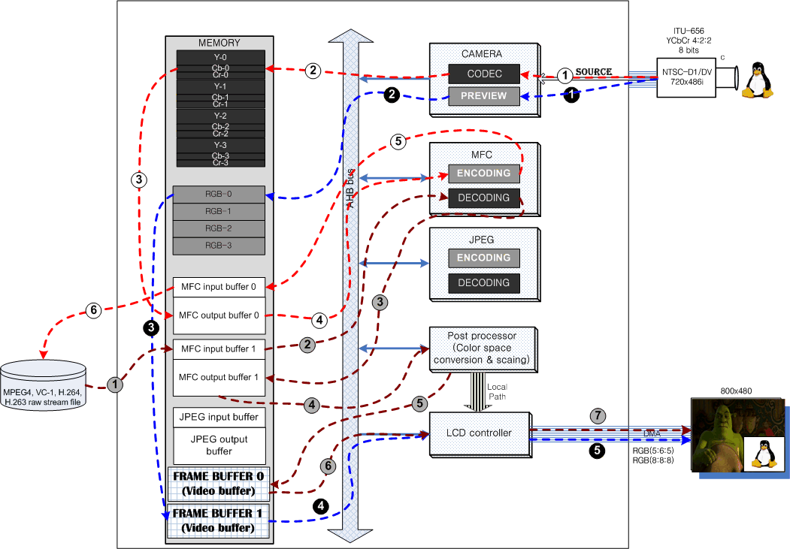

Camera preview & MFC encoding/decoding
Camera previewing is displayed on half of LCD and the other half of LCD displays decoded frame that is encoded by MFC.
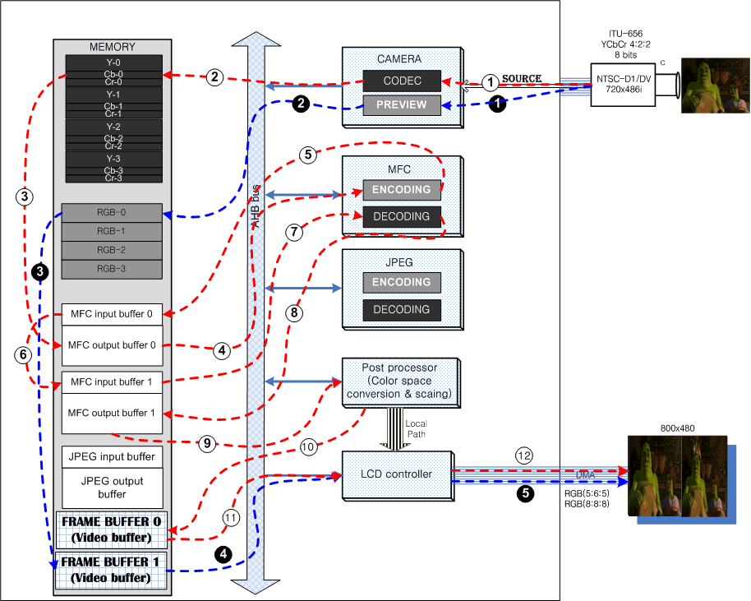

Camera input and JPEG encoding
This application encodes the YUV frame from Camera codec path and then encoded file(JPEG file) saves as .jpg file
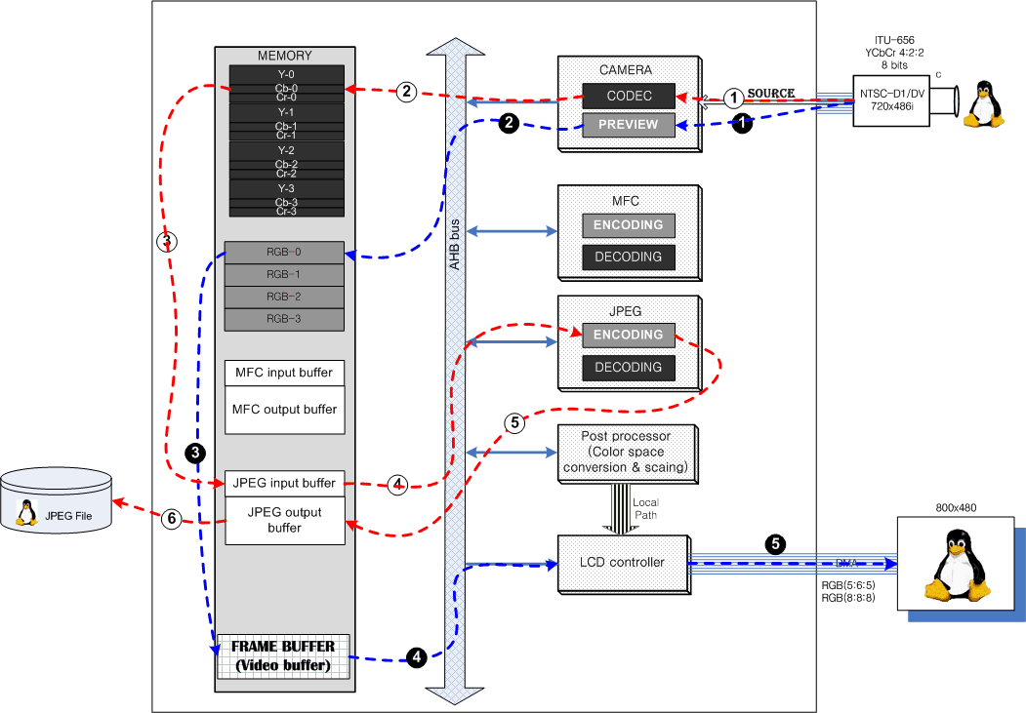

JPEG file display on LCD
This application displays on LCD after decoding jpg file

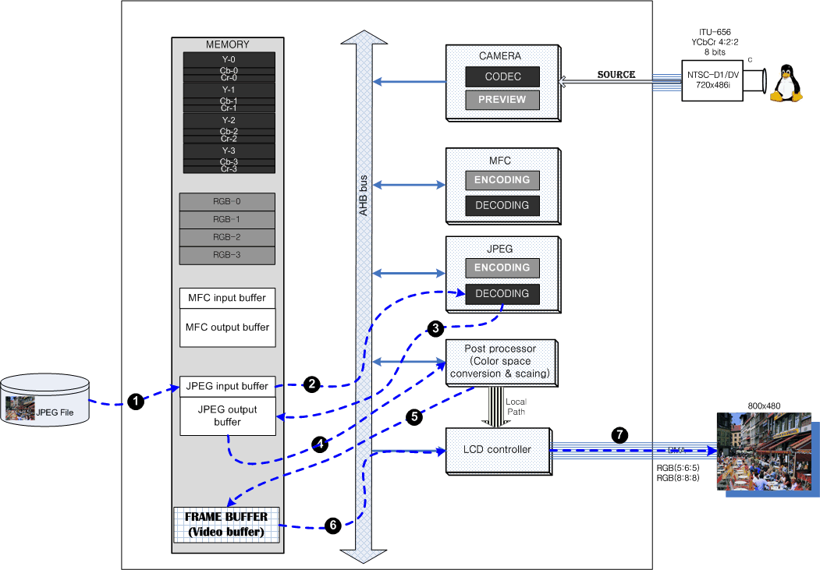

Package Guidelines

Directory Structure

Directory | Files | Description
/APPLICATIONS/Common | *.c, *.h | Common files of applications
/ APPLICATIONS/FrameExtractor | *.c, *.h | Frame extractor for decoder
/ APPLICATIONS/MFC_API | *.c, *.h | MFC API
/APPLICATIONS/JPEG_API | *.c, *.h | JPEG API
/ APPLICATIONS/TestVectors | *.jpg,, *.264, *.m4v, *.263, *.rcv | Test vectors for applications
/ APPLICATIONS/doc | *.doc, *.pdf | Documents for Scenario based applications
/ APPLICATIONS/ | *.c, *.h | Source codes of the Scenario based applications

How to test Scenario based applications

Procedure to build kernel, API and test application
- kernel compilation
- module compilation
- Test application compilation
- loading kernel
- insert module into kernel
- Execute test application binary

Procedure to test

Kernel configuration and building

Configure reserved memory layout
Some devices need reserved memory because they have to allocate physically continuous memory. So you must setup reserved memory layout using below file named “reserved_mem.h” before kernel compilation.
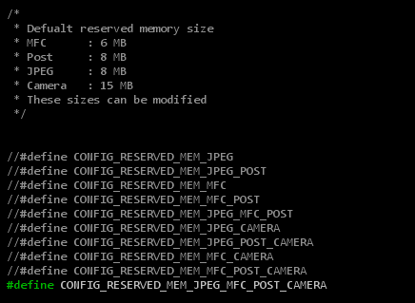

[NOTE]
1. This file is in
Include/asm-arm/arch-s3c64xx/reserved_mem.h (Linux2.6.16)
Include/asm-arm/arch-s3c2410/reserved_mem.h (Linux2.6.21)

2. For detailed information about how to build Linux kernel and how to download kernel image and cramfs, please refer to related porting guide documents.

You should modify DMA-consistent memory region in “include/asm-arm/memory.h” file.
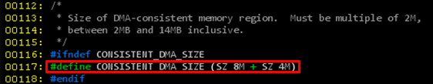

Configure Graphics options
You should command “make menuconfig”
[root@localhost s3c-linux-2.6.21]# make menuconfig

After “make menuconfig”, you can see the below figure. You should choose “Device Drivers”
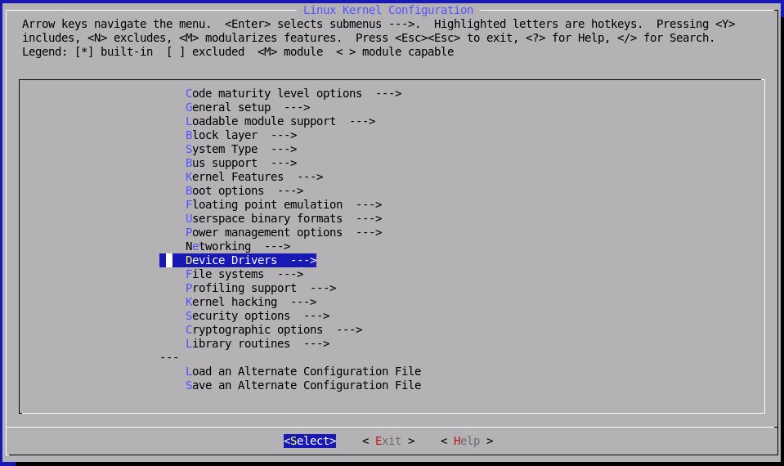

and then, please choose “Graphics support”
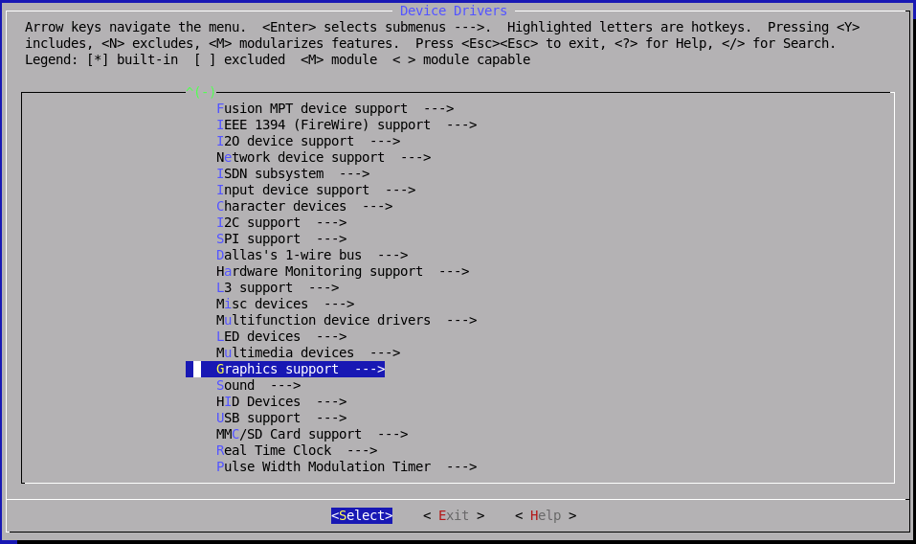

please set like below
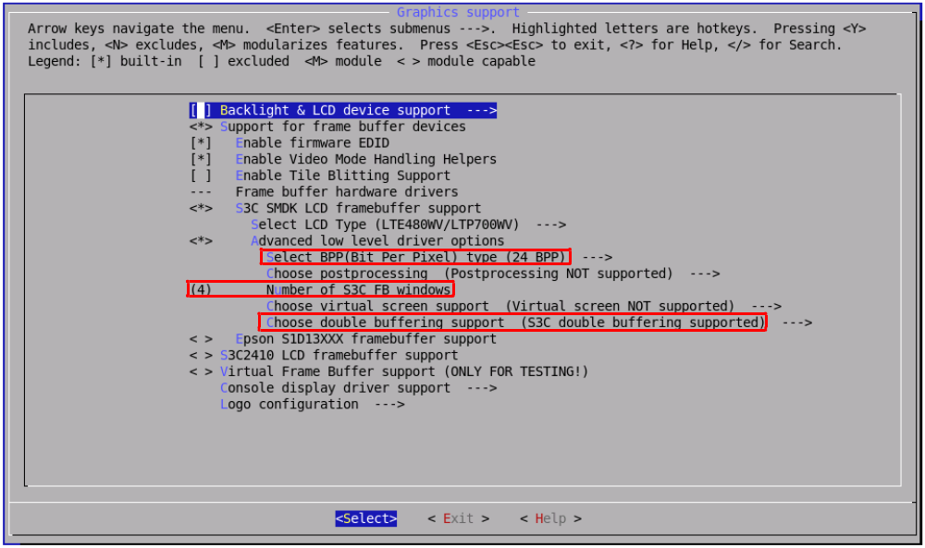

Module compilation

JPEG driver compilation
JPEG device driver should be compiled as a kernel module.

1. Modify Makefile
You should modify “Makefile” to set configuration according to your environment.
[root@localhost s3c-linux-2.6.21]# cd [module directory]/Multimedia_DD/JPEG_V1.01/jpeg_drv
[root@localhost jpeg_drv]# vi Makefile

#################################################
# Makefile for JPEG Driver
# 2007 (C) Samsung Electronics
# Author : Jiun. Yu <jiun.yu@samsung.com>
#################################################

KERNEL_DIR := /home/mobile/workspace/s3c-linux-2.6.21
TOPDIR := /home/mobile/workspace/s3c-linux-2.6.21

obj-m := s3c_jpeg.o

s3c_jpeg-y := LogMsg.o JPGOpr.o JPGMisc.o JPGMem.o s3c-jpeg.o

PWD := $(shell pwd)

here:
(cd $(KERNEL_DIR); make SUBDIRS=$(PWD) modules)

clean:
rm -rf *.ko
rm -rf *.mod.*
rm -rf .*.cmd
rm -rf *.o
rm -rf Module.*

2. Module compilation
After compilation, you can find newly created files. “s3c_jpeg.ko” file is module of JPEG device driver.
[root@localhost jpeg_drv]# make

MFC driver compilation
MFC device driver should be compiled as a kernel module.

1. Modify Makefile
You should modify “Makefile” to set configuration according to your environment.
[root@localhost s3c-linux-2.6.21]# cd [module directory]/Multimedia_DD/FIMV_MFC_V1.0/mfc_drv
[root@localhost mfc_drv]# vi Makefile

#################################################
# Makefile for MFC Driver
# 2007 (C) Samsung Electronics
# Author : Jiun. Yu <jiun.yu@samsung.com>
#################################################

KERNEL_DIR := /home/mobile/workspace/s3c-linux-2.6.21
TOPDIR := /home/mobile/workspace/s3c-linux-2.6.21

CFLAGS += -DLINUX
#CFLAGS += -DDIVX_TEST

obj-m := s3c_mfc.o

s3c_mfc-y := Prism_0503.o BitProcBuf.o DataBuf.o FramBufMgr.o \
LogMsg.o MFC_HW_Init.o MFC_Inst_Pool.o MFC_Instance.o MfcMemory.o MfcMutex.o MfcSfr.o \
s3c-mfc.o MfcIntrNotification.o MfcSetConfig.o

PWD := $(shell pwd)

here:
(cd $(KERNEL_DIR); make SUBDIRS=$(PWD) modules)

clean:
rm -rf *.ko
rm -rf *.mod.*
rm -rf .*.cmd
rm -rf *.o
rm -rf Module.*

2. Module compilation
After compilation, you can find newly created files. “s3c_mfc.ko” file is module of MFC device driver.
[root@localhost mfc_drv]# make

Post processor driver compilation
Post processor device driver should be compiled as a kernel module.

1. Modify Makefile
You should modify “Makefile” to set configuration according to your environment.
[root@localhost s3c-linux-2.6.21]# cd [module directory]/Multimedia_DD/PP_V2.5/pp_drv
[root@localhost pp_drv]# vi Makefile

#################################################
# Makefile for Post Processor
# 2007 (C) Samsung Electronics
# Author : Jiun. Yu <jiun.yu@samsung.com>
#################################################

KERNEL_DIR := /home/mobile/workspace/s3c-linux-2.6.21
TOPDIR := /home/mobile/workspace/s3c-linux-2.6.21

obj-m := s3c_pp.o

s3c_pp-y := s3c_pp_common.o s3c_pp_6400.o

PWD := $(shell pwd)

here:
(cd $(KERNEL_DIR); make SUBDIRS=$(PWD) modules)

clean:
rm -rf *.ko
rm -rf *.mod.*
rm -rf .*.cmd
rm -rf *.o
rm -rf Module.*

2. Module compilation
After compilation, you can find newly created files. “s3c_pp.ko” file is module of Post processor device driver.
[root@localhost pp_drv]# make

Test application compilation
After compilation, you can see the “app” which is executable file.
[root@localhost s3c-linux-2.6.21]# cd [module directory]/Multimedia_DD/APPLICATIONS
[root@localhost APPLICATIONS]# make

Test application execution(In target side)
After kernel booting, you should load driver modules(MFC, post processor, JPEG) firstly.
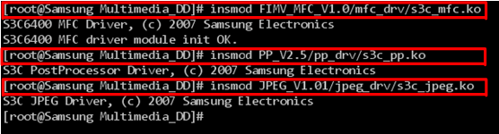

Second, you should execute “app” file which is in “Multimedia_DD/APPLICATIONS/”

And then, please select application you want to test
