

Codec Memory Management(CMM)
User’s Manual
(Linux)

S3C6400/6410
August 26, 2008
REV 1.11

Important Notice

The information in this publication has been carefully checked and is believed to be entirely accurate at the time of publication. Samsung assumes no responsibility, however, for possible errors or omissions, or for any consequences resulting from the use of the information contained herein.
Samsung reserves the right to make changes in its products or product specifications with the intent to improve function or design at any time and without notice and is not required to update this documentation to reflect such changes.
This publication does not convey to a purchaser of semiconductor devices described herein any license under the patent rights of Samsung or others.
Samsung makes no warranty, representation, or guarantee regarding the suitability of its products for any particular purpose, nor does Samsung assume any liability arising out of the application or use of any product or circuit and specifically disclaims any and all liability, including without limitation any consequential or incidental damages.
"Typical" parameters can and do vary in different applications. All operating parameters, including "Typicals" must be validated for each customer application by the customer's technical experts.
Samsung products are not designed, intended, or authorized for use as components in systems intended for surgical implant into the body, for other applications intended to support or sustain life, or for any other application in which the failure of the Samsung product could create a situation where personal injury or death may occur.
Should the Buyer purchase or use a Samsung product for any such unintended or unauthorized application, the Buyer shall indemnify and hold Samsung and its officers, employees, subsidiaries, affiliates, and distributors harmless against all claims, costs, damages, expenses, and reasonable attorney fees arising out of, either directly or indirectly, any claim of personal injury or death that may be associated with such unintended or unauthorized use, even if such claim alleges that Samsung was negligent regarding the design or manufacture of said product

S3C6400/6410 RISC Microprocessor
CMM User’s manual
Copyright © 2008 Samsung Electronics Co.,Ltd.
All rights reserved. No part of this publication may be reproduced, stored in a retrieval system, or transmitted in any form or by any means, electric or mechanical, by photocopying, recording, or otherwise, without the prior written consent of Samsung Electronics Co.,Ltd.
Samsung Electronics Co., Ltd.
San #24 Nongseo-Dong, Giheung-Gu
Yongin-City Gyeonggi-Do, Korea
446-711

Home Page: http://www.samsungsemi.com/
E-Mail: mobilesol.cs@samsung.com

Printed in the Republic of Korea

Revision History
Revision No | Description of Change | Refer to | Author(s) | Date
1.00 | Initial Version | - | Jiun Yu | 2008-07-05
1.10 | Node name is changed |  | Jiun Yu | 2008-07-19
1.11 | New ioctl’s command is added |  | Jiun Yu | 2008-08-26

Contents
1 Introduction 1
1.1 Purpose 1
1.2 Scope 1
1.3 Intended Audience 1
1.4 Definitions, Acronyms, and Abbreviations 1
1.5 References 1
2 Software Architecture 1
2.1 Overview 1
3 Package Guidelines 2
3.1 Directory Structure 2
4 How to Test CMM 3
4.1 Kernel Build 3
4.2 CMM driver module compilation 3
4.3 Test application compilation 3
4.4 Insert module and execute binary in Target side 3

Introduction

Purpose
The purpose of the document is to describe the CMM API for easy portability into different platforms by developers.

Scope
The scope of this document is to describe
- Software architecture of CMM
- Usage of CMM API
- How to use CMM driver

Intended Audience
Intended Audience | Tick whenever Applicable
Project Manager | Yes
Project Leader | Yes
Project Team Member | Yes
Test Engineer | Yes

Definitions, Acronyms, and Abbreviations

Abbreviations | Description
CMM | Codec Memory Management
API | Application Program Interface

References
Number | Reference | Description
1 | SMDK6400_WinCE6.0_FMD_PortingGuide.doc | OS porting guide
2 | SMDK6400_WinCE6.0_VideoDriver_UserManual.doc | Video Driver specification
3 | S3C6400_6410_Linux2.6.21_CMM_UserManual_REV1.00_20080705.doc | CMM v1.00 user’s manual

Software Architecture

Overview
When multimedia player use s/w decoder, Performance problem is often issued. CMM(Codec Memory Management) driver helps to improve rendering performance.

In common multimedia player, Decoded YUV data is transferred to video memory using memcpy(). It decreases much performance when the resolution of movie is large.

CMM Driver provides the interface to transfer decoded YUV data to video memory directly. At first, It allocates virtual address to the player. The virtual address is surely cacheable area. So, s/w decoder can utilize cache. After decoding, the player request for CMM to flush cached area. And then, the player request physical address of YUV buffer to CMM. With the physical address, the player calls video driver API for rendering. YUV data is transferred to h/w post processor by DMA.

It does not only reduce memcpy() time, but also make player to decode and render at the same time. Because rendering is done by only h/w, decoding performance is not decreased. You should make decoding and rendering as multi-threaded.

There are 2 methods to render YUV data. The one is using local path between h/w post processor and LCD. It doesn’t posses data BUS. But local path only supports RGB888. The other is using DMA between post processor and LCD.

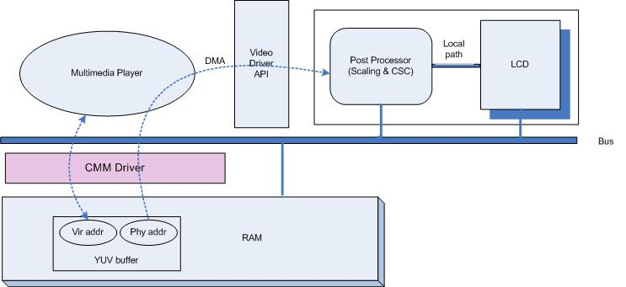

Figure 1. Architecture of CMM API

Package Guidelines

Directory Structure

Directory | Files | Description
/cmm_app/ | *.c, *.h | CMM test file
/cmm_drv/ | *.c, *.h | CMM Device Driver file
/doc | *.doc, *.pdf | CMM documents

How to Test CMM

Kernel Build
Before kernel compilation, you must setup memory layout below figure in “include/asm-arm/arch-s3c2410/reserved_mem.h” file
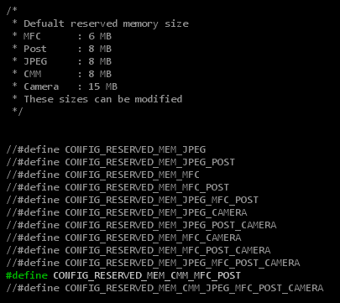

CMM driver module compilation
Node name : /dev/misc/s3c-cmm
Major number : 10
Minor number : 250
- how to make device node
[root@localhost CMM]# mknod /dev/misc/s3c-cmm c 10 250

- module compilation
[root@localhost cmm_drv]# make

Test application compilation
[root@localhost cmm_app] make

Insert module and execute binary in Target side
Below commands are executed in target side
[root@Samsung cmm_drv] insmod s3c_cmm.ko
[root@Samsung cmm_drv] cd ../cmm_app/
[root@Samsung cmm_app] ./cmm_test

