

S3C6400/6410 HW Multimedia Codec (MFC)
User’s Guide

S3C6400/6410
August 29, 2008
(Preliminary) REV 3.20

Important Notice

The information in this publication has been carefully checked and is believed to be entirely accurate at the time of publication. Samsung assumes no responsibility, however, for possible errors or omissions, or for any consequences resulting from the use of the information contained herein.
Samsung reserves the right to make changes in its products or product specifications with the intent to improve function or design at any time and without notice and is not required to update this documentation to reflect such changes.
This publication does not convey to a purchaser of semiconductor devices described herein any license under the patent rights of Samsung or others.
Samsung makes no warranty, representation, or guarantee regarding the suitability of its products for any particular purpose, nor does Samsung assume any liability arising out of the application or use of any product or circuit and specifically disclaims any and all liability, including without limitation any consequential or incidental damages.
"Typical" parameters can and do vary in different applications. All operating parameters, including "Typicals" must be validated for each customer application by the customer's technical experts.
Samsung products are not designed, intended, or authorized for use as components in systems intended for surgical implant into the body, for other applications intended to support or sustain life, or for any other application in which the failure of the Samsung product could create a situation where personal injury or death may occur.
Should the Buyer purchase or use a Samsung product for any such unintended or unauthorized application, the Buyer shall indemnify and hold Samsung and its officers, employees, subsidiaries, affiliates, and distributors harmless against all claims, costs, damages, expenses, and reasonable attorney fees arising out of, either directly or indirectly, any claim of personal injury or death that may be associated with such unintended or unauthorized use, even if such claim alleges that Samsung was negligent regarding the design or manufacture of said product

S3C6400/6410 RISC Microprocessor
User’s Guide
Copyright © 2007-2007 Samsung Electronics Co.,Ltd.
All rights reserved. No part of this publication may be reproduced, stored in a retrieval system, or transmitted in any form or by any means, electric or mechanical, by photocopying, recording, or otherwise, without the prior written consent of Samsung Electronics Co.,Ltd.
Samsung Electronics Co., Ltd.
San #24 Nongseo-Dong, Giheung-Gu
Yongin-City Gyeonggi-Do, Korea
446-711

Home Page: http://www.samsungsemi.com/
E-Mail: mobilesol.cs@samsung.com

Printed in the Republic of Korea

Revision History
Revision No | Description of Change | Refer to | Author(s) | Date
1.00 | Initial draft(refer to WinCE v5.4) | - | Simon Chun | Aug. 13, 2007
2.10 | Linux version document |  | Jiun Yu | Aug. 31, 2007
2.11 | Fig 2-3 is added |  | Jiun Yu | Sep. 1, 2007
2.20 | Ioctl command is added |  | Jiun Yu | Oct. 15, 2007
2.21 |  |  | Jiun Yu | Dec. 21, 2007
2.30 | Rotation function is added |  | Jiun Yu | Jan. 24, 2008
2.40 | Encoding options are added |  | JIun Yu | Mar. 31, 2008
3.00 | Supporting S3C6400 and 6410 |  | Jiun Yu | April 14, 2008
3.10 | Supporting Hybrid divx decoder |  | Jiun Yu | July 5, 2008
3.20 | Tested on s3c-linux-2.6.24 kernel |  | Jiun Yu | August 29, 2008

Contents
1 Introduction 1
1.1 Purpose 1
1.2 Scope 1
1.3 Intended Audience 1
1.4 Supported HW & SW 1
1.5 Definitions, Acronyms, and Abbreviations 1
1.6 References 1
2 Installation Guide 2
2.1 Directory Structure 2
2.1.1 Driver Source Code Structure 2
2.1.2 API Test application Source Code Structure 2
2.2 Installation Step (Linux BSP) 3
2.2.1 Kernel configuration and building 3
2.2.2 Module compilation 6
2.2.3 Test application compilation 7
2.2.4 Download module and test application(At target side) 9
2.2.5 Loading module and executing test applicatioin 9
2.3 Memory Configuration 9
2.3.1 Configuring the MFC Buffer Address 10
2.3.2 Required Memory Sized Calculation 12
3 File I/O Operatioin 15
3.1 Linux Device Driver’s File I/O Operation 15
3.1.1 open 15
3.1.2 ioctl 16
3.1.3 mmap 16
3.1.4 close 16
3.2 Control Codes for ioctl() 17
3.3 Data Structure for Passing the IOCTL Arguments 19
3.3.1 MFC_ENC_INIT_ARG 19
3.3.2 MFC_ENC_EXE_ARG 20
3.3.3 MFC_DEC_INIT_ARG 20
3.3.4 MFC_DEC_EXE_ARG 20
3.3.5 MFC_GET_BUF_ADDR_ARG 20
3.3.6 MFC_GET_CONFIG_ARG 21
3.3.7 MFC_SET_CONFIG_ARG 21
3.4 Obtainable Parameters for MFC 21
3.5 Configurable Parameters for MFC 21
3.5.1 MFC_SET_CONFIG_DEC_ROTATE 22
3.5.2 MFC_SET_CONFIG_ENC_H263_PARAM 23
3.5.3 MFC_SET_CONFIG_ENC_SLICE_MODE 23
3.5.4 MFC_SET_CONFIG_ENC_PARAM_CHANGE 24
3.5.5 MFC_SET_CONFIG_ENC_CUR_PIC_OPT 24
4 Annex A (H.264 Decoder Usage) 26

Figures
Fig 2-1 SW Layer of MFC Driver Source Code 2
Fig 2-2 MFC Test applications using File I/O
Fig 2-3 MFC Test application using API 3
Fig 2-4 Setup reserved memory layout 3
Fig 2-5 Select “Boot option” 4
Fig 2-6 Select 3rd line 5
Fig 2-7 Confirm “Default kernel command string” 5
Fig 2-8 Memory Layout in RAM for MFC 10
Fig 2-9 Size of BITPROC_BUF 12
Fig 2-10 Size of STRM_BUF with LINE_BUF and RING_BUF not-shared (Example) 13
Fig 2-11 Size of STRM_BUF with LINE_BUF and RING_BUF shared (Example) 13
Fig 2-12 Size of FRAM_BUF (Example) 14

Tables
Table 2-1 Directory Structure of MFC Driver and Test application Source Code 2
Table 2-2 MFC’s Buffer Description 10
Table 2-3 Required Memory Size (1 or 2 SD images) 14
Table 2-4 Required Memory Size (1 or 2 CIF images) 14
Table 3-1 Configurable parameter types for IOCTL_MFC_SET_CONFIG 22

Introduction

Purpose
This document is prepared for the purpose of describing the S3C6400/6410 HW codec (MFCv1.0) device driver’s API so that users can implement their multimedia application easily.

Scope
The scope of this document is to describe
- How to call the device driver’s API to decode/encode.
- Usage example of Decoder

Intended Audience

Intended Audience | Tick whenever Applicable
Project Manager | Yes
Project Leader | Yes
Project Team Member | Yes
Test Engineer | Yes

Supported HW & SW

Intended Audience | Tick whenever Applicable
HW | Samsung S3C6400/6410 HW Multimedia Codec
OS | Linux 2.6.16 and 2.6.24

Definitions, Acronyms, and Abbreviations
Abbreviations | Description
MFC | Multi-Format Codec (HW codec in S3C6400/6410 Samsung AP)

References
Number | Reference | Description
1 | S3C6400 Datasheet | S3C6400 Datasheet
2 | S3C6400WM60MfcDriver_UserManual_  REV5.60_20071228 | UserManual of the MFC Windows Mobile device driver

Installation Guide

Directory Structure

FIMV_MFC_V1.0
Doc | Documents(API specification, User’s guide, release note)
Mfc_app/File_Operation | MFC test application using File I/O
Mfc_app/API | MFC test application using API made by Samsung
Mfc_drv | MFC Linux device driver source code
Table -1 Directory Structure of MFC Driver and Test application Source Code

Driver Source Code Structure
Mfc driver souce code was separated into three layers which is shown in Error: Reference source not found.

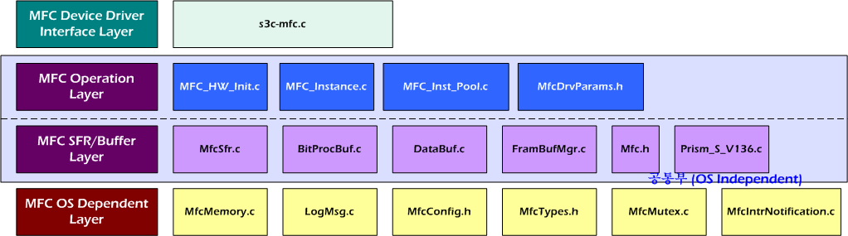Fig -1 SW Layer of MFC Driver Source Code

[MFC Device Driver Interface Layer] | It is the layer for the Linux OS device driver interface to be communicated with VFS. This layer is implementing the Linux character driver’s API specification.
[MFC Operation Layer] | It is implementing the operation logics for letting the MFC HW work.
[MFC SFR/Buffer Layer] | This layer is for handling components such as MFC SFR, Bit Processor’s buffer, etc.
[MFC OS System Layer] | It is an abstraction layer for the OS system call.

API Test application Source Code Structure

Fig 2-3 shows source code structure of the MFC test application using API. Blue boxes are API Layer.
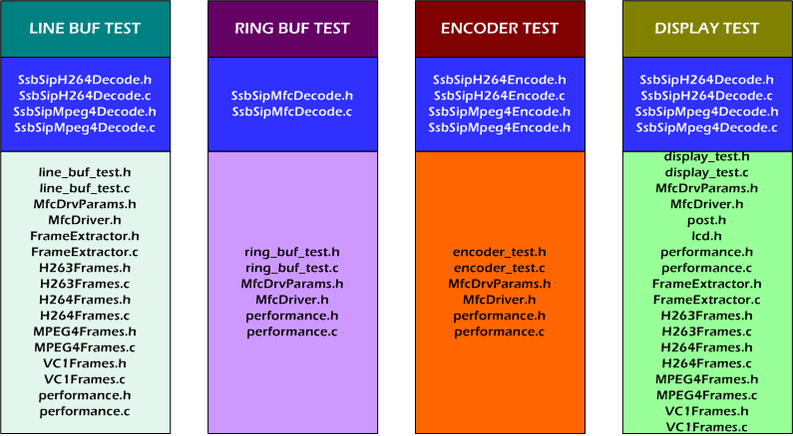
Fig -2 MFC Test application using API

Installation Step (Linux BSP)

Kernel configuration and building
Some devices need reserved memory because they have to allocate physically continuous memory. So You must setup reserved memory layout using below file named “reserved_mem.h” before kernel compilation.
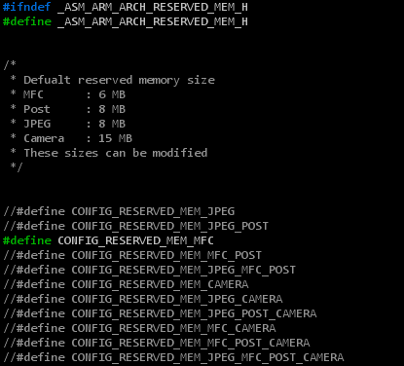
Fig -3 Setup reserved memory layout
[NOTE]

This file is in
include/asm/arch-s3c64xx/reserved_mem.h (Linux2.6.16)
include/asm/arch-s3c2410/reserved_mem.h (Linux2.6.21 and 2.6.24)

And then you must confirm “Boot option” in menuconfig using below procedure.
#cd [installed directory]/s3c-linux-2.6.24
[root@localhost s3c-linux-2.6.24]# make smdk6410mtd_defconfig
[root@localhost s3c-linux-2.6.24]# make menuconfig

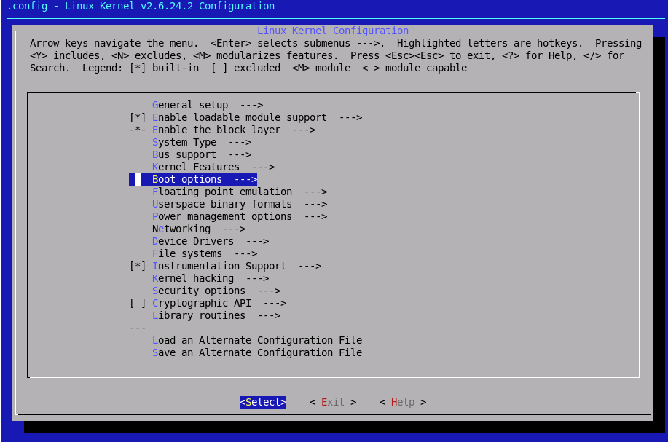
Fig -4 Select “Boot option”
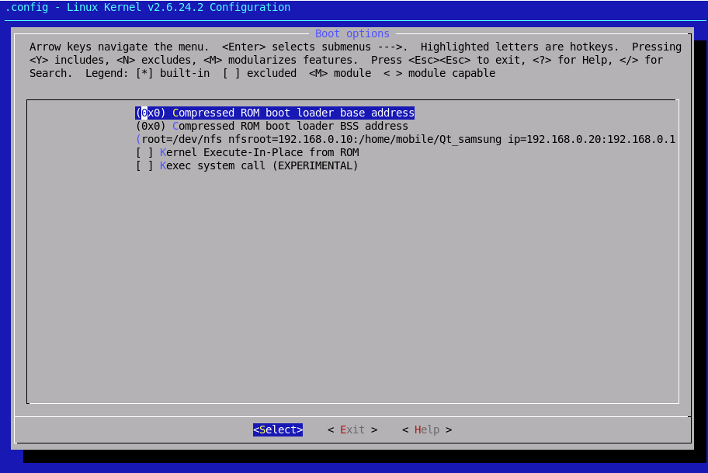
Fig -5 Select 3rd line

If there is “mem=128M” in “Default kernel command string”, please erase because you already modify reserved memory layout previous step.
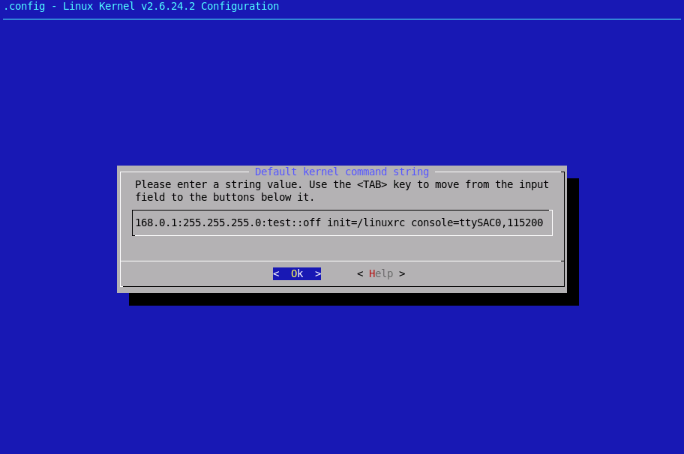
Fig -6 Confirm “Default kernel command string”

Save and exit in “menuconfig”

[root@localhost s3c-linux-2.6.24]# make clean
[root@localhost s3c-linux-2.6.24]# make
[root@localhost s3c-linux-2.6.24]# cp arch/arm/boot/zImage /tftpboot
When “zImage” is ready in the directory “/tftpboot”, then you can run “minicom” to download it to the target board.

[NOTE]

For detailed information about how to build Linux kernel and how to download kernel image and cramfs, please refer to related porting guide documents.

Module compilation
MFC device driver should be compiled as a kernel module.

Makefile
You should modify “Makefile” to set configuration according to your environment.
[root@localhost s3c-linux-2.6.24]# cd [module directory]/Multimedia_DD/FIMV_MFC_V1.0/mfc_drv
[root@localhost mfc_drv]# vi Makefile

#################################################
# Makefile for MFC Driver
# 2007 (C) Samsung Electronics
# Author : Jiun. Yu <jiun.yu@samsung.com>
#################################################

#where the kernel sources are located
KERNEL_DIR := ../../../ s3c-linux-2.6.24

CFLAGS_MODULE += -DLINUX
CFLAGS_MODULE += -DDIVX_ENABLE

obj-m := s3c_mfc.o

s3c_mfc-y := Prism_0503.o BitProcBuf.o DataBuf.o FramBufMgr.o \
LogMsg.o MFC_HW_Init.o MFC_Inst_Pool.o MFC_Instance.o MfcMemory.o MfcMutex.o MfcSfr.o \
s3c-mfc.o MfcIntrNotification.o MfcSetConfig.o

PWD := $(shell pwd)

here:
(cd $(KERNEL_DIR); make SUBDIRS=$(PWD) modules)

clean:
rm -rf *.ko
rm -rf *.mod.*
rm -rf .*.cmd
rm -rf *.o
rm -rf Module.*
In case of enabling DIVX_TEST macro, MFC’s output buffer’s scheme is changed like below. Below buffer scheme is used for Hybrid divx decoder.
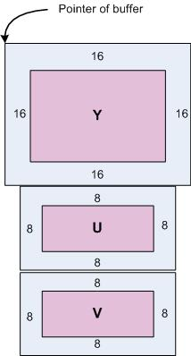

Compile
After compilation, you can find newly created files. “s3c_mfc.ko” file is module of MFC device driver.
[root@localhost mfc_drv]# make

Test application compilation
In this sub chapter, you should know how to compile and how to use test application. It is included encoder and decoder test

First, you should modify the “Makefile”. There are several macro. you should enable macro accoding to your development environment.
[root@localhost mfc_drv]# cd ../mfc_app/API
[root@localhost API]# vi Makefile

CC = /usr/local/arm/4.2.2-eabi/usr/bin/arm-linux-gcc

#[Definitions]
#FPS : performance measurement. It doesn't make the output file
#ROTATE_ENABLE : Rotation mode enable when testing line buffer and ring buffer.
# and if you want to test rotation, you must modify definition as "#define
# MFC_ROTATE_ENABLE 1" in MfcConfig.h file
#RGB24BPP : display as 24bpp. default is 16bpp
#DIVX_ENABLE : test for hybrid divx decoder

CFLAGS = -Wall -Os

CSRCS = ./MPEG4Frames.c \
./H264Frames.c \
./VC1Frames.c \
./H263Frames.c \
./FrameExtractor.c \
./line_buf_test.c \
./ring_buf_test.c \
./display_test.c \
./display_optimization1.c \
./display_optimization2.c \
./encoder_test.c \
./SsbSipH264Decode.c \
./SsbSipMpeg4Decode.c \
./SsbSipVC1Decode.c \
./SsbSipMfcDecode.c \
./SsbSipH264Encode.c \
./SsbSipMpeg4Encode.c \
./SsbSipLogMsg.c \
./performance.c \
./FileRead.c \
./demo.c \
./test.c

OBJS = $(CSRCS:.c=.o)

.SUFFIXES:.c.o

all: mfc

mfc: $(OBJS)
$(CC) $(CFLAGS) -g -o $@ $(OBJS) -lpthread

.c.o:
$(CC) $(CFLAGS) -g -c -o $@ $<

clean:
rm -f mfc $(OBJS)

Second, you should decide to test encoder or decoder.
[root@localhost mfc_drv]# cd ../mfc_app/API
[root@localhost API]# vi test.c

Modify “test.c” file. You can select encoder or decoder test
#include "line_buf_test.h"
#include "ring_buf_test.h"
#include "encoder_test.h"
#include "display_test.h"
#include "demo.h"
#include "display_optimization1.h"
#include "display_optimization2.h"

int main(int argc, char **argv)
{
Test_H263_Decoder_Line_Buffer(argc, argv);
//Test_H264_Decoder_Line_Buffer(argc, argv);
//Test_MPEG4_Decoder_Line_Buffer(argc, argv);
//Test_VC1_Decoder_Line_Buffer(argc, argv);
//Test_Decoder_Ring_Buffer(argc, argv);
//Test_Display_H264(argc, argv);
//Test_Display_MPEG4(argc, argv);
//Test_Display_H263(argc, argv);
//Test_Display_VC1(argc, argv);
//Test_H264_Encoder(argc, argv);
//Test_MPEG4_Encoder(argc, argv);
//Test_H263_Encoder(argc, argv);
//Demo(argc, argv);
//Test_Display_Optimization1(argc, argv);
//Test_Display_Optimization2(argc, argv);

return 0;
}

Third, you should compile the test application.
[root@localhost mfc_app]# make
After compilation, you can find newly created files. “mfc” is executable file.

Download module and test application(At target side)
Use “rz” command in root file system. This command enables you can transfer test application from host PC to target board through uart console by zmodem.
/tmp $ rz <ENTER>
After downloading completely, you need to change access right of this application. Use “chmod” command. If you are using NFS root file system, you just copy these created files to your NFS root directory.

Loading module and executing test applicatioin
/ $ insmod s3c_mfc.ko
S3C6400 MFC Driver, (c) 2007 Samsung Electronics
S3C6400 MFC driver module init OK.
./mfc [input filename] [output filename]

Memory Configuration

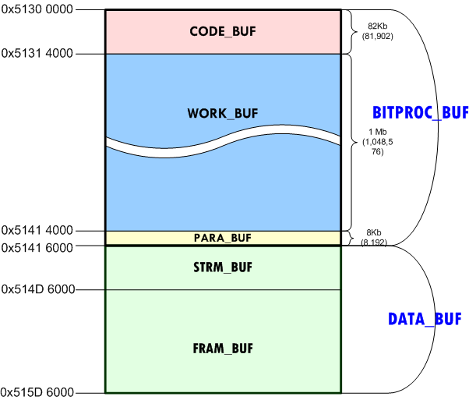
Fig -7 Memory Layout in RAM for MFC

There are two memory region to be reserved for the MFC to operate. One is BITPROC_BUF and its size is fixed as 1,138,688 bytes. The other is DATA_BUF, the size for this buffer is application-dependent.

BUF name | Description |  | BUF size  (Bytes)
BITPROC_BUF | Reserved area for the BITPROCESSOR(MFC’s internal processor)  Once the MFC is started, the address cannot be changed. |  | 1,138,688
BITPROC_BUF | CODE_BUF | BITPROCESSOR’s F/W code | 81,902
BITPROC_BUF | WORK_BUF | BITPROCESSOR’s working buffer | 1,048,576
BITPROC_BUF | PARA_BUF | Parameters on issuing command to MFC | 8,192
DATA_BUF | Input/Output buffer for encoding and decoding
DATA_BUF | STRM_BUF | Buffer for the compressed video stream. | ❶
DATA_BUF | FRAM_BUF | Buffer for the YUV420 frame | ❷
Table -2 MFC’s Buffer Description

BITPROC_BUF is reserved for the BITPROCESSOR and the size is fixed as 1,138,688 bytes.
DATA_BUF consists of STRM_BUF and FRAM_BUF for input and output buffer. In the STRM_BUF area, we allocates the LINE_BUF

Configuring the MFC Buffer Address

FIMV_MFC_V1.0/mfc_drv/MfcConfig.h

DEFINE | Description
S3C6400_BASEADDR_MFC_SFR | - Base address of MFC SFR  - [Value = 0x7e002000] is fixed. (Refer to S3C6400 Datasheet.)
S3C6400_BASEADDR_MFC_BITPROC_BUF | - Base address of MFC BITPROC_BUF  - Value is in RAM region
S3C6400_BASEADDR_MFC_DATA_BUF | - Base address of MFC DATA_BUF  - Value is in RAM region (Better if it is consecutive to BITPROC_BUF.)

DEFINE | Description
MFC_CODE_BUF_SIZE | - Size of CODE_BUF  - [Value = 81920] is fixed.
MFC_WORK_BUF_SIZE | - Size of WORK_BUF  - [Value = 1048576] is fixed.
MFC_PARA_BUF_SIZE | - Size of PARA_BUF  - [Value = 8192] is fixed.
MFC_BITPROC_BUF_SIZE | - Total size of BITPROC_BUF  - Value = MFC_CODE_BUF_SIZE + MFC_WORK_BUF_SIZE + MFC_PARA_BUF_SIZE

DEFINE | Description
MFC_NUM_INSTANCES_MAX | - Maximum number of MFC instances  - Value = 1 ~ 8
MFC_LINE_RING_SHARE | - LINE_BUF & RING_BUF are shared?  - Value = 0 or 1

DEFINE | Description
MFC_LINE_BUF_SIZE_PER_INSTANCE | - Size of LINE_BUF per instance  - [Recommended Value for VGA = 200 * 1024]  - [Recommended Value for QVGA = 100 * 1024]
MFC_LINE_BUF_SIZE | - MFC_LINE_BUF_SIZE_PER_INSTANCE * MFC_NUM_INSTANCES_MAX
MFC_RING_BUF_SIZE | - Size of RING_BUF  - [Recommended Value = 256000 * 3]
MFC_FRAM_BUF_SIZE | - Size of FRAM_BUF  - [Recommended Value = 720*480*3*4]
MFC_RING_BUF_PARTUNIT_SIZE | - Size of one PART of RING_BUF  - MFC_RING_BUF_SIZE / 3
MFC_STRM_BUF_SIZE | - MFC_LINE_BUF_SIZE + MFC_RING_BUF_SIZE
MFC_DATA_BUF_SIZE | - MFC_STRM_BUF_SIZE + MFC_FRAM_BUF_SIZE

Required Memory Sized Calculation

In this section, how to calculate the memory will be explained step by step.

① BITPROC_BUF size is fixed. (size = 1,138,688 bytes)

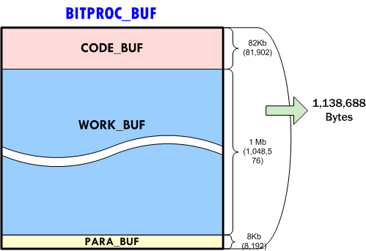
Fig -8 Size of BITPROC_BUF

② STRM_BUF size calculation.

STRM_BUF has LINE_BUF and RING_BUF. They can be separated or shared.

LINE_BUF & RING_BUF are in separate mode.
As shown in Error: Reference source not found, LINE_BUF and RING_BUF consume memory spaces respectively. For the 720x576-sized video, the possible maximum length of frame is 622,080 (720x576x1.5) bytes that is when it is not totally compressed. By assuming that it can be compressed to 30%, 204,800 bytes is the proper value for the maximum length of compressed frame.

Therefore, we can assume that the maximum length of compressed frame for different video size is
- SD image : 204,800 bytes or less
- CIF image : 102,400 bytes or less

LINE_BUF & RING_BUF are in shared mode.
As shown in Error: Reference source not found, LINE_BUF and RING_BUF are shared so that the required size of STRM_BUF is larger one. Typically, the RING_BUF size is equal to three times of LINE_BUF_PER_INSTANCE, the size for STRM_BUF can be set 614,400 bytes for SD-sized image.

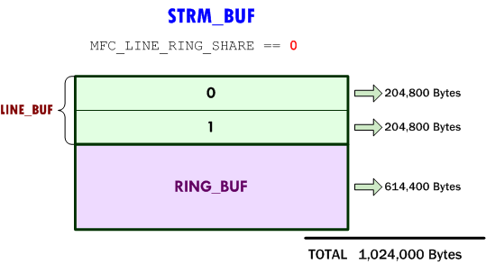
Fig -9 Size of STRM_BUF with LINE_BUF and RING_BUF not-shared (Example)

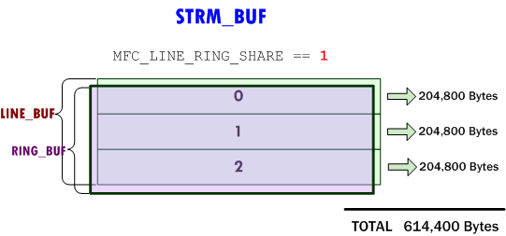
Fig -10 Size of STRM_BUF with LINE_BUF and RING_BUF shared (Example)

③ FRAM_BUF size calculation.

MFC requires that the output buffer size is three or four times bigger than the YUV frame size. The number is determined by the return value (frame count in MFC DEC_PIC_RUN command.) The number is commonly 3 (three times bigger).
For the SD-sized image, the required size of FRAM_BUF is shown in Error: Reference source not found.

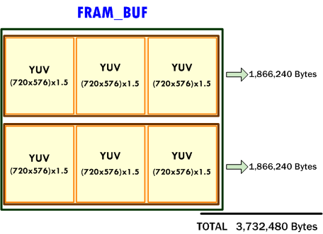
Fig -11 Size of FRAM_BUF (Example)

The following tables, Table 2-3 and Table 2-4, are showing required memory size examples for common situations. If we set the MFC to support 1 SD image, it requires 3.3 MB. Since it is greater than the case of 2 CIF images, 1 SD image setting is supporting the 2CIF image setting as well.

(Unit : Bytes)
 | 2 SD images |  | 1 SD image
 | LINE_RING split | LINE_RING share | LINE_RING split | LINE_RING share
BITPROC_BUF | 1,138,688 | 1,138,688 | 1,138,688 | 1,138,688
STRM_BUF | 1,024,000 | 614,400 | 512,000 | 307,200
FRAM_BUF | 3,732,480 | 3,732,480 | 1,866,240 | 1,866,240
TOTAL | 5,895,168  0x0059 F400 | 5,485,568  0x0053 B400 | 3,516,928  0x0035 AA00 | 3,312,128  0x0032 8A00
Table -3 Required Memory Size (1 or 2 SD images)

(Unit : Bytes)
 | 2 CIF images |  | 1 CIF image
 | LINE_RING split | LINE_RING share | LINE_RING split | LINE_RING share
BITPROC_BUF | 1,138,688 | 1,138,688 | 1,138,688 | 1,138,688
STRM_BUF | 512,000 | 307,200 | 512,000 | 307,200
FRAM_BUF | 912,384 | 912,384 | 912,384 | 912,384
TOTAL | 2,563,072  0x0027 1C00 | 2,358,272  0x0023 FC00 | 2,563,072  0x0027 1C00 | 2,358,272  0x0023 FC00
Table -4 Required Memory Size (1 or 2 CIF images)

File I/O Operatioin

Linux Device Driver’s File I/O Operation
API Functions | Description
open | Create the 6400 MFC instance.
ioctl | IOCTL_MFC_MPEG4_DEC_INIT  IOCTL_MFC_MPEG4_ENC_INIT  IOCTL_MFC_MPEG4_DEC_EXE  IOCTL_MFC_MPEG4_ENC_EXE  IOCTL_MFC_H264_DEC_INIT  IOCTL_MFC_H264_ENC_INIT  IOCTL_MFC_H264_DEC_EXE  IOCTL_MFC_H264_ENC_EXE  IOCTL_MFC_H263_DEC_INIT  IOCTL_MFC_H263_ENC_INIT  IOCTL_MFC_H263_DEC_EXE  IOCTL_MFC_H263_ENC_EXE  IOCTL_MFC_VC1_DEC_INIT  IOCTL_MFC_VC1_DEC_EXE  IOCTL_MFC_GET_LINE_BUF_ADDR  IOCTL_MFC_GET_RING_BUF_ADDR  IOCTL_MFC_GET_FRAM_BUF_ADDR  IOCTL_MFC_GET_PHY_FRAM_BUF_ADDR  IOCTL_MFC_GET_CONFIG  IOCTL_MFC_SET_CONFIG  IOCTL_MFC_SET_H263_MULTIPLE_SLICE
mmap | Map reserved memory for application
close | Close the 6400 MFC instance.

open

open
Syntax | int open(const char * path, int oflag);
Description | This function creates the 6400 MFC instance. Several MFC instance can be made simultaneously. This means that open function can be called several times in a process(task).
Parameters | path [IN] : path of the MFC device driver’s node  oflag[IN] : flags of MFC.
Returns | HANDLE(file descriptor) of the MFC instance.  If it fails, it returns INVALID_HANDLE_VALUE.

ioctl

ioctl
Syntax | int ioctl(int fd, int cmd, int arg);
Description | Most of functions are developed in ioctl. This system call has many functions which is separated by cmd
Parameters | fd [IN] : HANDLE returned by open() function.  cmd [IN] : Control codes for the operation. Detailed information of cmd will explain below.  arg[IN] : Structure of the MFC argument.
Returns | If the operation completes successfully, the return value is nonzero.  If the operation fails or is pending, the return value is zero.

mmap

mmap
Syntax | Void *mmap(void *addr,  size_t len,  int prot,  int flags,  int fd,  off_t off  );
Description | This function maps physically continuous memory. This memory can share user and device driver. It is used as Stream buffer and frame buffer of the MFC
Parameters | addr[IN] : none  len[IN] : mapped memory size  prot[IN] : memory access permission(PROT_READ, PROT_WRITE, etc)  flag[IN] : attribute of memory (MAP_SHARED, etc)  fd [IN] : HANDLE of the MFC  off[IN] : none
Returns | Base address of stream buffer. This address can use in user application.

close

Close
Syntax | int close(int fd);
Description | Closes an open MFC’s handle.
Parameters | fd [IN] : HANDLE returned by open() function
Returns | If the function succeeds, the return value is nonzero.  If the function fails, the return value is zero

Control Codes for ioctl()

IOCTL_MFC_MPEG4_DEC_INIT
IOCTL_MFC_H263_DEC_INIT
IOCTL_MFC_H264_DEC_INIT
IOCTL_MFC_VC1_DEC_INIT
Syntax | See 3.1.2
Description | It initializes the MFC’s instance with the configure stream.
Parameters | fd [IN] : HANDLE returned by open() function  cmd [IN] : IOCTL_MFC_MPEG4_DEC_INIT,  IOCTL_MFC_H263_DEC_INIT, IOCTL_MFC_H264_DEC_INIT, IOCTL_MFC_VC1_DEC_INIT  arg [IN/OUT] : Pointer to MFC_DEC_INIT_ARG structure.
Returns | If the operation completes successfully, the return value is nonzero.  If the operation fails or is pending, the return value is zero.

IOCTL_MFC_MPEG4_DEC_EXE
IOCTL_MFC_H263_DEC_EXE
IOCTL_MFC_H264_DEC_EXE
IOCTL_MFC_VC1_DEC_EXE
Syntax | See 3.1.2
Description | It decodes the stream in the LINE_BUF or RING_BUF.
Parameters | fd [IN] : HANDLE returned by open() function  cmd [IN] : IOCTL_MFC_MPEG4_DEC_EXE, IOCTL_MFC_H263_DEC_EXE, IOCTL_MFC_H264_DEC_EXE, IOCTL_MFC_VC1_DEC_EXE  arg [IN/OUT] : Pointer to MFC_DEC_EXE_ARG structure.
Returns | If the operation completes successfully, the return value is nonzero.  If the operation fails or is pending, the return value is zero.

IOCTL_MFC_MPEG4_ENC_INIT
IOCTL_MFC_H263_ENC_INIT
IOCTL_MFC_H264_ENC_INIT
IOCTL_MFC_VC1_ENC_INIT
Syntax | See 3.1.2
Description | It initializes the MFC’s encoding information.
Parameters | fd [IN] : HANDLE returned by open() function  cmd [IN] : IOCTL_MFC_MPEG4_ENC_INIT,  IOCTL_MFC_H263_ENC_INIT, IOCTL_MFC_H264_ENC_INIT, IOCTL_MFC_VC1_ENC_INIT  arg [IN/OUT] : Pointer to MFC_ENC_INIT_ARG structure.
Returns | If the operation completes successfully, the return value is nonzero.  If the operation fails or is pending, the return value is zero.

IOCTL_MFC_MPEG4_ENC_EXE
IOCTL_MFC_H263_ENC_EXE
IOCTL_MFC_H264_ENC_EXE
IOCTL_MFC_VC1_ENC_EXE
Syntax | See 3.1.2
Description | It encodes the stream in the FRAM_BUF.
Parameters | fd [IN] : HANDLE returned by open() function  cmd [IN] : IOCTL_MFC_MPEG4_ENC_EXE, IOCTL_MFC_H263_ENC_EXE, IOCTL_MFC_H264_ENC_EXE, IOCTL_MFC_VC1_ENC_EXE  arg [IN/OUT] : Pointer to MFC_ENC_EXE_ARG structure.
Returns | If the operation completes successfully, the return value is nonzero.  If the operation fails or is pending, the return value is zero.

IOCTL_MFC_GET_LINE_BUF_ADDR
IOCTL_MFC_GET_RING_BUF_ADDR
IOCTL_MFC_GET_FRAM_BUF_ADDR
Syntax | See 3.1.2
Description | It obtains the address of the LINE_BUF, RING_BUF or FRAM_BUF.
Parameters | fd [IN] : HANDLE returned by open() function  cmd [IN] : IOCTL_MFC_GET_LINE_BUF_ADDR,  IOCTL_MFC_GET_RING_BUF_ADDR,  IOCTL_MFC_GET_FRAM_BUF_ADDR  arg [IN/OUT] : Pointer to MFC_GET_BUF_ADDR_ARG structure.
Returns | If the operation completes successfully, the return value is nonzero.  If the operation fails or is pending, the return value is zero.

IOCTL_MFC_GET_PHY_FRAM_BUF_ADDR
Syntax | See 3.1.2
Description | It obtains the physical address of the FRAM_BUF.
Parameters | fd [IN] : HANDLE returned by open() function  cmd [IN] : IOCTL_MFC_GET_PHY_FRAM_BUF_ADDR  arg [IN/OUT] : Pointer to MFC_GET_BUF_ADDR_ARG structure.
Returns | If the operation completes successfully, the return value is nonzero.  If the operation fails or is pending, the return value is zero.

IOCTL_MFC_GET_CONFIG
Syntax | See 3.1.2
Description | It get the configurable parameters. The list of configurable parameters is described below.
Parameters | fd [IN] : HANDLE returned by open() function  cmd [IN] : IOCTL_MFC_GET_CONFIG  arg [IN/OUT] : Pointer to MFC_GET_CONFIG_ARG structure.
Returns | If the operation completes successfully, the return value is nonzero.  If the operation fails or is pending, the return value is zero.

IOCTL_MFC_SET_CONFIG
Syntax | See 3.1.2
Description | It set the configurable parameters with new value. The list of configurable parameters is described below.
Parameters | fd [IN] : HANDLE returned by open() function  cmd [IN] : IOCTL_MFC_SET_CONFIG  arg [IN/OUT] : Pointer to MFC_SET_CONFIG_ARG structure.
Returns | If the operation completes successfully, the return value is nonzero.  If the operation fails or is pending, the return value is zero.

IOCTL_MFC_SET_H263_MULTIPLE_SLICE
Syntax | See 3.1.2
Description | This command supports multiple slice mode in H.263 encoding case
Parameters | fd [IN] : HANDLE returned by open() function  cmd [IN] : IOCTL_MFC_SET_H263_MULTIPLE_SLICE
Returns | None

Data Structure for Passing the IOCTL Arguments

MFC_ENC_INIT_ARG

MFC_ENC_INIT_ARG
int ret_code | [OUT] Return code
int in_width | [IN] width of YUV420 frame to be encoded
int in_height | [IN] height of YUV420 frame to be encoded
int in_bitrate | [IN] Encoding parameter: Bitrate (kbps)
int in_gopNum | [IN] Encoding parameter: GOP Number (interval of I-frame)
int in_frameRateRes | [IN] Encoding parameter: Frame rate (Res)
int in_frameRateDiv | [IN] Encoding parameter: Frame rate (Divider)

MFC_ENC_EXE_ARG

MFC_ENC_EXE_ARG
int ret_code | [OUT] Return code
int out_encoded_size | [OUT] Length of Encoded video stream
Int out_header_size | [OUT] Length of Encoded header size

MFC_DEC_INIT_ARG

MFC_DEC_INIT_ARG
int ret_code | [OUT] Return code
int in_strmSize | [IN] Size of video stream filled in STRM_BUF
int out_width | [OUT] width of YUV420 frame
int out_height | [OUT] height of YUV420 frame

MFC_DEC_EXE_ARG

MFC_DEC_EXE_ARG
int ret_code | [OUT] Return code
int in_strmSize | [IN] Size of video stream filled in STRM_BUF

MFC_GET_BUF_ADDR_ARG

MFC_GET_BUF_ADDR_ARG
int ret_code | [OUT] Return code
int in_usr_data | [IN] address returned by mmap() function
int out_buf_addr | [OUT] Buffer address
int out_buf_size | [OUT] Size of buffer address

MFC_GET_CONFIG_ARG
MFC_GET_CONFIG_ARG
int ret_code | [OUT] Return code
int in_config_param | [IN] Configurable parameter type
int out_config_value[2] | [IN] Values to get for the configurable parameter. Maximum two integer values can be obtained.

MFC_SET_CONFIG_ARG

MFC_SET_CONFIG_ARG
int ret_code | [OUT] Return code
int in_config_param | [IN] Configurable parameter type
int in_config_value[2] | [IN] Values to be set for the configurable parameter. Maximum two integer values can be set
int out_config_value_old[2] | [OUT] Old values of the configurable parameter.

Obtainable Parameters for MFC

In this section, the obtainable parameters for MFC are explained. They are ‘obtainable parameter types’ which are obtained to out_config_param in MFC_GET_CONFIG_ARG that is an argument of IOCTL_MFC_GET_CONFIG command

Obtainable Paramter |  | Parameter Value
MFC_GET_CONFIG_DEC_  FRAME_NEED_COUNT |  | out_config_value_old[0] | Count of frame buffers
MFC_GET_CONFIG_DEC_  FRAME_NEED_COUNT |  | out_config_value_old[1] | Not Used

Configurable Parameters for MFC

In this section, the configurable parameters for MFC are explained. They are ‘configurable parameter types’ which are assigned to in_config_param in MFC_SET_CONFIG_ARG that is an argument of IOCTL_MFC_SET_CONFIG command

Configurable Paramter |  | Parameter Value
MFC_SET_CONFIG_DEC_  ROTATE | ‘Post rotation mode’ configurables the MFC to rotate and/or mirror the output YUV image during the decoding. | in_config_value[0] | PostRotMode
MFC_SET_CONFIG_DEC_  ROTATE |  | in_config_value[1] | Not Used
MFC_SET_CONFIG_DEC_  ROTATE |  | out_config_value_old[0] | Old value of PostRotMode
MFC_SET_CONFIG_DEC_  ROTATE |  | out_config_value_old[1] | Not Used
MFC_SET_CONFIG_DEC_  H264_REORDER  (Not implemented) |  | In_config_value[0] | ReorderEn
MFC_SET_CONFIG_DEC_  H264_REORDER  (Not implemented) |  | In_config_value[1] | Not used
MFC_SET_CONFIG_DEC_  H264_REORDER  (Not implemented) |  | Out_config_value_old[0] | Old value of ReorderEn
MFC_SET_CONFIG_DEC_  H264_REORDER  (Not implemented) |  | Out_config_value_old[1] | Not Used
MFC_SET_CONFIG_ENC_  H263_PARAM | ‘H.263 Encode  Parameters’ | In_config_value[0] | H.263 EncParam
MFC_SET_CONFIG_ENC_  H263_PARAM | ‘H.263 Encode  Parameters’ | In_config_value[1] | Not Used
MFC_SET_CONFIG_ENC_  H263_PARAM | ‘H.263 Encode  Parameters’ | Out_config_value_old[0] | Old value of H.263  EncParam
MFC_SET_CONFIG_ENC_  H263_PARAM | ‘H.263 Encode  Parameters’ | Out_config_value_old[1] | Not Used
MFC_SET_CONFIG_ENC_  SLICE_MODE | MFC ‘EncSliceMode’ | In_config_value[0] | 0: Single, 1: Multi
MFC_SET_CONFIG_ENC_  SLICE_MODE | MFC ‘EncSliceMode’ | In_config_value[1] | Number of Slices
MFC_SET_CONFIG_ENC_  SLICE_MODE | MFC ‘EncSliceMode’ | Out_config_value_old[0] | Old value of  Single/Multi
MFC_SET_CONFIG_ENC_  SLICE_MODE | MFC ‘EncSliceMode’ | Out_config_value_old[1] | Old value of  Number Of Slices
MFC_SET_CONFIG_ENC_  PARAM_CHANGE | ‘EncParamChange’ for  Changing encode  Parameter during the  Encoding | In_config_value[0] | Parameter to be  Changed
MFC_SET_CONFIG_ENC_  PARAM_CHANGE |  | In_config_value[1] | New value of the  Parameter
MFC_SET_CONFIG_ENC_  PARAM_CHANGE |  | Out_config_value_old[0] | Parameter to be  Changed
MFC_SET_CONFIG_ENC_  PARAM_CHANGE |  | Out_config_value_old[1] | Old value of the  Parameter
MFC_SET_CONFIG_ENC_  CUR_PIC_OPT |  | In_config_value[0] | Option Name
MFC_SET_CONFIG_ENC_  CUR_PIC_OPT |  | In_config_value[1] | Option Value
MFC_SET_CONFIG_ENC_  CUR_PIC_OPT |  | Out_config_value_old[0] | Not used
MFC_SET_CONFIG_ENC_  CUR_PIC_OPT |  | Out_config_value_old[1] | Not used
Table -5 Configurable parameter types for IOCTL_MFC_SET_CONFIG

MFC_SET_CONFIG_DEC_ROTATE

‘Post rotation mode’ configures the MFC to rotate and/or mirror the output YUV image during the decoding.

in_config_value[0] = {HorMir, VerMir, RotAng[1:0]}
HorMir : Horizontal mirroring
VerMir : Vertical mirroring
RotAng[1:0]
0 : 0 degree counterclockwise rotate
1 : 90 degree counterclockwise rotate
2 : 180 degree counterclockwise rotate
3 : 270 degree counterclockwise rotate

in_config_value[1] = Not Used
out_config_value[0] = Old value of PostRotMode
out_config_value[1] = Not Used
In_config_value[0] | HorMir | VerMir | RotAng
0x0000 | X | X | X
0x0010 | X | X | X
0x0011 | X | X | 90° rotate
0x0012 | X | X | 180° rotate
0x0013 | X | X | 270° rotate
0x0014 | X | O | X
0x0015 | X | O | 90° rotate
0x0016 | X | O | 180° rotate
0x0017 | X | O | 270° rotate
0x0018 | O | X | X
0x0019 | O | X | 90° rotate
0x001A | O | X | 180° rotate
0x001B | O | X | 270° rotate
0x001C | O | O | X
0x001D | O | O | 90° rotate
0x001E | O | O | 180° rotate
0x001F | O | O | 270° rotate

MFC_SET_CONFIG_ENC_H263_PARAM

‘H.263 Encode Annex’ sets the MFC to produce H.263 stream with the PLUSTYPE features as defined in H.263 standard specification document. The S3C6400 MFC supports four Annexes, Annex T, Annex J, Annex K and Annex I. They are enabled by bitwise-OR operation.

in_config_value[0] = {ANNEX_T_ON/OFF | ANNEX_K_ON/OFF | ANNEX_J_ON/OFF }
ANNEX_T_ON, ANNEX_T_OFF: Modified Quantization mode
ANNEX_K_ON, ANNEX_K_OFF : Slice Structured mode
ANNEX_J_ON, ANNEX_J_OFF : Deblocking Filter mode

in_config_value[1] = Not Used
out_config_value[0] = Old value of H.263 Annex Setting
out_config_value[1] = Not Used

in_config_value[0] | Annex T | Annex K | Annex J
0x0000 | X | X | X
0x0001 | O | X | X
0x0002 | X | O | X
0x0003 | O | O | X
0x0004 | X | X | O
0x0005 | O | X | O
0x0006 | X | O | O
0x0007 | O | O | O

MFC_SET_CONFIG_ENC_SLICE_MODE

‘EncSliceMode’ determines the encoded output stream format to be single or multiple slices.

in_config_value[0] = {0: single slice, 1: multiple slice}
in_config_value[1] = Number of slices per picture
out_config_value[0] = Old value of Single/Multiple
out_config_value[1] = Old value of NumSlices

in_config_value[0] | in_config_value[1] | Description
0 | ignored | Single slice
1 | 1 ~ 256 | Number of multiple slices  per picture

MFC_SET_CONFIG_ENC_PARAM_CHANGE

‘EncParamChange’ changes the encoding parameter during the encoding.
The encoding parameters such as frame rate and bitrate are set at the encoder initialization stage. Once the encoder is initialized, the parameters can be changed dynamically

in_config_value[0] = Encoding Parameter to be changed
in_config_value[1] = Parameter value to be set
out_config_value[0] = Encoding Parameter to be changed
out_config_value[1] = Old value of parameter

in_config_value[0] | in_config_value[1] | Description
ENC_PARAM_GOP_NUM | 0~60 | 0 – I, P, P, P, …  1 – I, I, I, I, …  2 – I, P, I, P, …  3 – I, P, P, I, P, P, I, …
ENC_PARAM_INTRA_QP | 1 ~ 31 (MPEG4/H.263),  0 ~ 51 (H.264) | Intra frame picture quantized step parameter
ENC_PARAM_BITRATE | 1 ~ 32767 | Target bitrate in kbps
ENC_PARAM_F_RATE | [FrameRateDiv-1]  [FrameRateRes] | Bits 31~16 : FrameRateDiv-1  Bits 15~0 : FrameRateRes  F_RATE =  [FrameRateRes] /  [FrameRateDiv-1]
ENC_PARAM_INTRA_REF | 0 ~ N | Intra MB refresh number.  0 – Intra MB refresh is not used  N – At least N number of MBs are encoded as intra mode at every picture
ENC_PARAM_SLICE_MODE | 0 ~ 256 | Number of multiple slices per picture  0 – Single slice  1 ~ 256 – Multiple slices

MFC_SET_CONFIG_ENC_CUR_PIC_OPT

in_config_value[0] = Encoding Parameter to be changed
in_config_value[1] = Parameter value to be set
out_config_value[0] = Encoding Parameter to be changed
out_config_value[1] = Old value of parameter

in_config_value[0] | in_config_value[1] | Description
ENC_PIC_OPT_IDR | 1 | The current source image is encoded as  H.264 – IDR picture  MPEG4/H263 – I picture
ENC_PIC_OPT_SKIP | 1 | The current source image is ignored. (Encoding is skipped.)
ENC_PIC_OPT_RECOVERY | 1 | The current and several following images will be encoded as multiple slice for the gradual recovery.  The SEI message which is containing the recovery point is generated.  H.264 only.

Annex A (H.264 Decoder Usage)

H.264 Decoding Example
#include “test.h”
#include “MfcDrvParams.h”

#define DEVICE_FILENAME "/dev/misc/s3c-mfc"
#define BUF_SIZE 0x459000

int Test_Decoder_Ring_Buffer(int argc, char **argv)
{
int dev_fd, in_fd, out_fd;
char *addr, *in_addr;
int cnt = 1;
int file_size;
int remain;
struct stat s;

// arguments of ioctl
MFC_DEC_INIT_ARG dec_init;
MFC_DEC_EXE_ARG dec_exe;
MFC_GET_BUF_ADDR_ARG get_buf_addr;

if (argc != 3) {
printf("Usage : mfc <input file name> <output filename>\n");
return -1;
}

//////////////////////
// In/Out file open //
//////////////////////
in_fd = open(argv[1], O_RDONLY);
out_fd = open(argv[2], O_RDWR | O_CREAT | O_TRUNC, 0644);
if( (in_fd < 0) || (out_fd < 0) ) {
printf("input/output file open error\n");
return -1;
}

// get input file size
fstat(in_fd, &s);
file_size = s.st_size;

// mapping input file to memory
in_addr = (char *)mmap(0, file_size, PROT_READ, MAP_SHARED, in_fd, 0);
if(in_addr == NULL) {
printf("input file memory mapping failed\n");
return -1;
}

////////////////////////////
// MFC device driver open //
////////////////////////////
dev_fd = open(DEVICE_FILENAME, O_RDWR|O_NDELAY);
if (dev_fd < 0) {
printf("MFC open error : %d\n", dev_fd);
return -1;
}

//////////////////////////////////////////////////////
// mapping shared in/out buffer between App and D/D //
//////////////////////////////////////////////////////
addr = (char *) mmap(0,
BUF_SIZE,
PROT_READ | PROT_WRITE,
MAP_SHARED,
dev_fd,
0
);
if (addr == NULL) {
printf("MFC mmap failed\n");
return -1;
}

// Get input buffer address in ring buffer mode //
// When below ioctl function is called for the first time, It returns double buffer size.
// So, Input buffer will be filled as 2 part unit size
get_buf_addr.in_usr_data = (int)addr;
ioctl(dev_fd, IOCTL_MFC_GET_RING_BUF_ADDR, &get_buf_addr);

remain = file_size;

// copy input stream to input buffer
memcpy((char *)get_buf_addr.out_buf_addr, in_addr, get_buf_addr.out_buf_size);
remain -= get_buf_addr.out_buf_size;
printf("remain : %d\n", remain);

////////////////////////////////
// MFC decoder initialization //
////////////////////////////////
dec_init.in_strmSize = get_buf_addr.out_buf_size;
ioctl(dev_fd, IOCTL_MFC_H264_DEC_INIT, &dec_init);
printf("out_width : %d, out_height : %d\n", dec_init.out_width, dec_init.out_height);

while(1)
{
/////////////////////////////////////
// Get input stream buffer address //
/////////////////////////////////////
ioctl(dev_fd, IOCTL_MFC_GET_RING_BUF_ADDR, &get_buf_addr);

if(get_buf_addr.out_buf_size > 0) {
if(remain >= get_buf_addr.out_buf_size) {
cnt++;
memcpy((char *)get_buf_addr.out_buf_addr, in_addr + (cnt * (get_buf_addr.out_buf_size)), get_buf_addr.out_buf_size);

remain -= get_buf_addr.out_buf_size;
dec_exe.in_strmSize = get_buf_addr.out_buf_size;
} else {
cnt++;
memcpy((char *)get_buf_addr.out_buf_addr, in_addr + (cnt * (get_buf_addr.out_buf_size)), remain);
dec_exe.in_strmSize = remain;
remain = 0;
}
printf("remain : %d\n", remain);
}
else {
dec_exe.in_strmSize = 0;
}

//////////////////
// MFC decoding //
//////////////////
ioctl(dev_fd, IOCTL_MFC_H264_DEC_EXE, &dec_exe);
if(dec_exe.ret_code < 0) {
printf("ret code : %d\n", dec_exe.ret_code);
break;
}

///////////////////////////////
// Get output buffer address //
///////////////////////////////
ioctl(dev_fd, IOCTL_MFC_GET_FRAM_BUF_ADDR, &get_buf_addr);
write(out_fd, (char *)get_buf_addr.out_buf_addr, get_buf_addr.out_buf_size);
}

close(dev_fd);
close(in_fd);
close(out_fd);

return 0;
}

