

JPEG Encoder/Decoder API Specification
(Linux)

S3C6400/6410
August 29, 2008
REV 3.10

Important Notice

The information in this publication has been carefully checked and is believed to be entirely accurate at the time of publication. Samsung assumes no responsibility, however, for possible errors or omissions, or for any consequences resulting from the use of the information contained herein.
Samsung reserves the right to make changes in its products or product specifications with the intent to improve function or design at any time and without notice and is not required to update this documentation to reflect such changes.
This publication does not convey to a purchaser of semiconductor devices described herein any license under the patent rights of Samsung or others.
Samsung makes no warranty, representation, or guarantee regarding the suitability of its products for any particular purpose, nor does Samsung assume any liability arising out of the application or use of any product or circuit and specifically disclaims any and all liability, including without limitation any consequential or incidental damages.
"Typical" parameters can and do vary in different applications. All operating parameters, including "Typicals" must be validated for each customer application by the customer's technical experts.
Samsung products are not designed, intended, or authorized for use as components in systems intended for surgical implant into the body, for other applications intended to support or sustain life, or for any other application in which the failure of the Samsung product could create a situation where personal injury or death may occur.
Should the Buyer purchase or use a Samsung product for any such unintended or unauthorized application, the Buyer shall indemnify and hold Samsung and its officers, employees, subsidiaries, affiliates, and distributors harmless against all claims, costs, damages, expenses, and reasonable attorney fees arising out of, either directly or indirectly, any claim of personal injury or death that may be associated with such unintended or unauthorized use, even if such claim alleges that Samsung was negligent regarding the design or manufacture of said product

S3C6400/6410 RISC Microprocessor
JPEG API specification
Copyright © 2008 Samsung Electronics Co.,Ltd.
All rights reserved. No part of this publication may be reproduced, stored in a retrieval system, or transmitted in any form or by any means, electric or mechanical, by photocopying, recording, or otherwise, without the prior written consent of Samsung Electronics Co.,Ltd.
Samsung Electronics Co., Ltd.
San #24 Nongseo-Dong, Giheung-Gu
Yongin-City Gyeonggi-Do, Korea
446-711

Home Page: http://www.samsungsemi.com/
E-Mail: mobilesol.cs@samsung.com

Printed in the Republic of Korea

Revision History
Revision No | Description of Change | Refer to | Author(s) | Date
1.00 | Initial Version | - | Jiun Yu | 2007-07-20
2.00 | Change buffer allocation | - | Jiun Yu | 2007-12-22
2.10 | Handling of incorrect input size | - | Jiun Yu | 2008-01-16
3.00 | Supporting JPEG driver on S3C6410 |  | Jiun Yu | 2008-07-05
3.10 | Tested on linux kernel 2.6.24 |  | Jiun Yu | 2008-08-29

Contents
1 Introduction 1
1.1 Purpose 1
1.2 Scope 1
1.3 Intended Audience 1
1.4 Definitions, Acronyms, and Abbreviations 1
1.5 References 1
2 Software Architecture 2
2.1 Overview 2
2.2 Features 2
2.3 Encoding/Decoding Process 3
2.4 Memory Management 3
2.5 How to check the results of decoding 4
3 Data Structure 5
3.1 Exif File Format 5
4 API 6
4.1 Initialization 6
4.2 Decode JPEG 6
4.3 Encode JPEG 6
4.4 Memory Access 7
4.5 Configuration 8
4.6 Finalization 9
5 Definition and Error Codes 10
5.1 Configuration 10
5.2 Sampling mode 10
5.3 Image Quality 10
5.4 Scaler Selection 10
5.5 Error Codes 10
6 Test Parameters 12
6.1 Decoder 12
6.2 Encoder 12
Annex A (JPEG Decoder Usage) 13
Annex B (JPEG Encoder Usage) 16

Figures
Figure 1. Architecture of JPEG API 2
Figure 2. Encoding/Decoding Process 3
Figure 3. Memory Usage 4
Figure 4. Handling of incorrect input size 4

Introduction

Purpose
The purpose of the document is to describe the JPEG Encoder/Decoder API for easy portability into different platforms by developers.

Scope
The scope of this document is to describe
- Software architecture of Encoder/Decoder
- Data structures and API used for Encoder/Decoder
- Usage example of Encoder/Decoder

Intended Audience
Intended Audience | Tick whenever Applicable
Project Manager | Yes
Project Leader | Yes
Project Team Member | Yes
Test Engineer | Yes

Definitions, Acronyms, and Abbreviations

Abbreviations | Description
JPEG | Joint Photographic Exports Grout
MCU | Minimum Coded Unit
EXIF | Exchangeable Image File Format
API | Application Program Interface

References
Number | Reference | Description
1 | SMDK6400_Linux_2.6.16_JPEG_PortingGuide_REV1_00_20070720.doc | OS porting guide
2 | S3C6400_WinCE6.0_WM6.0_JPEG_API_REV3.0_20071109.doc | API document.

- Software Architecture
  - Overview
Software architecture of JPEG Encoder/Decoder package mainly comprises of two major modules:
- Common JPEG API
- JPEG Encoder/Decoder Device Driver

Common JPEG API provides the same interface to user application even if operating system and Codec(H/W or S/W) is different. Figure 1. shows relationship among user application, API, device driver and codec

Common JPEG API consists of 5 operations
- Initialize : Initialize encoder/decoder. i.e. initialize memory and default variables.
- Buffer Management : Get input/output buffer address
- Execute : Execute encoding/decoding process
- Configuration : Set/Get parameters to execute encoding/decoding
- Finalization : Release encoder/decoder resources

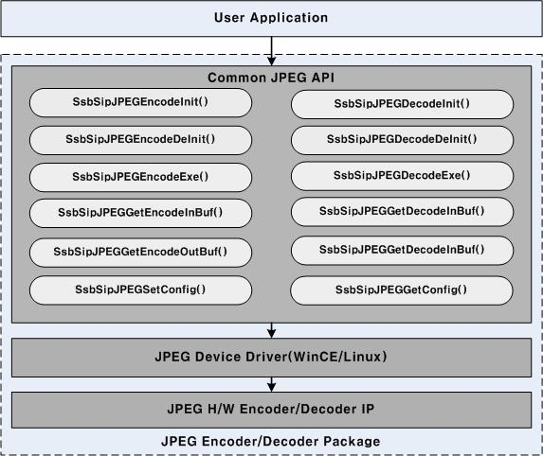

Figure 1. Architecture of JPEG API

  - Features
- Compression/decompression up to UXGA(1600*1200).
- Encoding format: interleaved YCBYCR (input format of JPEG engine).
- Decoding format: YCbCr4:4:4, YCbCr4:2:2, YCbCr4:2:0, YCbCr4:1:1 or Gray.
- Support Exif file and Thumbnail encoding.
- The resolution of thumbnail is up to 320*240.
- Support 4 different image quality levels during encoding.
- Support of direct compression from the camera output.
- Support of compression of memory data in interleaved YCBYCR.

  - Encoding/Decoding Process
Figure 2. shows the process of encoding/decoding. For both encoder and decoder, H/W encoder/decoder engine only support multiple resolution of MCU size. For example, MCU size of YUV420 is 16*16. therefore, if resolution is 200*200, encoding/decoding will fail.

S/W post processor overcome this limitation for decoder. But for encoder, the limitation still exits. Output format of H/W decoder is only interleaved YCBYCR.

For camera, Exif file format is supported in Encoder. But, Exif and thumbnail is S/W. If you want to get better performance. You may disable Exif and thumbnail encoding.

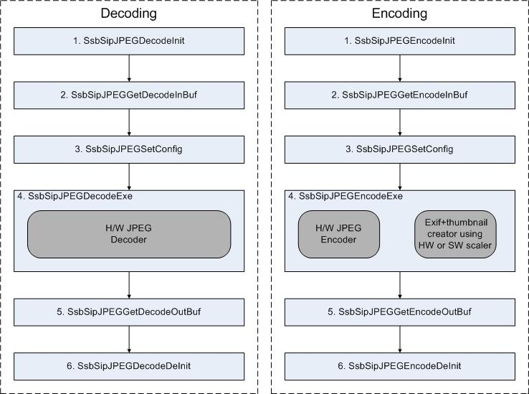
Figure 2. Encoding/Decoding Process

  - Memory Management
Operating system reserve memory to assign JPEG H/W IP.
To increase efficiency of buffer usage, SsbSipJPEGxxxxBuf return the logical address of buffer. The logical address is mapped to pre-assigned JPEG H/W IP buffer. Therefore, we reduced memcpy overhead.

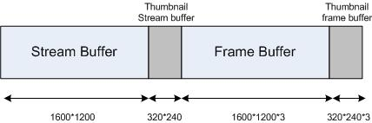
Figure 3. Memory Usage

In figure 3, stream buffer have JPEG file stream. And, Frame buffer have decoded YCBYCR. In the case of encoding, encoding frame(YCBYCR) is put in frame buffer. And, encoded JPEG file is put in stream buffer.

For thumbnail decoding, we assigned thumbnail stream/frame buffer. After encoding frame(YCBYCR) is put frame buffer. It is resized to thumbnail frame buffer with thumbnail resolution. Resized frame is finally encoded to thumbnail stream buffer.

  - How to check the results of decoding

Decoded output format of S3C6400 JPEG H/W Codec is only YUV422. And S3C6400 supports JPEG standard. In standard the size of YUV420 must be multiple of 16x16, the size of YUV422 must be multiple of 16x8, the size of YUV444 must be multiple of 8x8. If input size of JPEG decoder is correct, the output size will be the same of its input. But If the size of input don’t meet the standard, the following process will be done in JPEG driver.

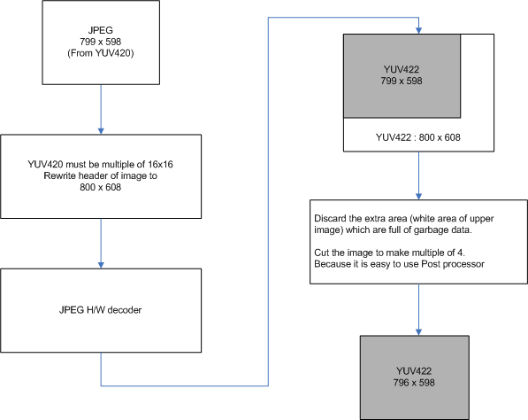
Figure 4. Handling of incorrect input size

In case of 799 x 598(YUV420) input image, the output size of decoding is YUV422 796x598

Data Structure

Exif File Format

ExifFileInfo
UCHAR Make[32] | Manufacturer name
Char Model[32] | Model name
Char Version[32] | Version number
Char DateTime[32] | Date
Char CopyRight[32] | Copy right
UINT Height | Primary image height
UINT Width | Primary image width
UINT Orientation | Direction for display
UINT ColorSpace | Color space of input frame
UINT Process | JPEG process
UINT Flash | Flash on/off
UINT FocalLengthNum | The length of focal length filed
UINT ExposureTimeNum | Exposure time
UINT ExposureTimeDen | Exposure time
UINT FNumberNum
UINT FNumberDen
UINT ApertureFNumber
Int SubjectDistanceNum | Subject distance
Int SubjectDistanceDen | Subject distance
UINT CCDWidth
Int ExposureBiasNum | Exposure bias
Int ExposureBiasDen | Exposure bias
Int WhiteBalance | whitebalnce
UINT MeteringMode | Metering mode
Int ExposureProgram | Exposure Program
UINT ISOSpeedRatings[2] | ISO speed ratings
UINT FocalPlaneXResolutionNum | Focal plane X resolution
UINT FocalPlaneXResolutionDen | Focal plane X resolution
UINT FocalPlaneYResolutionNum | Focal plane Y resolution
UINT FocalPlaneYResolutionDen | Focal plane Y resolution
UINT FocalPlaneResolutionUnit | Focal plane resolution unit
UINT XResolutionNum | X resolution
UINT XResolutionDen | X resolution
UINT YResolutionNum | Y resolution
UINT YResolutionDen | Y resolution
UINT RUnit
INT BrightnessNum | brightness
INT BrightnessDen | brightness
UCHAR UserComments[150] | User comment

API

Initialization

SsbSipJPEGDecodeInit()
Description | This function is  - to initialize codec variables  - to assign memory for JPEG H/W codec register
Syntax | int  SsbSipJPEGDecodeInit (void);
Parameters
Returns | Return handle after JPEG Decoder initialization.

SsbSipJPEGEncodeInit ()
Description | This function is  - to initialize codec variables  - to assign memory for JPEG H/W codec register
Syntax | int  SsbSipJPEGEncodeInit (void);
Parameters
Returns | Return handle after JPEG Encoder initialization.

Decode JPEG

SsbSipJPEGDecodeExe()
Description | This function is  - to decode JPEG file
Syntax | JPEG_ERRORTYPE  SsbSipJPEGDecodeExe (int dev_fd);
Parameters | [IN] dev_fd  Return value from SsbSipJPEGDecodeInit ().
Returns | JPEG_ERRORTYPE returns error code.

Encode JPEG

SsbSipJPEGEncodeExe()
Description | This function is  - to encode JPEG
Syntax | JPEG_ERRORTYPE  SsbSipJPEGEncodeExe (int dev_fd, ExifFileInfo *Exif, JPEG_SCALER scaler);
Parameters | [IN] dev_fd  Return value from SsbSipJPEGEncodeInit ().  [IN] Exif  Exif file Parameters. if It is NULL, Exif file is not included in JPEG file.  [IN] scaler  Both H/W and S/W scalers are supported. If H/W scaler is selected without real H/W post-processor driver, S/W scaler will be used.
Returns | JPEG_ERRORTYPE returns error code.

Memory Access

SsbSipJPEGGetDecodeInBuf ()
Description | This function is  - to get memory address for decoding input buffer
Syntax | Void *  SsbSipJPEGGetDecodeInBuf (int dev_fd, long size);
Parameters | [IN] size  Allocation size(byte)  [IN]dev_fd  Return value from SsbSipJPEGxxxInit ().
Returns | It returns memory address of decoding input buffer.  In H/W codec, physical address of decoding input buffer is statically set during initialization. Size is limited by 1600*1200*3 byte.

SsbSipJPEGGetDecodeOutBuf ()
Description | This function is  - to get memory address for decoding output buffer
Syntax | Void *  SsbSipJPEGGetDecodeOutBuf (int dev_fd, long *size);
Parameters | [IN] size  Allocation size(byte)  [IN]dev_fd  Return value from SsbSipJPEGxxxInit ().
Returns | It returns memory address of Frame buffer.  In H/W codec, physical address of decoding output buffer is statically set during initialization. Size is limited by 1600*1200 byte.

SsbSipJPEGGetEncodeInBuf ()
Description | This function is  - to get memory address for encoding input buffer
Syntax | Void *  SsbSipJPEGGetEncodeInBuf (int dev_fd, long size);
Parameters | [IN] size  Allocation size(byte)  [IN]dev_fd  Return value from SsbSipJPEGxxxInit ().
Returns | It returns memory address of encoding input buffer.  In H/W codec, physical address of encoding input buffer is statically set during initialization. Size is limited by 1600*1200 byte.

SsbSipJPEGGetEncodeOutBuf ()
Description | This function is  - to get memory address for encoding output buffer
Syntax | Void *  SsbSipJPEGGetStreamBuf (int dev_fd, long size);
Parameters | [IN] size  Allocation size(byte)  [IN]dev_fd  Return value from SsbSipJPEGxxxInit ().
Returns | It returns memory address of encoding output m buffer.  In H/W codec, physical address of encoding output buffer is statically set during initialization. Size is limited by 1600*1200*3 byte.

Configuration

SsbSipJPEGSetConfig ()
Description | This function is  - to set codec variables
Syntax | JPEG_ERRORTYPE  SsbSipJPEGSetConfig (JPEGConf type, INT32 value);
Parameters | [IN] type  Configuration type defined 5. Definition and Error codes  [IN] value  Configuration value.
Returns | JPEG_ERRORTYPE returns error code.

SsbSipJPEGGetConfig ()
Description | This function is  - to get codec variables
Syntax | JPEG_ERRORTYPE  SsbSipJPEGGetConfig (JPEGConf type, INT32 *value);
Parameters | [IN] type  Configuration type defined 5. Definition and Error codes  [OUT] value  Configuration value
Returns | JPEG_ERRORTYPE returns error code.

Finalization

SsbSipJPEGDecodeDeInit ()
Description | This function is  - to release codec resources
Syntax | JPEG_ERRORTYPE  SsbSipJPEGDecodeDeInit (int dev_fd);
Parameters | [IN] dev_fd  Return value after JPEG initialization.
Returns | JPEG_ERRORTYPE returns error code.

SsbSipJPEGEncodeDeInit ()
Description | This function is  - to release codec resources
Syntax | JPEG_ERRORTYPE  SsbSipJPEGEncodeDeInit (int dev_fd);
Parameters | [IN] dev_fd  Return value after JPEG initialization.
Returns | JPEG_ERRORTYPE returns error code.

Definition and Error Codes

Configuration

Definition | Description
JPEG_GET_DECODE_WIDTH | To get width of JPEG file.
JPEG_GET_DECODE_HEIGHT | To get height of JPEG file.
JPEG_GET_SAMPING_MODE | To get sampling mode of JPEG file.
JPEG_SET_ENCODE_WIDTH | To set width of JPEG file for encoding.
JPEG_SET_ENCODE_HEIGHT | To set height of JPEG file for encoding.
JPEG_SET_ENCODE_QUALITY | To set image quality level.
JPEG_SET_SAMPING_MODE | To set sampling mode for encoding
JPEG_SET_ENCODE_THUMBNAIL | To encode thumbnail picture when encoding.
JPEG_SET _THUMBNAIL_WIDTH | To set width of thumbnail picture
JPEG_SET _THUMBNAIL_HEIGHT | To set height of thumbnail picture

Sampling mode

Name | Description
JPG_444 | YUV444
JPG_422 | YUV422
JPG_420 | YUV420
JPG_411 | YUV411
JPG_400 | YUV400
JPG_UNKNOWN | Unknown type

Image Quality

Name | Description
JPG_QUALITY_LEVEL_1 | Compression ratio is about 30%
JPG_QUALITY_LEVEL_2 | Compression ratio is about 24%
JPG_QUALITY_LEVEL_3 | Compression ratio is about 20%
JPG_QUALITY_LEVEL_4 | Compression ratio is about 14%

Scaler Selection

Name | Description
JPEG_USE_HW_SCALER | Select H/W sclaer
JPEG_USE_SW_SCALER | Select S/W scaler

Error Codes

Name | Description
JPEG_FAIL | General failure
JPEG_OK | General success
JPEG_ENCODE_FAIL | Encoding failure
JPEG_ENCODE_OK | Encoding success
JPEG_DECODE_FAIL | Decoding failure
JPEG_DECODE_OK | Decoding success
JPEG_HEADER_PARSE_FAIL | Header parse error during decoding
JPEG_HEADER_PARSE_OK | Successful header paring during decoding

Test Parameters

Decoder
- input
  - input file: JPEG format. For example, input.jpg
- output
  - output file: YCBYCR format. For example output.yuv
  - width : width of jpg file. use JPEG_GET_DECODE_WIDTH
  - height : height of jpg file. use JPEG_GET_DECODE_HEIGHT
  - sampling mode : sampling mode of jpg file. use JPEG_GET_SAMPLING_MODE

Encoder
- input
  - input file : YCBYCR format. For example input.yuv
  - Width : width of YUV. Use JPEG_SET_ENCODE_WIDTH.
  - height : height of YUV. Use JPEG_SET_ENCODE_HEIGHT.
  - sampling mode : sampling mode of jpg file. Use JPEG_SET_SAMPLING_MODE
  - image quality : image quality of jpg file. Use JPEG_SET_ENCODE_QUALITY
  - thumbnail flag : whether thumbnail is included or not. Use JPEG_SET_ENCODE_THUMBNAIL
  - thumbnail width: width of thumbnail. Use JPEG_SET _THUMBNAIL_WIDTH
  - thumbnail height: height of thumbnail. Use JPEG_SET _THUMBNAIL_HEIGHT
  - Exif info: Exif information. Pass parameters via SsbSipJPEGEncodeExe()
- output
  - output file: JPEG format. For example, output.jpg

Annex A (JPEG Decoder Usage)
This is an example program to give information how to use API.
We will not accept responsibility for any errors about example program.

void TestDecoder()
{
char *InBuf = NULL;
char *OutBuf = NULL;
FILE *fp;
FILE *CTRfp;
UINT32 fileSize;
long streamSize;
int handle;
INT32 width, height, samplemode;
JPEG_ERRORTYPE ret;
char outFilename[128];
char inFilename[128];
BOOL result = TRUE;
#ifdef FPS
struct timeval start;
struct timeval stop;
unsigned int time = 0;
#endif

printf("------------------------Decoder Test Start ---------------------\n");

//////////////////////////////////////////////////////////////
// 0. Get input/output file name //
//////////////////////////////////////////////////////////////
CTRfp = fopen(CTRL_FILE_NAME, "rb");
if(CTRfp == NULL){
printf("file open error : %s\n", CTRL_FILE_NAME);
return;
}

do{
memset(outFilename, 0x00, sizeof(outFilename));
memset(inFilename, 0x00, sizeof(inFilename));

fscanf(CTRfp, "%s", inFilename);

if(inFilename[0] == '#'){
printf("------------------------Decoder Test Done ---------------------\n");
fclose(CTRfp);
return;
}

fscanf(CTRfp, "%s", outFilename);

if(inFilename == NULL || outFilename == NULL){
printf("read file error\n");
printf("------------------------Decoder Test Done ---------------------\n");
fclose(CTRfp);
return;
}

printf("inFilename : %s \noutFilename : %s\n", inFilename, outFilename);
//////////////////////////////////////////////////////////////
// 1. handle Init //
//////////////////////////////////////////////////////////////
#ifdef FPS
gettimeofday(&start, NULL);
#endif

handle = SsbSipJPEGDecodeInit();
if(handle < 0)
break;

#ifdef FPS
gettimeofday(&stop, NULL);
time += measureTime(&start, &stop);
#endif

//////////////////////////////////////////////////////////////
// 2. open JPEG file to decode //
//////////////////////////////////////////////////////////////
fp = fopen(inFilename, "rb");
if(fp == NULL){
result = FALSE;
printf("file open error : %s\n", inFilename);
break;
}
fseek(fp, 0, SEEK_END);
fileSize = ftell(fp);
fseek(fp, 0, SEEK_SET);

printD("filesize : %d\n", fileSize);

//////////////////////////////////////////////////////////////
// 3. get Input buffer address //
//////////////////////////////////////////////////////////////
InBuf = SsbSipJPEGGetDecodeInBuf(handle, fileSize);
if(InBuf == NULL){
printf("Input buffer is NULL\n");
result = FALSE;
break;
}
printD("inBuf : 0x%x\n", InBuf);

//////////////////////////////////////////////////////////////
// 4. put JPEG frame to Input buffer //
//////////////////////////////////////////////////////////////
fread(InBuf, 1, fileSize, fp);
fclose(fp);

//////////////////////////////////////////////////////////////
// 5. Decode JPEG frame //
//////////////////////////////////////////////////////////////
#ifdef FPS
gettimeofday(&start, NULL);
#endif

ret = SsbSipJPEGDecodeExe(handle);

#ifdef FPS
gettimeofday(&stop, NULL);
time += measureTime(&start, &stop);
printf("[JPEG Decoding Performance] Elapsed time : %u\n", time);
time = 0;
#endif

if(ret != JPEG_OK){
printf("Decoding failed\n");
result = FALSE;
break;
}

//////////////////////////////////////////////////////////////
// 6. get Output buffer address //
//////////////////////////////////////////////////////////////
OutBuf = SsbSipJPEGGetDecodeOutBuf(handle, &streamSize);
if(OutBuf == NULL){
printf("Output buffer is NULL\n");
result = FALSE;
break;
}
printD("OutBuf : 0x%x streamsize : %d\n", OutBuf, streamSize);

//////////////////////////////////////////////////////////////
// 7. get decode config. //
//////////////////////////////////////////////////////////////
SsbSipJPEGGetConfig(JPEG_GET_DECODE_WIDTH, &width);
SsbSipJPEGGetConfig(JPEG_GET_DECODE_HEIGHT, &height);
SsbSipJPEGGetConfig(JPEG_GET_SAMPING_MODE, &samplemode);

printD("width : %d height : %d samplemode : %d\n", width, height, samplemode);

//////////////////////////////////////////////////////////////
// 8. wirte output file & dispaly to LCD //
//////////////////////////////////////////////////////////////
#if (TEST_DECODE_OUTPUT_YCBYCR == 1)
DecodeFileOutYCBYCR(OutBuf, streamSize, outFilename); // YCBYCR interleaved
#elif (TEST_DECODE_OUTPUT_YUV422 == 1)
DecodeFileOutYUV422(OutBuf, streamSize, outFilename); // yuv422 non-interleaved
#endif

//////////////////////////////////////////////////////////////
// 9. finalize handle //
//////////////////////////////////////////////////////////////
SsbSipJPEGDecodeDeInit(handle);
sleep(1);
}while(1);

if(result == FALSE){
SsbSipJPEGDecodeDeInit(handle);
}

fclose(CTRfp);
printf("------------------------Decoder Test Done ---------------------\n");
}

Annex B (JPEG Encoder Usage)

void TestEncoder()
{
char *InBuf = NULL;
char *OutBuf = NULL;
FILE *fp;
FILE *CTRfp;
JPEG_ERRORTYPE ret;
UINT32 fileSize;
long frameSize;
int handle;
ExifFileInfo ExifInfo;
char outFilename[128];
char inFilename[128];
char widthstr[8], heightstr[8];
INT32 width, height;
BOOL result = TRUE;
#ifdef FPS
struct timeval start;
struct timeval stop;
unsigned int time = 0;
#endif

printf("------------------------Encoder Test Start---------------------\n");
//////////////////////////////////////////////////////////////
// 0. Get input/output file name //
//////////////////////////////////////////////////////////////
CTRfp = fopen(CTRL_FILE_NAME, "rb");
if(CTRfp == NULL){
printf("file open error : %s\n", CTRL_FILE_NAME);
return;
}

do{
memset(outFilename, 0x00, sizeof(outFilename));
memset(inFilename, 0x00, sizeof(inFilename));
memset(widthstr, 0x00, sizeof(widthstr));
memset(heightstr, 0x00, sizeof(heightstr));

fscanf(CTRfp, "%s", inFilename);
if(inFilename[0] == '#'){
printf("------------------------Encoder Test Done---------------------\n");
fclose(CTRfp);
return;
}

fscanf(CTRfp, "%s", outFilename);
fscanf(CTRfp, "%s", widthstr);
fscanf(CTRfp, "%s", heightstr);
width = (INT32)atoi(widthstr);
height = (INT32)atoi(heightstr);

if(inFilename == NULL || outFilename == NULL){
printf("read file error\n");
printf("------------------------Encoder Test Done---------------------\n");
fclose(CTRfp);
return;
}

printf("inFilename : %s \noutFilename : %s width : %d height : %d\n",
inFilename, outFilename, width, height);
//////////////////////////////////////////////////////////////
// 1. handle Init //
//////////////////////////////////////////////////////////////
#ifdef FPS
gettimeofday(&start, NULL);
#endif

handle = SsbSipJPEGEncodeInit();

#ifdef FPS
gettimeofday(&stop, NULL);
time += measureTime(&start, &stop);
#endif

if(handle < 0)
break;

//////////////////////////////////////////////////////////////
// 2. set decode config. //
//////////////////////////////////////////////////////////////
if((ret = SsbSipJPEGSetConfig(JPEG_SET_SAMPING_MODE, JPG_422)) != JPEG_OK){
result = FALSE;
break;
}
if((ret = SsbSipJPEGSetConfig(JPEG_SET_ENCODE_WIDTH, width)) != JPEG_OK){
result = FALSE;
break;
}
if((ret = SsbSipJPEGSetConfig(JPEG_SET_ENCODE_HEIGHT, height)) != JPEG_OK){
result = FALSE;
break;
}
if((ret = SsbSipJPEGSetConfig(JPEG_SET_ENCODE_QUALITY, JPG_QUALITY_LEVEL_2)) != JPEG_OK){
result = FALSE;
break;
}
#if (TEST_ENCODE_WITH_THUMBNAIL == 1)
if((ret = SsbSipJPEGSetConfig(JPEG_SET_ENCODE_THUMBNAIL, TRUE)) != JPEG_OK){
result = FALSE;
break;
}
if((ret = SsbSipJPEGSetConfig(JPEG_SET_THUMBNAIL_WIDTH, 160)) != JPEG_OK){
result = FALSE;
break;
}
if((ret = SsbSipJPEGSetConfig(JPEG_SET_THUMBNAIL_HEIGHT, 120)) != JPEG_OK){
result = FALSE;
break;
}
#endif

//////////////////////////////////////////////////////////////
// 3. open JPEG file to decode //
//////////////////////////////////////////////////////////////
fp = fopen(inFilename, "rb");
if(fp == NULL){
printf("file open error : %s\n", inFilename);
result = FALSE;
break;
}
fseek(fp, 0, SEEK_END);
fileSize = ftell(fp);
fseek(fp, 0, SEEK_SET);

//////////////////////////////////////////////////////////////
// 4. get Input buffer address //
//////////////////////////////////////////////////////////////
printD("filesize : %d\n", fileSize);
InBuf = SsbSipJPEGGetEncodeInBuf(handle, fileSize);
if(InBuf == NULL){
result = FALSE;
break;
}
printD("inBuf : 0x%x\n", InBuf);

//////////////////////////////////////////////////////////////
// 5. put YUV stream to Input buffer //
//////////////////////////////////////////////////////////////
fread(InBuf, 1, fileSize, fp);
fclose(fp);

//////////////////////////////////////////////////////////////
// 6. Make Exif info parameters //
//////////////////////////////////////////////////////////////
memset(&ExifInfo, 0x00, sizeof(ExifFileInfo));
makeExifParam(&ExifInfo);

//////////////////////////////////////////////////////////////
// 7. Encode YUV stream //
//////////////////////////////////////////////////////////////
#ifdef FPS
gettimeofday(&start, NULL);
#endif

#if (TEST_ENCODE_WITH_EXIF == 1)
ret = SsbSipJPEGEncodeExe(handle, &ExifInfo, JPEG_USE_SW_SCALER); //with Exif
#else
ret = SsbSipJPEGEncodeExe(handle, NULL, 0); //No Exif
#endif

#ifdef FPS
gettimeofday(&stop, NULL);
time += measureTime(&start, &stop);
printf("[JPEG Encoding Performance] Elapsed time : %u\n", time);
time = 0;
#endif

if(ret != JPEG_OK){
result = FALSE;
break;
}

//////////////////////////////////////////////////////////////
// 8. get output buffer address //
//////////////////////////////////////////////////////////////
OutBuf = SsbSipJPEGGetEncodeOutBuf(handle, &frameSize);
if(OutBuf == NULL){
result = FALSE;
break;
}

printD("OutBuf : 0x%x freamsize : %d\n", OutBuf, frameSize);

//////////////////////////////////////////////////////////////
// 9. write JPEG result file //
//////////////////////////////////////////////////////////////

fp = fopen(outFilename, "wb");
if(fp == NULL) {
printf("output file open error\n");
break;
}

fwrite(OutBuf, 1, frameSize, fp);
fclose(fp);

//////////////////////////////////////////////////////////////
// 10. finalize handle //
//////////////////////////////////////////////////////////////
SsbSipJPEGEncodeDeInit(handle);

sleep(1);
}while(1);

if(result == FALSE){
SsbSipJPEGEncodeDeInit(handle);
}
fclose(CTRfp);
printf("------------------------Encoder Test Done---------------------\n");
}

