Installation Manual
For Post processor

S3C6400/6410
August 29, 2008
(Preliminary) REV 2.10
본 ‘고객 배포 기술문서’ Head 부문 MS Word Format은 일반적인 문서작성을
위하여 서식, 스타일 등 MS Word의 고유 자동생성 기능들을 상당수 제외하고
제작되어졌음.
따라서 전문 Technical Writer 및 다수 page로 구성되는 문서의 경우는 본
Reference용 Format과 (Visual상) 동일한 형태라면 서식, 스타일 등의
자동 생성기능의 사용 및 기타 Tool(단, Global하게 사용이 가능한
Adobe Frame maker 등)의 사용이 가능함
* 글자 서식은 기본 Arial체, 본문 글자 크기 ‘10’폰트를 기준 Reference로 함
Important Notice

The information in this publication has been carefully checked and is believed to be entirely accurate at the time of publication. Samsung assumes no responsibility, however, for possible errors or omissions, or for any consequences resulting from the use of the information contained herein.
Samsung reserves the right to make changes in its products or product specifications with the intent to improve function or design at any time and without notice and is not required to update this documentation to reflect such changes.
This publication does not convey to a purchaser of semiconductor devices described herein any license under the patent rights of Samsung or others.
Samsung makes no warranty, representation, or guarantee regarding the suitability of its products for any particular purpose, nor does Samsung assume any liability arising out of the application or use of any product or circuit and specifically disclaims any and all liability, including without limitation any consequential or incidental damages.
"Typical" parameters can and do vary in different applications. All operating parameters, including "Typicals" must be validated for each customer application by the customer's technical experts.
Samsung products are not designed, intended, or authorized for use as components in systems intended for surgical implant into the body, for other applications intended to support or sustain life, or for any other application in which the failure of the Samsung product could create a situation where personal injury or death may occur.
Should the Buyer purchase or use a Samsung product for any such unintended or unauthorized application, the Buyer shall indemnify and hold Samsung and its officers, employees, subsidiaries, affiliates, and distributors harmless against all claims, costs, damages, expenses, and reasonable attorney fees arising out of, either directly or indirectly, any claim of personal injury or death that may be associated with such unintended or unauthorized use, even if such claim alleges that Samsung was negligent regarding the design or manufacture of said product

S3C6400/6410 RISC Microprocessor
Installation Manual for Post Processor
Copyright © 2008 Samsung Electronics Co.,Ltd.
All rights reserved. No part of this publication may be reproduced, stored in a retrieval system, or transmitted in any form or by any means, electric or mechanical, by photocopying, recording, or otherwise, without the prior written consent of Samsung Electronics Co.,Ltd.
Samsung Electronics Co., Ltd.
San #24 Nongseo-Dong, Giheung-Gu
Yongin-City Gyeonggi-Do, Korea
446-711

Home Page: http://www.samsungsemi.com/
E-Mail: mobilesol.cs@samsung.com

Printed in the Republic of Korea

Revision History
Revision | Description of Change | Refer to | Author(s) | Date
1.00 | - Master Copy | - | Jiun Yu | 2007-06-21
1.10 | - Updated |  | Jiun Yu | 2007-09-21
1.20 | - Test application is changed |  | Jiun Yu | 2007-10-29
1.21 | - Compiled as toolchain 4.2.2-eabi |  | Jiun Yu | 2008-01-17
2.00 | - Supporting Post processor driver on S3C6410 |  | Jiun Yu | 2008-07-05
2.10 | - Tested on linux kernel 2.6.24 |  | Jiun Yu | 2008-08-29

Contents
1 Introduction 6
1.1 Overview 6
1.2 FEATURES 6
2 Setup Post Processor Driver 7
2.1 Kernel Setup for S3C6400/6410 Post Processor 7
3 Test Post Processor Driver 10
3.1 Device node 10
3.2 Test application 10
3.3 Test of the Post Processor 11

Figures
FIGURE 1. Setup reserved memory 7
FIGURE 2. Makefile of Post processor 8
FIGURE 3. The post processor module compilation 8
FIGURE 4. Insert the module into the kernel 9
FIGURE 5. Post Processor device node 10
FIGURE 6. Usage of the Post Processor 10
FIGURE 7. Execute the Post Processor test application 11

Introduction
In this Chapter, you will understand the following:
- Section 1.1, “Overview”
- Section 1.2, “Features”
  - Overview
Post processor performs video/graphic scale, video format conversion and color space conversion.

  - FEATURES
The features of the Post Processor:
- AMBA AHB V2.0 compatible interface
- Dedicated DMA with offset address
- 3 channel scaling pipelines for video/graphic scaling up/down or zooming in/out
- Video input format: 420, 422 format
- Graphic input format: 16-bit(565 format) or 24-bit
- Graphics output format to memory: 16-bit(565 format) / 24-bit graphic data(progressive only)
- Video output format to memory: YCBCR420, YCBCR422
- Output format to external FIFO: YCBCR444 / RGB(30-bit) for interlace and progressive
- Free run mode operation
- Programmable source and destination image size up to 2048 x 2048 resolution
- Programmable scaling ratio
- Format conversion for video signals
- Color space conversion from YCBCR to RGB
- Color space conversion from RGB to YCBCR
- Maximum burst length is increased to 16 for DMA
- Separate processing clock with AHB interface clock
- This block cannot be the default master

Setup Post Processor Driver
In this Chapter, you will understand the following:
- Setup for S3C6400/6410 Post Processor

  - Kernel Setup for S3C6400/6410 Post Processor
Please follow the procedure given bellow to complete the test procedure for S3C6400/6410.
Post processor driver is made as module type. So it is compiled independently.

First, before compiling the kernel, please modify “reserved_mem.h” header file in kernel
The path of “reserved_mem.h” file is :
- s3c-linux-2.6.16/include/asm-arm/arch-s3c64xx/
- s3c-linux-2.6.21/include/asm-arm/arch-s3c2410/
Please modify like below.
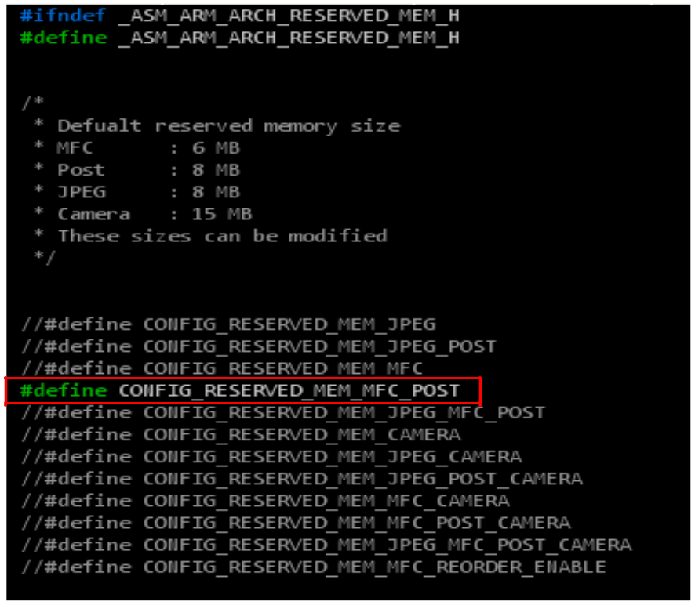
FIGURE 1. Setup reserved memory

NOTE: for detailed information about how to build Linux Kernel and how to download kernel image and cramfs, please refer to related porting guide documents.

Second, please compile the post processor module as shown below. (At Host Side)
Before compiling the post processor driver module, please modify “Makefile”. kernel directory should be modified in “Makefile” like below.
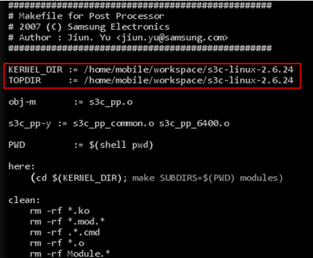
FIGURE 2. Makefile of Post processor

s3c_pp.ko file is module object.
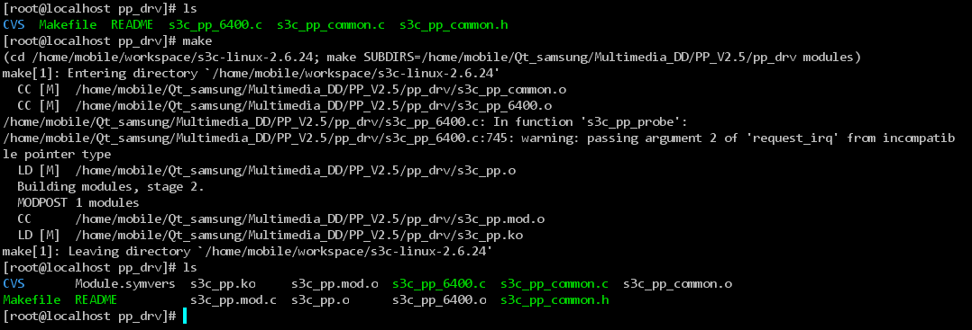
FIGURE 3. The post processor module compilation

Third, please do the following(At target Side). Insmod command must be used at target side.
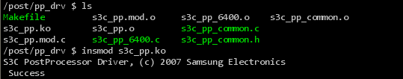
FIGURE 4. Insert the module into the kernel

Now, kernel setup for S3C6400/6410 post processor is finished.

Test Post Processor Driver
In this Chapter, you will understand the following:
- Test Procedure for S3C6400/6410 Post Processor

  - Device node
Post Processor driver’s node name is “s3c-pp”.
Major number is 10.
Minor number is 253.
If your filesystem doesn’t have “s3c-pp” nod, please make post processor’s nod using below command
/ $ mknod s3c-pp 10 253

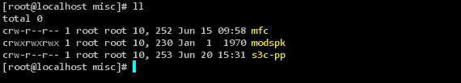
FIGURE 5. Post Processor device node

  - Test application
Usage is like below.
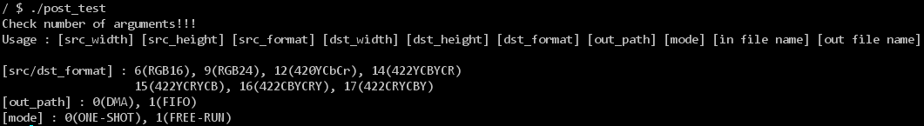
FIGURE 6. Usage of the Post Processor

  - Test of the Post Processor
Execute post processor test application
./post_test 240 320 12 480 640 6 0 0 [input file name] [output file name]
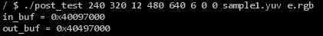
FIGURE 7. Execute the Post Processor test application

