Book of Shadows Documentation

Building
The book of shadows will build against any Qt version of 6.7 or higher. It may buid against an earlier version, but this hasn’t been tested.

Building in Linux
First install Qt 6.7 or greater from your distro’a repositories, as well as the compiler tools and cmake. If Qt 6.7 is unavailable in the repositories, you can get a later version from https://www.qt.io/.
Once these are installed, download the source code from the releases page at https://github.com/RichardGladman/book-of-shadows-qt/releases and run the following commands:
cd bool-of-shadows-qt
mkdir build
cd build
cmake ..
make

And if you want to install globally, run:

sudo make install

Installing on Windows
I’m afraid if you’re installing on Windows, you are mostly on your own. I haven’t used Windows since 2003 when XP came out. And why aren’t you running a version Linux anyway?
You can get the necessary software online.
Qt https:qt.io
Cmake https://cmake.org/download/
GCC Toolchain https://www.mingw-w64.org/
Once you have these installed, you can follow the same steps as in the Linux install.

List View
The list view is the main window of the book of shadows, Each menu entry under Arcana, Corresponders, Spellbook, and notes will have a list view.
From here you can carry out any operation against the data type. The basic operations are searching, viewing, adding, editing, and deleting.

Corresponder View / Add / Edit
These three views all use the same window, for edit and view, the fields are prepopulated and the buttons are adjusted accordingly..
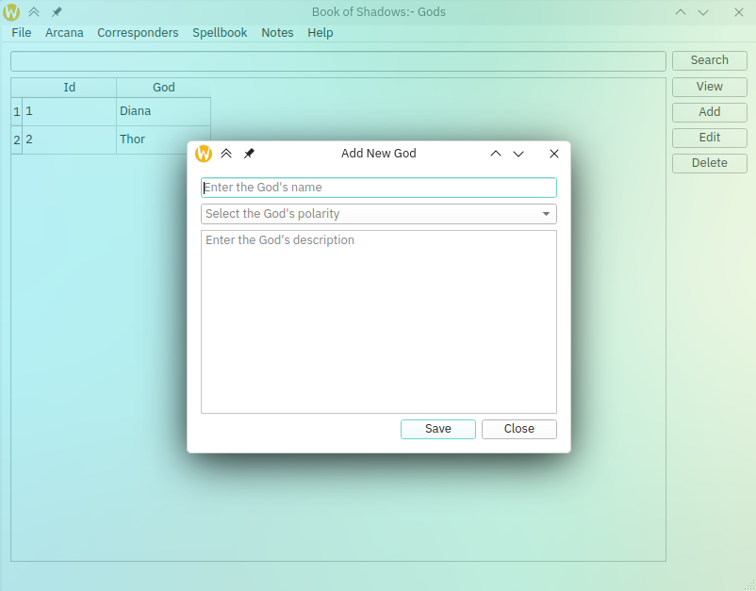

It goes without saying that the save button saves any changes you have made and the close button closes the window without saving your changes. It is worth mentioning that currently there are no warnings.

Arcana Add / Edit / View
These three views use the same layout to work with the specific data. For edit and view, the data is prepopulated and the buttons are adjusted accordingly.
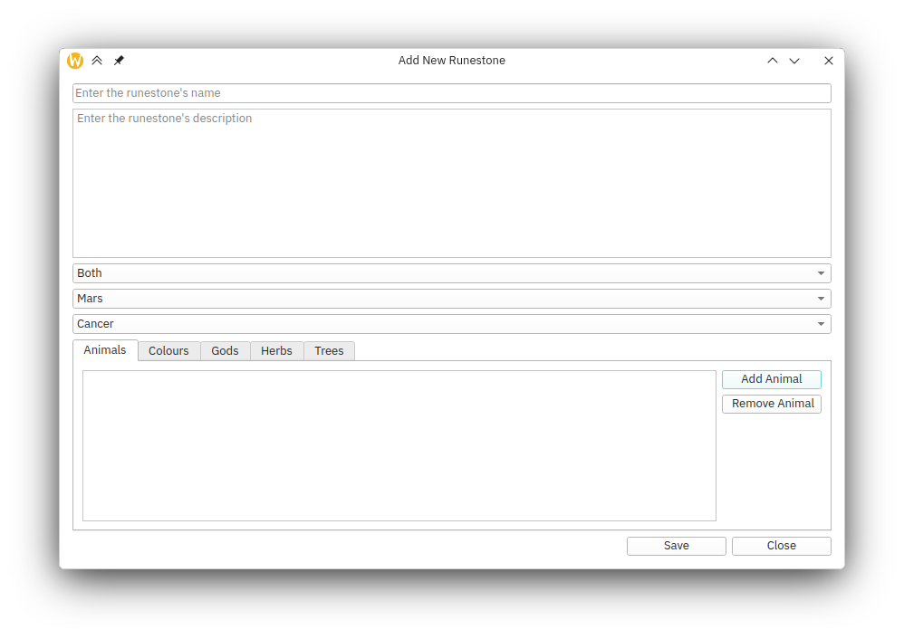
The save and close buttons act as you would expect, except that there is no warning when closing without saving your changes.

Delete view
The delete view is simply a confirmation that you want to carry out this irreversible action.
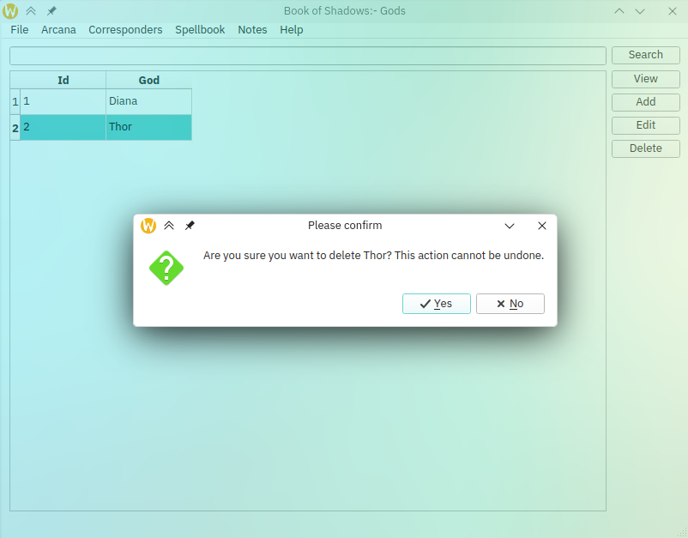

You can choose yes or no depending on your needs.

Spellbook
At the moment, the spellbook only provudes for rune spells.

Add / Edit / View Rune Spell
This window allows you to manage rune spells. You place and drag runes in to an appropriate pattern and fill in the details on the second tab.
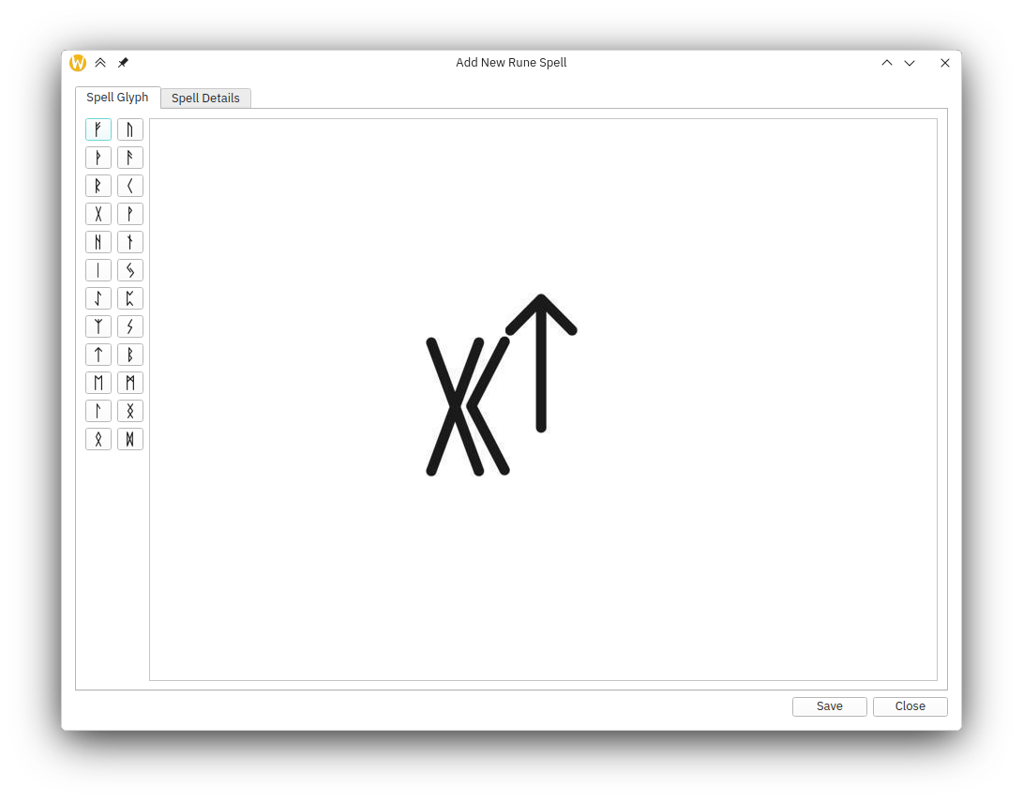
The save and close buttons work as you would expect, excepting that there are no warinins when closing the window without saving.

