CS301 Homework 2: Files Cleaner
A desktop app (Tauri + Rust) that scans a folder, trashes exact duplicates after the user approves a Plan, and can undo any Session. Nothing is permanently deleted.

1. Use Case Diagram
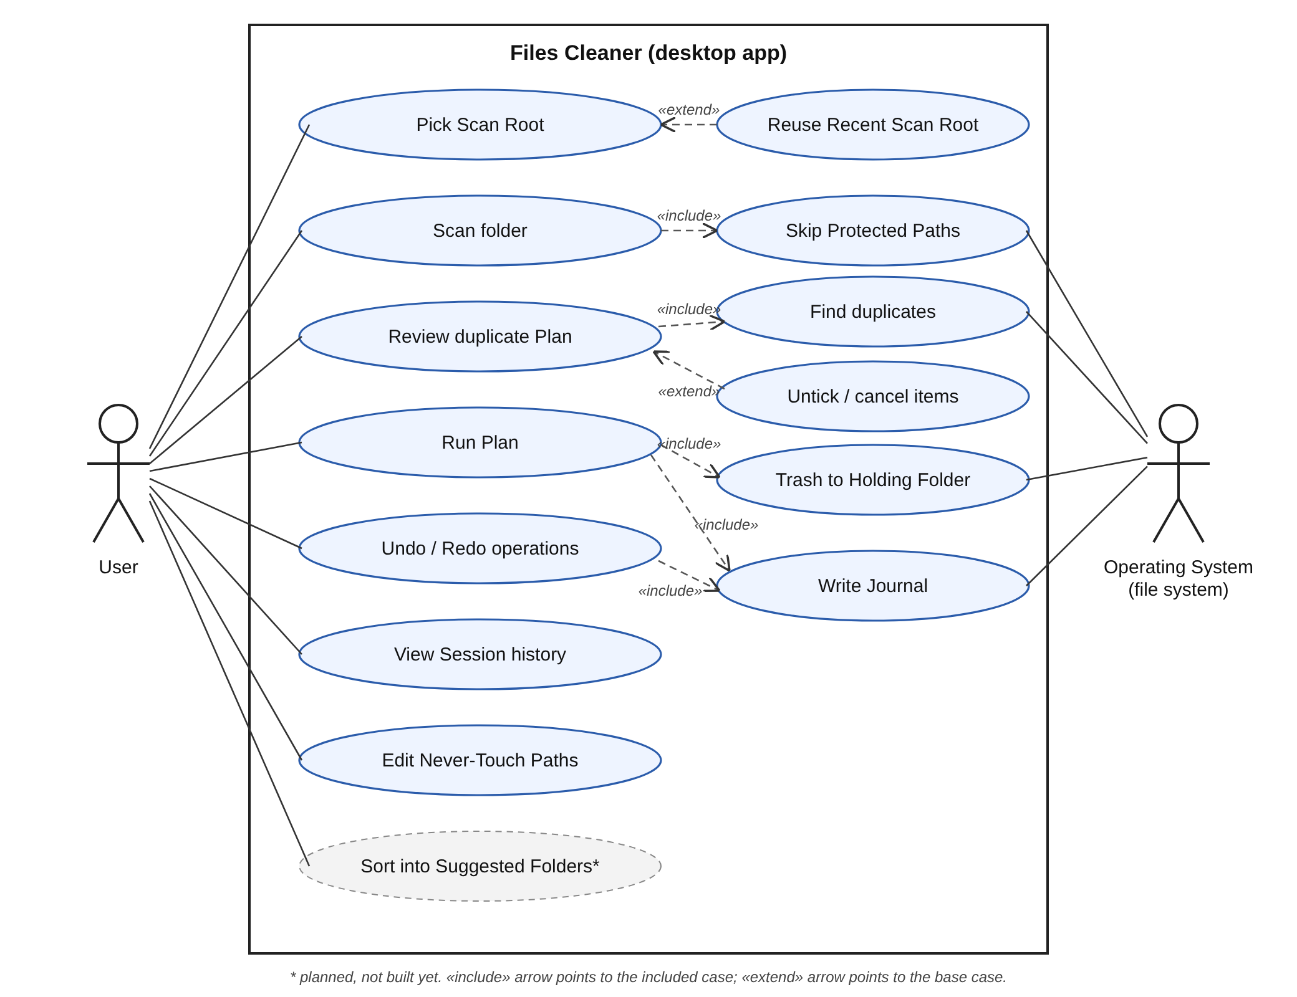
- User: picks a folder, reviews and approves the Plan, undoes or redoes changes, edits Never-Touch Paths.
- Operating System: supplies file metadata and contents, and carries out moves.
- Key rule: every change goes through Review Plan, and Run Plan always writes the Journal first, so Undo is always possible.

2. Data Flow Diagram
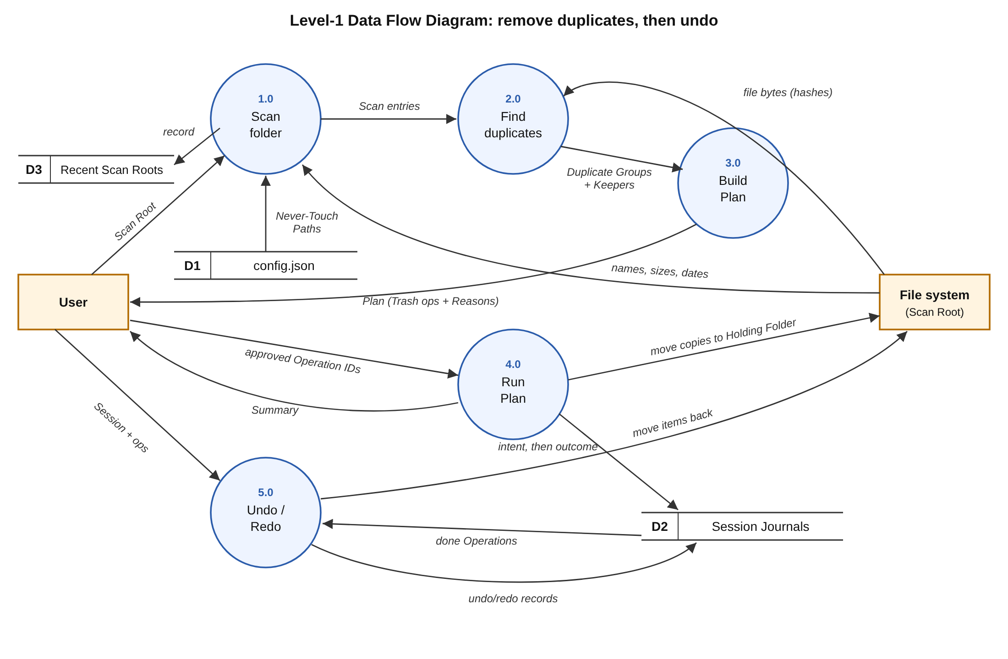
- 1.0 Scan: walks the Scan Root, skips Protected Paths (config.json + built-in OS lists).
- 2.0 Find duplicates: groups files by size, then a partial hash, then a full BLAKE3 hash; the newest copy is the Keeper.
- 3.0 Build Plan: one Trash Operation per extra copy, each with its Reason.
- 4.0 Run Plan: for each approved Operation, writes an intent to the Journal, moves the file to the Holding Folder, then records the outcome.
- 5.0 Undo/Redo: reads the Journal and moves items back (or forward), never overwriting.

3. Software Architecture Sketch
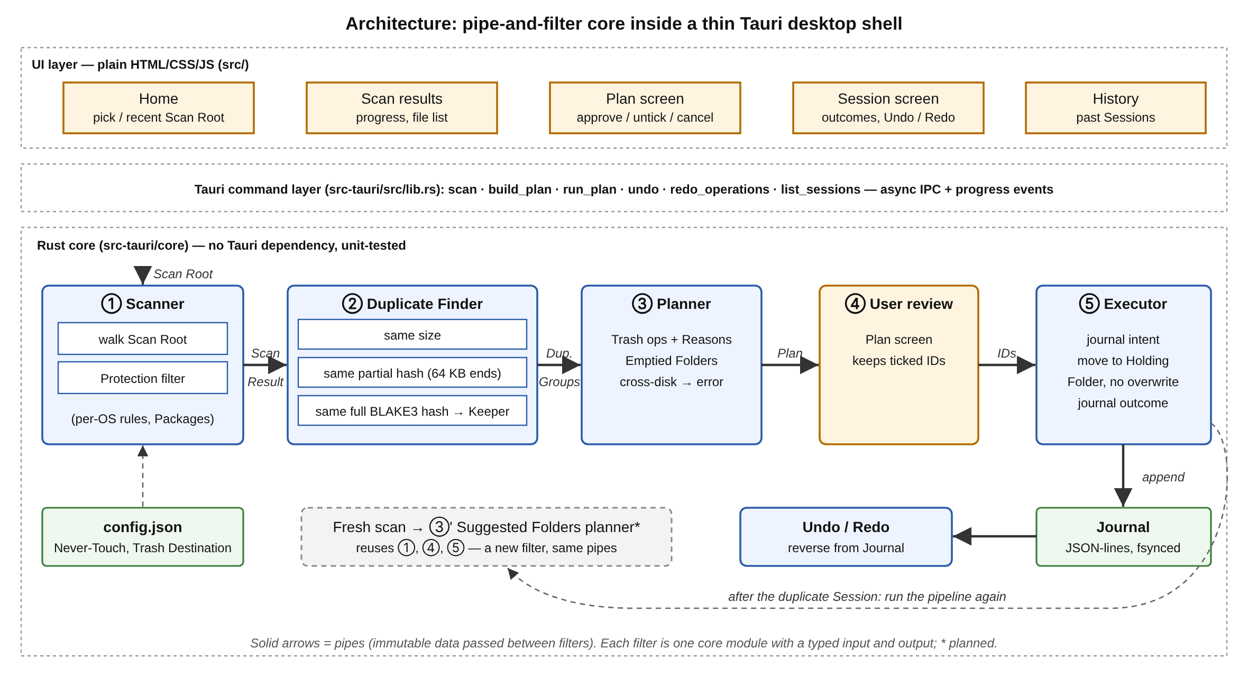
Style: pipe-and-filter, inside a thin layered desktop shell (UI → Tauri commands → Rust core).
Components
- Filters: Scanner → Duplicate Finder → Planner → User review → Executor. Each is one core module (scanner.rs, duplicates.rs, planner.rs, executor.rs).
- Pipes: typed data passed between them: ScanResult, Duplicate Groups, Plan, approved IDs, Summary.
- Stores: config.json (settings) and one JSON-lines Journal per Session.
- Shell: plain HTML/JS screens call the core through Tauri commands.
Why
- Matches the problem: cleaning is a one-way flow that narrows data step by step. Even the Duplicate Finder is a chain of filters (size → partial hash → full hash), so most files are never fully read.
- Easy to extend: Suggested Folders is a new planner filter that reuses the same Scanner, review and Executor.
- Testable: each filter has a clear input and output, and the core has no Tauri dependency, so it is tested with plain cargo test.
- Safe: the Executor is the only filter that touches the disk, and it journals before every move, so any Session can be undone.

