ROAD 2022 dataset
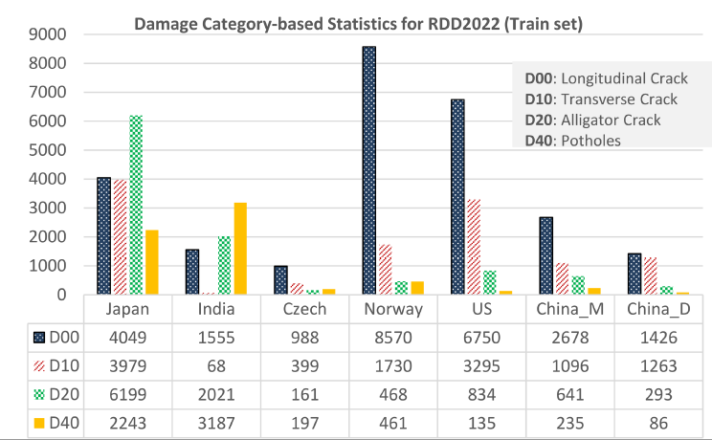

Type | Damage | Description (Chinese) | Description (English)
D00 | Longitudinal Crack (纵向裂缝)
D10 | Transverse Crack (横向裂缝)
D20 | Alligator Crack (网状裂缝/龟裂)
D40 | Potholes (坑槽)

(1) D00 纵向裂缝 (Longitudinal Crack)
简短标签：
- 道路纵向裂缝
- 沿行车方向的裂缝
长句描述：
- 路面上沿车辆行驶方向延伸的细长裂缝，通常出现在轮迹带位置，形态笔直或略弯。
- 裂缝多为线状，顺着道路纵向延展，反映了沥青层沿交通荷载方向的疲劳损伤。
扩展语义（提示性句式）：
- “这是一条沿道路方向延伸的纵向裂缝。”
- “路面表面可见一条或多条与道路轴线平行的开口。”
- “裂缝主要位于轮迹线上，形态狭长且连续。”
- “纵向裂缝一般由温度收缩或基层不均匀沉降引起。”

(2) D10 横向裂缝 (Transverse Crack)
简短标签：
- 道路横向裂缝
- 垂直车行方向的裂缝
长句描述：
- 裂缝方向大致垂直于行车方向，多为单条横断线或间隔分布，通常由温度变化或收缩应力产生。
- 它们切断了路面表层，形成明显的横向缝隙。
扩展语义：
- “在道路上看到一条横跨车行方向的裂缝。”
- “裂缝宽度较均匀，横向贯穿车道。”
- “横向裂缝常见于气温变化较大的地区。”
- “有时多条平行的横向裂缝间距相近。”

(3) D20 网裂 (Alligator Crack / Fatigue Crack)
简短标签：
- 网状裂缝
- 龟裂 / 鳄鱼皮裂缝
长句描述：
- 裂缝呈网状交叉分布，类似龟壳或鳄鱼皮花纹，通常由路面疲劳破坏造成。
- 出现在轮迹带附近，裂缝彼此相连，形成多边形块体。
扩展语义：
- “路面表层出现密集交叉裂缝，形状像龟壳。”
- “多条裂缝互相连接形成网络状结构。”
- “网裂往往预示基层失效或材料疲劳。”
- “严重时会伴随剥落和松散颗粒。”

(4) D40 坑槽 (Pothole)

简短标签：
- 坑洞 / 坑槽
- 路面凹陷破损
长句描述：
- 路面表层材料脱落后形成的明显凹坑，边缘不规则，深度不一，常积水或呈暗色。
- 通常由疲劳破坏、雨水侵蚀或冻融循环导致。
扩展语义：
- “路面上出现明显的坑洞或凹陷区域。”
- “破损区域边缘粗糙，内部较深。”
- “坑洞周围可见松散碎石或剥落。”
- “车辆经过时可能引起颠簸，是严重的路面损坏。”

✅ 综合提示语（可直接用于多模态大模型）
在模型调用阶段，可使用下列组合语句：
- “请识别图像中的道路损伤类型，包括纵向裂缝、横向裂缝、网状裂缝和坑洞。”
- “判断图像中是否存在沿道路方向的纵向裂缝、横向断裂或鳄鱼皮状裂纹。”
- “检测路面表面的破损模式：线状裂缝、交叉裂缝或明显凹坑。”
- “描述道路病害区域的形态特征与分布。”
D00 – Longitudinal Crack
Short Labels
- Longitudinal crack
- Crack parallel to the road direction
Full Descriptions
- A narrow, elongated crack that runs parallel to the direction of traffic.
- Usually appears in the wheel path area and extends along the length of the roadway.
- The crack may be continuous or slightly curved but maintains a longitudinal alignment.
Extended Semantic Sentences
- “A long and thin crack running parallel to the road’s centerline.”
- “A longitudinal opening typically caused by traffic load fatigue or asphalt shrinkage.”
- “This crack follows the wheel track and shows continuous linear separation.”

D10 – Transverse Crack
Short Labels
- Transverse crack
- Crack perpendicular to driving direction
Full Descriptions
- A crack that extends across the lane, roughly perpendicular to the traffic flow.
- Often appears as a single horizontal break or multiple parallel cracks.
- Generally caused by temperature variations, shrinkage, or structural stress.
Extended Semantic Sentences
- “A horizontal crack cutting across the lane.”
- “A clear separation line perpendicular to the road direction.”
- “Temperature-induced cracking across the pavement surface.”

D20 – Alligator Crack (Fatigue Crack)
Short Labels
- Alligator crack
- Fatigue crack
- Block/mesh crack
Full Descriptions
- A group of interconnected cracks forming a mesh or polygonal pattern resembling alligator skin.
- Typically located in wheel paths and indicates severe fatigue failure of the pavement.
- Cracks intersect at multiple points and form irregular blocks of various sizes.
Extended Semantic Sentences
- “A network of small, interconnected cracks similar to alligator skin.”
- “Multiple cracks forming irregular polygons due to fatigue damage.”
- “Dense cracking indicating structural failure of the asphalt layer.”

D40 – Pothole
Short Labels
- Pothole
- Pavement cavity
Full Descriptions
- A bowl-shaped or irregular depression caused by the loss of pavement material.
- The inner surface is darker and rougher, with loose debris or broken asphalt around it.
- Formed by water infiltration, freeze–thaw cycles, or advanced fatigue cracking.
Extended Semantic Sentences
- “A visible hole or depression in the pavement surface.”
- “A rough-edged cavity where asphalt material has broken away.”
- “A deep surface defect that may contain water or loose stones.”

