Ethereum Tutorial

1- Initiation to the Ethereum bases (voir le document prezEthereum.pdf )
2- How to build an Ethereum network
3- Create your own Blockchain Ethereum
4- Code smart-contracts with Solidity
5- TensorFlow.js / Deep Learning and Ethereum

Build a Network-Platform with DApps

2- How to build an Ethereum network

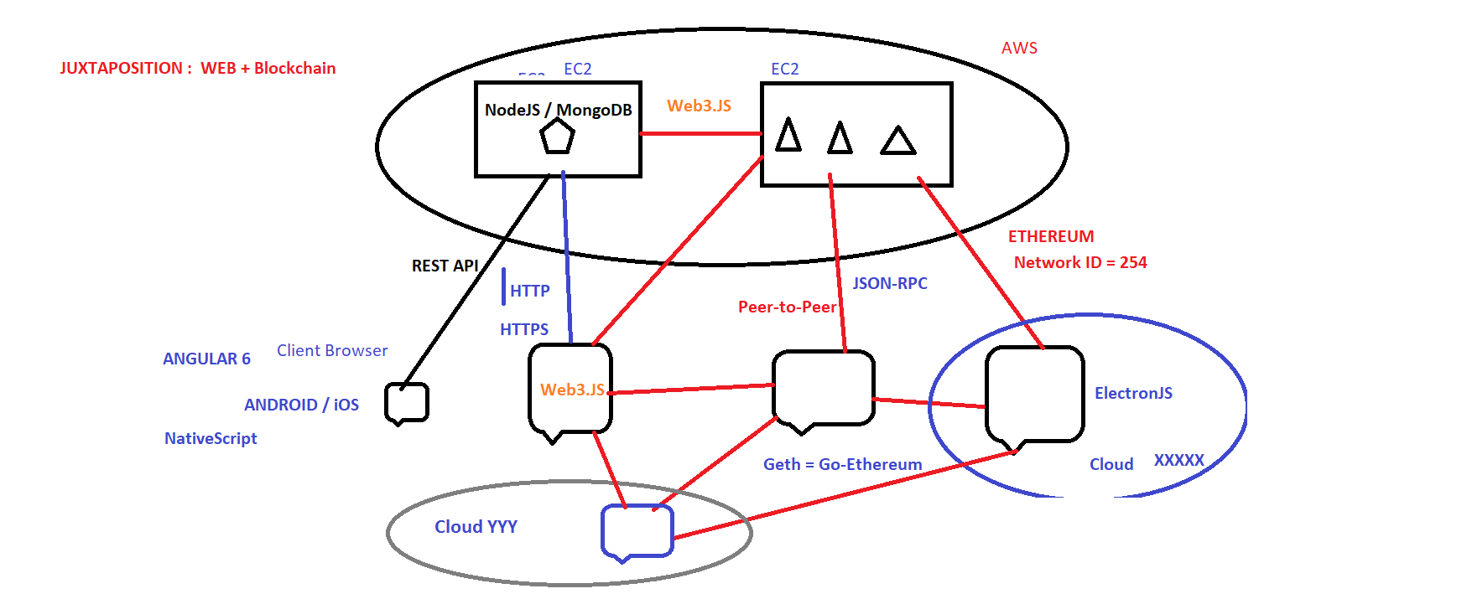

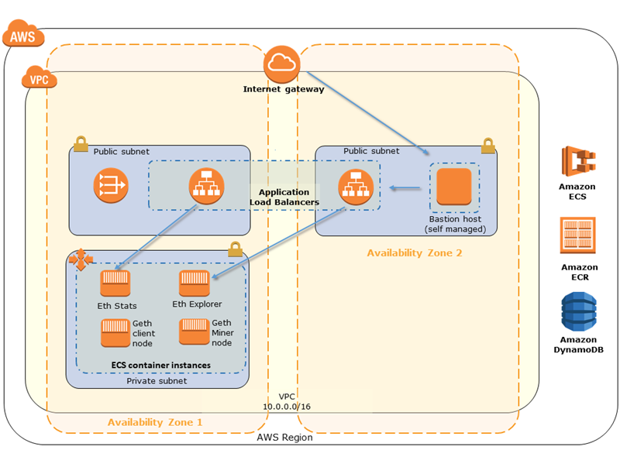

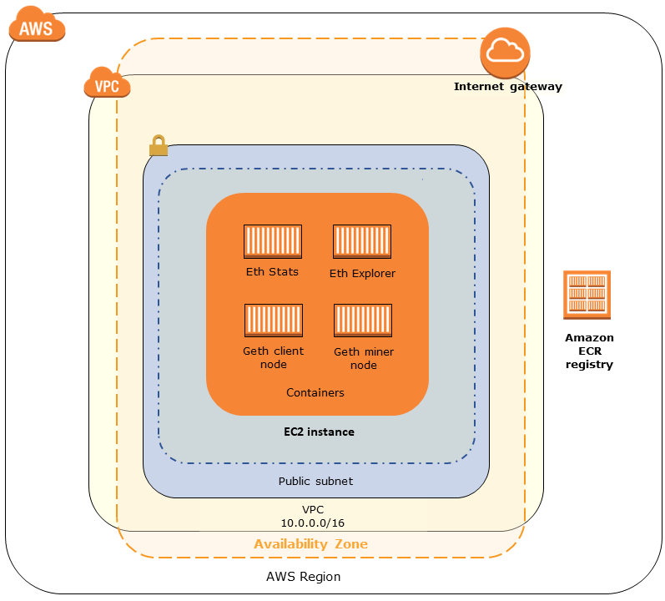

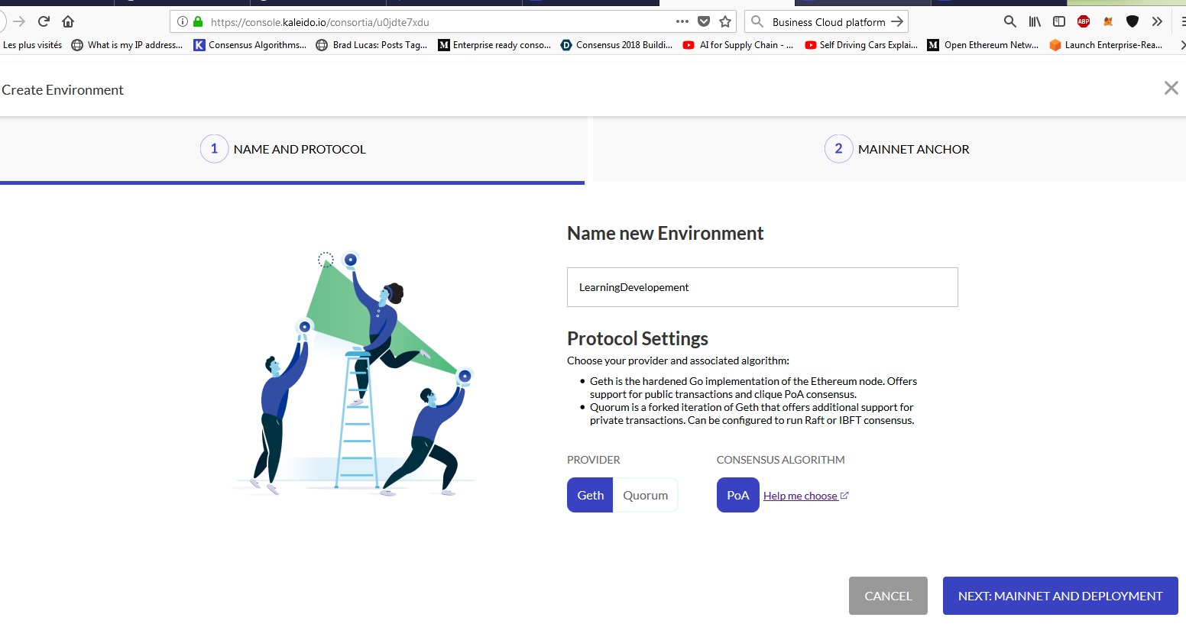

Development Environment

We are going to use : Visual Studio Code, NodeJS, NPM, Angular 6, React, ConsenSys Truffle Suite, Embark by Status.im … etc

0- Install Git, JDK 8 & 10, Visual Studio Code, Rust, GoLang… etc

Geth : Official Go implementation of the Ethereum protocol :
https://github.com/ethereum/go-ethereum

1- Install NodeJS / NPM last version 10.6.0 : https://nodejs.org/en/

Windows OS : npm install -g windows-build-tools

2- Install Truffle Suite : https://truffleframework.com/

3- Install Ganache

4- npm install -g solc : ( v0.4.24 ) : https://solidity.readthedocs.io/en/v0.4.24/

5- Embark by Status : npm install -g embark : https://embark.status.im/

6- Parity : https://www.parity.io/

7- ether-camp/ethereum-harmony : https://github.com/ether-camp/ethereum-harmony

8- MetaMask : https://metamask.io/

> npm install -g webpack webpack-cli

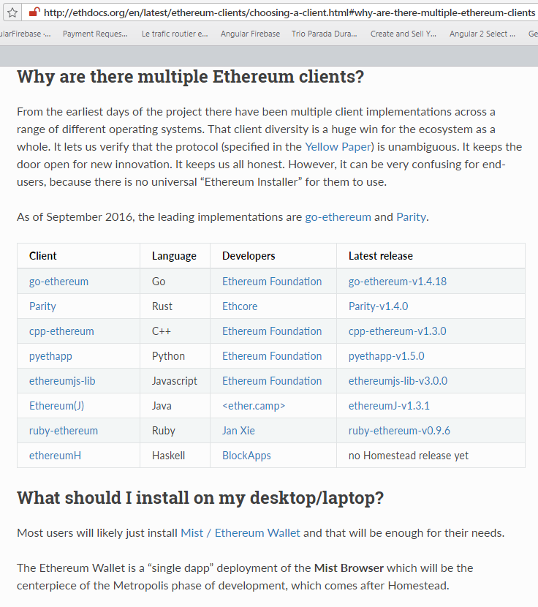

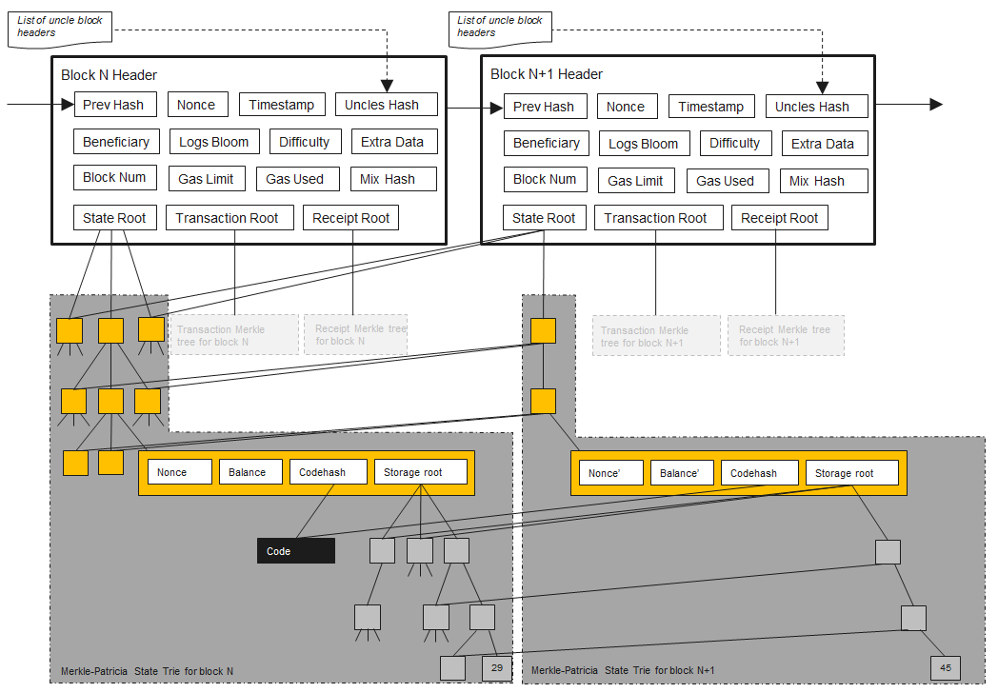

EXO1 - projet1

1- mkdir projet1
2- cd projet1
3- truffle init
4- truffle compile
5- truffle migrate
6- truffle console
7- .exit

File : truffle.js

module.exports = {
// See <http://truffleframework.com/docs/advanced/configuration>
// for more about customizing your Truffle configuration!
networks: {
development: {
host: "127.0.0.1",
port: 7545,
network_id: "*" // Match any network id
}
}
};

File : Election.sol

pragma solidity >0.4.23<0.5.0;

contract Election {

// Read/write candidate
string public candidate;

constructor() public {
candidate = "Candidate 1";
}
}

EXO2 – projet2

1- mkdir projet2
2- cd projet2
3- truffle unbox pet-shop

4- Smart-Contract

File : Election.sol

pragma solidity ^0.4.23;
contract Election {
struct Candidate {
uint id;
string name;
uint voteCount;
}
mapping(uint => Candidate) public candidates;
uint public candidatesCount;
constructor() public {
addCandidate("Candidate 1");
addCandidate("Candidate 2");
}
function addCandidate (string _name) private {
candidatesCount ++;
candidates[candidatesCount] = Candidate(candidatesCount, _name, 0);
}
}

5- truffle migrate --reset

6- truffle console

> Election.deployed().then(function(instance) { app = instance })

> app.candidates(1)
> app.candidates(2)
>.exit

7- Tests :

Create File : test/election.js

We'll write all our tests in Javascript inside this file with the Mocha testing framework and the Chai assertion library. These come bundled with the Truffle framework. We'll write all these tests in Javascript to simulate client-side interaction with our smart contract, much like we did in the console. Here is all the code for the tests:

var Election = artifacts.require("./Election.sol");

contract("Election", function(accounts) {
var electionInstance;

it("initializes with two candidates", function() {
return Election.deployed().then(function(instance) {
return instance.candidatesCount();
}).then(function(count) {
assert.equal(count, 2);
});
});

it("it initializes the candidates with the correct values", function() {
return Election.deployed().then(function(instance) {
electionInstance = instance;
return electionInstance.candidates(1);
}).then(function(candidate) {
assert.equal(candidate[0], 1, "contains the correct id");
assert.equal(candidate[1], "Candidate 1", "contains the correct name");
assert.equal(candidate[2], 0, "contains the correct votes count");
return electionInstance.candidates(2);
}).then(function(candidate) {
assert.equal(candidate[0], 2, "contains the correct id");
assert.equal(candidate[1], "Candidate 2", "contains the correct name");
assert.equal(candidate[2], 0, "contains the correct votes count");
});
});
});

The first test checks that the contract was initialized with the correct number of candidates by checking the candidates count is equal to 2.
The next test inspects the values of each candidate in the election, ensuring that each candidate has the correct id, name, and vote count.

8 - truffle test

Client-Side Application : Front-end Web

"index.html"

<!DOCTYPE html>
<html lang="en">
<head>
<meta charset="utf-8">
<meta http-equiv="X-UA-Compatible" content="IE=edge">
<meta name="viewport" content="width=device-width, initial-scale=1">
<!-- The above 3 meta tags *must* come first in the head; any other head content must come *after* these tags -->
<title>Election Results</title>

<!-- Bootstrap -->
<link href="css/bootstrap.min.css" rel="stylesheet">

<!-- HTML5 shim and Respond.js for IE8 support of HTML5 elements and media queries -->
<!-- WARNING: Respond.js doesn't work if you view the page via file:// -->
<!--[if lt IE 9]>
<script src="https://oss.maxcdn.com/html5shiv/3.7.3/html5shiv.min.js"></script>
<script src="https://oss.maxcdn.com/respond/1.4.2/respond.min.js"></script>
<![endif]-->
</head>
<body>
<div class="container" style="width: 650px;">
<div class="row">
<div class="col-lg-12">
<h1 class="text-center">Election Results</h1>
<hr/>
<br/>
<div id="loader">
<p class="text-center">Loading...</p>
</div>
<div id="content" style="display: none;">
<table class="table">
<thead>
<tr>
<th scope="col">#</th>
<th scope="col">Name</th>
<th scope="col">Votes</th>
</tr>
</thead>
<tbody id="candidatesResults">
</tbody>
</table>
<hr/>
<p id="accountAddress" class="text-center"></p>
</div>
</div>
</div>
</div>

<!-- jQuery (necessary for Bootstrap's JavaScript plugins) -->
<script src="https://ajax.googleapis.com/ajax/libs/jquery/1.12.4/jquery.min.js"></script>
<!-- Include all compiled plugins (below), or include individual files as needed -->
<script src="js/bootstrap.min.js"></script>
<script src="js/web3.min.js"></script>
<script src="js/truffle-contract.js"></script>
<script src="js/app.js"></script>
</body>
</html>

File « app.js »

App = {
web3Provider: null,
contracts: {},
account: '0x0',

init: function() {
return App.initWeb3();
},

initWeb3: function() {
// TODO: refactor conditional
if (typeof web3 !== 'undefined') {
// If a web3 instance is already provided by Meta Mask.
App.web3Provider = web3.currentProvider;
web3 = new Web3(web3.currentProvider);
} else {
// Specify default instance if no web3 instance provided
App.web3Provider = new Web3.providers.HttpProvider('http://localhost:7545');
web3 = new Web3(App.web3Provider);
}
return App.initContract();
},

initContract: function() {
$.getJSON("Election.json", function(election) {
// Instantiate a new truffle contract from the artifact
App.contracts.Election = TruffleContract(election);
// Connect provider to interact with contract
App.contracts.Election.setProvider(App.web3Provider);

return App.render();
});
},

render: function() {
var electionInstance;
var loader = $("#loader");
var content = $("#content");

loader.show();
content.hide();

// Load account data
web3.eth.getCoinbase(function(err, account) {
if (err === null) {
App.account = account;
$("#accountAddress").html("Your Account: " + account);
}
});

// Load contract data
App.contracts.Election.deployed().then(function(instance) {
electionInstance = instance;
return electionInstance.candidatesCount();
}).then(function(candidatesCount) {
var candidatesResults = $("#candidatesResults");
candidatesResults.empty();

for (var i = 1; i <= candidatesCount; i++) {
electionInstance.candidates(i).then(function(candidate) {
var id = candidate[0];
var name = candidate[1];
var voteCount = candidate[2];

// Render candidate Result
var candidateTemplate = "<tr><th>" + id + "</th><td>" + name + "</td><td>" + voteCount + "</td></tr>"
candidatesResults.append(candidateTemplate);
});
}

loader.hide();
content.show();
}).catch(function(error) {
console.warn(error);
});
}
};

$(function() {
$(window).load(function() {
App.init();
});
});

> truffle migrate –reset

> npm run dev

Configuration of MetaMask A) Unlock MetaMask B) custom RPC C)import accounts

EXO3 – projet3

File Election.sol

pragma solidity ^0.4.24;

contract Election {

struct Candidate {
uint id;
string name;
uint voteCount;
}

mapping(address => bool) public voters;

mapping(uint => Candidate) public candidates;

uint public candidatesCount;

function Election () public {
addCandidate("Candidate 1");
addCandidate("Candidate 2");
}

function addCandidate (string _name) private {
candidatesCount ++;
candidates[candidatesCount] = Candidate(candidatesCount, _name, 0);
}

function vote (uint _candidateId) public {
// they haven't voted before
require(!voters[msg.sender]);

// a valid candidate
require(_candidateId > 0 && _candidateId <= candidatesCount);

// record that voter has voted
voters[msg.sender] = true;

// update candidate vote Count
candidates[_candidateId].voteCount ++;
}
}

TESTS

We want to test two things here:

Test that the function increments the vote count for the candidate.
Test that the voter is added to the mapping whenever they vote.

it("allows a voter to cast a vote", function() {
return Election.deployed().then(function(instance) {
electionInstance = instance;
candidateId = 1;
return electionInstance.vote(candidateId, { from: accounts[0] });
}).then(function(receipt) {
return electionInstance.voters(accounts[0]);
}).then(function(voted) {
assert(voted, "the voter was marked as voted");
return electionInstance.candidates(candidateId);
}).then(function(candidate) {
var voteCount = candidate[2];
assert.equal(voteCount, 1, "increments the candidate's vote count");
})
});

Let's write a test to ensure that our vote function throws an exception for double voting:

it("throws an exception for invalid candidates", function() {
return Election.deployed().then(function(instance) {
electionInstance = instance;
return electionInstance.vote(99, { from: accounts[1] })
}).then(assert.fail).catch(function(error) {
assert(error.message.indexOf('revert') >= 0, "error message must contain revert");
return electionInstance.candidates(1);
}).then(function(candidate1) {
var voteCount = candidate1[2];
assert.equal(voteCount, 1, "candidate 1 did not receive any votes");
return electionInstance.candidates(2);
}).then(function(candidate2) {
var voteCount = candidate2[2];
assert.equal(voteCount, 0, "candidate 2 did not receive any votes");
});
});

Now let's write a test to ensure that we prevent double voting:

it("throws an exception for double voting", function() {
return Election.deployed().then(function(instance) {
electionInstance = instance;
candidateId = 2;
electionInstance.vote(candidateId, { from: accounts[1] });
return electionInstance.candidates(candidateId);
}).then(function(candidate) {
var voteCount = candidate[2];
assert.equal(voteCount, 1, "accepts first vote");
// Try to vote again
return electionInstance.vote(candidateId, { from: accounts[1] });
}).then(assert.fail).catch(function(error) {
assert(error.message.indexOf('revert') >= 0, "error message must contain revert");
return electionInstance.candidates(1);
}).then(function(candidate1) {
var voteCount = candidate1[2];
assert.equal(voteCount, 1, "candidate 1 did not receive any votes");
return electionInstance.candidates(2);
}).then(function(candidate2) {
var voteCount = candidate2[2];
assert.equal(voteCount, 1, "candidate 2 did not receive any votes");
});
});

> truffle test

Client Front-end Web

Let's add a form that allows accounts to vote below the table in our "index.html" file:

<form onSubmit="App.castVote(); return false;">
<div class="form-group">
<label for="candidatesSelect">Select Candidate</label>
<select class="form-control" id="candidatesSelect">
</select>
</div>
<button type="submit" class="btn btn-primary">Vote</button>
<hr />
</form>

Let's examine a few things about this form:

We create the form with an empty select element. We will populate the select options with the candidates provided by our smart contract in our "app.js" file.
The form has an "onSubmit" handler that will call the "castVote" function. We will define this in our "app.js" file.

Now let's update our app.js file to handle both of those things. First we list all the candidates from the smart contract inside the form's select element.

render: function() {
var electionInstance;
var loader = $("#loader");
var content = $("#content");

loader.show();
content.hide();

// Load account data
web3.eth.getCoinbase(function(err, account) {
if (err === null) {
App.account = account;
$("#accountAddress").html("Your Account: " + account);
}
});

// Load contract data
App.contracts.Election.deployed().then(function(instance) {
electionInstance = instance;
return electionInstance.candidatesCount();
}).then(function(candidatesCount) {
var candidatesResults = $("#candidatesResults");
candidatesResults.empty();

var candidatesSelect = $('#candidatesSelect');
candidatesSelect.empty();

for (var i = 1; i <= candidatesCount; i++) {
electionInstance.candidates(i).then(function(candidate) {
var id = candidate[0];
var name = candidate[1];
var voteCount = candidate[2];

// Render candidate Result
var candidateTemplate = "<tr><th>" + id + "</th><td>" + name + "</td><td>" + voteCount + "</td></tr>"
candidatesResults.append(candidateTemplate);

// Render candidate ballot option
var candidateOption = "<option value='" + id + "' >" + name + "</ option>"
candidatesSelect.append(candidateOption);
});
}
return electionInstance.voters(App.account);
}).then(function(hasVoted) {
// Do not allow a user to vote
if(hasVoted) {
$('form').hide();
}
loader.hide();
content.show();
}).catch(function(error) {
console.warn(error);
});
}

Next, we want to write a function that's called whenever the form is submitted:

castVote: function() {
var candidateId = $('#candidatesSelect').val();
App.contracts.Election.deployed().then(function(instance) {
return instance.vote(candidateId, { from: App.account });
}).then(function(result) {
// Wait for votes to update
$("#content").hide();
$("#loader").show();
}).catch(function(err) {
console.error(err);
});
}

> truffle migrate –reset

> npm run dev

EXO4 – projet4

The very last step in this tutorial is to trigger an event whenever a vote is cast.

contract Election {
// ...
event votedEvent (
uint indexed _candidateId
);
// ...
}

function vote (uint _candidateId) public {
// require that they haven't voted before
require(!voters[msg.sender]);

// require a valid candidate
require(_candidateId > 0 && _candidateId <= candidatesCount);

// record that voter has voted
voters[msg.sender] = true;

// update candidate vote Count
candidates[_candidateId].voteCount ++;

// trigger voted event
emit votedEvent(_candidateId);
}

> truffle migrate --reset

TESTS : We can also update our tests to check for this voting event like this:

it("allows a voter to cast a vote", function() {
return Election.deployed().then(function(instance) {
electionInstance = instance;
candidateId = 1;
return electionInstance.vote(candidateId, { from: accounts[0] });
}).then(function(receipt) {
assert.equal(receipt.logs.length, 1, "an event was triggered");
assert.equal(receipt.logs[0].event, "votedEvent", "the event type is correct");
assert.equal(receipt.logs[0].args._candidateId.toNumber(), candidateId, "the candidate id is correct");
return electionInstance.voters(accounts[0]);
}).then(function(voted) {
assert(voted, "the voter was marked as voted");
return electionInstance.candidates(candidateId);
}).then(function(candidate) {
var voteCount = candidate[2];
assert.equal(voteCount, 1, "increments the candidate's vote count");
})
});

Now let's update the client-side application to listen for the voted event and fire a page refresh any time that it is triggered. We can do that with a "listenForEvents" function like this:

listenForEvents: function() {
App.contracts.Election.deployed().then(function(instance) {
instance.votedEvent({}, {
fromBlock: 0,
toBlock: 'latest'
}).watch(function(error, event) {
console.log("event triggered", event)
// Reload when a new vote is recorded
App.render();
});
});
}

This function does a few things. First, we subscribe to the voted event by calling the "votedEvent" function. We pass in some metadata that tells us to listen to all events on the blockchain. Then we "watch" this event. Inside here, we log to the console anytime a "votedEvent" is triggered. We also re-render all the content on the page. This will get rid of the loader after the vote has been recorded, and show the updated vote count on the table.

Finally, we can call this function whenever we initialize the contract:

initContract: function() {
$.getJSON("Election.json", function(election) {
// Instantiate a new truffle contract from the artifact
App.contracts.Election = TruffleContract(election);
// Connect provider to interact with contract
App.contracts.Election.setProvider(App.web3Provider);

App.listenForEvents();

return App.render();
});
}

https://github.com/dappuniversity/election_react

> git clone https://github.com/dappuniversity/election_react.git

> cd election_react

> npm install
> npm install -g webpack webpack-cli
> npm run start

