**Result**

**Figure 1**: Spatial pattern topo-plot

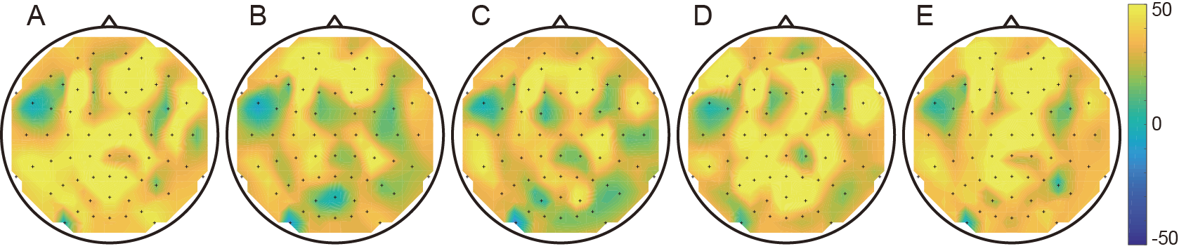

**Fig** Topographical mapping of motor imagery class. (A: left twisting, B: right twisting, C: grasping, D: opening and E: resting)

Reference figure

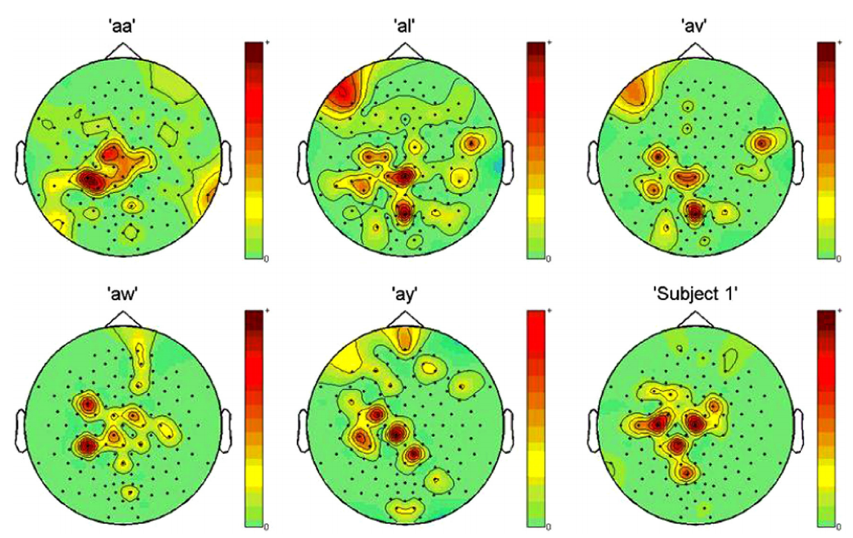

**Fig** Topographical mapping of channels selected using NSGA-II for each subject in BCI Competition III: Data Set IVa and Data Set IVc (Frequently selected channels have higher color intensity).

(From Multi-objective genetic algorithm as channel selection method for P300 and motor imagery data set, 2013, Neuroimage)

**Figure 2**: Temporal domain parameter distribution

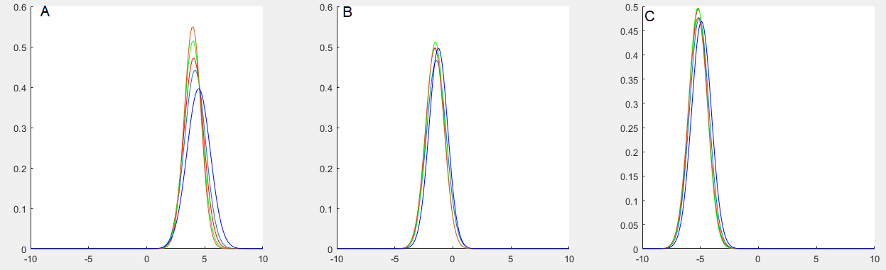

Fig The distribution of the classes around time domain features (A: p0, B: p1 and C: p2)

Reference figure

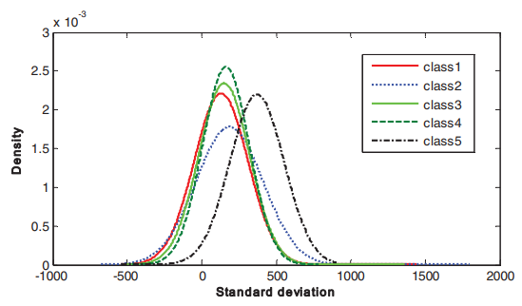

**Fig** The distributions of the classes around feature F3 (standard deviation)

(From Evidence Theory-based Approach for Epileptic Seizure Detection using EEG Signals, 2012, Conference)

**Figure 3**: Power spectral density plot

Preparing

Reference figure

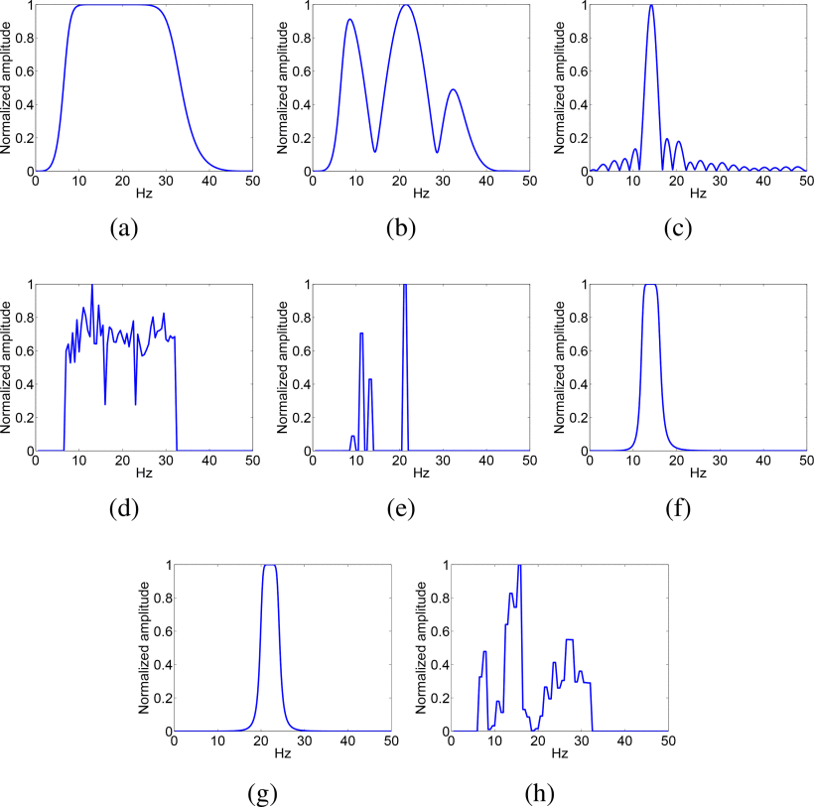

**Fig** The amplitude characteristics of spectral filters designed by each of the comparative methods. (a) CSP (b) CSSP (c) DFBCSP (d) SWCSP (e) ISSPL (f) FBCSP (g) OSSFN (h) MMISS.

(from Simultaneously Optimizing Spatial Spectral Features Based on Mutual Information for EEG Classification, 2014, IEEE transactions on biomedical engineering)

**Table** Binary classification result 1 (Grasp & Open vs. Rest)

|  |  |  |  |  |  |  |  |  |  |  |  |  |
| --- | --- | --- | --- | --- | --- | --- | --- | --- | --- | --- | --- | --- |
| Subject | CSP | | | | TDP | | | | PSD | | | |
| LSVM | KSVM | GB | SRLDA | LSVM | KSVM | GB | SRLDA | LSVM | KSVM | GB | SRLDA |
| 1 | 51.0±12.4 | 53.0±13.3 | 56.0±13.2 | 52.0±11.7 | 65.0±6.3 | 62.0±10.3 | 64.0±3.7 | 73.0±6.0 | 50.0±6.3 | 54.0±4.9 | 55.0±2.2 | 60.0±8.9 |
| 2 | 52.0±8.7 | 55.0±7.1 | 53.0±10.3 | 56.0±10.7 | 73.0±6.8 | 69.0±5.8 | 68.0±13.3 | 82.0±2.4 | 74.0±11.6 | 69.0±10.7 | 49.0±3.3 | 51.0±3.7 |
| 3 | 54.0±11.1 | 56.0±8.0 | 55.0±6.3 | 52.0±6.8 | 78.0±6.8 | 77.0±5.1 | 73.0±6.0 | 79.0±7.3 | 56.0±8.0 | 52.0±6.8 | 48.0±4.9 | 63.0±12.1 |
| 4 | 74.5±6.2 | 75.5±5.3 | 66.5±5.4 | 74.5±5.8 | 87.0±2.9 | 85.5±1.9 | 81.0±3.4 | 91.0±5.1 | 54.5±2.9 | 51.5±1.2 | 58.0±3.7 | 64.0±9.0 |
| 5 | 60.0±4.6 | 58.3±6.3 | 56.0±3.7 | 59.3±4.9 | 70.0±4.3 | 70.7±3.9 | 77.3±5.4 | 74.7±3.2 | 53.0±2.4 | 50.7±2.5 | 48.3±6.9 | 60.7±8.3 |
| 6 | 61.3±2.7 | 59.7±4.5 | 55.0±4.5 | 60.0±3.7 | 74.0±4.0 | 74.7±4.4 | 79.3±5.3 | 76.3±6.3 | 51.3±2.7 | 50.3±0.7 | 52.8±4.3 | 49.7±1.6 |
| 7 | 85.0±3.2 | 83.0±6.8 | 82.0±9.3 | 89.0±4.9 | 93.0±5.1 | 89.0±7.3 | 92.0±6.8 | 93.0±2.4 | 51.0±2.0 | 51.0±2.0 | 74.5±5.5 | 57.0±7.5 |
| 8 | 60.0±5.5 | 57.0±10.8 | 57.0±5.1 | 58.0±6.0 | 66.0±10.2 | 59.0±7.3 | 78.0±12.1 | 77.0±10.8 | 54.0±8.0 | 52.0±4.0 | 56.0±5.8 | 56.0±8.6 |
| 9 | 58.0±4.0 | 61.0±6.6 | 58.0±15.7 | 62.0±6.0 | 67.0±14.4 | 61.0±16.2 | 67.0±6.8 | 65.0±17.0 | 58.0±9.3 | 53.0±6.0 | 60.5±12.2 | 50.0±3.2 |
| 10 | 88.0±6.8 | 88.0±5.1 | 91.0±4.9 | 93.0±5.1 | 93.0±8.7 | 93.0±6.8 | 95.0±5.5 | 92.0±6.0 | 77.0±9.3 | 61.0±10.7 | 43.5±12.4 | 63.0±8.7 |
| Average | 64.4±6.5 | 64.6±7.4 | 63.0±7.8 | **65.6±6.6** | 76.6±7.0 | 74.1±6.9 | 77.5±6.8 | **80.3±6.6** | 57.9±6.2 | 54.4±5.0 | 54.6±6.1 | **57.4±7.2** |

**Table** Binary classification result 2 (Twist vs. Rest)

|  |  |  |  |  |  |  |  |  |  |  |  |  |
| --- | --- | --- | --- | --- | --- | --- | --- | --- | --- | --- | --- | --- |
| Subject | CSP | | | | TDP | | | | PSD | | | |
| LSVM | KSVM | GB | SRLDA | LSVM | KSVM | GB | SRLDA | LSVM | KSVM | GB | SRLDA |
| 1 | 44.0±18.3 | 43.0±17.5 | 45.0±12.2 | 43.0±17.2 | 68.0±6.8 | 68.0±8.1 | 69.0±8.6 | 71.0±3.7 | 65.0±5.5 | 60.0±7.7 | 56.0±3.2 | 49.0±3.7 |
| 2 | 46.0±13.9 | 46.0±11.6 | 47.0±13.3 | 47.0±15.0 | 75.0±8.4 | 79.0±5.8 | 78.0±7.5 | 81.0±9.7 | 76.0±10.7 | 77.0±11.7 | 53.0±5.3 | 63.0±4.0 |
| 3 | 47.0±5.1 | 50.0±8.4 | 46.0±4.9 | 49.0±3.7 | 78.0±7.5 | 72.0±6.0 | 86.0±3.7 | 79.0±3.7 | 71.0±8.0 | 68.0±6.8 | 55.0±3.3 | 59.0±13.2 |
| 4 | 52.5±6.7 | 56.0±4.4 | 52.0±3.7 | 54.0±5.8 | 83.0±4.8 | 79.5±4.6 | 77.5±6.1 | 85.0±1.6 | 50.0±0.0 | 50.0±0.0 | 66.5±3.4 | 60.5±7.8 |
| 5 | 54.0±4.4 | 52.7±2.3 | 49.3±6.9 | 54.0±3.6 | 80.0±7.3 | 80.3±4.3 | 77.3±3.7 | 84.3±2.5 | 61.0±4.0 | 53.7±2.4 | 56.0±3.7 | 70.7±5.3 |
| 6 | 54.7±3.4 | 56.3±4.1 | 52.3±4.3 | 54.7±4.6 | 73.3±9.8 | 72.7±7.0 | 69.7±5.7 | 73.7±5.1 | 51.0±2.0 | 50.0±0.0 | 55.0±4.5 | 58.7±4.9 |
| 7 | 74.0±5.8 | 74.0±5.8 | 75.0±10.5 | 76.0±8.6 | 83.0±7.5 | 83.0±5.1 | 76.0±5.8 | 85.0±4.5 | 62.0±6.8 | 61.0±8.6 | 72.0±6.3 | 52.0±4.0 |
| 8 | 50.0±8.9 | 55.0±11.4 | 56.0±5.8 | 53.0±6.8 | 62.0±7.5 | 64.0±4.9 | 70.0±5.5 | 71.0±3.7 | 54.0±4.9 | 55.0±3.2 | 57.0±5.1 | 49.0±6.6 |
| 9 | 60.0±13.0 | 60.0±13.8 | 60.0±15.2 | 61.0±9.7 | 87.0±5.1 | 84.0±3.7 | 90.0±4.5 | 79.0±3.7 | 60.0±6.3 | 50.0±0.0 | 58.0±13.7 | 77.0±10.8 |
| 10 | 44.0±9.7 | 42.0±13.3 | 43.0±14.4 | 42.0±14.7 | 81.0±10.7 | 80.0±11.0 | 74.0±12.4 | 82.0±4.0 | 64.0±8.0 | 63.0±10.8 | 71.0±4.9 | 60.0±3.2 |
| Average | 52.6±8.9 | **53.5±9.3** | 52.6±9.1 | 53.4±9.0 | 77.0±7.5 | 76.2±6.0 | 76.8±6.4 | **79.1±4.2** | **61.4±5.6** | 58.8±5.1 | 60.0±5.3 | 59.9±6.4 |

**Table** Ternary classification result 1 (Grasp vs. Open vs. Rest)

|  |  |  |  |  |  |  |  |  |  |  |  |  |
| --- | --- | --- | --- | --- | --- | --- | --- | --- | --- | --- | --- | --- |
| Subject | CSP | | | | TDP | | | | PSD | | | |
| LSVM | KSVM | GB | SRLDA | LSVM | KSVM | GB | SRLDA | LSVM | KSVM | GB | SRLDA |
| 1 | 39.0±5.8 | 46.0±5.8 | 39.0±6.6 | 40.0±12.2 | 44.0±11.1 | 49.0±6.6 | 45.0±9.5 | 51.0±3.7 | 34.0±8.6 | 35.0±8.4 | 45.0±8.4 | 45.0±11.4 |
| 2 | 45.0±13.0 | 48.0±9.3 | 47.0±4.0 | 48.0±9.3 | 55.0±6.3 | 53.0±7.5 | 48.0±16.0 | 65.0±8.4 | 40.0±16.4 | 41.0±12.4 | 49.0±8.6 | 43.0±9.3 |
| 3 | 44.0±12.8 | 48.0±12.9 | 48.0±6.0 | 44.0±14.6 | 60.0±10.5 | 64.0±10.2 | 55.0±7.1 | 60.0±10.5 | 59.0±8.0 | 50.0±11.8 | 54.0±13.9 | 51.0±13.2 |
| 4 | 49.5±5.8 | 52.5±3.9 | 53.0±4.6 | 52.0±7.6 | 64.0±2.5 | 63.0±6.4 | 61.5±3.4 | 68.0±6.8 | 46.5±6.4 | 43.0±5.6 | 52.5±9.6 | 50.5±6.6 |
| 5 | 46.7±5.3 | 47.7±6.2 | 45.7±4.8 | 50.0±6.8 | 56.3±6.2 | 56.0±8.3 | 59.3±3.9 | 59.7±1.2 | 46.3±10.7 | 47.3±6.7 | 52.3±5.3 | 51.0±10.0 |
| 6 | 50.0±2.4 | 48.0±3.2 | 49.0±2.9 | 51.0±2.5 | 56.0±10.7 | 57.7±8.0 | 63.3±6.4 | 60.3±7.3 | 45.0±10.7 | 49.3±9.6 | 61.0±5.6 | 55.7±7.0 |
| 7 | 57.0±6.8 | 54.0±7.3 | 57.0±10.3 | 64.0±7.3 | 74.0±9.2 | 73.0±6.8 | 70.0±10.0 | 74.0±5.8 | 48.0±9.3 | 44.0±5.8 | 65.0±4.5 | 57.0±9.3 |
| 8 | 30.0±11.0 | 42.0±6.8 | 43.0±6.8 | 34.0±9.2 | 60.0±8.9 | 52.0±9.3 | 70.0±8.9 | 60.0±12.2 | 48.0±6.8 | 41.0±7.3 | 61.0±10.2 | 43.0±10.3 |
| 9 | 37.0±8.7 | 48.0±7.5 | 42.0±11.7 | 50.0±5.5 | 47.0±20.9 | 53.0±20.6 | 47.0±8.1 | 51.0±17.7 | 31.0±6.6 | 34.0±10.7 | 52.0±8.1 | 47.0±13.6 |
| 10 | 63.0±8.1 | 69.0±8.6 | 62.0±11.7 | 67.0±6.8 | 71.0±5.8 | 73.0±6.8 | 72.0±6.0 | 70.0±5.5 | 66.0±13.9 | 67.0±12.9 | 76.0±8.0 | 56.0±4.9 |
| Average | 46.1±8.0 | **50.3±7.2** | 48.6±6.9 | 50.0±8.2 | 58.7±9.2 | 59.4±9.0 | 59.1±7.9 | **61.9±7.9** | 46.4±9.7 | 45.2±9.1 | **56.8±8.2** | 49.9±9.6 |

**Table** Ternary classification result 2 (Left twist vs. Right twist vs. Rest)

|  |  |  |  |  |  |  |  |  |  |  |  |  |
| --- | --- | --- | --- | --- | --- | --- | --- | --- | --- | --- | --- | --- |
| Subject | CSP | | | | TDP | | | | PSD | | | |
| LSVM | KSVM | GB | SRLDA | LSVM | KSVM | GB | SRLDA | LSVM | KSVM | GB | SRLDA |
| 1 | 33.0±10.3 | 43.0±8.7 | 48.0±2.4 | 33.0±10.3 | 50.0±7.7 | 46.0±8.6 | 57.0±7.5 | 52.0±11.2 | 39.0±3.7 | 33.0±6.8 | 45.0±7.7 | 37.0±18.6 |
| 2 | 35.0±16.4 | 49.0±8.0 | 50.0±3.2 | 48.0±6.0 | 54.0±14.3 | 62.0±10.8 | 62.0±12.9 | 63.0±13.3 | 48.0±11.7 | 47.0±12.9 | 51.0±8.0 | 39.0±10.7 |
| 3 | 41.0±9.7 | 49.0±2.0 | 50.0±5.5 | 47.0±4.0 | 52.0±7.5 | 57.0±11.2 | 61.0±8.6 | 51.0±10.2 | 50.0±11.8 | 46.0±5.8 | 48.0±14.4 | 53.0±6.8 |
| 4 | 36.5±5.8 | 39.5±5.3 | 44.5±4.3 | 41.5±8.5 | 59.5±6.2 | 59.5±8.3 | 55.0±5.0 | 61.5±3.4 | 50.0±4.2 | 45.0±5.2 | 56.0±6.6 | 51.5±5.8 |
| 5 | 42.7±4.4 | 44.3±3.6 | 47.3±4.4 | 46.7±2.4 | 60.3±3.7 | 57.3±5.4 | 55.7±4.3 | 61.3±6.9 | 50.3±4.9 | 52.0±7.0 | 65.7±4.0 | 58.7±4.3 |
| 6 | 40.7±4.3 | 42.3±3.9 | 45.0±5.1 | 44.0±4.8 | 55.0±9.1 | 51.3±6.7 | 55.0±10.8 | 54.7±11.7 | 57.3±3.1 | 56.3±3.9 | 62.3±5.4 | 62.7±6.8 |
| 7 | 48.0±6.8 | 50.0±7.1 | 52.0±5.1 | 52.0±10.8 | 69.0±6.6 | 65.0±10.0 | 60.0±7.1 | 68.0±6.8 | 51.0±11.1 | 48.0±9.8 | 63.0±6.0 | 64.0±10.2 |
| 8 | 36.0±10.7 | 45.0±8.9 | 47.0±2.4 | 39.0±8.6 | 44.0±3.7 | 49.0±8.6 | 60.0±4.5 | 55.0±8.4 | 36.0±2.0 | 31.0±13.6 | 55.0±6.3 | 39.0±5.8 |
| 9 | 47.0±9.8 | 48.0±5.1 | 51.0±10.2 | 38.0±9.3 | 54.0±8.0 | 50.0±6.3 | 64.0±11.1 | 48.0±4.0 | 47.0±5.1 | 37.0±5.1 | 56.0±9.7 | 43.0±12.9 |
| 10 | 39.0±5.8 | 46.0±9.7 | 45.0±3.2 | 44.0±6.6 | 63.0±15.4 | 60.0±13.0 | 61.0±5.8 | 62.0±11.7 | 44.0±3.7 | 45.0±7.1 | 52.0±10.3 | 42.0±5.1 |
| Average | 39.9±8.4 | 45.6±6.2 | **48.0±4.6** | 43.3±7.1 | 56.1±8.2 | 55.7±8.9 | **59.1±7.8** | 57.6±8.8 | 47.3±6.1 | 44.0±7.7 | **55.4±7.8** | 49.0±8.7 |

**Table** Quinary classification result (Grasp vs. Open vs. Left twist vs. Right twist vs. Rest)

|  |  |  |  |  |  |  |  |  |  |  |  |  |
| --- | --- | --- | --- | --- | --- | --- | --- | --- | --- | --- | --- | --- |
| Subject | CSP | | | | TDP | | | | PSD | | | |
| LSVM | KSVM | GB | SRLDA | LSVM | KSVM | GB | SRLDA | LSVM | KSVM | GB | SRLDA |
| 1 | 35.5±5.1 | 45.5±3.7 | 46.0±4.6 | 40.0±3.2 | 44.0±6.4 | 50.0±0.0 | 51.5±5.6 | 50.0±8.4 | 38.5±4.6 | 44.5±5.1 | 44.5±2.9 | 38.5±10.1 |
| 2 | 40.5±8.3 | 48.5±3.0 | 50.5±4.3 | 48.5±4.6 | 60.0±6.9 | 50.0±0.0 | 59.5±7.5 | 66.5±8.2 | 31.5±7.2 | 51.0±7.8 | 54.5±9.0 | 39.5±6.8 |
| 3 | 36.5±5.8 | 47.0±5.1 | 51.0±2.5 | 46.0±4.9 | 58.0±4.3 | 56.0±3.4 | 60.0±5.9 | 57.5±10.4 | 49.5±8.6 | 52.0±5.3 | 52.5±4.2 | 48.0±10.9 |
| 4 | 47.0±1.7 | 49.7±0.5 | 50.5±4.9 | 44.0±5.0 | 60.8±2.7 | 50.0±0.0 | 59.7±6.0 | 62.8±3.3 | 41.8±5.0 | 47.5±3.6 | 52.8±3.1 | 47.0±4.9 |
| 5 | 43.7±4.1 | 50.0±0.5 | 46.0±0.6 | 43.7±3.0 | 56.3±2.8 | 50.2±0.3 | 57.3±2.2 | 59.7±4.9 | 45.5±6.6 | 49.3±0.6 | 55.7±0.8 | 56.2±4.9 |
| 6 | 41.8±4.8 | 50.0±0.0 | 47.7±2.7 | 48.2±4.1 | 53.3±7.8 | 53.7±1.5 | 60.0±4.7 | 56.0±5.2 | 47.0±3.5 | 49.8±0.8 | 57.5±7.8 | 57.5±6.5 |
| 7 | 50.5±7.8 | 52.5±4.2 | 53.0±4.0 | 52.5±4.7 | 65.5±5.6 | 64.0±7.2 | 70.0±7.2 | 66.5±9.2 | 45.5±5.1 | 48.0±1.9 | 51.5±6.2 | 52.0±7.8 |
| 8 | 36.0±6.6 | 48.0±2.9 | 44.5±5.8 | 44.0±3.4 | 50.5±12.1 | 50.0±0.0 | 53.5±8.3 | 53.5±8.5 | 32.5±8.2 | 46.0±6.4 | 51.5±3.4 | 45.0±5.7 |
| 9 | 43.0±3.3 | 50.0±3.2 | 46.0±3.4 | 42.5±2.2 | 49.0±12.5 | 51.0±2.0 | 58.5±4.1 | 51.5±10.2 | 36.5±4.1 | 46.5±2.5 | 48.0±4.8 | 46.0±9.4 |
| 10 | 48.5±7.8 | 54.0±3.0 | 52.5±2.7 | 53.5±1.2 | 65.0±8.1 | 62.0±4.8 | 62.5±9.1 | 63.0±8.3 | 54.5±5.3 | 51.5±3.0 | 60.0±8.7 | 48.0±8.1 |
| Average | 42.3±5.5 | **49.5±2.6** | 48.8±3.6 | 46.3±3.6 | 56.2±6.9 | 53.7±1.9 | **59.2±6.1** | 58.7±7.7 | 42.3±5.8 | 48.6±3.7 | **52.8±5.1** | 47.8±7.5 |

**Table 5**: Classification result applied SMOTE

|  |  |  |  |  |  |  |  |  |  |  |  |  |
| --- | --- | --- | --- | --- | --- | --- | --- | --- | --- | --- | --- | --- |
| Subject | CSP | | | | TDP | | | | PSD | | | |
| LSVM | KSVM | GB | SRLDA | LSVM | KSVM | GB | SRLDA | LSVM | KSVM | GB | SRLDA |
| 1 | 37.0±8.0 | 38.0±4.8 | 40.5±6.0 | 32.0±3.3 | 41.5±6.6 | 31.0±4.1 | 44.5±4.8 | 45.5±9.3 | 30.5±7.3 | 45.5±5.2 | 41.5±2.5 | 37.0±6.2 |
| 2 | 31.0±4.6 | 43.5±5.1 | 46.0±3.4 | 36.0±4.6 | 43.0±7.0 | 44.5±4.3 | 51.5±1.2 | 44.5±7.0 | 36.0±3.7 | 57.5±4.9 | 43.0±8.1 | 37.5±5.5 |
| 3 | 37.0±6.8 | 45.0±5.0 | 42.0±9.9 | 37.0±4.8 | 42.0±10 | 35.5±5.8 | 48.0±5.6 | 47.0±6.0 | 31.5±9.2 | 49.0±4.6 | 43.0±6.6 | 32.5±6.3 |
| 4 | 40.0±8.2 | 48.5±2.5 | 49.0±4.9 | 42.5±6.7 | 57.5±5.7 | 52.5±5.7 | 60.0±5.5 | 64.0±6.0 | 32.0±7.0 | 51.5±6.6 | 47.5±9.7 | 41.5±3.7 |
| 5 | 36.5±3.7 | 47.0±6.8 | 49.0±2.0 | 42.5±3.9 | 59.0±2.5 | 61.5±7.8 | 60.0±5.5 | 56.5±7.2 | 50.0±8.9 | 52.0±5.3 | 55.0±9.5 | 47.5±8.4 |
| 6 | 32.3±6.1 | 33.0±4.2 | 42.5±5.2 | 33.5±6.3 | 60.3±5.0 | 51.8±4.9 | 57.3±5.1 | 60.5±1.5 | 41.0±5.4 | 48.5±3.6 | 47.0±3.9 | 43.0±4.8 |
| 7 | 29.7±4.6 | 30.7±4.9 | 39.3±3.3 | 32.0±3.8 | 51.5±2.9 | 50.3±2.3 | 57.3±3.3 | 54.8±5.4 | 39.0±8.6 | 47.3±1.7 | 53.3±1.9 | 52.8±4.6 |
| 8 | 24.8±3.0 | 29.3±4.0 | 36.8±4.8 | 29.5±5.7 | 50.8±4.8 | 49.5±9.2 | 55.7±4.2 | 51.5±9.5 | 44.2±6.3 | 49.8±1.9 | 54.0±7.0 | 53.5±4.2 |
| 9 | 51.5±5.4 | 56.0±7.3 | 53.5±4.4 | 52.5±6.5 | 68.0±4.3 | 70.0±8.4 | 66.0±5.1 | 66.5±9.8 | 46.0±3.7 | 48.0±1.9 | 55.0±6.5 | 51.5±8.6 |
| 10 | 38.0±1.9 | 45.5±7.0 | 42.5±6.5 | 34.0±7.7 | 50.5±10.4 | 47.0±9.3 | 54.5±8.9 | 47.5±13.1 | 28.5±8.3 | 46.0±6.4 | 50.5±7.6 | 34.5±4.8 |
| 11 | 29.5±4.3 | 35.5±8.0 | 39.0±5.8 | 26.5±7.2 | 24.0±1.2 | 17.0±4.6 | 38.5±4.1 | 28.0±3.3 | 25.5±8.0 | 41.5±4.5 | 33.0±5.8 | 26.0±3.0 |
| 12 | 39.0±6.6 | 42.0±6.4 | 45.5±3.7 | 39.0±8.2 | 45.0±12.7 | 52.0±9.3 | 61.5±4.1 | 48.5±12.7 | 36.0±3.7 | 46.7±3.1 | 48.5±1.2 | 42.0±8.0 |
| 13 | 49.0±7.0 | 45.5±4.3 | 50.0±5.7 | 46.0±2.5 | 66.5±6.2 | 66.5±5.1 | 65.0±9.6 | 59.0±11.0 | 53.0±4.8 | 51.8±3.4 | 65.6±5.4 | 44.5±7.3 |
| Average | 36.6±5.4 | 41.5±5.4 | **44.3±5.0** | 37.2±5.5 | 50.7±6.1 | 48.4±6.2 | **55.4±5.2** | 51.8±7.8 | 37.9±6.5 | 48.9±4.1 | **49.0±5.8** | 41.8±5.8 |

**Table 6**: Classification result merged analysis

|  |  |  |  |  |  |  |  |  |  |  |  |  |
| --- | --- | --- | --- | --- | --- | --- | --- | --- | --- | --- | --- | --- |
| Subject | CSP&TDP | | | | CSP&PSD | | | | TDP&PSD | | | |
| LSVM | KSVM | GB | SRLDA | LSVM | KSVM | GB | SRLDA | LSVM | KSVM | GB | SRLDA |
| 1 | 47.5±4.2 | 44.5±7.0 | 48.0±5.6 | 46.5±1.2 | 45.5±4.8 | 39.5±5.3 | 50.0±2.2 | 40.0±4.7 | 43.0±6.2 | 45.0±6.1 | 52.0±4.8 | 40.5±7.0 |
| 2 | 43.0±4.8 | 42.5±3.2 | 46.5±6.4 | 46.0±1.2 | 36.5±5.1 | 44.5±4.8 | 49.0±2.5 | 42.5±4.7 | 45.0±6.9 | 46.5±6.4 | 49.5±4.8 | 48.0±10.3 |
| 3 | 46.0±6.6 | 49.5±4.0 | 50.0±6.5 | 50.5±6.8 | 44.5±5.1 | 43.0±6.0 | 50.0±3.5 | 45.5±6.0 | 52.0±6.2 | 45.0±7.6 | 49.0±5.1 | 41.0±11.2 |
| 4 | 55.5±6.2 | 55.0±5.0 | 52.0±3.7 | 64.5±4.8 | 43.0±9.7 | 48.0±1.9 | 48.5±4.1 | 44.0±5.1 | 59.0±8.6 | 59.5±7.5 | 57.5±7.6 | 53.5±4.9 |
| 5 | 56.5±6.4 | 55.0±5.2 | 50.5±1.9 | 61.0±8.0 | 41.0±3.4 | 46.5±6.6 | 52.5±4.2 | 51.5±4.9 | 56.0±4.6 | 57.5±9.1 | 56.0±5.6 | 54.0±7.7 |
| 6 | 57.2±4.4 | 56.8±7.2 | 60.0±2.9 | 61.0±5.1 | 45.2±4.0 | 40.2±2.5 | 56.8±4.5 | 48.0±2.3 | 60.0±3.2 | 60.7±5.1 | 59.5±4.1 | 53.2±1.3 |
| 7 | 55.3±3.4 | 51.0±3.9 | 56.3±2.3 | 61.0±2.1 | 45.3±2.3 | 41.7±3.4 | 52.5±3.2 | 54.8±3.6 | 56.5±2.1 | 53.3±4.4 | 59.0±2.3 | 58.8±2.8 |
| 8 | 50.3±9.0 | 52.0±3.8 | 57.8±4.8 | 56.8±5.0 | 47.0±4.3 | 47.0±3.3 | 59.2±6.1 | 55.5±6.7 | 55.8±1.4 | 52.3±8.9 | 61.7±6.5 | 60.3±6.3 |
| 9 | 65.0±5.5 | 65.5±6.4 | 58.0±4.3 | 61.5±6.0 | 51.5±6.6 | 56.0±7.3 | 55.5±6.8 | 60.0±8.8 | 69.0±5.6 | 69.5±6.0 | 68.0±4.8 | 61.5±8.2 |
| 10 | 49.0±8.2 | 50.5±2.9 | 52.0±6.2 | 48.5±8.5 | 40.0±4.2 | 46.0±5.1 | 46.5±3.4 | 45.5±6.2 | 53.5±13.1 | 52.5±8.5 | 54.0±7.5 | 49.0±6.6 |
| 11 | 39.0±8.6 | 39.0±7.2 | 41.5±6.4 | 44.5±6.2 | 30.5±4.8 | 35.0±9.2 | 45.5±3.7 | 40.5±4.0 | 37.5±6.7 | 28.0±3.3 | 43.5±5.1 | 38.5±3.4 |
| 12 | 51.5±7.8 | 53.0±4.6 | 53.0±2.9 | 50.5±9.9 | 40.5±3.3 | 43.5±5.1 | 45.0±2.2 | 44.5±8.6 | 48.5±6.6 | 47.5±11.7 | 63.5±7.7 | 50.0±12.0 |
| 13 | 63.5±8.2 | 65.5±9.4 | 57.0±3.7 | 64.0±9.4 | 48.0±8.6 | 46.0±4.4 | 55.5±1.9 | 56.5±3.7 | 65.5±8.0 | 67.5±8.8 | 63.5±7.2 | 58.5±4.6 |
| Average | 52.3±52.3 | 52.3±52.3 | 52.5±52.5 | **55.1±55.1** | 43.0±43.0 | 44.4±44.4 | **51.3±51.3** | 48.4±48.4 | 53.9±53.9 | 52.7±52.7 | **56.7±56.7** | 51.3±51.3 |

**Table 7**: Classification result (3 class, grasp)

|  |  |  |  |  |  |  |  |  |  |  |  |  |
| --- | --- | --- | --- | --- | --- | --- | --- | --- | --- | --- | --- | --- |
| Subject | CSP | | | | TDP | | | | PSD | | | |
| LSVM | KSVM | GB | SRLDA | LSVM | KSVM | GB | SRLDA | LSVM | KSVM | GB | SRLDA |
| 1 | 41.0±12.0 | 45.0±10.5 | 42.0±10.3 | 44.0±4.9 | 50.0±10.5 | 40.0±10.5 | 42.0±6.8 | 48.0±12.9 | 39.0±4.9 | 39.0±8.6 | 49.0±3.7 | 47.0±4.0 |
| 2 | 39.0±5.8 | 46.0±5.8 | 39.0±6.6 | 40.0±12.2 | 44.0±11.1 | 49.0±6.6 | 45.0±9.5 | 51.0±3.7 | 34.0±8.6 | 35.0±8.4 | 45.0±8.4 | 45.0±11.4 |
| 3 | 28.0±12.9 | 37.0±13.6 | 38.0±6.8 | 37.0±13.6 | 53.0±20.6 | 50.0±17.9 | 55.0±4.5 | 53.0±17.8 | 40.0±11.0 | 41.0±9.7 | 41.0±2.0 | 33.0±10.8 |
| 4 | 45.0±13.0 | 48.0±9.3 | 47.0±4.0 | 48.0±9.3 | 55.0±6.3 | 53.0±7.5 | 48.0±16.0 | 65.0±8.4 | 40.0±16.4 | 41.0±12.4 | 49.0±8.6 | 43.0±9.3 |
| 5 | 44.0±12.8 | 48.0±12.9 | 48.0±6.0 | 44.0±14.6 | 60.0±10.5 | 64.0±10.2 | 55.0±7.1 | 60.0±10.5 | 59.0±8.0 | 50.0±11.8 | 54.0±13.9 | 51.0±13.2 |
| 6 | 49.5±5.8 | 52.5±3.9 | 53.0±4.6 | 52.0±7.6 | 64.0±2.5 | 63.0±6.4 | 61.5±3.4 | 68.0±6.8 | 46.5±6.4 | 43.0±5.6 | 52.5±9.6 | 50.5±6.6 |
| 7 | 46.7±5.3 | 47.7±6.2 | 45.7±4.8 | 50.0±6.8 | 56.3±6.2 | 56.0±8.3 | 59.3±3.9 | 59.7±1.2 | 46.3±10.7 | 47.3±6.7 | 52.3±5.3 | 51.0±10.0 |
| 8 | 50.0±2.4 | 48.0±3.2 | 49.0±2.9 | 51.0±2.5 | 56.0±10.7 | 57.7±8.0 | 63.3±6.4 | 60.3±7.3 | 45.0±10.7 | 49.3±9.6 | 61.0±5.6 | 55.7±7.0 |
| 9 | 57.0±6.8 | 54.0±7.3 | 57.0±10.3 | 64.0±7.3 | 74.0±9.2 | 73.0±6.8 | 70.0±10.0 | 74.0±5.8 | 48.0±9.3 | 44.0±5.8 | 65.0±4.5 | 57.0±9.3 |
| 10 | 30.0±11.0 | 42.0±6.8 | 43.0±6.8 | 34.0±9.2 | 60.0±8.9 | 52.0±9.3 | 70.0±8.9 | 60.0±12.2 | 48.0±6.8 | 41.0±7.3 | 61.0±10.2 | 43.0±10.3 |
| 11 | 40.0±7.1 | 40.0±11.0 | 39.0±9.7 | 41.0±3.7 | 33.0±4.0 | 38.0±6.0 | 31.0±7.3 | 41.0±9.7 | 35.0±12.6 | 39.0±7.3 | 38.0±8.7 | 39.0±8.6 |
| 12 | 37.0±8.7 | 48.0±7.5 | 42.0±11.7 | 50.0±5.5 | 47.0±20.9 | 53.0±20.6 | 47.0±8.1 | 51.0±17.7 | 31.0±6.6 | 34.0±10.7 | 52.0±8.1 | 47.0±13.6 |
| 13 | 63.0±8.1 | 69.0±8.6 | 62.0±11.7 | 67.0±6.8 | 71.0±5.8 | 73.0±6.8 | 72.0±6.0 | 70.0±5.5 | 66.0±13.9 | 67.0±12.9 | 76.0±8.0 | 56.0±4.9 |
| Average | 43.9±43.9 | **48.1±48.1** | 46.5±46.5 | 47.8±47.8 | 55.6±55.6 | 55.5±55.5 | 55.3±55.3 | **58.5±58.5** | 44.4±44.4 | 43.9±43.9 | **53.5±53.5** | 47.6±47.6 |

**Table 8**: Classification result (3 class, twist)

|  |  |  |  |  |  |  |  |  |  |  |  |  |
| --- | --- | --- | --- | --- | --- | --- | --- | --- | --- | --- | --- | --- |
| Subject | CSP | | | | TDP | | | | PSD | | | |
| LSVM | KSVM | GB | SRLDA | LSVM | KSVM | GB | SRLDA | LSVM | KSVM | GB | SRLDA |
| 1 | 32.0±9.3 | 36.0±3.7 | 43.0±6.8 | 37.0±5.1 | 50.0±10.5 | 42.0±6.0 | 57.0±8.1 | 45.0±13.0 | 41.0±8.0 | 41.0±8.0 | 50.0±7.1 | 40.0±12.6 |
| 2 | 33.0±10.3 | 43.0±8.7 | 48.0±2.4 | 33.0±10.3 | 50.0±7.7 | 46.0±8.6 | 57.0±7.5 | 52.0±11.2 | 39.0±3.7 | 33.0±6.8 | 45.0±7.7 | 37.0±18.6 |
| 3 | 43.0±7.5 | 38.0±5.1 | 51.0±8.0 | 41.0±6.6 | 53.0±5.1 | 50.0±7.7 | 45.0±7.1 | 53.0±5.1 | 49.0±12.0 | 45.0±14.1 | 47.0±7.5 | 53.0±6.8 |
| 4 | 35.0±16.4 | 49.0±8.0 | 50.0±3.2 | 48.0±6.0 | 54.0±14.3 | 62.0±10.8 | 62.0±12.9 | 63.0±13.3 | 48.0±11.7 | 47.0±12.9 | 51.0±8.0 | 39.0±10.7 |
| 5 | 41.0±9.7 | 49.0±2.0 | 50.0±5.5 | 47.0±4.0 | 52.0±7.5 | 57.0±11.2 | 61.0±8.6 | 51.0±10.2 | 50.0±11.8 | 46.0±5.8 | 48.0±14.4 | 53.0±6.8 |
| 6 | 36.5±5.8 | 39.5±5.3 | 44.5±4.3 | 41.5±8.5 | 59.5±6.2 | 59.5±8.3 | 55.0±5.0 | 61.5±3.4 | 50.0±4.2 | 45.0±5.2 | 56.0±6.6 | 51.5±5.8 |
| 7 | 42.7±4.4 | 44.3±3.6 | 47.3±4.4 | 46.7±2.4 | 60.3±3.7 | 57.3±5.4 | 55.7±4.3 | 61.3±6.9 | 50.3±4.9 | 52.0±7.0 | 65.7±4.0 | 58.7±4.3 |
| 8 | 40.7±4.3 | 42.3±3.9 | 45.0±5.1 | 44.0±4.8 | 55.0±9.1 | 51.3±6.7 | 55.0±10.8 | 54.7±11.7 | 57.3±3.1 | 56.3±3.9 | 62.3±5.4 | 62.7±6.8 |
| 9 | 48.0±6.8 | 50.0±7.1 | 52.0±5.1 | 52.0±10.8 | 69.0±6.6 | 65.0±10.0 | 60.0±7.1 | 68.0±6.8 | 51.0±11.1 | 48.0±9.8 | 63.0±6.0 | 64.0±10.2 |
| 10 | 36.0±10.7 | 45.0±8.9 | 47.0±2.4 | 39.0±8.6 | 44.0±3.7 | 49.0±8.6 | 60.0±4.5 | 55.0±8.4 | 36.0±2.0 | 31.0±13.6 | 55.0±6.3 | 39.0±5.8 |
| 11 | 30.0±5.5 | 43.0±6.8 | 45.0±5.5 | 40.0±4.5 | 38.0±10.3 | 39.0±7.3 | 49.0±11.6 | 42.0±11.2 | 27.0±13.6 | 23.0±9.3 | 40.0±7.1 | 31.0±13.2 |
| 12 | 47.0±9.8 | 48.0±5.1 | 51.0±10.2 | 38.0±9.3 | 54.0±8.0 | 50.0±6.3 | 64.0±11.1 | 48.0±4.0 | 47.0±5.1 | 37.0±5.1 | 56.0±9.7 | 43.0±12.9 |
| 13 | 39.0±5.8 | 46.0±9.7 | 45.0±3.2 | 44.0±6.6 | 63.0±15.4 | 60.0±13.0 | 61.0±5.8 | 62.0±11.7 | 44.0±3.7 | 45.0±7.1 | 52.0±10.3 | 42.0±5.1 |
| Average | 38.8±38.8 | 44.1±44.1 | **47.6±47.6** | 42.4±42.4 | 54.0±54.0 | 52.9±52.9 | 57.1±57.1 | **55.1±55.1** | 45.4±45.4 | 42.3±42.3 | **53.2±53.2** | 47.2±47.2 |

**Table 9**: Classification result applied SMOTE (3 class, grasp)

|  |  |  |  |  |  |  |  |  |  |  |  |  |
| --- | --- | --- | --- | --- | --- | --- | --- | --- | --- | --- | --- | --- |
| Subject | CSP | | | | TDP | | | | PSD | | | |
| LSVM | KSVM | GB | SRLDA | LSVM | KSVM | GB | SRLDA | LSVM | KSVM | GB | SRLDA |
| 1 | 39.0±13.9 | 45.0±13.0 | 38.0±10.3 | 44.0±15.0 | 47.0±12.1 | 42.0±11.2 | 41.0±8.6 | 47.0±13.3 | 35.0±5.5 | 39.0±8.6 | 45.0±13.0 | 46.0±4.9 |
| 2 | 37.0±5.1 | 47.0±6.0 | 45.0±8.4 | 38.0±8.7 | 43.0±9.8 | 49.0±6.6 | 41.0±3.7 | 49.0±3.7 | 38.0±7.5 | 35.0±8.4 | 39.0±9.2 | 40.0±6.3 |
| 3 | 27.0±12.5 | 36.0±12.0 | 37.0±8.7 | 30.0±13.0 | 56.0±13.6 | 50.0±18.4 | 53.0±6.0 | 54.0±18.8 | 41.0±11.6 | 41.0±9.7 | 39.0±8.0 | 35.0±7.7 |
| 4 | 44.0±12.4 | 48.0±9.3 | 47.0±4.0 | 49.0±4.9 | 58.0±8.7 | 53.0±7.5 | 53.0±17.5 | 66.0±4.9 | 39.0±15.6 | 41.0±12.4 | 48.0±10.3 | 43.0±8.7 |
| 5 | 44.0±12.8 | 48.0±12.9 | 49.0±7.3 | 46.0±15.0 | 59.0±13.2 | 64.0±10.2 | 58.0±4.0 | 59.0±10.2 | 58.0±12.5 | 50.0±11.8 | 55.0±11.8 | 46.0±16.2 |
| 6 | 50.0±9.4 | 52.0±7.3 | 50.0±6.1 | 51.0±8.7 | 65.5±6.0 | 63.5±4.6 | 61.5±4.9 | 68.0±6.2 | 47.0±8.0 | 43.0±5.6 | 55.0±8.9 | 49.5±7.3 |
| 7 | 40.7±7.6 | 38.3±9.7 | 46.0±7.5 | 43.7±6.2 | 55.0±7.2 | 56.7±7.7 | 62.0±6.1 | 59.7±3.2 | 44.0±8.9 | 46.7±6.8 | 51.7±9.3 | 48.7±8.4 |
| 8 | 44.0±2.5 | 44.0±3.9 | 44.3±3.4 | 45.3±1.2 | 58.7±9.6 | 58.3±7.7 | 60.7±2.7 | 58.7±8.8 | 44.0±9.0 | 49.7±8.8 | 59.3±6.0 | 55.7±6.0 |
| 9 | 58.0±6.8 | 54.0±7.3 | 57.0±8.1 | 63.0±8.1 | 75.0±8.4 | 73.0±6.8 | 71.0±9.7 | 78.0±5.1 | 44.0±11.1 | 44.0±5.8 | 63.0±12.1 | 56.0±9.7 |
| 10 | 32.0±12.1 | 41.0±8.0 | 42.0±7.5 | 38.0±7.5 | 61.0±9.7 | 52.0±9.3 | 65.0±14.8 | 57.0±9.3 | 46.0±10.2 | 41.0±7.3 | 59.0±8.6 | 45.0±9.5 |
| 11 | 40.0±7.1 | 42.0±6.8 | 40.0±7.1 | 36.0±8.0 | 32.0±4.0 | 37.0±6.8 | 32.0±4.0 | 36.0±5.8 | 34.0±11.6 | 39.0±7.3 | 42.0±10.3 | 40.0±10.0 |
| 12 | 38.0±9.8 | 48.0±7.5 | 46.0±8.6 | 48.0±6.0 | 49.0±18.5 | 52.0±22.0 | 48.0±10.3 | 49.0±18.3 | 29.0±7.3 | 34.0±10.7 | 53.0±9.3 | 37.0±10.3 |
| 13 | 63.0±8.1 | 69.0±8.6 | 65.0±11.4 | 67.0±2.4 | 70.0±6.3 | 73.0±6.8 | 75.0±8.4 | 70.0±3.2 | 66.0±13.9 | 67.0±12.9 | 72.0±9.3 | 55.0±6.3 |
| Average | 42.8±42.8 | **47.1±47.1** | 46.6±46.6 | 46.1±46.1 | 56.1±56.1 | 55.7±55.7 | 55.5±55.5 | **57.8±57.8** | 43.5±43.5 | 43.9±43.9 | **52.4±52.4** | 45.9±45.9 |

**Table 10**: Classification result applied SMOTE (3 class, twist)

|  |  |  |  |  |  |  |  |  |  |  |  |  |
| --- | --- | --- | --- | --- | --- | --- | --- | --- | --- | --- | --- | --- |
| Subject | CSP | | | | TDP | | | | PSD | | | |
| LSVM | KSVM | GB | SRLDA | LSVM | KSVM | GB | SRLDA | LSVM | KSVM | GB | SRLDA |
| 1 | 28.0±4.0 | 36.0±5.8 | 41.0±4.9 | 33.0±5.1 | 43.0±6.8 | 43.0±6.8 | 47.0±6.8 | 46.0±10.7 | 38.0±9.3 | 41.0±8.0 | 43.0±2.4 | 39.0±14.6 |
| 2 | 33.0±5.1 | 44.0±8.6 | 49.0±2.0 | 36.0±5.8 | 51.0±11.6 | 45.0±7.1 | 60.0±5.5 | 53.0±11.7 | 39.0±3.7 | 33.0±6.8 | 49.0±11.1 | 38.0±18.6 |
| 3 | 45.0±6.3 | 41.0±6.6 | 46.0±5.8 | 42.0±9.3 | 55.0±7.1 | 50.0±7.7 | 48.0±9.3 | 54.0±3.7 | 47.0±13.6 | 45.0±14.1 | 47.0±10.3 | 55.0±3.2 |
| 4 | 35.0±15.8 | 49.0±8.0 | 49.0±5.8 | 50.0±5.5 | 57.0±11.2 | 62.0±10.8 | 58.0±13.6 | 63.0±13.6 | 49.0±13.2 | 47.0±12.9 | 48.0±12.9 | 37.0±11.7 |
| 5 | 40.0±10.5 | 49.0±2.0 | 49.0±5.8 | 44.0±3.7 | 52.0±7.5 | 57.0±11.2 | 64.0±7.3 | 52.0±9.3 | 49.0±13.2 | 46.0±5.8 | 52.0±9.8 | 50.0±5.5 |
| 6 | 34.0±4.6 | 36.0±1.2 | 42.0±5.6 | 38.5±4.6 | 58.5±3.0 | 60.5±7.3 | 58.0±7.5 | 61.5±3.7 | 44.5±4.3 | 45.0±5.2 | 52.5±7.1 | 49.0±7.2 |
| 7 | 39.3±3.4 | 39.7±6.6 | 43.3±5.9 | 40.0±3.0 | 57.3±6.2 | 57.7±4.5 | 55.7±2.5 | 58.3±6.2 | 52.0±6.4 | 52.0±7.0 | 63.3±2.8 | 57.3±3.1 |
| 8 | 37.3±4.3 | 42.3±6.2 | 43.3±7.7 | 41.3±4.5 | 55.3±8.9 | 50.7±8.1 | 53.0±7.6 | 49.7±6.2 | 56.3±6.4 | 56.3±3.9 | 62.3±5.0 | 60.3±6.5 |
| 9 | 46.0±8.0 | 49.0±8.6 | 53.0±5.1 | 54.0±6.6 | 68.0±6.8 | 65.0±10.0 | 63.0±5.1 | 65.0±10.0 | 50.0±13.4 | 48.0±9.8 | 50.0±8.9 | 63.0±9.3 |
| 10 | 30.0±3.2 | 46.0±9.2 | 48.0±8.1 | 38.0±6.0 | 47.0±5.1 | 48.0±8.1 | 69.0±7.3 | 54.0±12.0 | 34.0±4.9 | 31.0±13.6 | 55.0±8.4 | 32.0±4.0 |
| 11 | 29.0±8.0 | 38.0±5.1 | 44.0±3.7 | 36.0±2.0 | 36.0±13.6 | 39.0±7.3 | 47.0±6.8 | 39.0±8.6 | 27.0±13.6 | 23.0±9.3 | 28.0±7.5 | 30.0±14.1 |
| 12 | 48.0±8.1 | 48.0±5.1 | 54.0±5.8 | 47.0±9.8 | 52.0±6.8 | 50.0±6.3 | 59.0±12.0 | 54.0±6.6 | 45.0±3.2 | 37.0±5.1 | 54.0±9.2 | 43.0±12.1 |
| 13 | 37.0±5.1 | 47.0±9.8 | 46.0±2.0 | 39.0±7.3 | 62.0±14.7 | 60.0±13.0 | 57.0±13.6 | 60.0±11.4 | 44.0±3.7 | 45.0±7.1 | 56.0±12.4 | 43.0±5.1 |
| Average | 37.0±37.0 | 43.5±43.5 | **46.7±46.7** | 41.4±41.4 | 53.4±53.4 | 52.9±52.9 | **56.8±56.8** | 54.6±54.6 | 44.2±44.2 | 42.3±42.3 | **50.8±50.8** | 45.9±45.9 |

**Table 11**: Classification result merged analysis (3 class, grasp)

|  |  |  |  |  |  |  |  |  |  |  |  |  |
| --- | --- | --- | --- | --- | --- | --- | --- | --- | --- | --- | --- | --- |
| Subject | CSP&TDP | | | | CSP&PSD | | | | TDP&PSD | | | |
| LSVM | KSVM | GB | SRLDA | LSVM | KSVM | GB | SRLDA | LSVM | KSVM | GB | SRLDA |
| 1 | 47.0±14.0 | 43.0±6.0 | 46.0±13.9 | 44.0±13.2 | 35.0±5.5 | 39.0±8.6 | 46.0±6.6 | 45.0±4.5 | 37.0±5.1 | 39.0±8.6 | 54.0±11.6 | 44.0±7.3 |
| 2 | 54.0±3.7 | 54.0±10.2 | 44.0±8.6 | 51.0±12.0 | 32.0±12.1 | 35.0±8.4 | 52.0±5.1 | 43.0±9.8 | 30.0±6.3 | 35.0±8.4 | 45.0±5.5 | 45.0±11.4 |
| 3 | 43.0±12.5 | 43.0±9.3 | 50.0±8.4 | 44.0±13.2 | 41.0±10.2 | 41.0±9.7 | 40.0±8.4 | 34.0±10.2 | 40.0±11.0 | 41.0±9.7 | 46.0±7.3 | 34.0±14.6 |
| 4 | 53.0±9.3 | 59.0±7.3 | 48.0±5.1 | 59.0±9.7 | 38.0±14.7 | 41.0±12.4 | 48.0±4.0 | 47.0±8.1 | 38.0±14.7 | 41.0±12.4 | 57.0±11.7 | 52.0±10.3 |
| 5 | 54.0±8.6 | 58.0±7.5 | 55.0±4.5 | 57.0±8.1 | 60.0±8.9 | 50.0±11.8 | 50.0±8.4 | 51.0±5.8 | 62.0±9.3 | 50.0±11.8 | 57.0±9.8 | 49.0±15.3 |
| 6 | 65.0±5.5 | 63.0±4.0 | 60.0±5.2 | 63.5±6.2 | 43.5±7.3 | 43.0±5.6 | 53.5±3.0 | 49.0±7.3 | 43.5±8.6 | 43.0±5.6 | 59.0±6.0 | 48.0±6.6 |
| 7 | 50.3±8.6 | 51.0±7.0 | 60.7±6.8 | 60.0±5.5 | 46.0±11.4 | 47.3±6.7 | 55.3±10.3 | 50.0±8.2 | 46.0±7.6 | 47.3±6.7 | 56.0±8.7 | 53.3±5.5 |
| 8 | 57.7±4.0 | 59.7±4.4 | 60.7±7.7 | 60.7±7.3 | 47.3±5.4 | 49.3±9.6 | 62.0±4.6 | 58.7±9.9 | 47.3±9.8 | 49.7±10.1 | 63.0±2.2 | 57.0±7.7 |
| 9 | 64.0±2.0 | 65.0±7.1 | 57.0±8.7 | 72.0±4.0 | 51.0±11.1 | 44.0±5.8 | 60.0±8.4 | 62.0±9.3 | 53.0±10.3 | 44.0±5.8 | 73.0±7.5 | 63.0±7.5 |
| 10 | 43.0±10.3 | 49.0±5.8 | 47.0±9.3 | 46.0±5.8 | 45.0±5.5 | 41.0±7.3 | 46.0±5.8 | 42.0±6.8 | 49.0±8.6 | 41.0±7.3 | 59.0±13.6 | 45.0±9.5 |
| 11 | 42.0±8.7 | 40.0±7.1 | 43.0±8.1 | 39.0±5.8 | 31.0±9.7 | 39.0±7.3 | 43.0±4.0 | 41.0±8.6 | 35.0±8.4 | 39.0±7.3 | 36.0±10.7 | 37.0±6.8 |
| 12 | 52.0±6.8 | 50.0±7.1 | 47.0±11.7 | 54.0±12.0 | 31.0±6.6 | 34.0±10.7 | 51.0±6.6 | 47.0±13.6 | 34.0±8.0 | 34.0±10.7 | 53.0±8.7 | 47.0±11.7 |
| 13 | 69.0±5.8 | 69.0±10.7 | 65.0±3.2 | 72.0±7.5 | 65.0±13.8 | 67.0±12.9 | 61.0±10.2 | 64.0±3.7 | 66.0±13.9 | 67.0±12.9 | 73.0±9.3 | 72.0±6.8 |
| Average | 53.4±53.4 | 54.1±54.1 | 52.6±52.6 | **55.6±55.6** | 43.5±43.5 | 43.9±43.9 | **51.4±51.4** | 48.7±48.7 | 44.7±44.7 | 43.9±43.9 | **56.2±56.2** | 49.7±49.7 |

**Table 12**: Classification result merged analysis (3 class, twist)

|  |  |  |  |  |  |  |  |  |  |  |  |  |
| --- | --- | --- | --- | --- | --- | --- | --- | --- | --- | --- | --- | --- |
| Subject | CSP&TDP | | | | CSP&PSD | | | | TDP&PSD | | | |
| LSVM | KSVM | GB | SRLDA | LSVM | KSVM | GB | SRLDA | LSVM | KSVM | GB | SRLDA |
| 1 | 38.0±7.5 | 42.0±6.8 | 44.0±9.7 | 38.0±10.3 | 39.0±5.8 | 41.0±8.0 | 41.0±5.8 | 40.0±8.4 | 42.0±5.1 | 41.0±8.0 | 51.0±8.6 | 37.0±10.8 |
| 2 | 46.0±6.6 | 43.0±6.8 | 48.0±5.1 | 47.0±9.3 | 39.0±3.7 | 33.0±6.8 | 46.0±6.6 | 40.0±17.6 | 39.0±3.7 | 33.0±6.8 | 56.0±3.7 | 45.0±15.8 |
| 3 | 49.0±3.7 | 52.0±4.0 | 45.0±7.1 | 50.0±10.0 | 48.0±12.9 | 45.0±14.1 | 46.0±3.7 | 47.0±6.8 | 49.0±11.6 | 45.0±14.1 | 48.0±6.0 | 56.0±5.8 |
| 4 | 57.0±7.5 | 54.0±9.2 | 49.0±2.0 | 61.0±6.6 | 48.0±13.6 | 47.0±12.9 | 47.0±4.0 | 39.0±14.6 | 48.0±11.7 | 47.0±12.9 | 48.0±11.2 | 41.0±13.6 |
| 5 | 51.0±7.3 | 52.0±5.1 | 55.0±0.0 | 49.0±2.0 | 47.0±12.9 | 46.0±5.8 | 52.0±4.0 | 52.0±8.1 | 48.0±11.7 | 46.0±5.8 | 66.0±8.6 | 52.0±4.0 |
| 6 | 58.0±11.7 | 58.0±8.9 | 52.0±5.1 | 57.0±2.4 | 51.0±5.1 | 45.0±5.2 | 57.0±5.8 | 49.5±6.2 | 50.5±2.4 | 45.0±5.2 | 55.0±7.4 | 48.5±9.4 |
| 7 | 60.7±7.3 | 54.0±5.1 | 59.0±4.3 | 63.3±5.1 | 51.7±6.0 | 52.0±7.0 | 64.7±3.9 | 57.3±5.4 | 54.7±4.9 | 52.0±7.0 | 64.7±3.6 | 59.7±5.8 |
| 8 | 55.7±7.8 | 53.0±5.8 | 54.7±9.6 | 54.7±7.0 | 54.0±6.3 | 56.3±3.9 | 61.0±5.4 | 61.3±5.3 | 56.3±1.9 | 56.3±3.9 | 64.3±5.1 | 62.7±3.6 |
| 9 | 62.0±9.3 | 67.0±6.8 | 62.0±7.5 | 64.0±5.8 | 51.0±10.2 | 48.0±9.8 | 58.0±13.6 | 65.0±7.1 | 50.0±11.4 | 48.0±9.8 | 59.0±3.7 | 65.0±10.5 |
| 10 | 49.0±7.3 | 51.0±8.6 | 48.0±6.8 | 51.0±5.8 | 32.0±5.1 | 31.0±13.6 | 52.0±4.0 | 38.0±8.1 | 35.0±6.3 | 31.0±13.6 | 61.0±10.2 | 37.0±6.8 |
| 11 | 43.0±15.4 | 45.0±10.0 | 46.0±5.8 | 47.0±8.1 | 24.0±10.2 | 23.0±9.3 | 49.0±5.8 | 34.0±13.2 | 27.0±14.4 | 23.0±9.3 | 40.0±7.1 | 32.0±12.9 |
| 12 | 52.0±8.1 | 59.0±6.6 | 59.0±8.0 | 56.0±10.2 | 47.0±2.4 | 37.0±5.1 | 59.0±7.3 | 43.0±12.1 | 46.0±2.0 | 37.0±5.1 | 65.0±3.2 | 47.0±4.0 |
| 13 | 58.0±9.8 | 57.0±4.0 | 61.0±5.8 | 57.0±7.5 | 42.0±5.1 | 45.0±7.1 | 50.0±5.5 | 43.0±5.1 | 44.0±3.7 | 45.0±7.1 | 52.0±13.6 | 43.0±5.1 |
| Average | 52.3±52.3 | 52.8±52.8 | 52.5±52.5 | **53.5±53.5** | 44.1±44.1 | 42.3±42.3 | **52.5±52.5** | 46.9±46.9 | 45.3±45.3 | 42.3±42.3 | **56.2±56.2** | 48.1±48.1 |

Reference table

**Tab** Classification result obtained by different feature extraction approach on the KSC dataset

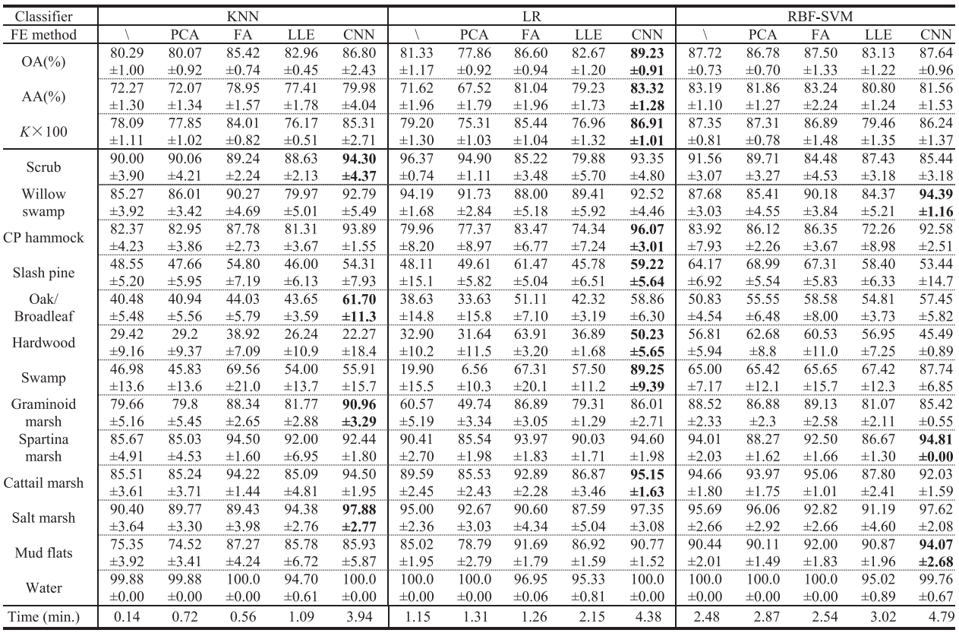

(From Deep feature extraction and classification of hyperspectral images based on convolutional neural network, 2016, IEEE Geoscience)

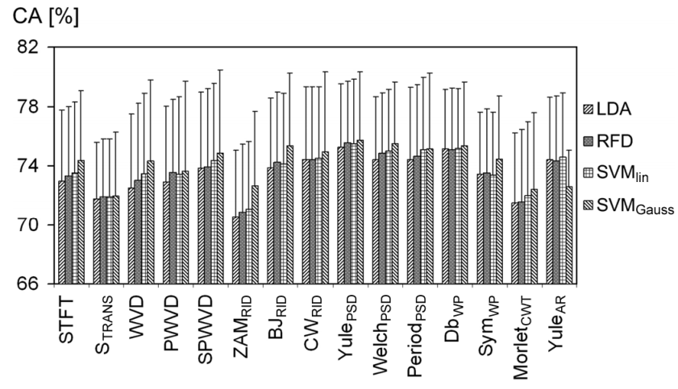

**Fig** Mean CA rates obtained on Session I data using the inner–outer CV scheme (five-fold splits with multiple runs) and averaged over 11 subjects. Vertical lines denote the inter-subject standard deviations of the respective mean CA values.

(From Comparative analysis of spectral approaches to feature extraction for EEG-based motor imagery classification, 2008, IEEE Rehab)