On December 7, 1941, the Japanese side inherited an aeronautical industry that was not optimized at all not optimized at all, with small-scale factories manufacturing small series. There were also units doing research for engine or aircraft models that were to be released in 1945! aircraft models to be released in 1945! But also factories manufacturing engines or planes that the that the navy and the army no longer wanted at the beginning of the conflict. The models are not manufactured or not at a sufficient level. Thus the Kate torpedo bomber that equipped the aircraft carriers was not built. From the day after Pearl Harbor, it was important to devote time to reorganizing this activity. reorganization of this activity. The end of the production of engines for aircraft that were aircraft already outdated at the beginning of the conflict is an absolute emergency. The production of obsolete aircraft will be continued until the stocks of engines then it will be necessary to think of the reconversion of the factories. The aeronautical production at AE, identical in principle to that of WITP, differs by a finer distinction in the models and engines. Thus from 5 or 6 engines in WITP, we go to the management of 20 types. It is the same for aircraft where the basic model is declined in 2 or 3 versions which succeeded one another in the time. So more details, and in the end a higher complexity. One can ask oneself the the interest of going down to such a level of detail that doesn't add much to the game. to the game. Moreover, all the factories are present on the map from the start of scenario 1 or 2. It will therefore be necessary to adjust the production around this existing. Only the experience of each player will allow to refine these preliminary observations. Thank you for enriching the subject with your remarks and comments.
Engines:
The most important engine is the Nakajima Ha-35 which powers the Zeros
and Oscars and later upgrades of these aircraft such as the Tojo.
A factory based in Tokyo has a capacity of 180.
and possibly convert another factory if necessary.

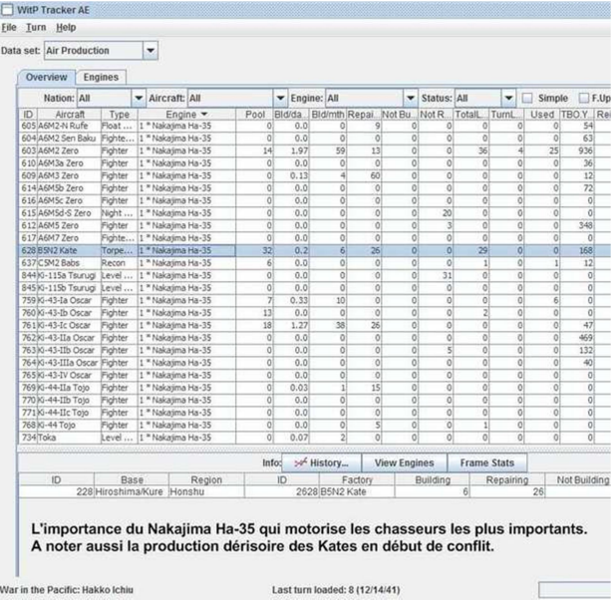

Immediately stop the manufacture of the Hitachi "early" engine which equips obsolete
obsolete aircraft from the beginning of the conflict like the Ida, Theresa...
To exhaust the stock of engines by continuing to produce Idas which is the most useful
of the planes in this mismatched stock.
To exhaust the stocks of Kawasaki "early" while continuing to produce the bomber
dive bomber Ki-32 Mary however obsolete.
To stop the production of Nakajima Kotobuki engines and to stop the production of
Nates when the stock of these engines is exhausted by converting it into Oscar for
for example. The Nate is a useful model to train young pilots' squadrons,
but at the beginning of the conflict, due to the shortage of Zeros and Oscars, this model is often
in the front line. Its great maneuverability at low altitude compensates for its
its lack of armament and its lack of speed.
It should be noted that the Hitachi Amakaze only equipped the Glens seaplanes which embarked
on submarines. Many "house rules" prohibit for reasons of historicity
the conversion of Glens embarked by other seaplanes. In this case, it will be necessary to
therefore in this case of figure it will be necessary to preserve the production of this engine carried out on a very
small scale.
Kajaba Arbus: only powers the Ka-I, a patrol plane which came out in 44 with 10 or 15 years of delay in its design.
15 years of delay in its design. The factory of Ka-I is to be reconverted whatever it
and the location of the engine factory to be reconverted into an engine worthy
worthy of interest.
To adjust the production of the engines equipping the large series: Zeros, Oscars,
(Nakajima Ha-35) Sallys (Mitshubishi Ha-32), Hellens (Nakajima Ha-34).

Hunters:
Increase production of Zeros (A6M2) between 70-100/month. Slowly convert the
squadrons equipped in Claude with Zeros by allocating the aircraft in priority to
to squadrons on board APs. Plan to allocate aircraft to be placed in reserve in
reserve in the 1st line squadrons. At the beginning of the conflict the Japanese do not have
the means to do it.
To capitalize then on the A6M3 but this plane does not embark on PA.
To replace urgently the Claudes equipping in December 41 the CVL and CVE.
To equip the CV Tayo which starts the war without plane.
The number of Zeros included in the embarked squadrons is only 18.
In total, the estimated needs in Zeros until the end of 42 are 700
taking into account the conversion of the Claudes and the arrival of new squadrons
equipping the APs coming out of the building sites.
To put into service the R and D factory of the A6M3 to try to gain one month on the
of this aircraft.
The A6M2 is upgraded in February 44 with the A6M2 Sen Baku which is a fighter
bomber.
To convert the factories of hunters reserved for the army by capitalizing on the
Ki-43-Ic (Oscar), and then switch the army's fighter squadrons to this
on this model. The squadrons based in China and Manchuria are not a priority.
The Oscar in AE is a rehabilitated aircraft with superior maneuverability
to the Zero.

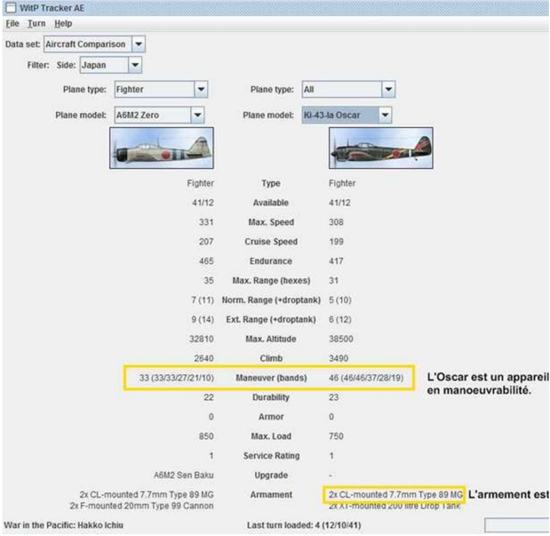
The problem is that there are on the map 3 factories of Oscar producing the versions a,b,c.
Only 3 squadrons of Oscars are present on the map, one equipped with the
version, the two others with the b. The factory c apparently produces to reconvert
the Nates squadrons. While waiting and rather than making irreversible decisions, I did not
irreversible decisions I did not touch the factories producing the a and b versions to
to allow the replacement of the aircraft lost in the 3 active squadrons
of Oscars.
The maximum number of fighters that the Japanese army can put on line is
582 + 102 in the static squadrons that cannot leave the Japanese islands or Manchuria.
Manchuria.
Japan started with 92 Oscars in service. It is therefore necessary in principle to build
500, which will take 10 to 15 months. In the meantime, the Nates must
continue their service and serve as training aircraft until they are
extinction. To do this, the PDU option must be set to "On" in order to have the possibility of
possibility of upgrading as well as downgrading the squadrons. 200 fighters
deployed in the 1st line, if we estimate that 1/3 of the squadrons are employed in combat at a given time
200 in reserve in the pool, should be enough for the first year of the war.
first year of the war.
After 15 months, the first Tojos and Tonys entered service. It should be noted that
the Tojo does not arrive alone. A factory had to be converted. There is no
There is no Tojo squadron arriving as a reinforcement either. The Tojo only enters the game by
reconversion decided by the player of the Nates and Oscars squadrons. The question
arises on the interest of having Tojos. But we are not yet in 1942!

Bombers:
Keep Nells and Bettys in production. Increase production of Bettys to 60-
80/month.
The Nell goes from its G3M2 version to G3M3 equipped with a radar in May 42 whereas the Betty
the Betty receives a radar only in June 44. Contrary to WITP one has, it seems,
interest to keep Nells, still it is necessary to have an idea of what gives a radar
embarked on a plane.
To increase the production of Kate torpedo boats (B5N2) by putting the Hiroshima factory into operation
of Hiroshima and Vals (D3A1) dive bombers at 40-50/month.
The Japanese bomber squadrons of the army can house a maximum of 779 aircraft
779 aircraft, including about 230 Sallys. Maintaining the level of production
production level of the Sallys as it is, but to increase the production of the Helens to the
the same level as the Sallys.

Seaplanes:
Requirements are relatively limited.
Convert and reorganize production into 20-30 E13A1, 10-15 F1M, and 5-10 E14Y1.
Convert all non-submarine based seaplanes between E13A1 and F1M. The
E13A1 is an excellent observer but the F1M is a seaplane with fighter
capabilities of a fighter.
Upgrading the H6K4 to H6K5 is not essential. It is better to wait
the arrival of the Emily. However the H6K5 Maevis has a radar in June 42 whereas the Emily is not equipped with one.
the Emily is equipped only in March 1943. How important is the radar at AE?
Only practice will determine this.

Transport aircraft:
Switch all production to the MC21 (Sally) or L2D2Tabby.

After the first 6 months of the war:
Keep the A6M2 as a long-range escort but switch to the A6M3a
which is superior in high-altitude maneuvers and has a higher rate of climb
and has a higher rate of climb.
Convert the D3A to the D4Y
Produce the B6N in place of the B5N when available.
Convert the reconnaissance seaplanes to the H8K (Emily)
Switch the transport seaplanes to the H8K2-L.
Divide the army's fighter aircraft production between Ki-43-
IIa, Ki-45-KAIa, Ki-44-IIa and Ki-61-Ia in the proportions 20/40/20/20.
Distribute the army's bomber production between Ki-48-Iib, Ki-21-Iib,
and the
Ki-49, then later on the Ki-67.
The factories producing the army's reconnaissance aircraft are automatically converted to the Ki-48-Iib
automatically converted to the Ki-46-III.
Convert factories producing transports to the Ki-49-II KAI.
Prefer aircraft equipped with radar as a matter of priority

Factory conversion:
Convert Nates factories in Harbin to A6M2 and Maebashi factory to Oscar.
Convert Ki-36 factories to Oscar.
Convert the Ki-51 factory to Ki-48 which is an armored bomber in a 2nd
version.
Convert the Ki-56 factory to C5M or as needed.
To put in mothballs the factories making research on models having to leave
in 1943 or later or convert them to research on models to be released
coming out earlier.

Upgrade of the aircraft:
The ways to upgrade aircraft are not always obvious:
so the upgrade of the A6M2 depends on the squadron and not on the aircraft model.

