Incorporating Internet of Things in Soil Mechanics Lab

Richard Muri
Master's student
ECE Department

Paul Fortier
Faculty
ECE Department February 16, 2018
Introduction

Modern technology is changing the way engineering work is performed. The proclivity of Internet of Things (IoT) devices has improved our ability to perform laboratory exercises. In order to expose undergraduate civil engineering students to this concept, the Soil Mechanics Consolidation test is being updated to reflect modern sensor capabilities. Internet connected sensors will be added to the existing test apparatus to provide data logging functionality, which in conjunction with a database, will give students access to near real time measurements from anywhere.

Background

The Soil Consolidation Test measures the soil coefficient of consolidation used to estimate rate of consolidation for a soil sample. The loading device used is pictured below in Figure 1.

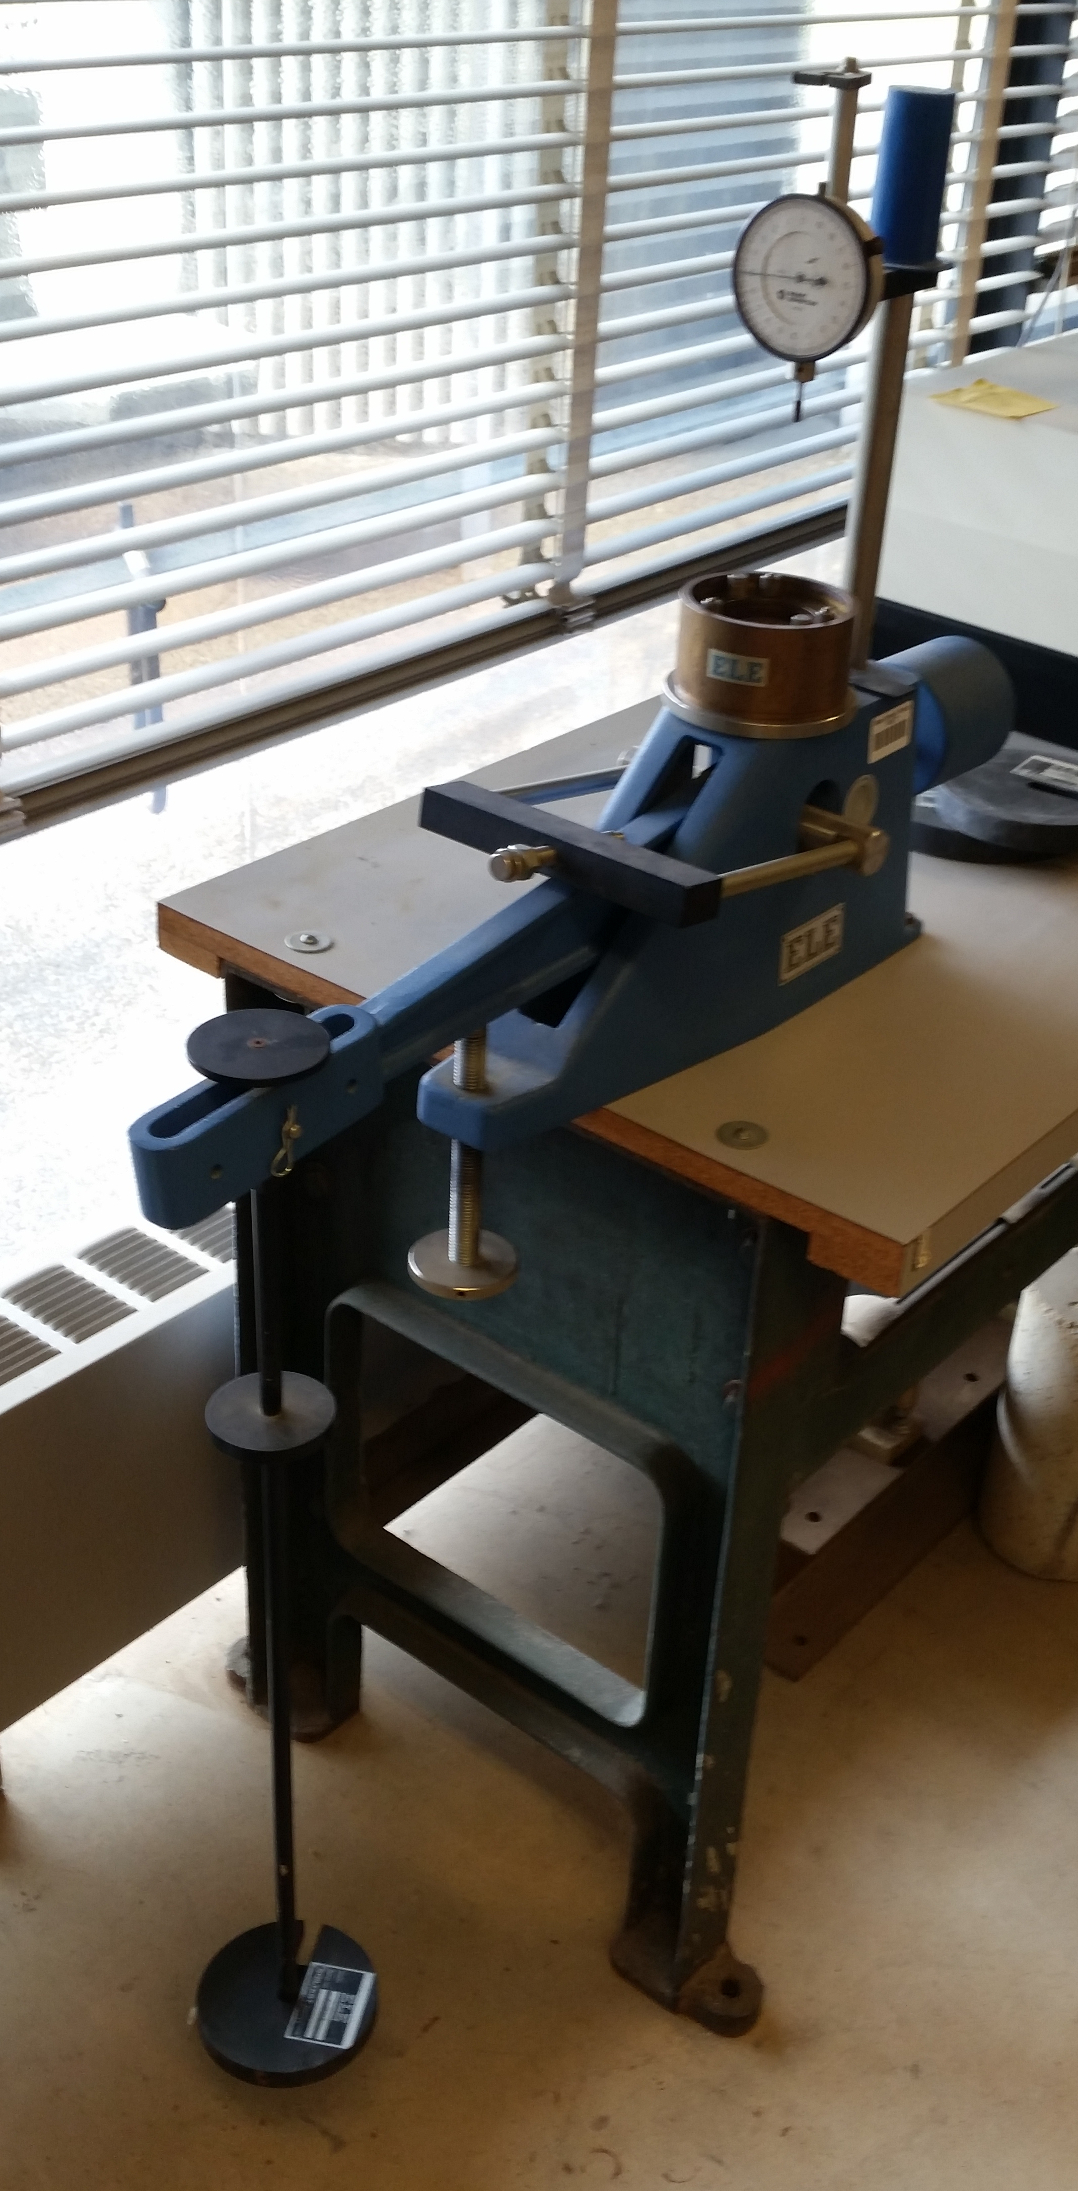

Figure 1: Loading device
The circular brass plate holds a soil sample. Weights, pictured below in Figure 2, are added to a lever which applies force to the soil sample, measured in tons/ft². The gauge above the soil sample measures the linear displacement of the sample. The displacement over long periods of time (on the order of days) is used to calculate the consolidation of the soil sample, and changes as the loading devices compresses the sample.
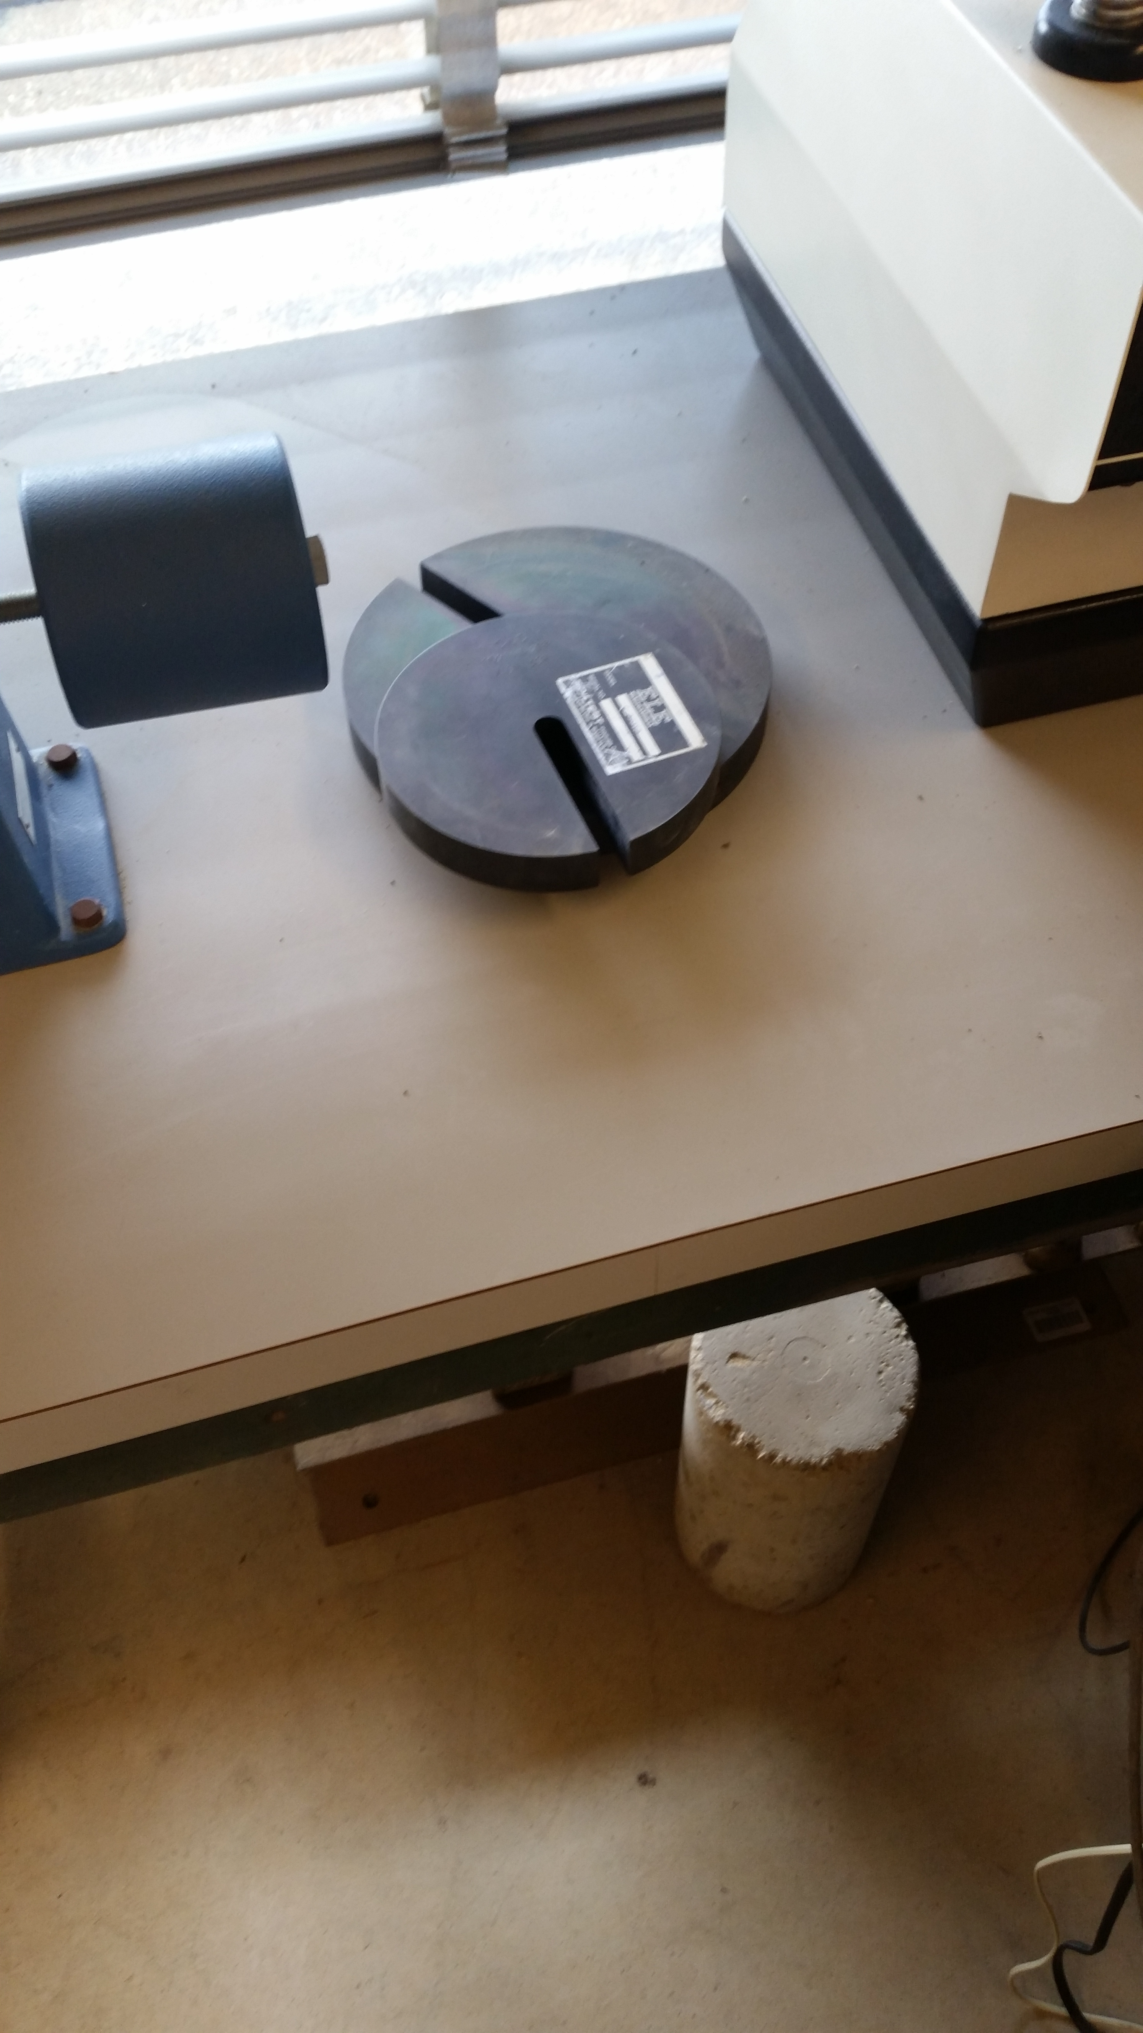

Figure 2: Load device weights

Project Requirements and Methodology

The requirements of the design are as follows:
- Measure linear displacement of the soil sample with precision to 10⁻⁴ inches
- Measure lever arm weight. Possible discrete weight values are known in advance, and tons/feet² in the lever arm can be determined for each value.
- Log the time all measurements are taken at. Measurements should be taken every few seconds (no more than approximately 10 seconds apart)
- Store weight, displacement, and time in a database.
- Group sets of data as separate experiments
- Create a web interface where students can access the database
- Document the process and provide instructions on how to use the equipment

Design goals are as follows:
- Build a system that is easy to use and maintain, particulary for someone who did not design it
- Minimize the cost of the system
- Minimize the amount of hardware required

Shown below on the following page in Figure 3 is a block diagram of a proposed high level design concept. A pressure sensor on the lever arm will measure the weight currently on the load apparatus. Because the weighted values are known, this sensor does not have to be high resolution, it only has to distinguish between distinct weights. A linear displacement sensor is placed above the consolidator to measure the soil compression. The resolution needs to be on the order of 10⁻⁴ inches.

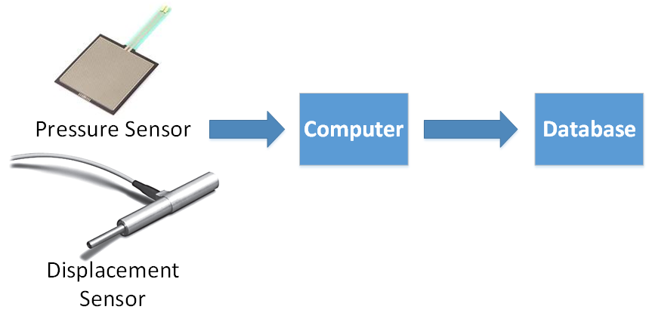

Figure 3: Block Diagram of Abstract Design Proposal

Sensors will communicate with a computer; either a microcontroller board will be used, or the existing Windows 2007 machine in the lab. Tradeoffs to both methods will be evaluated as part of the project before deciding on the design. Ideally the communication will occur wirelessly, although depending on available sensors a wired connection may be required. The goal of the project is to produce a system that can be easily used an maintained by somebody other than the engineer that designed it, for a low cost. Digital sensors will be given preference to avoid adding additional hardware requirements, but it is possible that the design will include a board that converts analog sensor output into digital data.

The database used will be chosen based on database software CITS already has available. The anticipated design is an SQL database that features an access page for students to download data.

A rough timeline for the project is shown in the table below. This timeline could change depending on final hardware requirements, and component shipping times. It is implicit that weekly updates will be given, and every week will include an ongoing documentation process.

Time Frame | Project Goal
Week of 2/19 | Research suitable sensors
Week of 2/26 | Order sensors for prototyping, work on computer/microcontroller software
Week of 3/5 | Prototype sensors. Research and order new sensors if necessary
Week of 3/12 | If PCB design is necessary, finish design and order this week. Else begin assembling sensors onto load device
Week of 3/19 | Hardware testing (Sensors on load device) Modify hardware design if necessary
Weeks 3/26 to 4/9 | Software Design (Database and computer)
Weeks of 4/16 to 4/30 | Integration and testing (hardware and software)
Week of 5/7 | Training (Working with the lab technician to make sure device can still be used when I'm gone)
Weeks of 5/14 and 5/21 | Final documentation pass. Troubleshooting guide

